**ACKNOWLEDGEMENT**

The magnitude of this project demanded the co-operation, guidance and assistance from a number of people and by the grace of god we have been fortunate enough to have this entire process of completion of our project work.

We would like to thank our principal Dr. Hala Naik for providing us the facilities to carry out the project work. We thank Mr. Vishwanath Pai, Head of the department of Computer Science, Mahatma Gandhi Memorial College, Udupi for having permitted us to take this project.

We would like to place on record the valuable guidance and constant encouragement your guide, Mr. Raghuram Holla, Department of Computer Science, Mahatma Gandhi Memorial College, Udupi for the suggestion to give a nice shape to this project.

We would like to express our sincere gratitude to Mr. Pramod Madhwaraj, Raj Fish Meal & Oil Co. who in spite of his busy schedule took keen interest in giving us all the necessary information for developing a good system and for his unlisted encouragement guidance and timely supports till our successful completion of the project work.

We would like to thank all teaching and non teaching staff members of Computer Science Department, Mahatma Gandhi Memorial College, Udupi for their co-operation and constant encouragement which helped us in successfully completing our project.

Finally, our heartfelt gratitude to all those who have helped us directly or indirectly, thus making the project successful.

* Punith
* Rajesh
* Sandesh

**SYNOPSIS**

**TITLE OF THE PROJECT**:

Computerized Management for

“**RAJ FISHMEAL & OIL COMPANY**”

**OBJECTIVES OF THE PROJECT:**

* To automate the management system
* To reduce manual work involved in the system.
* To develop user friendly software.
* To store, retrieve and maintain information efficiently.
* To give stock level details.
* To minimize error during manual entry.
* Provides security in various transactions.
* To create report on different transactions, on different level of performance.

**PROJECT CATEGORY:**

Windows application with user friendly front end as Microsoft VB.Net 2005 and back end as Microsoft SQL Server 2005.

**TOOLS TO BE USED:**

* Requirement analysis tools:
  + Questionnaire to the Employer
  + Questionnaire to the user
* Programming tools:
  + Back end: Microsoft SQL Server 2005
  + Front end: : Microsoft VB.Net 2005
* Kind of hardware needed for the project:
  + Intel Pentium or higher version processors
  + 160 GB Hard Disk
  + 1 GB RAM
  + Color Monitor
* Testing tools:
  + Manual testing with set of real time data

**STRUCTURE OF THE PROJECT:**

Problem analysis:

In this the need of the client and user will be understood. The current system is a manual system functioning with a lot of people, paper documents, registers, etc.

Proposed system:

* The new automated system will reduce manual work.
* The use of paper documents is reduced.
* The system will contain information about employees, billing, suppliers, clients, sales and purchase details.
* Users can reach for a supplier, purchase details just by entering any of the criteria like supplier name, supplied goods, or any keyword regarding supplier or purchase details.
* Proper tracking of items purchased and manufactured fish products sold out.
* Attendance of employees working and monthly payroll will be generated.
* Following reports will be generated:
  + Purchase report: This report generates the details of inventories (Raw materials) purchased for a particular date.
  + Daily report: This report generates the report on daily transactions.
  + Factory consumption report: This report generates the report on the products consumed from store house to factory.
  + Sales report: This report generates sales details about the products on a monthly, yearly basis.
  + Stock report: This report generates details about opening and closing stocks.

**MODULES**

1. Employee
2. Inventory
3. Supplier
4. Purchase
5. Finished Goods
6. Sales
7. Customer
8. User Settings
9. Reports
   1. Daily report
   2. Purchase Report
   3. Factory Consumption Report
   4. Sales Report
   5. Stock Report
10. Settings
11. Logout

**MODULE DESCRIPTION:**

1. Employee: This module contains the information about employees of various departments and details of the amount of salary being paid to the employees.
2. Inventory: This module includes raw inventory details. It contains sub module of inventories like factory consumption and search inventory.
3. Supplier: This module consists information about suppliers supplying raw inventories to the factory
4. Purchase: This module includes the details like inventory purchased, dealer name, price, quantity, date of purchase, tax, VAT, invoice number, etc required by the firm.
5. Finished Goods: This module contains details about produced stock.
6. Sales: This module gives the sales detail of the manufactured product sold like fish soluble, fish meal and fish oil.
7. Customer: This module gives information about customers buying fish products.
8. User settings: Each user of the Software is provided with login IDs. Any new user can be added using this module. The Login details can be modified using this module.
9. Reports:
   1. Purchase report: This report generates the details of inventories (Raw materials) purchased for a particular date.
   2. Daily reports: This report generates the report on daily transactions.
   3. Factory consumption report: This report generates the report on the products consumed from store house to factory.
   4. Sales report: This report generates sales details about the products on a monthly, yearly basis.
   5. Stock report: This report generates details about opening and closing stocks.
10. Settings: This module is used to modify the DA, HRA, PF, Discount and VAT.
11. Exit: This module is used to exit or close the application.

**INDEX**

1. **Introduction**

* Purpose
* Scope
* About the organization
* Project overview

2. **Objectives**

3**. Tools/Environment to be used**

* Languages Used
* Front end
* Back end

4. **Requirement Analysis Document**

* Software Requirement Specification
* E-R diagrams
* Data Flow Diagrams
* Data dictionary

5. **Design Document**

* System & Detailed - Modularization
* Data integrity &constraints including database design
* Procedural design
* User interface design

6**. Program code**

7. **Testing**

8. **Input and Output Screens**

9. **Limitation**

10. **Bibliography**

11. **Future scope**

**INTRODUCTION**

**Purpose**

The main intent of project work is to put knowledge into practical use that we have been cumulating in the classrooms, to sharpen and test our skills that we have acquired in our course so far. Project helps us to develop our programming skills and to optimize our coding techniques. Working on a project also gives us a taste of the real challenge that a professional face. Apart from helping us develop our project work predicts the development of our technical skills namely co-ordination, communication, participation, group discussion etc. We learn values like working hard, persistence, diligence etc…

**Scope**

The process involves in the maintenance and the management of the fish products may be lengthy. The aim of our project is to reduce and simplify this process. This reduces the manual work involved in developing relationship between customer and this indirectly helps the organization to yield more accurate results. In this project we mainly focus on the service/packages taken by the customer, their sales bill and package description, quantity of the stock, suppliers, and employees. This software is also used for billing store the details of the inventory and the purchase order. This software is also used to analyze the stock.

**About Organization**

With a vision to be a globally respected organization and the providers of best quality of fish products, RAJ FISH MEAL AND OIL COMPANY started its business operation long back in the year 1967. The company, crossing several milestones of expansions and up gradation in its overall trade practices, has grown as the pioneer manufacturer and exporter of vast variety of fish meal, refined fish oil derivatives and fish soluble products. Our range comprises of steam dried fish meal, prink perch fish meal, sardine fish meal, centrifuged fish oil, and concentrated fish soluble, etc. At RAJ FISHMEAL AND OIL COMPANY, target growth not merely in terms of sales and margin but more in terms of quality of products and services they deliver to the final customer. To avail optimum satisfaction to their customers they constantly keep upgrading their facilities and exploring new ways for achieving better production results.

They are the steam Dried fish meal and Centrifuged fish Oil producing company situated in the West Cost of India, Karnataka (previously Coronet Fishmeal & Oil Company). They are proud to state that they are the pioneers and largest producers and exporters of Fishmeal and Oil in the West Cost since 1967. Their production capacity is 150 tons of fish meal and about 60 tons of fish Oil per day. They also have a well equipped nutrition laboratory.

West Cost of India is bestowed with vast resources of pelagic fishes mainly Mackerels and Sardines. Fishing season in West Cost is form August to June, for about 10 months in a year. Raj Fishmeal & Oil Co., Maple is aimed to efficiently utilize the maximum extent of catches of sardines in the West Cost. RAJ FISHMEAL AND OIL COMPANY was initially named as “CORONET FISH MEAL AND OIL COMPANY”, MALPE by its owner late M. Madhwaraj and was inaugurated on 26-12-1967 by the then chief minister of Karnataka, late S. Nijalingappa. It was renamed as RAJ FISHMEAL AND OIL COMPANY, in 1987 and hence forth, it is operating in the market with the same identity.

**Nature of the business carried**

RAJ FISH MEAL AND OIL COMPANY is basically a manufacturer and exporter of vast variety of fish meal, refined fish oil derivates and fish soluble products. RAJ FISH MEAL AND OIL COMPANY is strategically located at Karnataka, the West Cost of their factory that they have developed the capacity to produce 150 tons of fish meal and about 60 tons of fish oil on a daily basis.

They are supported by a team highly experienced professionals, who are positive, proactive and productive to take up new challenges in their work areas. This is perfect combination of man and machines in the successful completion of milestones.

**Project Overview**

This application has been developed for a fish meal company using Microsoft VB .NET 2005 and SQL Server 2005. Product of this project is software, which replaces all the records, which are handled manually.

There are many records such as customer information, supplier details etc. since it involves a lot of work it is very difficult task for the user to maintain all these manually. This helps to maintain the records efficiently

**OBJECTIVES**

**OBJECTIVES OF THE PROJECT:**

* To automate the management system
* To reduce manual work involved in the system.
* To develop user friendly software.
* To store, retrieve and maintain information efficiently.
* To give stock level details.
* To minimize error during manual entry.
* Provides security in various transactions.
* To create report on different transactions, on different level of performance.

**Product perspective:**

Product of this project is software that reduces work, which is handled manually by Raj Fish Meal & Oil Co. There are many modules to be handled such as purchase, sales, and stock maintenance, employee salary etc. Handling these modules is a difficult task for the users. This product provides an easy way of maintaining details.

**Product Function**

* Provides user friendly GUI by means of VB.Net forms.
* More efficient and fast access of management system is possible.
* All the manually handling procedure for maintaining records is replaced by software.

**USER CHARACTERISTICS**

**Administrative user**

These users have got high value of authority. He has the rights to modify any of the software modules. He has an authority of creating User ID and password of any of the users including his own.

**Manager User**

These users are the managers of various departments like sales, purchase, store etc… Here users have authority of their respective departments.

**User**

These users are none other than employees. Here the users have less authority compared to administrative users.

**General constraints**

The developed system should run on any type of operating system that supports VB.Net and MS SQL server 2000.Only one user can access the system.

**TOOLS/ENVIRONMENT TO BE USED**

**Languages USED: FRONT END AS VB.NET 2000**

What is VB.net?

Vb.net is the successor of the Visual Basic 6 programming language. VB.Net has brought about a great number of architectural changes in the Visual Basic language that are not backward compatible.

A number of core elements and concepts in VB6 have been modified or removed. A great number of new features have been added to the VB.Net language. It will be right to say that VB.Net will change the way Visual Basic programmers perceive their development. VB.Net has gained some credibility among serious programmers.

Visual Basic has gained much favor amongst many developers. Currently, there are more VB programmers in the world then there are for any other programming language and there is more application development done in VB then in any other programming language.

In the Microsoft VB.Net platform, VB.Net (along with C# .Net) is the language of choice. It’s probable that most of the current VB6 programmers would like to switch to VB.Net when they decide to move to the .Net platform which ultimately all windows developers will have to; certainly the .Net platform is very much a part of Long Horn Development.

**VB.NET AS A PROGRAMMING LANGUAGE:**

VB.Net is now a full-fledged object oriented programming language. It contains classes, objects, inheritance, polymorphism, abstract classes, interfaces, structures, enumerations, delegates and other common object oriented concepts. In VB.Net, the error handling mechanism has been modified and is now more structured.VB.Net uses the .Net standard garbage collector to release memory that is no more referenced by your application. Probably the best thing about VB.Net is that it is a part of the .Net framework and is integrated in the .net platform. It means that VB.Net programs can employ all the features and services exposed by the .Net framework. It can use the .Net framework class libraries, interact with program modules written in other .Net language and also use the old COM and ActiveX components. Previously, Visual basic was mainly used to create console applications windows application, web application, .Net components, .Net Form controls, .Net web controls, Window services, web services, database applications, and more. Using the .Net framework libraries you can program new exciting features like reflection, attributes, marshaling, remoting, threads, streams and also data access with ADO.Net compared to using VB6, VB.Net will feel extremely powerful .

**VISUAL STUDIO.NET AND ITS COMMON FEATURES:**

Microsoft Visual studio .Net is an Integrated Development Environment (IDE), which is a successor of Visual Studio 6.It eases the development process of .Net application by a great deal for VC#.Net, VB.Net, VC++.Net, Jscript.Net, J#.Net, ASP.Net etc…

The revolutionary approach in this new Visual Studio.Net debugger, project and solution explorer, class view, properties tab, toolbox, standard menu and toolbars.

The key feature of Visual Studio.Net includes:

1. Keyword and syntax highlighting.
2. Intelligence(auto complete), which helps by automatically completing the syntax as you type a dot(.) with objects, enumerations, namespaces and when you use the new keyword.
3. Project and solution management with solution explorer that helps to manage applications consisting of multiple files, which is what usually happens.
4. Help building user interface with simple drag and drop over form window.
5. Properties tab that allow you to set different properties on a number of windows and web controls.
6. Standard debugger that allows you to debug you program by putting break points for observing run-time behavior of the program.
7. Hot compiler that checks the syntax of you code as you type it and report any errors present.
8. Dynamic help on a number of topics using the Microsoft development network (MSDN) Library.
9. Compiling and building applications.

10. Execution of your application with/without the debugger.

11. Deploying you .Net application over the internet or on CDs.

**PROJECT AND SOLUTIONS:**

A project is a combination of executable and library files that make an application or module. A project’s information is usually placed in a file with the extension ‘.vbproj’ where ‘VB’ represents Visual Basic. Similarly, C#.Net project are stored as ‘.csproj’ files.

There are several different kinds of projects such as console applications, windows application, ASP.Net web application project and a windows form project. The information for a solution is stored in ‘.sln’ files and can be managed using Visual Studio. Net’s solution explorer. Solutions are similar to VB 6’s project group and VC++6’s workspace.

**TOOLBOX, PROPERTIES AND CLASS VIEW TABS:**

Now there is a single toolbox for the entire visual studio. Net’s language and tools. The toolbox usually presents on the left hand side contains a number of common controls for windows, web and data applications like the textbox, checkbox, tree view, list box, menus, file open dialog, etc…

The properties tab (usually present on the right hand side in the IDE) allows you to set the properties on controls and forms without getting into code. The class view tab shows all the classes that your project contains along with the methods and fields in tree hierarchy. This is similar to VCC++6’s class view.

**BACKEND AS SQL SERVER:**

Structured Query Language server (SQL server) Microsoft SQL server 2000 extends the performance, reliability, quality and ease of use of Microsoft SQL server version 7.0. Microsoft SQL server 2000 includes several new features that make it an excellent database platform for large scale online transactional processing (OLTP), data warehousing and e-commerce applications.

The OLAP service feature available in SQL server version 7.0 is now called SQL server 2000 analysis services. The term OLAP services have been replaced with the term analysis services. Analysis services also include a new data-mining component.

The repository component available in SQL server version 7.0 is now called Microsoft SQL server 2000 Meta data services. References to the component now use the term Meta data services.

The new topic contains brief overviews of the new features and links to relevant conceptual topics that provide more detailed information. These concept topics provide links to topic that describes the commands or statements you use to work these features.

**ACCESSIBILITY FOR PEOPLE WITH DISABILITIES:**

Microsoft is committed to making its product and services easier for everyone to use. This topic provides information about the following features, procedures and services that make Microsoft windows, Microsoft windows NT and Microsoft SQL servers 2000 more accessible for people with disabilities.

* Accessibility of Microsoft SQL server 2000.
* Features and hints for customizing windows or Windows NT
* Microsoft services for people who are deaf or hard of hearing.
* Microsoft software documentation online, or on audio cassette, floppy disk or CD.
* Third-party a utility that enhances accessibility.
* Other products and services foe with disabilities.

Note: Information in this section applies only to users who license Microsoft products in the United States. If you obtained this product outside the United States, your package contains a subsidiary information card listing Microsoft support services telephone number and addressed.

You can contact your subsidiary to find out whether the type of products and services described in this section are available in your area.

**SQL SERVER 2000 ACCESSIBILITY FEATURES:**

In addition to windows and Windows NT accessibility products and services the following make Microsoft SQL server 2000 more accessible for people with disabilities.

**THE HELP VIEWER:**

The help viewer for Microsoft HTML help is the tool through which you read the product documentation. It is equipped with accessibility features, including shortcut keys for navigation and commands. The help viewer also uses some of the accessibility features of Microsoft Internet Explorer. For example, it allows you to change the colors of the display on your computer screen.

**CUSTOMIZING WINDOWS OR WINDOWS NT:**

There are many ways you can customize windows operating system and Windows NT 4.0 to make your computer more accessible. Accessibility features have been built into windows and Windows NT since the introduction of Windows 95. These features are useful for individuals who have difficulty typing or using a mouse, have moderately version, or who are deaf or hard of hearing. The features can be installed during step, or you can add them later from your windows installation disks.

For information about installing and using these features look up “accessibility” in windows help index. Some of the accessibility features built into Windows and Windows NT can be added to earlier versions of these products, and to Microsoft MS-DOS, through access pack files, or you can add them on disk from Microsoft.

You can also use control panel and other built in features to adjust the appearance and behavior of windows or Windows NT to suit varying version and motor abilities. These include adjusting colors and sizes, sound volume and the behavior of mouse and keyboard in windows 98, the majority of accessibility wizard or control panel. The accessibility wizard presents features sorted by disability, making it easy to customize windows to individual needs. The accessibility wizard also enables you to save your settings to a file that can be used on another computer.

DVORAK keyboard layouts make the most frequently typed characters on a keyboard more accessible if you have difficulty using the standard QWERTY layout. There are 3 DVORAK layouts: one if you are a two handed user, one if you type with left hand only, and one if you type with your right hand only. You do not need to purchase any special equipment to use these features.

The specific features available, whether they are built in or must be obtained separately, depends on which operating system you are using.

For full documentation on the accessibility features available in the operating system you are using, obtain the document listed below. Accessibility features are also documented in the Microsoft Windows 95 resource kit, the Microsoft Windows NT resource kit.

Structured query language helps in manipulating data in tables; creating and changing the structure of tables. Structured query language queries are constructed to retrieve records from database table match related data in multiple tables and manipulate a data control. They are also used to manipulate database in code, using the DAO, RDO, or ADO object models. SQL is a standard method for forms by many databases. It is implemented in various forms by much relational database system such as Microsoft SQL server. Generally, SQL is used to creating queries that extract data from the database. Also SQL commands can perform other functions in databases such as tables and fields.

SQL commands are of two categories as explained below:

* Data definition language(DDL) command-

These enable to use SQL query components of the databases such as tables, fields and indexes.

* Data manipulation languages(DML) commands-

These are designed to retrieve records from databases.

**SOFTWARE REQUIREMENT AND SPECIFICATION**

**External interface requirements**

**User Interface**

The interface should be user friendly. Users will have restricted access and system should not allow access to unauthorized users.

* Any standard keyboard
* Any standard mouse

**Hardware requirements**

* Any standard keyboard
* Any standard mouse
* Any standard monitor

**Software requirements**

* Front end-Visual Basic.Net
* Back end-SQL Server

**Functional requirements**

It specifies which output should be produced from the given inputs. They describe the relationship between the input and output of the system.

All the operations to be performed on the input data to obtain the output should be specified. An important part of the specification is the system behavior in the abnormal situation like invalid input or error during the computation. The functional requirements must clearly state what the system should do if such situation occur. This includes specifying the validity checks on the input.

**Input design**

The inputs of various forms correspond to the details regarding the inventory management. It deals with the entry of details about new inventory. It also includes details about engineer’s department. Input form should reflect clarity, easy, uniform standard and user friendly.

**Output design**:

The output of the system would be details regarding inventory, purchased inventory reports. The output should be accurate and at the same time be presented with high clarity for easy understanding.

**Performance requirements**

This part of an SRS specifies the performance constraints on the software system. All the requirements relating to the performance characteristics of the system must be clearly specified.

There are two types of performance requirements:

* + 1. Static Requirements:

Static requirements are those that do not impose constraints on the execution characteristics of the system. These include requirements like the number of terminals to be supported, the number of simultaneous users to be supported and the number of files that the system has to process and their sizes.

* + 1. Dynamic requirements:

Dynamic requirements specify constraints on the execution behavior of the system. These typically include response time and throughput constraints on the system.

**Design constraints:**

There are a number of factors in client’s environment that may restrict the choices of designer. Such factors include standards that may be followed, resource limits, and operating environment, reliability and security requirements.

1. Standard compliances:

This specifies the requirements for the standard the system must follow. The standard may include the report format and accounting procedure.

1. Hardware Limitations

It can include the type of machines to be used, operating system available on the system, languages supported and limits on primary and secondary storage.

1. Reliability and fault tolerance:

Reliability requirements are very important for critical applications. Fault tolerance requirements can place major constraints on how the system is to be designed. It often makes the system more complex and expensive.

1. Security:

Security requirements are particularly significant in many database systems. Security requirements place restrictions on the use of certain commands, control access to data, provide different kinds of access requirements for different people, requirement the use of password.

STRUCTURE OF SYSTEM DESIGN:

System design is a solution to the creation of a new system. This important phase consists of several steps. It provides the understanding and procedural details necessary for implementing the system recommended in the feasibility study. Emphasis is on translating the performance requirements into design specification.

Design goes through logical and physical development. Logical designs preview the present physical development. Logical designs preview the present physical systems, prepare input and output specifications and detail the implementation plans and the internal logic of each of the modules. Here it should be ensured that the design should technically sound with minimum of redundancy and maintains concern. The physical design maps out the details of the physical systems, plans the system that specifies any new hardware and software.

The purpose of design phase is to plan a solution of the problem specified by the requirement document. This phase is the first step in moving from the problem domain to the solution domain. It is also a bridge between requirement specification and final solution domain for satisfying the requirements. The design of the items is perhaps the most critical factor, which affects the quality of the final products it has a very major effect on the later phases such as testing as well as maintenance.

Software design is a multi step process that focuses on 4 distinct attributes of the program. They are:

1. Data Structure
2. Software architecture
3. Interface presentations
4. Procedural details

The design process translates the requirements into representations of the software that can be assessed for quality, modularity, concept of abstraction enable the designer to simplify and reuse software components. Program and data structure contributes to the overall view of software architecture while procedure provides the details necessary for the algorithm segmentation.

The goal of the design phase is to produce a module or representation o f the system, which can be used later to build that system. The produced model is called as design of the system. The two most important properties that concern designs are efficiency and simplicity.

**CFD (CONTEXT FLOW DIAGRAM)**

The context switch diagram for Raj Fish Meal & Oil Co. Inventory Automation system is shown in the below figure. The inputs of this section are shown in the diagram. However, a number of details about the function of the automation system are given here. Using this as a starting point, a logical DFD of the system is given in the below figure. The environment in which the software is used is depicted in the picture.

**CFD Diagram:**

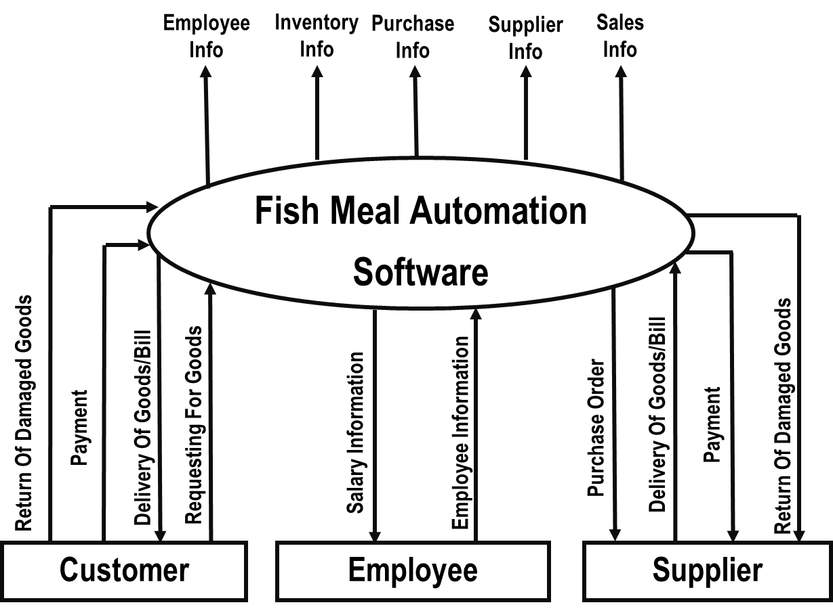

**Data Flow Diagram (DFD)**

The DFD describes the flow of data with the help of various levels in a crystal clear way.

The DFD serves two purposes:

* To provide an indication of flow data that is transformed as they move through the system.
* To depict the function that transforms the data flow.

It provides additional information that is used during the analysis of the information domain and serves as a basis for modeling function. The DFD is also known as a Data flow graph or bubble chart.

The DFD may be used to represent a system or software at any level of abstraction. In fact DFD may be partitioned into a level that represents increasing information flow and functions detail. Therefore the DFD provides a mechanism for functional modeling as well as information flow modeling.

A level of DFD also called fundamental system model or a context model represents the entire software elements as a single bubble with input and output data indicated incoming and outgoing arrows, respectively.

Additional process (bubbles) and information flows paths are represented as level 0 DFD, which is partitioned to reveal more details.

For example: a level 0 DFD might contain four or five bubbles with inter connecting arrows. Each processes represented at level 1 is sub-function of the overall systems depicted in the context model.

The basic notation used to create a DFD makes it easy to analyze and understand. The DFD is a graphical tool that can be very valuable during software requirement analysis.

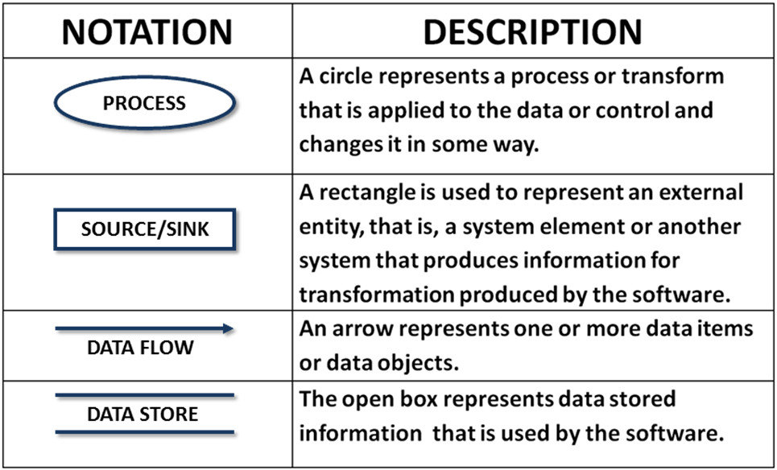

**DFD Diagram:**

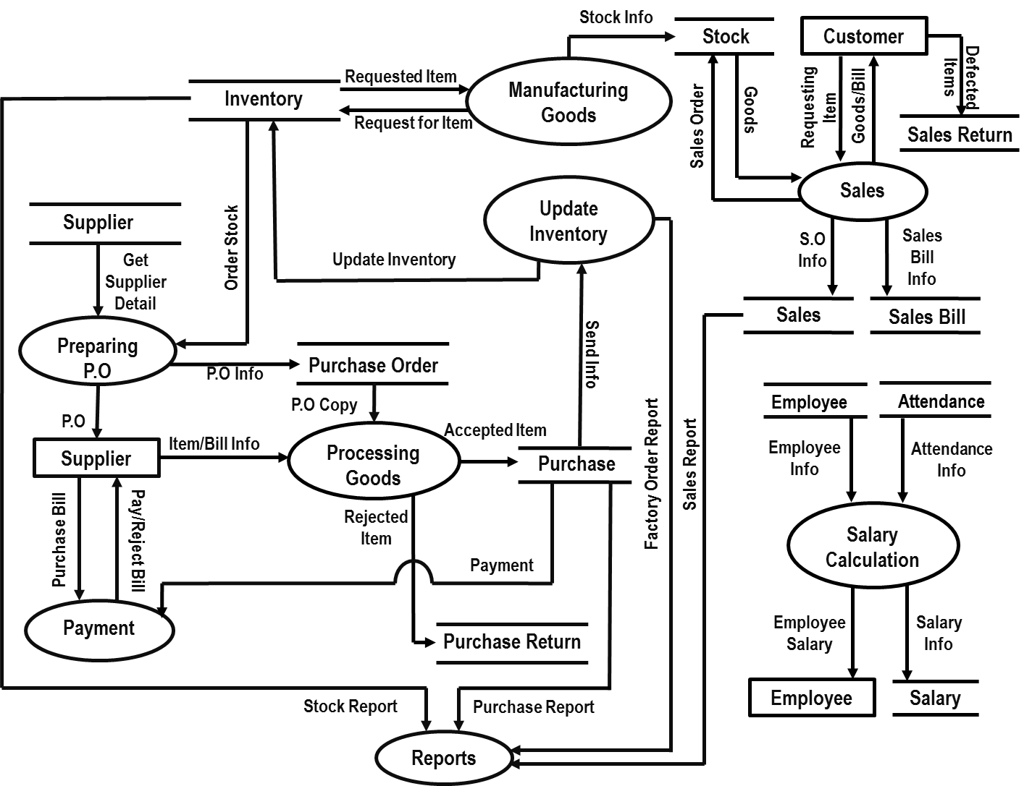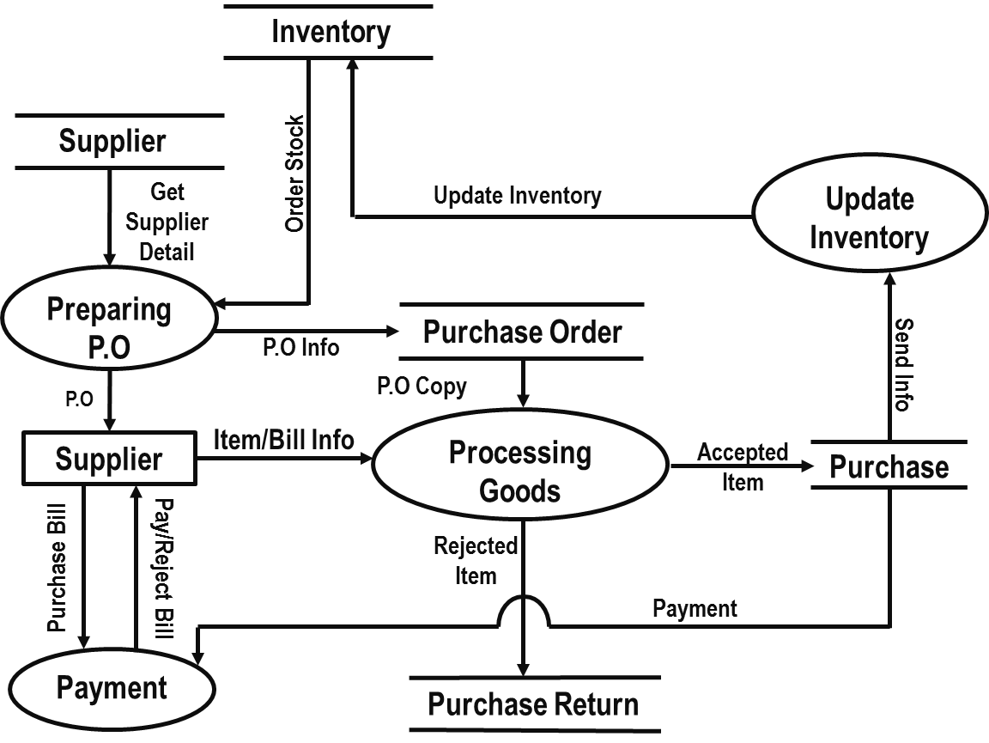

Purchase

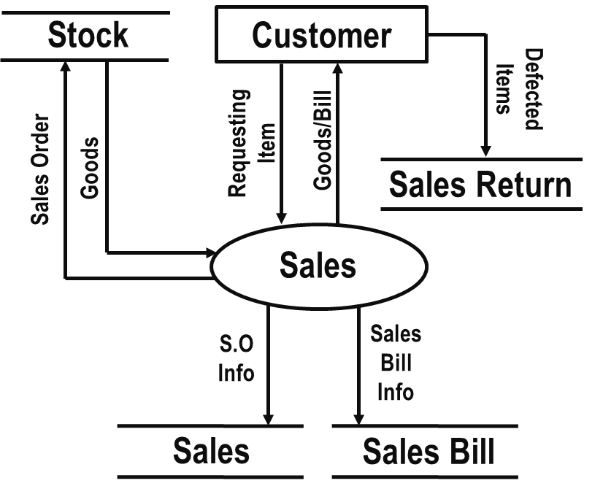

Sales

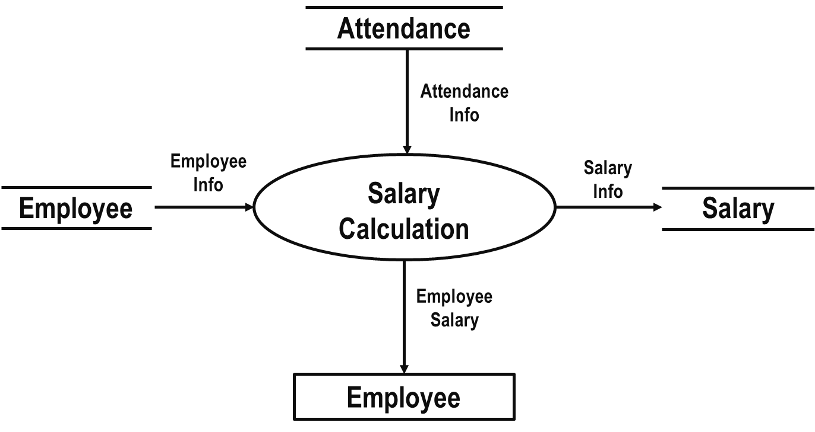

Employee

**ER DIAGRAMS**

**Introduction for ER model:**

An entity-relationship model(ER model for short) is an abstract and conceptual representation of data. Entity-relationship modeling is a database modeling model, used to produce a type of conceptual schema or semantic data model of a system, often a relational database, and its requirements in a top-down fashion. Diagrams created by this process are called entity-relationship diagrams or ER diagrams.

The building blocks: entities, relationships and attributes:

PERFORMS

**SONG**

ARTIST

Two related entities

**Employee**

An entity with an attribute

**Proved**

A relationship with an attribute

**Primary key:**

An entity may be defined as a thing which is recognized as being capable of an independent existence and which can be uniquely identified. An entity is an abstraction from the complexities of some domain. When we speak of an entity we normally speak of some aspect of the real world which can be distinguished from other aspects of the real world.

An entity may be a physical object such as a house or a car, an event such as a house sale or a car service, or a car service, or a concept such as a customer transaction or order. Although the term entity is the one most commonly used, following Chen we should really distinguish between an entity and an entity type. An entity is a category. An entity, strictly speaking, is an instance of a given entity type. Because the term entity-type is somewhat cumbersome; most people tend to use the term entity as a synonym for this term.

Entities can be thought of as nouns. Examples: a computer, an employee, a song, a mathematical theorem.

The model’s linguistic aspect described above is utilized in the declarative database query language ERROL, which mimics natural language, constructs. ERROL’s semantics and implementation are based on reshaped relational algebra (RRA), a relational algebra which is adapted to the entity-relationship model and captures its linguistic aspect.

Entities and relationships can both have attributes. Examples: an *employee* entity might have *a social security number* (SSN) attribute; the *proved* relationship may have a *date* attribute.

For entity (unless it is a weak entity) must have a minimal set of uniquely identifying attributes, which is called the entity’s primary key.

Entity-relationship diagrams don’t show single entities or single instances of relations. Rather, they show entity sets and relationship sets. Example: a particular *song* is an entity. The collection of all songs in a database is an entity set.

**Cardinalities:**

However some modifications to the original specification are beneficial. Chen described look-across cardinalities.UML perpetuates this.

Recent researchers have shown that this is more coherent when applied to n-ary relationships of order>2

In dulletet.alia “An analysis of structural validity in entity-relationship modeling” one reads” A ‘look across’ notation such as used in the UML does not effectively represent the semantics of participation constraints imposed on relationships where the degree is higher than binary.

**Diagramming conventions:**

**Chen**

**N**

**Person**

**Location**

Birthplace

1

N

birthplace

**IDEFIX**

**Person Location**

Bachman

Born in

Location

Person

Birthplace of

Martin/IE/C rows foot

Person

Born in

Location

Birthplace of

Location

(1.1)Born in

Min-Max/ISO

Person

Birth place of (0,N)

<<Relationship>>

Born In>

<Birthplace of

0..N

<<Entity>>

Location

<<Entity>>

Person

1

Various methods of representation the same one too many relationship. In each case, the diagram shows the relationship between a person and place of birth: each person must have been born at one, and one location, but each location may have zero or more people born at it.

song

Artist

performs

Two related entities shown using Crow’s foot notation. In this example, an optional relationship is shown between artist and song; the symbols closest to song entity represents “zero, one, or many”, whereas a song has “one and only one” artist. The former is therefore read as, an artist (can) perform(s) “zero, one, or many” song (s).

Chen’s notation for entity-relationship modeling uses rectangles to represent entities, and diamonds to represent relationships appropriate for first-class objects: they can have attributes and relationships of their own. Entity sets are drawn as rectangles, relationship sets as diamonds. If an entity set participates in a relationship set, they are connected with a line.

Attributes are drawn as ovals and are connected with a line to exactly one entity or relationship set.

Cardinality constraints are expressed as follows:

* A double line indicates a *participation constraint*, totality or surjectivity: all entities in the entity set must participate in *atleast one* relationship in the relationship set;
* An arrow from entity set to relationship set indicates a key constraint, i.e., injectivity: each entity of the entity set can participate in at *most one* relationship in the relationship set;
* A thick line indicates both, i.e. bijectivity: each entity in the entity set is involved in *exactly* one relationship.
* An underlined name of an attribute indicates that it is a key: two different entities or relationships with this attribute always have different values for this attribute.

Attributes are often omitted as they can clutter up a diagram; other diagram techniques often list entity attributes within the rectangles drawn for entity sets.

**Limitations:**

ER models assume information content that can be readily been represented in a relational database. They describe only a relational structure for this information.

Hence, they are inadequate for systems in which the information cannot readily be represented in relational form, such as with semi structured data.

Furthermore, for many systems, the possible changes to the information contained are nontrivial and important enough to warrant explicit specification. Some authors have extended ER modeling with constructs to represent change, an approach supported by the original author; an example is anchor modeling.

Another limitation: ER modeling is aimed at specifying information from scratch. This suits the design of new, standalone information systems, but is of less help in integrating pre-existing information sources that already define their own data representations in detail.

|  |  |
| --- | --- |
| SYMBOLS | MEANING |
|  | ENTITY TYPE |
|  | WEAK ENTITY |
|  | RELATIONSHIP TYPE |
|  | IDENTIFYING RELATIONSHIP |
|  | ATTRIBUTE |
|  | KEY ATTRIBUTE |
|  | COMPOSITE ATTRIBUTE |
|  | DERIVED ATTRIBUTE |
| 1  N  E2  E1  R | CARDINALITY RATIO 1:N FOR E1:E2 IN R |
| E2  E1  R | TOTAL PARTICIPATE OF E2 IN R |
| (min, max)  E  R | STRUCTURAL CONSTRAINT (min, max) ON PARTICIPATION OF E IN R |

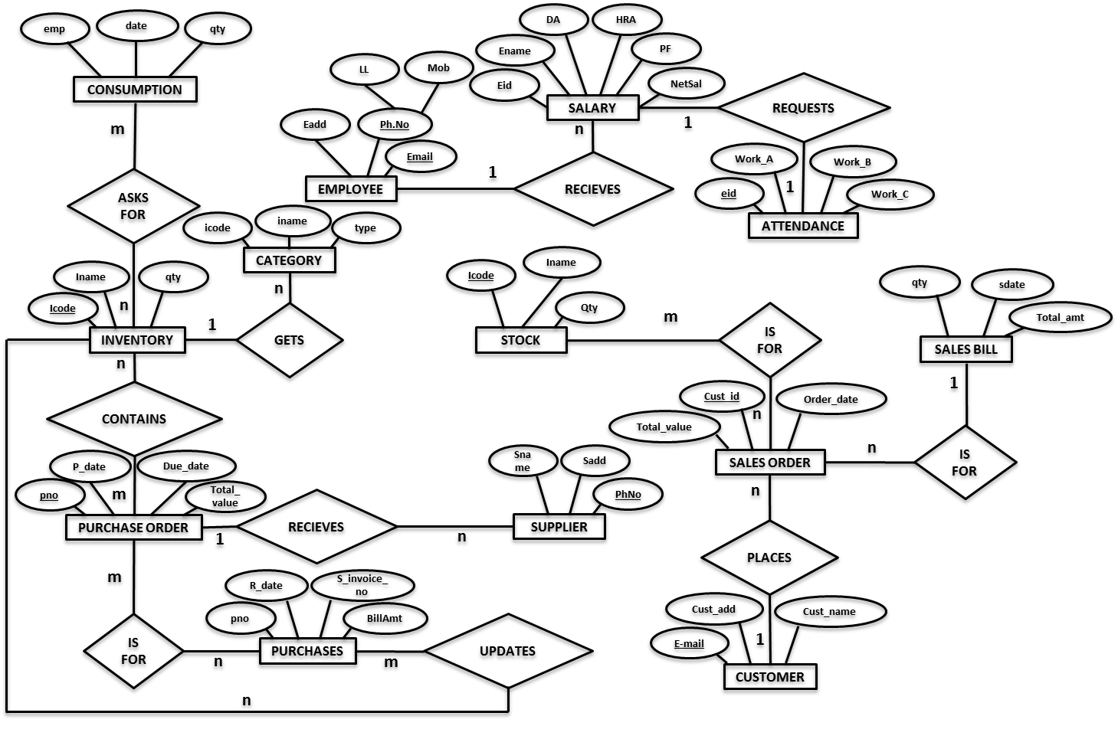

**DATA DICTIONARY**

1.Employee=@empid+empname+dob+gender+address+land+mob+email+qualification+doj+designation+department+empimage+basic

empid=E+{0-9}

empname={A-Z|a-z}

dob={valid date}

gender={A-Z|a-z}

address={legal characters}

land={0-9}

mob={0-9}

email={A-Z|a-z|0-9|_+@+.}

qualification={A-Z|a-z}

doj={valid date}

designation={A-Z|a-z}

department={A-Z|a-z}

empimage={image}

salary={0-9}

2. Login=empid+usertype+department+username+password+empimage+lock

Empid= E+{0-9}

Usertype={A-Z|a-z}

department={A-Z|a-z}

Username={A-Z|a-z}

password={A-Z|a-z}+{0-9}

empimage={image}

lock={0-9}

3. Customer= @custid+custname+custadd+custphone+custemail

Custid=C+{0-9}

custname={A-Z|a-z}

custadd={legal characters}

Custphone={0-9}

Custemail={A-Z|a-z|0-9|_+@+.}

4.Supplier=@supid+sname+address+phone+email+bankaccno+branch+ifsccode+neftcode

Supid=S+{0-9}

Sname={A-Z|a-z}

Address={legal characters}

Phone={0-9}

Email={A-Z|a-z|0-9|_+@+.}

Bankaccno={0-9}

Branch={A-Z|a-z}

Ifsccode={A-Z}+{0-9}

Neftcode={A-Z}+{0-9}

5. Consumption=consumptiondate+qty+empname+itemcode

Consumptiondate={valid date}

Qty={0-9}

Empname={A-Z|a-z}

itemcode=I+{0-9}

6. Stockinventory=@productcode+pname+price+qty+description

Productcode=P+{0-9}

Pname={A-Z|a-z}

Price={0-9}

Qty={0-9}

description={legal characters}

7. Salesorder=@orderno+orderdate+custid

Orderno=P+{0-9}

Orderdate={valid date}

custid=C+{0-9}

**DESIGN DOCUMENT**

STRUCTURE OF THE DETAILED DESIGN

**INTRODUCTION:**

In the detailed design we decide the internal logic for the module, which implements the given specification. Detailed design is one of the levels of the design process of software items. Detailed design, which is also known as logic design, involves the internal sign of the module and how the specification of the module can be satisfied. Detailed design is an extensive of system design.

The first step before the detailed design or code for a module can be developed is that the specification of the module be given precisely. Once the module is precisely specified, the external logic for the module that will implement the given identification can be decided.

The basic logic in detailed design is to specify the logic for the different modules that has been specified during system design. Specifying the logic will require developing an algorithm that will implement the given specification.

The phase includes the specification of table structures, which makes us understand the internal logic of the system. The tables are described with their field names, data types, table constraints, description of the field etc.

**TABLE STRUCTURE:**

1. Login

|  |  |  |  |
| --- | --- | --- | --- |
| FIELD | TYPE | LENGTH | CONSTRAINTS |
| Empid | nvarchar | 50 |  |
| usertype | varchar | 50 |  |
| department | varchar | 50 |  |
| username | varchar | 50 |  |
| password | nvarchar | 50 |  |
| empimage | Image | 16 |  |
| lock | int | 4 |  |

2. Employee

|  |  |  |  |
| --- | --- | --- | --- |
| FIELD | TYPE | LENGTH | CONSTRAINTS |
| empid | Nvarchar | 50 |  |
| empname | varchar | 50 |  |
| dob | datetime | 8 |  |
| gender | varchar | 50 |  |
| address | nvarchar | 50 |  |
| landline | nvarchar | 50 |  |
| mob | nvarchar | 50 |  |
| email | nvarchar | 50 |  |
| qualification | nvarchar | 50 |  |
| doj | datetime | 8 |  |
| designation | varchar | 50 |  |
| department | varchar | 50 |  |
| empimage | image | 16 |  |
| basic | money | 8 |  |

3. Attendance

|  |  |  |  |
| --- | --- | --- | --- |
| FIELD | TYPE | LENGTH | CONSTRAINTS |
| empid | nvarchar | 50 |  |
| Work_a | numeric | 9 |  |
| Work_b | numeric | 9 |  |
| Work_c | numeric | 9 |  |
| Work_month | varchar | 50 |  |
| Work_year | bigint | 8 |  |

4. Shift A

|  |  |  |  |
| --- | --- | --- | --- |
| FIELD | TYPE | LENGTH | CONSTRAINTS |
| empid | nvarchar | 50 |  |
| attdate | datetime | 8 |  |
| eattendance | varchar | 50 |  |

5. Shift B

|  |  |  |  |
| --- | --- | --- | --- |
| FIELD | TYPE | LENGTH | CONSTRAINTS |
| empid | nvarchar | 50 |  |
| attdate | datetime | 8 |  |
| eattendance | varchar | 50 |  |

6. Shift C

|  |  |  |  |
| --- | --- | --- | --- |
| FIELD | TYPE | LENGTH | CONSTRAINTS |
| empid | nvarchar | 50 |  |
| attdate | datetime | 8 |  |
| eattendance | varchar | 50 |  |

7. Supplier

|  |  |  |  |
| --- | --- | --- | --- |
| FIELD | TYPE | LENGTH | CONSTRAINTS |
| supid | nvarchar | 50 |  |
| sname | varchar | 50 |  |
| address | nvarchar | 50 |  |
| phone | nvarchar | 50 |  |
| email | nvarchar | 50 |  |
| bankaccno | nvarchar | 50 |  |
| branch | varchar | 50 |  |
| ifsccode | nvarchar | 50 |  |
| neftcode | nvarchar | 50 |  |

8. Customer

|  |  |  |  |
| --- | --- | --- | --- |
| FIELD | TYPE | LENGTH | CONSTRAINTS |
| custid | nvarchar | 50 |  |
| custname | varchar | 50 |  |
| custadd | nvarchar | 50 |  |
| custphone | nvarchar | 50 |  |
| custemail | nvarchar | 50 |  |

9. Rawinventory

|  |  |  |  |
| --- | --- | --- | --- |
| FIELD | TYPE | LENGTH | CONSTRAINTS |
| Itemcode | nvarchar | 50 |  |
| catid | Nvarchar | 50 |  |
| qty | bigint | 8 |  |

10. Category

|  |  |  |  |
| --- | --- | --- | --- |
| FIELD | TYPE | LENGTH | CONSTRAINTS |
| catid | nvarchar | 50 |  |
| catname | varchar | 50 |  |
| type | varchar | 50 |  |

11. Category_supplier

|  |  |  |  |
| --- | --- | --- | --- |
| FIELD | TYPE | LENGTH | CONSTRAINTS |
| slno | bigint | 8 |  |
| supid | nvarchar | 50 |  |
| catid | nvarchar | 50 |  |

12. Purchaseorder

|  |  |  |  |
| --- | --- | --- | --- |
| FIELD | TYPE | LENGTH | CONSTRAINTS |
| porderno | nvarchar | 50 |  |
| orderdate | datetime | 8 |  |

13. Purchaseorderdetails

|  |  |  |  |
| --- | --- | --- | --- |
| FIELD | TYPE | LENGTH | CONSTRAINTS |
| slno | varchar | 50 |  |
| catid | nvarchar | 50 |  |
| supid | nvarchar | 50 |  |
| rqty | bigint | 8 |  |
| porderno | nvarchar | 50 |  |
| status | bigint | 8 |  |

14. Purchaseinvoice

|  |  |  |  |
| --- | --- | --- | --- |
| FIELD | TYPE | LENGTH | CONSTRAINTS |
| pbillno | nvarchar | 50 |  |
| porder | nv | 50 |  |
| taxamounttotal | money | 8 |  |
| totalqty | bigint | 8 |  |
| subtotal | money | 8 |  |
| nettotal | money | 8 |  |

15. Purchaseinvoicedetails

|  |  |  |  |
| --- | --- | --- | --- |
| FIELD | TYPE | LENGTH | CONSTRAINTS |
| slno | bigint | 8 |  |
| catid | nvarchar | 50 |  |
| recdate | datetime | 8 |  |
| rate | money | 8 |  |
| qtyrecv | Bigint | 8 |  |
| tax | money | 8 |  |
| netrate | money | 8 |  |
| amount | money | 8 |  |
| pbillno | nvarchar | 50 |  |

16. Consumption

|  |  |  |  |
| --- | --- | --- | --- |
| FIELD | TYPE | LENGTH | CONSTRAINTS |
| consumdate | datetime | 8 |  |
| qty | bigint | 8 |  |
| empname | varchar | 50 |  |
| itemcode | nvarchar | 50 |  |

17. Dailyproduction

|  |  |  |  |
| --- | --- | --- | --- |
| FIELD | TYPE | LENGTH | CONSTRAINTS |
| productcode | nvarchar | 50 |  |
| mfgdate | datetime | 8 |  |
| qty | bigint | 8 |  |

18. Salesorder

|  |  |  |  |
| --- | --- | --- | --- |
| FIELD | TYPE | LENGTH | CONSTRAINTS |
| orderno | nvarchar | 50 |  |
| orderdate | datetime | 8 |  |
| custid | nvarchar | 50 |  |

19. Salesorderdetails

|  |  |  |  |
| --- | --- | --- | --- |
| FIELD | TYPE | LENGTH | CONSTRAINTS |
| orderno | nvarchar | 50 |  |
| productcode | nvarchar | 50 |  |
| productname | varchar | 50 |  |
| qty | bigint | 8 |  |
| netamt | money | 8 |  |

20. Stockinventory

|  |  |  |  |
| --- | --- | --- | --- |
| FIELD | TYPE | LENGTH | CONSTRAINTS |
| productcode | nvarchar | 50 |  |
| pname | varchar | 50 |  |
| price | money | 8 |  |
| qty | numeric | 9 |  |
| description | nvarchar | 50 |  |

21. Salesbill

|  |  |  |  |
| --- | --- | --- | --- |
| FIELD | TYPE | LENGTH | CONSTRAINTS |
| billno | nvarchar | 50 |  |
| billdate | datetime | 8 |  |
| orderno | nvarchar | 50 |  |
| custid | nvarchar | 50 |  |
| netamt | decimal | 9 |  |
| totalamt | decimal | 9 |  |

22. Salesdetails

|  |  |  |  |
| --- | --- | --- | --- |
| FIELD | TYPE | LENGTH | CONSTRAINTS |
| billno | nvarchar | 50 |  |
| productcode | nvarchar | 50 |  |
| qty | numeric | 9 |  |

23. Salary

|  |  |  |  |
| --- | --- | --- | --- |
| FIELD | TYPE | LENGTH | CONSTRAINTS |
| empid | nvarchar | 50 |  |
| saldate | datetime | 8 |  |
| salmonth | varchar | 50 |  |
| salyear | bigint | 8 |  |
| gross | decimal | 9 |  |
| da | decimal | 9 |  |
| hra | decimal | 9 |  |
| pf | decimal | 9 |  |
| netsal | decimal | 9 |  |
| flag | int | 4 |  |

24. Settings

|  |  |  |  |
| --- | --- | --- | --- |
| FIELD | TYPE | LENGTH | CONSTRAINTS |
| da | float | 8 |  |
| hra | float | 8 |  |
| pf | float | 8 |  |
| discount | float | 8 |  |
| vat | float | 8 |  |

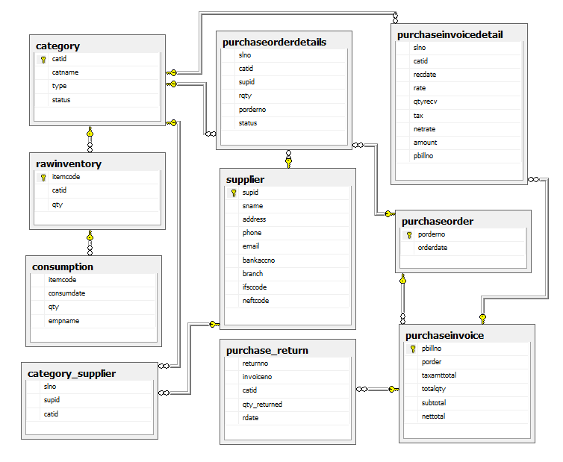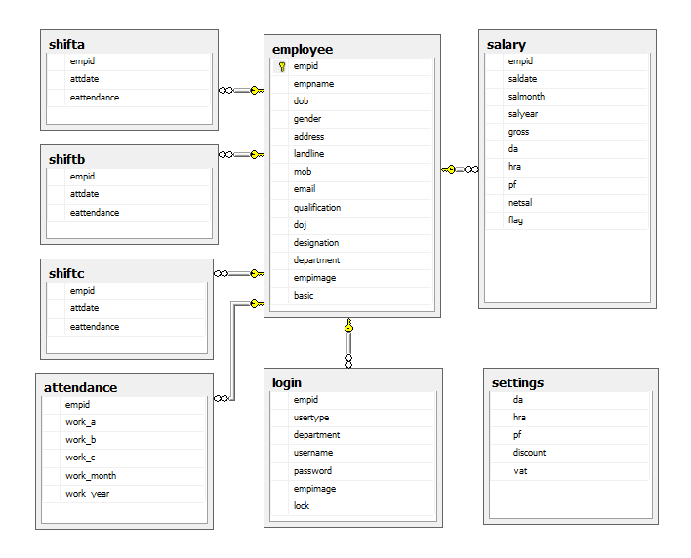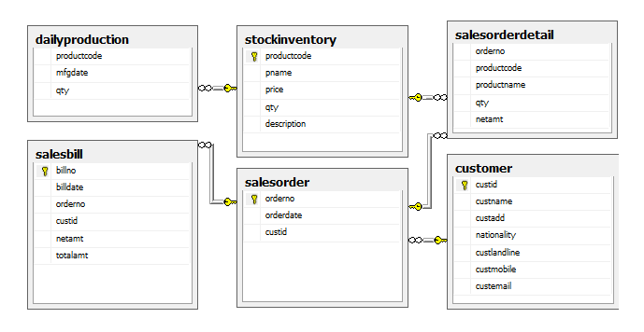

**CODING**

**LOGINPIC:**

Public Class login_pic

Public da As New SqlClient.SqlDataAdapter

Public ds As New DataSet

Private Sub btnadmin_Click_1(ByVal sender As System.Object, ByVal e As System.EventArgs) Handles btnadmin.Click

usertype = "Administrator"

frmlogin.LinkLabel1.Visible = True

Me.btnadmin.BackColor = Color.DimGray

Me.btnmgr.BackColor = Color.Transparent

Me.btnstaff.BackColor = Color.Transparent

Me.PictureBox1.Visible = True

Me.Timer1.Enabled = True

picsel = "Administrator"

Try

connect()

issuecommand.CommandText = "select empid,department,username,empimage,lock from login where usertype='" & picsel & "'"

da.SelectCommand = issuecommand

da.Fill(ds, "login")

eid = ds.Tables("login").Rows(0).Item(0)

dept = ds.Tables("login").Rows(0).Item(1)

uname = ds.Tables("login").Rows(0).Item(2)

Dim mstream As IO.MemoryStream

Dim imgbyte As Byte()

imgbyte = ds.Tables("login").Rows(0).Item(3)

mstream = New IO.MemoryStream(imgbyte)

eimage = Image.FromStream(mstream)

Catch ex As Exception

MsgBox(ex.ToString)

Finally

cnnstr.Close()

End Try

End Sub

Private Sub btnmgr_Click_1(ByVal sender As System.Object, ByVal e As System.EventArgs) Handles btnmgr.Click

usertype = "Manager"

frmlogin.LinkLabel1.Visible = False

Me.btnmgr.BackColor = Color.DimGray

Me.btnstaff.BackColor = Color.Transparent

Me.btnadmin.BackColor = Color.Transparent

Me.PictureBox1.Visible = True

Me.Timer1.Enabled = True

picsel = "Manager"

End Sub

Private Sub btnstaff_Click_1(ByVal sender As System.Object, ByVal e As System.EventArgs) Handles btnstaff.Click

usertype = "Staff"

frmlogin.LinkLabel1.Visible = False

Me.btnstaff.BackColor = Color.DimGray

Me.btnadmin.BackColor = Color.Transparent

Me.btnmgr.BackColor = Color.Transparent

Me.PictureBox1.Visible = True

Me.Timer1.Enabled = True

picsel = "Staff"

End Sub

Private Sub PictureBox2_Click(ByVal sender As System.Object, ByVal e As System.EventArgs) Handles PictureBox2.Click

btnadmin_Click_1(sender, e)

End Sub

Private Sub PictureBox3_Click(ByVal sender As System.Object, ByVal e As System.EventArgs) Handles PictureBox3.Click

btnmgr_Click_1(sender, e)

End Sub

Private Sub PictureBox4_Click(ByVal sender As System.Object, ByVal e As System.EventArgs) Handles PictureBox4.Click

btnstaff_Click_1(sender, e)

End Sub

Private Sub btnclose_Click(ByVal sender As System.Object, ByVal e As System.EventArgs) Handles btnclose.Click

Me.Close()

home.Close()

End Sub

Private Sub Timer1_Tick(ByVal sender As System.Object, ByVal e As System.EventArgs) Handles Timer1.Tick

If Me.Timer1.Interval = 1000 Then

Me.PictureBox1.Visible = False

Me.Timer1.Stop()

If picsel <> "Administrator" Then

selpic.Show()

Me.Hide()

Else

Me.PictureBox1.Image = eimage

frmlogin.lbluname.Text = uname

frmlogin.lblutype.Text = picsel

frmlogin.txtpassword.Text = ""

frmlogin.Show()

Me.Hide()

End If

End If

End Sub

Private Sub login_pic_Load(ByVal sender As System.Object, ByVal e As System.EventArgs) Handles MyBase.Load

home.Hide()

Me.PictureBox1.Visible = False

ToolTip1.SetToolTip(Me.btnadmin, "Administrator")

ToolTip1.SetToolTip(Me.btnmgr, "Manager")

ToolTip1.SetToolTip(Me.btnstaff, "Staff")

ToolTip1.SetToolTip(Me.PictureBox2, "Administrator")

ToolTip1.SetToolTip(Me.PictureBox3, "Manager")

ToolTip1.SetToolTip(Me.PictureBox4, "Staff")

ToolTip1.SetToolTip(Me.btnclose, "Close")

ToolTip1.SetToolTip(Me.btnclose1, "Close")

Dim dt, dt1 As New DataTable

Try

connect()

issuecommand.CommandText = "select empid,department,username,empimage,lock from login where usertype='Staff'"

da.SelectCommand = issuecommand

dt.Clear()

da.Fill(dt)

If dt.Rows.Count = 0 Then

Me.btnstaff.Enabled = False

Me.PictureBox4.Enabled = False

End If

issuecommand.CommandText = "select empid,department,username,empimage,lock from login where usertype='Manager'"

da.SelectCommand = issuecommand

dt1.Clear()

da.Fill(dt1)

If dt1.Rows.Count = 0 Then

Me.btnmgr.Enabled = False

Me.PictureBox3.Enabled = False

End If

Catch ex As Exception

MsgBox(ex.ToString)

Finally

cnnstr.Close()

End Try

End Sub

Private Sub PictureBox2_MouseHover(ByVal sender As Object, ByVal e As System.EventArgs) Handles PictureBox2.MouseHover

Me.PictureBox2.BorderStyle = BorderStyle.Fixed3D

End Sub

Private Sub PictureBox3_MouseHover(ByVal sender As Object, ByVal e As System.EventArgs) Handles PictureBox3.MouseHover

Me.PictureBox3.BorderStyle = BorderStyle.Fixed3D

End Sub

Private Sub PictureBox4_MouseHover(ByVal sender As Object, ByVal e As System.EventArgs) Handles PictureBox4.MouseHover

Me.PictureBox4.BorderStyle = BorderStyle.Fixed3D

End Sub

Private Sub PictureBox2_MouseLeave(ByVal sender As Object, ByVal e As System.EventArgs) Handles PictureBox2.MouseLeave

Me.PictureBox2.BorderStyle = BorderStyle.FixedSingle

End Sub

Private Sub PictureBox3_MouseLeave(ByVal sender As Object, ByVal e As System.EventArgs) Handles PictureBox3.MouseLeave

Me.PictureBox3.BorderStyle = BorderStyle.FixedSingle

End Sub

Private Sub PictureBox4_MouseLeave(ByVal sender As Object, ByVal e As System.EventArgs) Handles PictureBox4.MouseLeave

Me.PictureBox4.BorderStyle = BorderStyle.FixedSingle

End Sub

Private Sub btnclose1_Click(ByVal sender As System.Object, ByVal e As System.EventArgs) Handles btnclose1.Click

home.Close()

selpic.Close()

frmlogin.Close()

Me.Close()

End Sub

Private Sub btnclose_MouseHover(ByVal sender As Object, ByVal e As System.EventArgs) Handles btnclose.MouseHover

Me.btnclose1.Visible = True

Me.btnclose.Visible = False

End Sub

Private Sub btnclose1_MouseLeave(ByVal sender As Object, ByVal e As System.EventArgs) Handles btnclose1.MouseLeave

Me.btnclose.Visible = True

Me.btnclose1.Visible = False

End Sub

End Class

**SelPic:**

Public Class selpic

Dim i, j, m, n, h, v, k, a As Integer

Dim pic As New Button

Dim piccount As Integer

Public da As New SqlClient.SqlDataAdapter

Public ds As New DataSet

Dim seid() As String

Dim suname() As String

Dim sdept() As String

Private Sub selpic_Load(ByVal sender As System.Object, ByVal e As System.EventArgs) Handles MyBase.Load

login_pic.Close()

ToolTip1.SetToolTip(Me.btnclose, "Close")

ToolTip1.SetToolTip(Me.btnclose1, "Close")

ToolTip1.SetToolTip(Me.btnback, "Back")

ToolTip1.SetToolTip(Me.Label1, usertype)

Me.Label1.Text = usertype

seid = New String() {""}

suname = New String() {""}

sdept = New String() {""}

login_pic.Hide()

Me.PictureBox1.Visible = False

Try

connect()

issuecommand.CommandText = "select empid,department,username,empimage,lock from login where usertype='" & picsel & "'"

da.SelectCommand = issuecommand

da.Fill(ds, "login")

piccount = ds.Tables("login").Rows.Count

j = 0

k = 0

m = Me.Size.Height - 150

v = m \ 170

a = v

ReDim seid(piccount)

ReDim suname(piccount)

ReDim sdept(piccount)

For i = 0 To piccount - 1

seid(i) = ds.Tables("login").Rows(i).Item(0)

sdept(i) = ds.Tables("login").Rows(i).Item(1)

suname(i) = ds.Tables("login").Rows(i).Item(2)

pic = New Button

With pic

.Location = New Point(130 + j, 150 + k)

.Size = New Size(170, 170)

.Name = "btn" & i

Dim mstream As IO.MemoryStream

Dim imgbyte As Byte()

imgbyte = ds.Tables("login").Rows(i).Item(3)

mstream = New IO.MemoryStream(imgbyte)

.BackgroundImage = Image.FromStream(mstream)

.BackgroundImageLayout = ImageLayout.Stretch

.FlatStyle = FlatStyle.Flat

.FlatAppearance.BorderSize = 5

.FlatAppearance.BorderColor = Color.DarkGray

.Cursor = Cursors.Hand

If ds.Tables("login").Rows(i).Item(4) = 1 Then

Dim dimg As String

dimg = Application.StartupPath

Dim len = dimg.Length

dimg = Mid(dimg, 1, len - 9)

.Image = Image.FromFile(dimg & "Resources\293.gif")

.ImageAlign = ContentAlignment.MiddleCenter

End If

k += 180

If i + 1 = v Then

j += 180

k = 0

v += a

End If

End With

Controls.Add(pic)

AddHandler pic.Click, AddressOf btnclick

ToolTip1.SetToolTip(pic, suname(i))

AddHandler pic.MouseHover, AddressOf btnmousehover

AddHandler pic.MouseLeave, AddressOf btnmouseleave

Next

Catch ex As Exception

MsgBox(ex.ToString)

Finally

cnnstr.Close()

End Try

End Sub

Private Sub btnclick(ByVal sender As System.Object, ByVal e As System.EventArgs)

Me.PictureBox1.Visible = True

Me.Timer1.Enabled = True

Dim btn As Button = DirectCast(sender, Button)

For i = 0 To piccount

If btn.Name = "btn" & i Then

eimage = btn.BackgroundImage

uname = suname(i)

eid = seid(i)

dept = sdept(i)

End If

Next

End Sub

Private Sub btnmouseleave(ByVal sender As System.Object, ByVal e As System.EventArgs)

Dim btn As Button = DirectCast(sender, Button)

For i = 0 To piccount

If btn.Name = "btn" & i Then

btn.FlatAppearance.BorderColor = Color.DarkGray

btn.FlatAppearance.BorderSize = 5

End If

Next

End Sub

Private Sub btnmousehover(ByVal sender As System.Object, ByVal e As System.EventArgs)

Dim btn As Button = DirectCast(sender, Button)

For i = 0 To piccount

If btn.Name = "btn" & i Then

btn.FlatAppearance.BorderColor = Color.RoyalBlue

btn.FlatAppearance.BorderSize = 7

End If

Next

End Sub

Private Sub Timer1_Tick(ByVal sender As System.Object, ByVal e As System.EventArgs) Handles Timer1.Tick

If Me.Timer1.Interval = 1000 Then

frmlogin.Show()

Me.Timer1.Stop()

End If

End Sub

Private Sub btnclose1_Click(ByVal sender As Object, ByVal e As System.EventArgs) Handles btnclose1.Click

home.Close()

login_pic.Close()

frmlogin.Close()

Me.Close()

End Sub

Private Sub btnclose_MouseHover(ByVal sender As Object, ByVal e As System.EventArgs) Handles btnclose.MouseHover

Me.btnclose1.Visible = True

Me.btnclose.Visible = False

End Sub

Private Sub btnclose1_MouseLeave(ByVal sender As Object, ByVal e As System.EventArgs) Handles btnclose1.MouseLeave

Me.btnclose.Visible = True

Me.btnclose1.Visible = False

End Sub

Private Sub btnback_Click(ByVal sender As System.Object, ByVal e As System.EventArgs) Handles btnback.Click

login_pic.Show()

Me.Close()

End Sub

End Class

**LOGIN FORM:**

Imports System.Net.Mail

Public Class frmlogin

Public da As New SqlClient.SqlDataAdapter

Public ds As New DataSet

Dim counter, flag As Integer

Dim n = 0

Sub linklbl()

Try

connect()

issuecommand.CommandText = "select email from employee where designation='Administrator'"

Dim k = issuecommand.ExecuteScalar

issuecommand.CommandText = "select password from login where usertype='Administrator'"

Dim i = issuecommand.ExecuteScalar

Dim msg As New MailMessage

msg.From = New MailAddress(k.ToString)

msg.[To].Add(k.ToString)

msg.Subject = "Hi Admin,"

msg.Body = "Your password is " & i

Dim smtp As New SmtpClient()

smtp.Host = "smtp.gmail.com"

smtp.Port = 587

smtp.Credentials = New System.Net.NetworkCredential("sandeshacharya761@gmail.com", "sandeshblue")

smtp.EnableSsl = True

smtp.Send(msg)

Me.Timer1.Enabled = True

Me.Panel2.BringToFront()

Me.Panel2.Visible = True

Catch ex As Exception

Beep()

MsgBox("No internet connection", MsgBoxStyle.Information, "Login")

Finally

cnnstr.Close()

End Try

End Sub

Public Sub frmlogin_Load(ByVal sender As System.Object, ByVal e As System.EventArgs) Handles MyBase.Load

Me.KeyPreview = True

selpic.Close()

ToolTip1.SetToolTip(Me.btnclose, "Close")

ToolTip1.SetToolTip(Me.btnclose1, "Close")

ToolTip1.SetToolTip(Me.btnback, "Back")

ToolTip1.SetToolTip(Me.PictureBox1, uname)

ToolTip1.SetToolTip(Me.lbluname, "User name")

ToolTip1.SetToolTip(Me.lblutype, "Designation")

ToolTip1.SetToolTip(Me.txtpassword, "Password")

ToolTip1.SetToolTip(Me.btnok, "Click OK to try again")

ToolTip1.SetToolTip(Me.btnlogin, "Click to login")

ToolTip1.SetToolTip(Me.LinkLabel1, "Click here, if forgot your password." & ControlChars.CrLf & "Your password will be sent your E-mail address.")

ToolTip1.SetToolTip(Me.btnlckok, "Click OK to close")

ToolTip1.SetToolTip(Me.btnpok, "OK")

ToolTip1.SetToolTip(Me.btnpcancel, "Cancel")

Me.PictureBox1.Image = eimage

Me.lbluname.Text = uname

Me.lblutype.Text = picsel

Me.txtpassword.Text = ""

counter = 0

Dim dt As New DataTable

Try

connect()

issuecommand.CommandText = "select lock from login where empid='" & eid & "' and username='" & uname & "' and usertype='" & usertype & "'"

da.SelectCommand = issuecommand

dt.Clear()

da.Fill(dt)

If dt.Rows(0).Item(0) = 1 Then

Me.Label2.Text = "Your account is locked. Contact administrator to change password."

Me.Panel1.BringToFront()

Me.Panel1.Visible = True

End If

Catch ex As Exception

MsgBox(ex.ToString)

Finally

cnnstr.Close()

End Try

End Sub

Private Sub btnback_Click(ByVal sender As System.Object, ByVal e As System.EventArgs) Handles btnback.Click

login_pic.Show()

Me.Close()

End Sub

Private Sub btnlogin_Click_1(ByVal sender As System.Object, ByVal e As System.EventArgs) Handles btnlogin.Click

Dim pwrd = Me.txtpassword.Text

Dim i, n As Integer

Try

flag = 0

connect()

issuecommand.CommandText = "select * from login"

da.SelectCommand = issuecommand

da.Fill(ds, "login")

n = ds.Tables("login").Rows.Count

For i = 0 To n - 1

If usertype = ds.Tables("login").Rows(i).Item(1) And uname = ds.Tables("login").Rows(i).Item(3) And pwrd = ds.Tables("login").Rows(i).Item(4) Then

If usertype = "Administrator" Then

frmmdihome.MenuToolStripMenuItem.Visible = True

frmmdihome.EmployeeToolStripMenuItem.Visible = True

frmmdihome.SalesToolStripMenuItem.Visible = True

frmmdihome.FinishedGoodsToolStripMenuItem.Visible = True

frmmdihome.CustomerToolStripMenuItem.Visible = True

frmmdihome.InventoryToolStripMenuItem.Visible = True

frmmdihome.PurchaseToolStripMenuItem.Visible = True

frmmdihome.SupplierToolStripMenuItem.Visible = True

frmmdihome.ReportsToolStripMenuItem.Visible = True

frmmdihome.ToolStripMenuItem4.Visible = True

frmmdihome.PictureBox1.Image = eimage

frmmdihome.Label3.Text = uname

frmmdihome.frmmdihome_Load(sender, e)

frmmdihome.Show()

ElseIf usertype = "Manager" Then

If dept = "Purchase" Or dept = "Stock" Then

frmmdihome.MenuToolStripMenuItem.Visible = False

frmmdihome.EmployeeToolStripMenuItem.Visible = False

frmmdihome.SalesToolStripMenuItem.Visible = False

frmmdihome.FinishedGoodsToolStripMenuItem.Visible = False

frmmdihome.CustomerToolStripMenuItem.Visible = False

frmmdihome.InventoryToolStripMenuItem.Visible = True

frmmdihome.PurchaseToolStripMenuItem.Visible = True

frmmdihome.SupplierToolStripMenuItem.Visible = True

frmmdihome.ReportsToolStripMenuItem.Visible = False

frmmdihome.ToolStripMenuItem4.Visible = False

frmmdihome.PictureBox1.Image = eimage

frmmdihome.Label3.Text = uname

frmmdihome.PictureBox1.Image = eimage

frmmdihome.Label3.Text = uname

frmmdihome.frmmdihome_Load(sender, e)

frmmdihome.Show()

ElseIf dept = "Sales" Then

frmmdihome.MenuToolStripMenuItem.Visible = False

frmmdihome.EmployeeToolStripMenuItem.Visible = False

frmmdihome.SalesToolStripMenuItem.Visible = True

frmmdihome.FinishedGoodsToolStripMenuItem.Visible = True

frmmdihome.CustomerToolStripMenuItem.Visible = True

frmmdihome.InventoryToolStripMenuItem.Visible = False

frmmdihome.PurchaseToolStripMenuItem.Visible = False

frmmdihome.SupplierToolStripMenuItem.Visible = False

frmmdihome.ReportsToolStripMenuItem.Visible = False

frmmdihome.ToolStripMenuItem4.Visible = False

frmmdihome.PictureBox1.Image = eimage

frmmdihome.Label3.Text = uname

frmmdihome.frmmdihome_Load(sender, e)

frmmdihome.Show()

End If

ElseIf usertype = "Staff" Then

frmmdihome.MenuToolStripMenuItem.Visible = False

frmmdihome.EmployeeToolStripMenuItem.Visible = False

frmmdihome.SalesToolStripMenuItem.Visible = True

frmmdihome.FinishedGoodsToolStripMenuItem.Visible = True

frmmdihome.CustomerToolStripMenuItem.Visible = True

frmmdihome.InventoryToolStripMenuItem.Visible = True

frmmdihome.PurchaseToolStripMenuItem.Visible = True

frmmdihome.SupplierToolStripMenuItem.Visible = True

frmmdihome.ReportsToolStripMenuItem.Visible = False

frmmdihome.ToolStripMenuItem4.Visible = False

frmmdihome.PictureBox1.Image = eimage

frmmdihome.Label3.Text = uname

frmmdihome.frmmdihome_Load(sender, e)

frmmdihome.Show()

End If

Exit For

Else

flag = 1

End If

Next

If flag = 1 Then

Me.txtpassword.Visible = False

Me.invalid.Visible = True

Me.btnok.Visible = True

counter = counter + 1

If counter = 3 Then

Try

If usertype <> "Administrator" Then

issuecommand.CommandText = "update login set lock=" & 1 & " where empid='" & eid & "' and username='" & uname & "' and usertype='" & usertype & "'"

issuecommand.ExecuteNonQuery()

Me.Panel1.Visible = True

Else

Me.Panel3.BringToFront()

Me.Panel3.Visible = True

End If

Catch ex As Exception

MsgBox(ex.ToString)

End Try

End If

End If

Catch ex As Exception

MsgBox(ex.ToString)

Finally

cnnstr.Close()

End Try

End Sub

Private Sub btnok_Click(ByVal sender As System.Object, ByVal e As System.EventArgs) Handles btnok.Click

Me.txtpassword.Visible = True

Me.btnok.Visible = True

Me.invalid.Visible = False

Me.btnok.Visible = False

Me.txtpassword.Focus()

Me.txtpassword.Text = ""

Me.LinkLabel1.Visible = False

End Sub

Private Sub txtpassword_GotFocus(ByVal sender As Object, ByVal e As System.EventArgs) Handles txtpassword.GotFocus

If IsKeyLocked(Keys.CapsLock) Then

ToolTip1.SetToolTip(Me.txtpassword, "Capslock is on")

End If

End Sub

Private Sub txtpassword_KeyDown(ByVal sender As Object, ByVal e As System.Windows.Forms.KeyEventArgs) Handles txtpassword.KeyDown

If e.KeyCode = Keys.Enter Then

Me.btnlogin_Click_1(sender, e)

End If

End Sub

Private Sub btnclose_MouseHover(ByVal sender As Object, ByVal e As System.EventArgs) Handles btnclose.MouseHover

Me.btnclose1.Visible = True

Me.btnclose.Visible = False

End Sub

Private Sub btnclose1_Click(ByVal sender As Object, ByVal e As System.EventArgs) Handles btnclose1.Click

home.Close()

login_pic.Close()

selpic.Close()

Me.Close()

End Sub

Private Sub btnclose1_MouseLeave(ByVal sender As Object, ByVal e As System.EventArgs) Handles btnclose1.MouseLeave

Me.btnclose.Visible = True

Me.btnclose1.Visible = False

End Sub

Private Sub txtpassword_KeyPress(ByVal sender As Object, ByVal e As System.Windows.Forms.KeyPressEventArgs) Handles txtpassword.KeyPress

If txtpassword.TextLength > 24 Then

Beep()

e.Handled = True

End If

End Sub

Private Sub LinkLabel1_LinkClicked(ByVal sender As System.Object, ByVal e As System.Windows.Forms.LinkLabelLinkClickedEventArgs) Handles LinkLabel1.LinkClicked

linklbl()

End Sub

Private Sub Timer1_Tick(ByVal sender As Object, ByVal e As System.EventArgs) Handles Timer1.Tick

If Me.Timer1.Interval = 3000 Then

Me.Panel2.Visible = False

Me.Timer1.Stop()

End If

End Sub

Private Sub Button1_Click(ByVal sender As System.Object, ByVal e As System.EventArgs) Handles Button1.Click

Panel2.Visible = False

End Sub

Private Sub btnpok_Click1(ByVal sender As Object, ByVal e As System.EventArgs) Handles btnpok.Click

Try

linklbl()

Me.Panel3.Visible = False

btnback_Click(sender, e)

Catch ex As Exception

MsgBox(ex.ToString)

End Try

End Sub

Private Sub btnpcancel_Click1(ByVal sender As Object, ByVal e As System.EventArgs) Handles btnpcancel.Click

Me.Panel3.Visible = False

btnback_Click(sender, e)

End Sub

Private Sub btnlckok_Click(ByVal sender As Object, ByVal e As System.EventArgs) Handles btnlckok.Click

login_pic.Show()

Me.Close()

End Sub

End Class

**MENU FORM:**

Public Class frmmdihome

Public da As New SqlClient.SqlDataAdapter

Public ds As New DataSet

Sub onlyone()

Me.btnhome.Visible = True

Dim i As Form

For Each i In Me.MdiChildren

i.Close()

Next

End Sub

Private Sub AddEmployeeToolStripMenuItem_Click(ByVal sender As System.Object, ByVal e As System.EventArgs) Handles AddEmployeeToolStripMenuItem.Click

onlyone()

Me.Panel3.Hide()

Me.btnhome.Visible = True

Dim a As frmaddemployee

a = frmaddemployee

a.MdiParent = Me

a.StartPosition = FormStartPosition.CenterScreen

a.Show()

a.WindowState = FormWindowState.Maximized

Me.Panel1.SendToBack()

End Sub

Private Sub CreateLoginToolStripMenuItem_Click(ByVal sender As System.Object, ByVal e As System.EventArgs) Handles CreateLoginToolStripMenuItem.Click

onlyone()

Me.Panel3.Hide()

Me.btnhome.Visible = True

Dim a As createnewuser

a = createnewuser

a.MdiParent = Me

a.StartPosition = FormStartPosition.CenterScreen

a.Show()

a.WindowState = FormWindowState.Maximized

Me.Panel1.SendToBack()

End Sub

Private Sub SearchInventoryToolStripMenuItem_Click(ByVal sender As System.Object, ByVal e As System.EventArgs) Handles SearchInventoryToolStripMenuItem.Click

onlyone()

Me.Panel3.Hide()

Me.btnhome.Visible = True

Dim a As searchinventory

a = searchinventory

a.MdiParent = Me

a.StartPosition = FormStartPosition.CenterScreen

a.Show()

a.WindowState = FormWindowState.Maximized

Me.Panel1.SendToBack()

End Sub

Private Sub AddSupplierToolStripMenuItem_Click(ByVal sender As System.Object, ByVal e As System.EventArgs) Handles AddSupplierToolStripMenuItem.Click

onlyone()

Me.Panel3.Hide()

Me.btnhome.Visible = True

Dim a As addnewsupplier

a = addnewsupplier

a.MdiParent = Me

a.StartPosition = FormStartPosition.CenterScreen

a.Show()

a.WindowState = FormWindowState.Maximized

Me.Panel1.SendToBack()

End Sub

Private Sub EditSupplierToolStripMenuItem_Click(ByVal sender As System.Object, ByVal e As System.EventArgs) Handles EditSupplierToolStripMenuItem.Click

onlyone()

Me.Panel3.Hide()

Me.btnhome.Visible = True

Dim a As editsupplier

a = editsupplier

a.MdiParent = Me

a.StartPosition = FormStartPosition.CenterScreen

a.Show()

a.WindowState = FormWindowState.Maximized

Me.Panel1.SendToBack()

End Sub

Private Sub ToolStripMenuItem2_Click(ByVal sender As System.Object, ByVal e As System.EventArgs) Handles ToolStripMenuItem2.Click

onlyone()

Me.Panel3.Hide()

Me.btnhome.Visible = True

Dim a As removeemployee

a = removeemployee

a.MdiParent = Me

a.StartPosition = FormStartPosition.CenterScreen

a.Show()

a.WindowState = FormWindowState.Maximized

Me.Panel1.SendToBack()

End Sub

Private Sub InventoryToolStripMenuItem1_Click(ByVal sender As System.Object, ByVal e As System.EventArgs) Handles InventoryToolStripMenuItem1.Click

onlyone()

Me.Panel3.Hide()

Me.btnhome.Visible = True

Dim a As factoryconsumption

a = factoryconsumption

a.MdiParent = Me

a.StartPosition = FormStartPosition.CenterScreen

a.Show()

a.WindowState = FormWindowState.Maximized

Me.Panel1.SendToBack()

End Sub

Private Sub EmployeeDetailsToolStripMenuItem_Click(ByVal sender As System.Object, ByVal e As System.EventArgs) Handles EmployeeDetailsToolStripMenuItem.Click

onlyone()

Me.Panel3.Hide()

Me.btnhome.Visible = True

Dim a As employeedetails

a = employeedetails

a.MdiParent = Me

a.StartPosition = FormStartPosition.CenterScreen

a.Show()

a.WindowState = FormWindowState.Maximized

Me.Panel1.SendToBack()

End Sub

Private Sub SalaryToolStripMenuItem_Click(ByVal sender As System.Object, ByVal e As System.EventArgs) Handles SalaryToolStripMenuItem.Click

onlyone()

Me.Panel3.Hide()

Me.btnhome.Visible = True

Dim a As salary

a = salary

a.MdiParent = Me

a.StartPosition = FormStartPosition.CenterScreen

a.Show()

a.WindowState = FormWindowState.Maximized

Me.Panel1.SendToBack()

End Sub

Private Sub AttendanceToolStripMenuItem_Click(ByVal sender As System.Object, ByVal e As System.EventArgs) Handles AttendanceToolStripMenuItem.Click

onlyone()

Me.Panel3.Hide()

Me.btnhome.Visible = True

Dim a As attendance

a = attendance

a.MdiParent = Me

a.StartPosition = FormStartPosition.CenterScreen

a.Show()

a.WindowState = FormWindowState.Maximized

Me.Panel1.SendToBack()

End Sub

Private Sub CreatePurchaseOrderToolStripMenuItem_Click(ByVal sender As System.Object, ByVal e As System.EventArgs) Handles CreatePurchaseOrderToolStripMenuItem.Click

onlyone()

Me.Panel3.Hide()

Me.btnhome.Visible = True

Dim a As createpurchaseorder

a = createpurchaseorder

a.MdiParent = Me

a.StartPosition = FormStartPosition.CenterScreen

a.Show()

a.WindowState = FormWindowState.Maximized

Me.Panel1.SendToBack()

End Sub

Private Sub PurchaseBillToolStripMenuItem_Click(ByVal sender As System.Object, ByVal e As System.EventArgs) Handles PurchaseBillToolStripMenuItem.Click

onlyone()

Me.Panel3.Hide()

Me.btnhome.Visible = True

Dim a As purchaseinvoice

a = purchaseinvoice

a.MdiParent = Me

a.StartPosition = FormStartPosition.CenterScreen

a.Show()

a.WindowState = FormWindowState.Maximized

Me.Panel1.SendToBack()

End Sub

Private Sub SearchSupplierToolStripMenuItem_Click(ByVal sender As System.Object, ByVal e As System.EventArgs) Handles SearchSupplierToolStripMenuItem.Click

onlyone()

Me.Panel3.Hide()

Me.btnhome.Visible = True

Dim a As searchsupplier

a = searchsupplier

a.MdiParent = Me

a.StartPosition = FormStartPosition.CenterScreen

a.Show()

a.WindowState = FormWindowState.Maximized

Me.Panel1.SendToBack()

End Sub

Private Sub DeleteSupplierToolStripMenuItem_Click(ByVal sender As System.Object, ByVal e As System.EventArgs) Handles DeleteSupplierToolStripMenuItem.Click

onlyone()

Me.Panel3.Hide()

Me.btnhome.Visible = True

Dim a As deletesupplier

a = deletesupplier

a.MdiParent = Me

a.StartPosition = FormStartPosition.CenterScreen

a.Show()

a.WindowState = FormWindowState.Maximized

Me.Panel1.SendToBack()

End Sub

Private Sub ToolStripMenuItem1_Click(ByVal sender As System.Object, ByVal e As System.EventArgs) Handles ToolStripMenuItem1.Click

onlyone()

Me.Panel3.Hide()

Me.btnhome.Visible = True

Dim a As unlockuser

a = unlockuser

a.MdiParent = Me

a.StartPosition = FormStartPosition.CenterScreen

a.Show()

a.WindowState = FormWindowState.Maximized

Me.Panel1.SendToBack()

End Sub

Private Sub RemoveLoginToolStripMenuItem_Click(ByVal sender As System.Object, ByVal e As System.EventArgs) Handles RemoveLoginToolStripMenuItem.Click

onlyone()

Me.Panel3.Hide()

Me.btnhome.Visible = True

Dim a As removeuser

a = removeuser

a.MdiParent = Me

a.StartPosition = FormStartPosition.CenterScreen

a.Show()

a.WindowState = FormWindowState.Maximized

Me.Panel1.SendToBack()

End Sub

Private Sub ToolStripMenuItem3_Click(ByVal sender As System.Object, ByVal e As System.EventArgs) Handles ToolStripMenuItem3.Click

onlyone()

Me.Panel3.Hide()

Me.btnhome.Visible = True

Dim a As editemployee

a = editemployee

a.MdiParent = Me

a.StartPosition = FormStartPosition.CenterScreen

a.Show()

a.WindowState = FormWindowState.Maximized

Me.Panel1.SendToBack()

End Sub

Private Sub SalesOrderToolStripMenuItem_Click(ByVal sender As System.Object, ByVal e As System.EventArgs) Handles SalesOrderToolStripMenuItem.Click

onlyone()

Me.Panel3.Hide()

Me.btnhome.Visible = True

Dim a As salesorder

a = salesorder

a.MdiParent = Me

a.StartPosition = FormStartPosition.CenterScreen

a.Show()

a.WindowState = FormWindowState.Maximized

Me.Panel1.SendToBack()

End Sub

Private Sub AddCustomerToolStripMenuItem_Click(ByVal sender As System.Object, ByVal e As System.EventArgs) Handles AddCustomerToolStripMenuItem.Click

onlyone()

Me.Panel3.Hide()

Me.btnhome.Visible = True

Dim a As addcustomer

a = addcustomer

a.MdiParent = Me

a.StartPosition = FormStartPosition.CenterScreen

a.Show()

a.WindowState = FormWindowState.Maximized

Me.Panel1.SendToBack()

End Sub

Private Sub ViewCustomerToolStripMenuItem_Click(ByVal sender As System.Object, ByVal e As System.EventArgs) Handles ToolStripMenuItem6.Click

onlyone()

Me.Panel3.Hide()

Me.btnhome.Visible = True

Dim a As viewcustomer

a = viewcustomer

a.MdiParent = Me

a.StartPosition = FormStartPosition.CenterScreen

a.Show()

a.WindowState = FormWindowState.Maximized

Me.Panel1.SendToBack()

End Sub

Private Sub EditCustomerToolStripMenuItem_Click(ByVal sender As System.Object, ByVal e As System.EventArgs) Handles EditCustomerToolStripMenuItem.Click

onlyone()

Me.Panel3.Hide()

Me.btnhome.Visible = True

Dim a As updatecustomer

a = updatecustomer

a.MdiParent = Me

a.StartPosition = FormStartPosition.CenterScreen

a.Show()

a.WindowState = FormWindowState.Maximized

Me.Panel1.SendToBack()

End Sub

Private Sub DeleteCustomerToolStripMenuItem_Click(ByVal sender As System.Object, ByVal e As System.EventArgs) Handles DeleteCustomerToolStripMenuItem.Click

onlyone()

Me.Panel3.Hide()

Me.btnhome.Visible = True

Dim a As deletecustomer

a = deletecustomer

a.MdiParent = Me

a.StartPosition = FormStartPosition.CenterScreen

a.Show()

a.WindowState = FormWindowState.Maximized

Me.Panel1.SendToBack()

End Sub

Private Sub SalesBillToolStripMenuItem_Click(ByVal sender As System.Object, ByVal e As System.EventArgs) Handles SalesBillToolStripMenuItem.Click

onlyone()

Me.Panel3.Hide()

Me.btnhome.Visible = True

Dim a As salesbill

a = salesbill

a.MdiParent = Me

a.StartPosition = FormStartPosition.CenterScreen

a.Show()

a.WindowState = FormWindowState.Maximized

Me.Panel1.SendToBack()

End Sub

Private Sub SalesDetailsToolStripMenuItem_Click(ByVal sender As System.Object, ByVal e As System.EventArgs) Handles SalesDetailsToolStripMenuItem.Click

onlyone()

Me.Panel3.Hide()

Me.btnhome.Visible = True

Dim a As salesdetails

a = salesdetails

a.MdiParent = Me

a.StartPosition = FormStartPosition.CenterScreen

a.Show()

a.WindowState = FormWindowState.Maximized

Me.Panel1.SendToBack()

End Sub

Private Sub AddStockToolStripMenuItem_Click(ByVal sender As System.Object, ByVal e As System.EventArgs) Handles AddStockToolStripMenuItem.Click

onlyone()

Me.Panel3.Hide()

Me.btnhome.Visible = True

Dim a As addstock

a = addstock

a.MdiParent = Me

a.StartPosition = FormStartPosition.CenterScreen

a.Show()

a.WindowState = FormWindowState.Maximized

Me.Panel1.SendToBack()

End Sub

Private Sub ViewStockToolStripMenuItem_Click(ByVal sender As System.Object, ByVal e As System.EventArgs) Handles ViewStockToolStripMenuItem.Click

onlyone()

Me.Panel3.Hide()

Me.btnhome.Visible = True

Dim a As viewstock

a = viewstock

a.MdiParent = Me

a.StartPosition = FormStartPosition.CenterScreen

a.Show()

a.WindowState = FormWindowState.Maximized

Me.Panel1.SendToBack()

End Sub

Private Sub PurchaseReturnToolStripMenuItem_Click(ByVal sender As System.Object, ByVal e As System.EventArgs) Handles PurchaseReturnToolStripMenuItem.Click

onlyone()

Me.Panel3.Hide()

Me.btnhome.Visible = True

Dim a As purchasereturn

a = purchasereturn

a.MdiParent = Me

a.StartPosition = FormStartPosition.CenterScreen

a.Show()

a.WindowState = FormWindowState.Maximized

Me.Panel1.SendToBack()

End Sub

Private Sub ToolStripMenuItem4_Click(ByVal sender As System.Object, ByVal e As System.EventArgs) Handles ToolStripMenuItem4.Click

Me.Panel3.Hide()

Me.btnhome.Visible = True

Dim a As settings

a = settings

a.MdiParent = Me

a.StartPosition = FormStartPosition.CenterScreen

a.Show()

a.WindowState = FormWindowState.Maximized

Me.Panel1.SendToBack()

End Sub

Private Sub frmmdihome_FormClosed(ByVal sender As Object, ByVal e As System.Windows.Forms.FormClosedEventArgs) Handles Me.FormClosed

frmlogin.Close()

login_pic.Close()

home.Close()

End Sub

Private Sub frmmdihome_FormClosing(ByVal sender As Object, ByVal e As System.Windows.Forms.FormClosingEventArgs) Handles Me.FormClosing

If Me.Panel5new.Visible = True Or Me.Panel4current.Visible = True Then

e.Cancel = True

End If

End Sub

Public Sub frmmdihome_Load(ByVal sender As System.Object, ByVal e As System.EventArgs) Handles MyBase.Load

frmlogin.Close()

Me.Panel2.Visible = True

Me.PictureBox1.Image = eimage

Me.Label3.Text = uname

Me.btnhome.Visible = False

Me.Panel4current.Visible = False

Me.Panel5new.Visible = False

End Sub

Private Sub Timer1_Tick(ByVal sender As System.Object, ByVal e As System.EventArgs) Handles Timer1.Tick

If Me.Timer1.Interval = 10 Then

Me.Timer1.Interval = 10

End If

Dim min, hr, str As String

str = "am"

If (DateAndTime.Minute(Now) < 10) Then

min = "0" & DateAndTime.Minute(Now)

Else

min = DateAndTime.Minute(Now)

End If

hr = DateAndTime.Hour(Now)

If (hr > 12) Then

str = "pm"

hr = hr - 12

End If

If (hr < 10) Then

hr = "0" & hr

End If

Me.Label1.Text = hr & ":" & min ' ControlChars.CrLf &

Me.Label2.Text = DateAndTime.WeekdayName(DateAndTime.Weekday(Now)) & ControlChars.CrLf & DateAndTime.MonthName(DateAndTime.Month(Now)) & " " & DateAndTime.Day(Now)

End Sub

Private Sub MenuToolStripMenuItem_MouseHover(ByVal sender As Object, ByVal e As System.EventArgs) Handles MenuToolStripMenuItem.MouseHover

Me.MenuToolStripMenuItem.ShowDropDown()

End Sub

Private Sub EmployeeToolStripMenuItem_MouseHover(ByVal sender As Object, ByVal e As System.EventArgs) Handles EmployeeToolStripMenuItem.MouseHover

Me.EmployeeToolStripMenuItem.ShowDropDown()

End Sub

Private Sub InventoryToolStripMenuItem_MouseHover(ByVal sender As Object, ByVal e As System.EventArgs) Handles InventoryToolStripMenuItem.MouseHover

Me.InventoryToolStripMenuItem.ShowDropDown()

End Sub

Private Sub PurchaseToolStripMenuItem_MouseHover(ByVal sender As Object, ByVal e As System.EventArgs) Handles PurchaseToolStripMenuItem.MouseHover

Me.PurchaseToolStripMenuItem.ShowDropDown()

End Sub

Private Sub SupplierToolStripMenuItem_MouseHover(ByVal sender As Object, ByVal e As System.EventArgs) Handles SupplierToolStripMenuItem.MouseHover

Me.SupplierToolStripMenuItem.ShowDropDown()

End Sub

Private Sub SalesToolStripMenuItem_MouseHover(ByVal sender As Object, ByVal e As System.EventArgs) Handles SalesToolStripMenuItem.MouseHover

Me.SalesToolStripMenuItem.ShowDropDown()

End Sub

Private Sub FinishedGoodsToolStripMenuItem_MouseHover(ByVal sender As Object, ByVal e As System.EventArgs) Handles FinishedGoodsToolStripMenuItem.MouseHover

Me.FinishedGoodsToolStripMenuItem.ShowDropDown()

End Sub

Private Sub CustomerToolStripMenuItem_MouseHover(ByVal sender As Object, ByVal e As System.EventArgs) Handles CustomerToolStripMenuItem.MouseHover

Me.CustomerToolStripMenuItem.ShowDropDown()

End Sub

Private Sub ReportsToolStripMenuItem_MouseHover(ByVal sender As Object, ByVal e As System.EventArgs) Handles ReportsToolStripMenuItem.MouseHover

Me.ReportsToolStripMenuItem.ShowDropDown()

End Sub

Private Sub ExitToolStripMenuItem_Click(ByVal sender As System.Object, ByVal e As System.EventArgs)

Me.Close()

End Sub

Private Sub ExitToolStripMenuItem1_Click(ByVal sender As System.Object, ByVal e As System.EventArgs)

Me.Close()

End Sub

Private Sub frmmdihome_MdiChildActivate(ByVal sender As Object, ByVal e As System.EventArgs) Handles Me.MdiChildActivate

Me.Panel2.Visible = False

End Sub

Private Sub LogoutToolStripMenuItem1_Click(ByVal sender As System.Object, ByVal e As System.EventArgs) Handles LogoutToolStripMenuItem1.Click

onlyone()

frmlogin.frmlogin_Load(sender, e)

login_pic.Show()

frmlogin.txtpassword.Text = ""

Me.Hide()

End Sub

Private Sub Panel2_Click(ByVal sender As Object, ByVal e As System.EventArgs) Handles Panel2.Click

If Me.Panel3.Visible = True Then

Me.Panel3.Visible = False

Else

Me.Panel3.BringToFront()

Me.Panel3.Visible = True

Me.Panel3.Focus()

Me.Timer3.Enabled = True

End If

End Sub

Private Sub Panel2_MouseHover(ByVal sender As Object, ByVal e As System.EventArgs) Handles Panel2.MouseHover

Me.Panel2.BackColor = Color.FromArgb(65, 65, 65)

End Sub

Private Sub Panel2_MouseLeave(ByVal sender As Object, ByVal e As System.EventArgs) Handles Panel2.MouseLeave

Me.Panel2.BackColor = Color.FromArgb(35, 35, 35)

End Sub

Private Sub ListBox1_LostFocus(ByVal sender As Object, ByVal e As System.EventArgs)

Me.Panel3.Visible = False

End Sub

Private Sub Label3_Click(ByVal sender As System.Object, ByVal e As System.EventArgs) Handles Label3.Click

If Me.Panel3.Visible = True Then

Me.Panel3.Visible = False

Else

Me.Panel3.Visible = True

Me.Panel3.Focus()

Me.Timer3.Enabled = True

End If

End Sub

Private Sub PictureBox1_Click(ByVal sender As System.Object, ByVal e As System.EventArgs) Handles PictureBox1.Click

If Me.Panel3.Visible = True Then

Me.Panel3.Visible = False

Else

Me.Panel3.Visible = True

Me.Panel3.Focus()

Me.Timer3.Enabled = True

End If

End Sub

Private Sub Label3_MouseHover(ByVal sender As Object, ByVal e As System.EventArgs) Handles Label3.MouseHover

Me.Panel2.BackColor = Color.FromArgb(65, 65, 65)

End Sub

Private Sub Label3_MouseLeave(ByVal sender As Object, ByVal e As System.EventArgs) Handles Label3.MouseLeave

Me.Panel2.BackColor = Color.FromArgb(35, 35, 35)

End Sub

Private Sub PictureBox1_MouseHover(ByVal sender As Object, ByVal e As System.EventArgs) Handles PictureBox1.MouseHover

Me.Panel2.BackColor = Color.FromArgb(65, 65, 65)

End Sub

Private Sub PictureBox1_MouseLeave(ByVal sender As Object, ByVal e As System.EventArgs) Handles PictureBox1.MouseLeave

Me.Panel2.BackColor = Color.FromArgb(35, 35, 35)

End Sub

Private Sub btnchangepswrd_Click(ByVal sender As System.Object, ByVal e As System.EventArgs) Handles btnchangepswrd.Click

Me.Panel3.Visible = False

Me.MenuStrip1.Enabled = False

Me.Panel2.Enabled = False

Me.Panel4current.BringToFront()

Me.Panel4current.Visible = True

Me.PictureBox2.Image = eimage

Me.lbluname.Text = uname

Me.Label7.Visible = False

Me.Label12.Visible = False

Me.TextBox1.Clear()

Me.Label7.Visible = False

Me.Label12.Visible = False

End Sub

Private Sub btnlck_Click(ByVal sender As System.Object, ByVal e As System.EventArgs) Handles btnlck.Click

Me.Panel3.Visible = False

frmlockscreen.WindowState = FormWindowState.Maximized

frmlockscreen.Show()

End Sub

Private Sub btnsignout_Click(ByVal sender As System.Object, ByVal e As System.EventArgs) Handles btnsignout.Click

onlyone()

Me.Panel3.Visible = False

frmlogin.frmlogin_Load(sender, e)

login_pic.Show()

frmlogin.txtpassword.Text = ""

Me.Hide()

End Sub

Private Sub btnnxt1_Click(ByVal sender As System.Object, ByVal e As System.EventArgs) Handles btnnxt1.Click

Dim dt As New DataTable

Try

connect()

issuecommand.CommandText = "select password from login where empid='" & eid & "'"

da.SelectCommand = issuecommand

dt.Clear()

da.Fill(dt)

If Me.TextBox1.Text <> "" Then

If Me.TextBox1.Text = dt.Rows(0).Item(0) Then

Me.Panel5new.BringToFront()

Me.Panel5new.Visible = True

Me.Panel4current.Visible = False

Me.Label7.Visible = True

Me.Button4.Visible = True

Me.PictureBox3.Visible = False

Me.Label3.Visible = False

Me.Label14.Visible = False

Me.Label5.Visible = False

Me.TextBox2.Clear()

Me.TextBox3.Clear()

Else

Me.Label12.Visible = True

Me.Label7.Visible = False

Me.TextBox1.Clear()

End If

Else

Me.Label7.Visible = True

Me.Label12.Visible = False

End If

Catch ex As Exception

MsgBox(ex.ToString)

Finally

cnnstr.Close()

End Try

End Sub

Private Sub btncancel1_Click(ByVal sender As System.Object, ByVal e As System.EventArgs) Handles btncancel1.Click

Me.Panel4current.Visible = False

Me.Panel5new.Visible = False

Me.TextBox1.Clear()

Me.MenuStrip1.Enabled = True

Me.Panel2.Enabled = True

End Sub

Private Sub Button5_Click(ByVal sender As System.Object, ByVal e As System.EventArgs) Handles Button5.Click

Try

connect()

If Me.TextBox3.TextLength >= 8 Then

If Me.TextBox2.Text = Me.TextBox3.Text Then

issuecommand.CommandText = "update login set password='" & Me.TextBox2.Text & "' where empid='" & eid & "'"

issuecommand.ExecuteNonQuery()

Me.Button4.Visible = False

Me.PictureBox3.Visible = True

Me.Label13.BringToFront()

Me.Label13.Visible = True

Me.MenuStrip1.Enabled = True

Me.Panel2.Enabled = True

Me.Timer2.Enabled = True

Else

Me.Label5.Visible = True

Me.Label14.Visible = False

End If

Else

Me.Label14.Visible = True

Me.Label5.Visible = False

Me.TextBox2.Text = ""

End If

Catch ex As Exception

MsgBox(ex.ToString)

Finally

cnnstr.Close()

End Try

End Sub

Private Sub Timer2_Tick(ByVal sender As System.Object, ByVal e As System.EventArgs) Handles Timer2.Tick

If Me.Timer2.Interval = 2000 Then

Me.Panel5new.Visible = False

Me.Timer2.Stop()

Me.PictureBox3.Visible = False

Me.Label13.Visible = False

End If

End Sub

Private Sub Button4_Click(ByVal sender As System.Object, ByVal e As System.EventArgs) Handles Button4.Click

Me.Panel4current.Visible = False

Me.Panel5new.Visible = False

Me.TextBox1.Clear()

Me.MenuStrip1.Enabled = True

Me.Panel2.Enabled = True

End Sub

Private Sub Button1_Click(ByVal sender As System.Object, ByVal e As System.EventArgs) Handles btnhome.Click

onlyone()

Me.Panel2.Visible = True

Me.btnhome.Visible = False

End Sub

Private Sub Timer3_Tick(ByVal sender As System.Object, ByVal e As System.EventArgs) Handles Timer3.Tick

If Me.Timer3.Interval = 3000 Then

Me.Panel3.Visible = False

End If

End Sub

Private Sub Panel3_MouseEnter(ByVal sender As Object, ByVal e As System.EventArgs) Handles Panel3.MouseEnter

Me.Timer3.Stop()

End Sub

Private Sub Panel3_MouseLeave(ByVal sender As Object, ByVal e As System.EventArgs) Handles Panel3.MouseLeave

Me.Timer3.Interval = 3000

Me.Timer3.Start()

End Sub

Private Sub btnchangepswrd_MouseEnter(ByVal sender As Object, ByVal e As System.EventArgs) Handles btnchangepswrd.MouseEnter

Me.Timer3.Stop()

End Sub

Private Sub btnlck_MouseEnter(ByVal sender As Object, ByVal e As System.EventArgs) Handles btnlck.MouseEnter

Me.Timer3.Stop()

End Sub

Private Sub btnsignout_MouseEnter(ByVal sender As Object, ByVal e As System.EventArgs) Handles btnsignout.MouseEnter

Me.Timer3.Stop()

End Sub

Private Sub btnchangepswrd_MouseLeave(ByVal sender As Object, ByVal e As System.EventArgs) Handles btnchangepswrd.MouseLeave

Me.Timer3.Interval = 3000

Me.Timer3.Start()

End Sub

Private Sub btnlck_MouseLeave(ByVal sender As Object, ByVal e As System.EventArgs) Handles btnlck.MouseLeave

Me.Timer3.Interval = 3000

Me.Timer3.Start()

End Sub

Private Sub btnsignout_MouseLeave(ByVal sender As Object, ByVal e As System.EventArgs) Handles btnsignout.MouseLeave

Me.Timer3.Interval = 3000

Me.Timer3.Start()

End Sub

Private Sub FactoryOrderReportToolStripMenuItem_Click(ByVal sender As System.Object, ByVal e As System.EventArgs) Handles FactoryOrderReportToolStripMenuItem.Click

factconsumrpt.Show()

End Sub

Private Sub EmployeeToolStripMenuItem1_Click(ByVal sender As System.Object, ByVal e As System.EventArgs) Handles dailyreportToolStripMenuItem1.Click

Dim dt As New DataTable

Try

connect()

issuecommand.CommandText = "select * from dailyproduction where mfgdate='" & Today.Date & "'"

da.SelectCommand = issuecommand

dt.Clear()

da.Fill(dt)

If dt.Rows.Count <> 0 Then

rpt4 = "{dailyproduction.mfgdate}=#" & Today.Date & "#"

Me.Panel3.Hide()

Me.Panel1.SendToBack()

Me.btnhome.Visible = False

Dim a As Form

a = frmdailyreport

a.MdiParent = Me

a.StartPosition = FormStartPosition.CenterScreen

a.Show()

a.WindowState = FormWindowState.Maximized

Else

MsgBox("No record found.", MsgBoxStyle.Information + MsgBoxStyle.OkOnly, "Daily report")

End If

Catch ex As Exception

MsgBox(ex.ToString)

Finally

cnnstr.Close()

End Try

End Sub

Private Sub PurchaseReportToolStripMenuItem_Click(ByVal sender As System.Object, ByVal e As System.EventArgs) Handles PurchaseReportToolStripMenuItem.Click

Dim dt As New DataTable

Try

connect()

issuecommand.CommandText = "select * from purchaseinvoicedetail where recdate='" & Today.Date & "'"

da.SelectCommand = issuecommand

dt.Clear()

da.Fill(dt)

If dt.Rows.Count <> 0 Then

rpt5 = "{purchaseinvoicedetail.recdate}=#" & Today.Date & "#"

Me.Panel3.Hide()

Me.Panel1.SendToBack()

Me.btnhome.Visible = False

Dim a As Form

a = frmpurchasereport

a.MdiParent = Me

a.StartPosition = FormStartPosition.CenterScreen

a.Show()

a.WindowState = FormWindowState.Maximized

Else

MsgBox("No record found.", MsgBoxStyle.Information + MsgBoxStyle.OkOnly, "Purchase report")

End If

Catch ex As Exception

MsgBox(ex.ToString)

Finally

cnnstr.Close()

End Try

End Sub

End Class

**Lock Screen:**

Public Class frmlockscreen

Dim i As Integer = 0

Dim j As Integer = Me.Size.Height

Private Sub frmlockscreen_Click(ByVal sender As Object, ByVal e As System.EventArgs) Handles Me.Click

Me.WindowState = FormWindowState.Normal

Me.Size = New Size(frmmdihome.Size.Width, frmmdihome.Size.Height)

Me.WindowState = FormWindowState.Normal

Me.Timer2.Enabled = True

End Sub

Private Sub Timer1_Tick(ByVal sender As System.Object, ByVal e As System.EventArgs) Handles Timer1.Tick

If Me.Timer1.Interval = 10 Then

Me.Timer1.Interval = 10

End If

Dim min, hr, str As String

str = "am"

If (DateAndTime.Minute(Now) < 10) Then

min = "0" & DateAndTime.Minute(Now)

Else

min = DateAndTime.Minute(Now)

End If

hr = DateAndTime.Hour(Now)

If (hr > 12) Then

str = "pm"

hr = hr - 12

End If

If (hr < 10) Then

hr = "0" & hr

End If

Me.Label1.Text = hr & ":" & min ' ControlChars.CrLf &

Me.Label2.Text = DateAndTime.WeekdayName(DateAndTime.Weekday(Now)) & "," & DateAndTime.MonthName(DateAndTime.Month(Now)) & " " & DateAndTime.Day(Now)

End Sub

Private Sub Label1_Click(ByVal sender As System.Object, ByVal e As System.EventArgs) Handles Label1.Click

Me.WindowState = FormWindowState.Normal

Me.Size = New Size(frmmdihome.Size.Width, frmmdihome.Size.Height)

Me.WindowState = FormWindowState.Normal

Me.Timer2.Enabled = True

End Sub

Private Sub PictureBox5_Click(ByVal sender As System.Object, ByVal e As System.EventArgs) Handles PictureBox5.Click

Me.WindowState = FormWindowState.Normal

Me.Size = New Size(frmmdihome.Size.Width, frmmdihome.Size.Height)

Me.WindowState = FormWindowState.Normal

Me.Timer2.Enabled = True

End Sub

Private Sub Label2_Click(ByVal sender As System.Object, ByVal e As System.EventArgs) Handles Label2.Click

Me.WindowState = FormWindowState.Normal

Me.Size = New Size(frmmdihome.Size.Width, frmmdihome.Size.Height)

Me.WindowState = FormWindowState.Normal

Me.Timer2.Enabled = True

End Sub

Private Sub Timer2_Tick(ByVal sender As System.Object, ByVal e As System.EventArgs) Handles Timer2.Tick

i = i - 20

Me.Location = New Point(0, i)

j = j - 5

If j <= 0 Then

Me.Close()

End If

If Me.Timer2.Interval = 10 Then

Me.Timer2.Interval = 10

End If

End Sub

End Class

**ADD EMPLOYEE:**

Imports System.Text.RegularExpressions

Public Class frmaddemployee

Public da As New SqlClient.SqlDataAdapter

Public ds As New DataSet

Public dt As New DataTable

Dim item As Control

Dim ydiff, flag, ctr As Integer

Dim path As Integer

Dim img1 As Image

Public space = 0

Private Sub cmdnewemp_Click(ByVal sender As System.Object, ByVal e As System.EventArgs) Handles cmdnewemp.Click

Try

Me.cmdsaveemp.Enabled = True

Me.cmdnewemp.Enabled = False

Me.grpnewemp.Enabled = True

txtemployeename.Focus()

Dim n, k As Integer

Dim m, i As String

Dim a() As Integer

a = New Integer() {0}

n = 1

For Each item In Me.grpnewemp.Controls

If TypeOf (item) Is TextBox Or TypeOf (item) Is DateTimePicker Or TypeOf (item) Is ComboBox Then

item.Text = ""

End If

Next

Me.rdbfemale.Checked = False

Me.rdbmale.Checked = False

Me.txtlandline.Clear()

Me.txtmobile.Clear()

empimage.Image = img1

connect()

issuecommand.CommandText = "select empid from employee"

da.SelectCommand = issuecommand

dt.Clear()

da.Fill(dt)

ReDim a(dt.Rows.Count)

For k = 0 To dt.Rows.Count - 1

i = dt.Rows(k).Item(0)

m = ""

Dim length = Len(i)

For n = 1 To length

Dim ch = Mid(i, n, 1)

If (Char.IsNumber(ch)) Then

m = m + ch

End If

Next

a(k) = Int(m)

Next

'Code for reduce the empid, if empid is deleted then it can be reused

Dim len1 = a.Length

Dim t, j, temp, max As Integer

For t = 0 To len1 - 1

For j = t + 1 To len1 - 1

If a(t) > a(j) Then

temp = a(t)

a(t) = a(j)

a(j) = temp

End If

Next

Next

t = 1

For j = 0 To len1 - 1

If t = a(j) Then

t += 1

j = 0

End If

Next

max = t

txtemployeeid.Text = "E" & max

Catch ex As Exception

MsgBox(ex.ToString)

Finally

cnnstr.Close()

End Try

End Sub

Private Sub cmdimgbrowse_Click_1(ByVal sender As System.Object, ByVal e As System.EventArgs) Handles cmdimgbrowse.Click

Try

OpenFileDialog1.ShowDialog()

empimage.SizeMode = PictureBoxSizeMode.StretchImage

If DialogResult <> Windows.Forms.DialogResult.Cancel Then

Me.empimage.Image = Image.FromFile(Me.OpenFileDialog1.FileName)

path = 1

Me.ErrorProvider1.SetError(Me.lblemployeeimage, "")

End If

Catch ex As Exception

Finally

cnnstr.Close()

End Try

End Sub

Private Sub cmdsaveemp_Click(ByVal sender As System.Object, ByVal e As System.EventArgs) Handles cmdsaveemp.Click

Try

flag = 0

If Me.txtemployeename.Text = "" Then

flag = 1

Me.ErrorProvider1.SetError(Me.txtemployeename, "Name of the employee must be entered")

Else

Me.ErrorProvider1.SetError(Me.txtemployeename, "")

End If

If ydiff < 14 Then

flag = 1

Me.ErrorProvider1.SetError(Me.DateTimePickerempdob, "Date of birth must be entered")

Else

Me.ErrorProvider1.SetError(Me.DateTimePickerempdob, "")

End If

If Me.DateTimePickerempdoj.Value.Date < DateAndTime.DateAdd(DateInterval.Year, 14, Me.DateTimePickerempdob.Value.Date) Then

flag = 1

Me.ErrorProvider1.SetError(Me.DateTimePickerempdoj, "Invalid join date. This is a mandatory field.")

Else

Me.ErrorProvider1.SetError(Me.DateTimePickerempdoj, "")

End If

If (Me.rdbmale.Checked = False And Me.rdbfemale.Checked = False) Then

flag = 1

Me.ErrorProvider1.SetError(Me.Panel1, "Select gender of the employee")

Else

Me.ErrorProvider1.SetError(Me.Panel1, "")

End If

If txtempaddress.Text = "" Then

flag = 1

Me.ErrorProvider1.SetError(Me.txtempaddress, "Address of the employee must be entered")

Else

Me.ErrorProvider1.SetError(Me.txtempaddress, "")

End If

If Me.txtlandline.TextLength = 0 And Me.txtmobile.TextLength = 0 Then

flag = 1

Me.ErrorProvider1.SetError(Me.Panel2, "Enter any contact number")

Else

Me.ErrorProvider1.SetError(Me.Panel2, "")

End If

If Me.cmbdesig1.SelectedIndex = 0 Then

If Me.txtbasic.Text = "" Then

Me.ErrorProvider1.SetError(Me.txtbasic, "Basic salary must be entered")

flag = 1

Else

Me.ErrorProvider1.SetError(Me.txtbasic, "")

End If

End If

If path <> 1 Then

flag = 1

Me.ErrorProvider1.SetError(Me.lblemployeeimage, "Choose your image")

Else

Me.ErrorProvider1.SetError(Me.lblemployeeimage, "")

End If

If cmbdesig1.Text = "" Then

flag = 1

Me.ErrorProvider1.SetError(Me.cmbdesig1, "Choose designation")

Else

Me.ErrorProvider1.SetError(Me.cmbdesig1, "")

End If

If Me.cmbdesig1.SelectedIndex = 0 Then

If Me.cmbdesig2.Text = "" Then

flag = 1

Me.ErrorProvider1.SetError(Me.cmbdesig2, "Choose department")

Else

Me.ErrorProvider1.SetError(Me.cmbdesig2, "")

End If

End If

If flag = 0 Then

Me.cmdsaveemp.Enabled = False

Me.cmdnewemp.Enabled = True

Me.grpnewemp.Enabled = False

Dim gender As String

gender = ""

If Me.rdbmale.Checked = True Then

gender = "male"

ElseIf Me.rdbfemale.Checked = True Then

gender = "female"

End If

connect()

issuecommand.CommandText = "insert into employee values(@empid,@empname,@dob,@gender,@address,@landline,@mob,@email,@qualification,@doj,@designation,@department,@empimage,@basic)"

issuecommand.CommandType = CommandType.Text

issuecommand.Parameters.Clear()

issuecommand.Parameters.Add("@empid", SqlDbType.NVarChar, 50).Value = txtemployeeid.Text

issuecommand.Parameters.Add("@empname", SqlDbType.VarChar, 50).Value = txtemployeename.Text

issuecommand.Parameters.Add("@dob", SqlDbType.DateTime, 8).Value = DateTimePickerempdob.Value.Date

issuecommand.Parameters.Add("@gender", SqlDbType.VarChar, 50).Value = gender

issuecommand.Parameters.Add("@address", SqlDbType.NVarChar, 50).Value = txtempaddress.Text

issuecommand.Parameters.Add("@landline", SqlDbType.NVarChar, 50).Value = txtlandline.Text

issuecommand.Parameters.Add("@mob", SqlDbType.NVarChar, 50).Value = txtmobile.Text

issuecommand.Parameters.Add("@email", SqlDbType.NVarChar, 50).Value = txtemailid.Text

issuecommand.Parameters.Add("@qualification", SqlDbType.NVarChar, 50).Value = txtqualification.Text

issuecommand.Parameters.Add("@doj", SqlDbType.DateTime, 8).Value = DateTimePickerempdoj.Value.Date

issuecommand.Parameters.Add("@designation", SqlDbType.VarChar, 50).Value = cmbdesig1.Text

issuecommand.Parameters.Add("@department", SqlDbType.VarChar, 50).Value = cmbdesig2.Text

Dim img As Image

Dim mstream As IO.MemoryStream = New IO.MemoryStream

img = Me.empimage.Image

img.Save(mstream, System.Drawing.Imaging.ImageFormat.Jpeg)

issuecommand.Parameters.Add("@empimage", SqlDbType.Image).Value = mstream.GetBuffer

issuecommand.Parameters.Add("@basic", SqlDbType.Money).Value = Val(Me.txtbasic.Text)

issuecommand.ExecuteNonQuery()

MsgBox("Details saved successfully.")

Me.ErrorProvider1.Clear()

For Each item In Me.grpnewemp.Controls

If TypeOf (item) Is TextBox Or TypeOf (item) Is DateTimePicker Or TypeOf (item) Is ComboBox Then

item.Text = ""

End If

Next

Me.rdbfemale.Checked = False

Me.rdbmale.Checked = False

Me.txtbasic.Enabled = False

Me.txtlandline.Clear()

Me.txtmobile.Clear()

empimage.Image = img1

path = 0

Else

MsgBox("Enter all mandatory fields!")

End If

Catch ex As Exception

MsgBox(ex.ToString)

Finally

cnnstr.Close()

End Try

End Sub

Private Sub frmaddemployee_FormClosed(ByVal sender As Object, ByVal e As System.Windows.Forms.FormClosedEventArgs) Handles Me.FormClosed

frmmdihome.Panel1.BringToFront()

End Sub

Private Sub frmaddemployee_Load(ByVal sender As System.Object, ByVal e As System.EventArgs) Handles MyBase.Load

Me.cmdsaveemp.Enabled = False

Me.grpnewemp.Enabled = False

Me.cmbdesig2.Enabled = False

Me.txtbasic.Enabled = False

ToolTip1.SetToolTip(Me.cmdnewemp, "Click here to add new employee")

ToolTip1.SetToolTip(Me.cmdsaveemp, "Click here to save employee information")

ToolTip1.SetToolTip(Me.txtemployeename, "Enter employee name")

ToolTip1.SetToolTip(Me.DateTimePickerempdob, "Select employee's birth date")

ToolTip1.SetToolTip(Me.txtempaddress, "Enter employee's address")

ToolTip1.SetToolTip(Me.txtemailid, "Enter employee's email address")

ToolTip1.SetToolTip(Me.txtqualification, "Enter employee's qualification")

ToolTip1.SetToolTip(Me.DateTimePickerempdoj, "Select employee's joining date")

ToolTip1.SetToolTip(Me.cmbdesig1, "Select employee's designation")

ToolTip1.SetToolTip(Me.cmbdesig2, "Select employee's department")

ToolTip1.SetToolTip(Me.txtbasic, "Enter employee's basic salary")

ToolTip1.SetToolTip(Me.Panel1, "Select gender")

ToolTip1.SetToolTip(Me.rdbmale, "Male")

ToolTip1.SetToolTip(Me.rdbfemale, "Female")

ToolTip1.SetToolTip(Me.empimage, "Employee's image")

ToolTip1.SetToolTip(Me.txtemployeeid, "Employee id")

ToolTip1.SetToolTip(Me.Panel2, "Employee's contact details")

ToolTip1.SetToolTip(Me.txtlandline, "Employee's landline number")

ToolTip1.SetToolTip(Me.txtmobile, "Employee's mobile number")

Me.ToolTip1.SetToolTip(Me.cmdimgbrowse, "Click here to choose picture")

path = 0

img1 = empimage.Image

ctr = 0

End Sub

Private Sub txtemployeename_KeyPress(ByVal sender As Object, ByVal e As System.Windows.Forms.KeyPressEventArgs) Handles txtemployeename.KeyPress

ctr += 1

If Not ((Asc(e.KeyChar) >= 65 And Asc(e.KeyChar) <= 90) Or (Asc(e.KeyChar) >= 97 And Asc(e.KeyChar) <= 122) Or Asc(e.KeyChar) = 32 Or Asc(e.KeyChar) = 8) Then '8 for backspace and 32 for space

Beep()

Me.ErrorProvider1.SetError(Me.txtemployeename, "Invalid character!")

e.Handled = True

Else

Me.ErrorProvider1.SetError(Me.txtemployeename, "")

End If

If ctr = 1 Then

If (Asc(e.KeyChar) = 32) Then

ctr = 0

e.Handled = True

End If

End If

If (Asc(e.KeyChar) = 32) Then

space += 1

Else

space = 0

End If

If space > 1 Then

Beep()

e.Handled = True

End If

End Sub

Private Sub DateTimePickerempdob_LostFocus(ByVal sender As Object, ByVal e As System.EventArgs) Handles DateTimePickerempdob.LostFocus

Me.ErrorProvider1.SetError(Me.DateTimePickerempdoj, "")

Try

Dim dt As Date

Dim day, month, year, tday, tmonth, tyear As Integer

dt = Me.DateTimePickerempdob.Value

If dt.Date > Today.Date Then

Beep()

Me.ErrorProvider1.SetError(Me.DateTimePickerempdob, "Date of birth cannot exceed the today's date, Please enter valid date.")

Me.DateTimePickerempdob.Value = Today

Me.Timer1.Enabled = True

Exit Sub

Else

Me.ErrorProvider1.SetError(Me.DateTimePickerempdob, "")

End If

day = Int(dt.Day)

month = Int(dt.Month)

year = Int(dt.Year)

tday = Today.Day

tmonth = Today.Month

tyear = Today.Year

If (day > tday) Then

tmonth -= 1

tday += 30

End If

If (month > tmonth) Then

tyear -= 1

tmonth += 12

End If

ydiff = tyear - year

If ydiff < 14 Then

Beep()

Me.ErrorProvider1.SetError(Me.DateTimePickerempdob, "Employee age must be greater than 14!")

Me.DateTimePickerempdob.Value = Today

Exit Sub

Else

Me.ErrorProvider1.SetError(Me.DateTimePickerempdob, "")

End If

If ydiff > 60 Then

Beep()

Me.ErrorProvider1.SetError(Me.DateTimePickerempdob, "Invalid date. Employee age cannot be greater than 60 years.")

Me.DateTimePickerempdob.Value = Today

flag = 1

Exit Sub

Else

Me.ErrorProvider1.SetError(Me.DateTimePickerempdob, "")

End If

Catch ex As Exception

MsgBox(ex.ToString)

End Try

End Sub

Private Sub txtemailid_Leave(ByVal sender As Object, ByVal e As System.EventArgs) Handles txtemailid.Leave

If Me.txtemailid.Text <> "" Then

Dim rex As System.Text.RegularExpressions.Match = Regex.Match(Trim(txtemailid.Text), "^([0-9a-z]([-.\w]*[0-9a-zA-Z])*@([0-9a-zA-Z][-\w]*[0-9a-zA-Z]\.)+[a-zA-Z]{2,3})$", RegexOptions.IgnoreCase)

If rex.Success = False Then

Beep()

Me.txtemailid.Text = ""

Me.ErrorProvider1.SetError(Me.txtemailid, "Enter valid email Address")

Else

Me.ErrorProvider1.SetError(Me.txtemailid, "")

End If

End If

End Sub

Private Sub DateTimePickerempdoj_LostFocus(ByVal sender As Object, ByVal e As System.EventArgs) Handles DateTimePickerempdoj.LostFocus

Dim dt As Date

dt = Me.DateTimePickerempdoj.Value

If Me.DateTimePickerempdoj.Value.Date < DateAndTime.DateAdd(DateInterval.Year, 14, Me.DateTimePickerempdob.Value.Date) Then

Beep()

Me.ErrorProvider1.SetError(Me.DateTimePickerempdoj, "Enter valid join date.")

Me.DateTimePickerempdoj.Value = Today

flag = 1

Exit Sub

Else

Me.ErrorProvider1.SetError(Me.DateTimePickerempdoj, "")

End If

If dt.Date > Today.Date Then

Beep()

Me.ErrorProvider1.SetError(Me.DateTimePickerempdoj, "Date of join cannot exceed the today's date. Enter valid join date.")

Me.DateTimePickerempdoj.Value = Today

Exit Sub

Else

Me.ErrorProvider1.SetError(Me.DateTimePickerempdoj, "")

End If

End Sub

Private Sub txtemployeename_Validating(ByVal sender As Object, ByVal e As System.ComponentModel.CancelEventArgs) Handles txtemployeename.Validating

If Me.txtemployeename.Text.Length = 0 Then

Me.ErrorProvider1.SetError(Me.txtemployeename, "Name must be entered")

Else

Me.ErrorProvider1.SetError(Me.txtemployeename, "")

End If

End Sub

Private Sub txtempaddress_Validating(ByVal sender As Object, ByVal e As System.ComponentModel.CancelEventArgs) Handles txtempaddress.Validating

If txtempaddress.Text = "" Then

Me.ErrorProvider1.SetError(Me.txtempaddress, "Employee address must be entered")

Else

Me.ErrorProvider1.SetError(Me.txtempaddress, "")

End If

End Sub

Private Sub cmbdesig1_KeyPress(ByVal sender As Object, ByVal e As System.Windows.Forms.KeyPressEventArgs) Handles cmbdesig1.KeyPress

e.Handled = True

End Sub

Private Sub cmbdesig1_SelectedIndexChanged(ByVal sender As Object, ByVal e As System.EventArgs) Handles cmbdesig1.SelectedIndexChanged

Me.ErrorProvider1.SetError(Me.cmbdesig1, "")

If Me.cmbdesig1.SelectedIndex = 0 Then

Me.cmbdesig2.Enabled = True

Me.txtbasic.Enabled = True

End If

If Me.cmbdesig1.SelectedIndex = 1 Then

Me.cmbdesig2.Text = ""

Me.txtbasic.Clear()

Me.cmbdesig2.Enabled = False

Me.txtbasic.Enabled = False

Me.ErrorProvider1.SetError(Me.cmbdesig2, "")

Me.ErrorProvider1.SetError(Me.txtbasic, "")

End If

End Sub

Private Sub OpenFileDialog1_FileOk(ByVal sender As System.Object, ByVal e As System.ComponentModel.CancelEventArgs) Handles OpenFileDialog1.FileOk

empimage.Image = Image.FromFile(OpenFileDialog1.FileName)

End Sub

Private Sub txtbasic_KeyPress(ByVal sender As Object, ByVal e As System.Windows.Forms.KeyPressEventArgs) Handles txtbasic.KeyPress

If Me.txtbasic.TextLength > 4 Then

Beep()

e.Handled = True

End If

If Not ((Asc(e.KeyChar) >= 48 And Asc(e.KeyChar) <= 57) Or Asc(e.KeyChar) = 8) Then '8 for backspace and 32 for space

Beep()

Me.ErrorProvider1.SetError(Me.txtbasic, "Invalid character!")

e.Handled = True

Else

Me.ErrorProvider1.SetError(Me.txtbasic, "")

End If

If Asc(e.KeyChar) = 8 Then

e.Handled = False

Exit Sub

End If

End Sub

Private Sub Timer1_Tick(ByVal sender As System.Object, ByVal e As System.EventArgs) Handles Timer1.Tick

If Me.Timer1.Interval = 2000 Then

Me.ErrorProvider1.SetError(Me.DateTimePickerempdob, "")

Me.ErrorProvider1.SetError(Me.DateTimePickerempdoj, "")

Me.Timer1.Stop()

End If

End Sub

Private Sub cmbdesig2_KeyPress(ByVal sender As Object, ByVal e As System.Windows.Forms.KeyPressEventArgs) Handles cmbdesig2.KeyPress

e.Handled = True

End Sub

Private Sub cmbdesig2_SelectedIndexChanged(ByVal sender As System.Object, ByVal e As System.EventArgs) Handles cmbdesig2.SelectedIndexChanged

Me.ErrorProvider1.SetError(Me.cmbdesig2, "")

End Sub

Private Sub txtempaddress_TextChanged(ByVal sender As System.Object, ByVal e As System.EventArgs) Handles txtempaddress.TextChanged

Me.ErrorProvider1.SetError(Me.txtempaddress, "")

End Sub

Private Sub txtlandline_KeyPress1(ByVal sender As Object, ByVal e As System.Windows.Forms.KeyPressEventArgs) Handles txtlandline.KeyPress

If Not ((Asc(e.KeyChar) >= 48 And Asc(e.KeyChar) <= 57) Or Asc(e.KeyChar) = 8) Then '8 for backspace and 32 for space

Beep()

Me.ErrorProvider1.SetError(Me.Panel2, "Landline number can contain only numbers!")

e.Handled = True

Else

Me.ErrorProvider1.SetError(Me.Panel2, "")

End If

If Me.txtlandline.Text.Length > 10 Then

Beep()

e.Handled = True

End If

If Asc(e.KeyChar) = 8 Then

e.Handled = False

Exit Sub

End If

End Sub

Private Sub txtmobile_KeyPress1(ByVal sender As Object, ByVal e As System.Windows.Forms.KeyPressEventArgs) Handles txtmobile.KeyPress

If Not ((Asc(e.KeyChar) >= 48 And Asc(e.KeyChar) <= 57) Or Asc(e.KeyChar) = 8) Then '8 for backspace and 32 for space

Beep()

Me.ErrorProvider1.SetError(Me.Panel2, "Mobile number can contain only numbers!")

e.Handled = True

Else

Me.ErrorProvider1.SetError(Me.Panel2, "")

End If

If Me.txtmobile.Text.Length > 9 Then

Beep()

e.Handled = True

End If

If Asc(e.KeyChar) = 8 Then

e.Handled = False

Exit Sub

End If

End Sub

Private Sub txtlandline_Leave1(ByVal sender As Object, ByVal e As System.EventArgs) Handles txtlandline.Leave

If Me.txtlandline.TextLength <> 0 Then

If Me.txtlandline.TextLength < 10 Then

Beep()

Me.txtlandline.Clear()

Me.ErrorProvider1.SetError(Me.Panel2, "Invalid phone number")

Else

Me.ErrorProvider1.SetError(Me.Panel2, "")

End If

End If

End Sub

Private Sub txtmobile_Leave1(ByVal sender As Object, ByVal e As System.EventArgs) Handles txtmobile.Leave

If Me.txtmobile.TextLength <> 0 Then

If Me.txtmobile.TextLength < 10 Then

Beep()

Me.txtmobile.Clear()

Me.ErrorProvider1.SetError(Me.Panel2, "Invalid phone number")

Else

Me.ErrorProvider1.SetError(Me.Panel2, "")

End If

End If

End Sub

Private Sub txtlandline_TextChanged_1(ByVal sender As System.Object, ByVal e As System.EventArgs) Handles txtlandline.TextChanged

Me.ErrorProvider1.SetError(Me.Panel2, "")

End Sub

Private Sub txtmobile_TextChanged_1(ByVal sender As System.Object, ByVal e As System.EventArgs) Handles txtmobile.TextChanged

Me.ErrorProvider1.SetError(Me.Panel2, "")

End Sub

Private Sub rdbmale_CheckedChanged_1(ByVal sender As System.Object, ByVal e As System.EventArgs) Handles rdbmale.CheckedChanged

Me.ErrorProvider1.SetError(Me.Panel1, "")

End Sub

Private Sub rdbfemale_CheckedChanged_1(ByVal sender As System.Object, ByVal e As System.EventArgs) Handles rdbfemale.CheckedChanged

Me.ErrorProvider1.SetError(Me.Panel1, "")

End Sub

Private Sub txtbasic_Leave(ByVal sender As Object, ByVal e As System.EventArgs) Handles txtbasic.Leave

If Val(Me.txtbasic.Text) < 5000 Then

Beep()

Me.ErrorProvider1.SetError(Me.txtbasic, "Basic salary must be greater than 5000")

Me.txtbasic.Clear()

End If

End Sub

Private Sub txtbasic_TextChanged(ByVal sender As System.Object, ByVal e As System.EventArgs) Handles txtbasic.TextChanged

End Sub

End Class

**EDIT EMPLOYEE:**

Imports System.Text.RegularExpressions

Imports System.IO

Public Class editemployee

Public da As New SqlClient.SqlDataAdapter

Public ds As New DataSet

Public dt As New DataTable

Dim item As Control

Dim ydiff, flag, ctr As Integer

Dim path As Integer

Dim img1 As Image

Public space = 0

Sub dobvalid()

Try

Dim dt As Date

Dim day, month, year, tday, tmonth, tyear As Integer

dt = Me.DateTimePickerempdob.Value

If dt.Date > Today.Date Then

Beep()

Me.ErrorProvider1.SetError(Me.DateTimePickerempdob, "Date of birth cannot exceed the today's date, Please enter valid date.")

Me.DateTimePickerempdob.Value = Today

Me.Timer1.Enabled = True

Exit Sub

Else

Me.ErrorProvider1.SetError(Me.DateTimePickerempdob, "")

End If

day = Int(dt.Day)

month = Int(dt.Month)

year = Int(dt.Year)

tday = Today.Day

tmonth = Today.Month

tyear = Today.Year

If (day > tday) Then

tmonth -= 1

tday += 30

End If

If (month > tmonth) Then

tyear -= 1

tmonth += 12

End If

ydiff = tyear - year

If ydiff < 14 Then

Beep()

Me.ErrorProvider1.SetError(Me.DateTimePickerempdob, "Employee age must be greater than 14!")

Me.DateTimePickerempdob.Value = Today

Exit Sub

Else

Me.ErrorProvider1.SetError(Me.DateTimePickerempdob, "")

End If

If ydiff > 60 Then

Beep()

Me.ErrorProvider1.SetError(Me.DateTimePickerempdob, "Invalid date. Employee age cannot be greater than 60 years.")

Me.DateTimePickerempdob.Value = Today

flag = 1

Exit Sub

Else

Me.ErrorProvider1.SetError(Me.DateTimePickerempdob, "")

End If

Catch ex As Exception

MsgBox(ex.ToString)

End Try

End Sub

Private Sub frmaddemployee_FormClosed(ByVal sender As Object, ByVal e As System.Windows.Forms.FormClosedEventArgs) Handles Me.FormClosed

frmmdihome.Panel1.BringToFront()

End Sub

Private Sub frmaddemployee_Load(ByVal sender As System.Object, ByVal e As System.EventArgs) Handles MyBase.Load

'tooltips

ToolTip1.SetToolTip(Me.cmdupadateemp, "Click here to update employee information")

Me.ToolTip1.SetToolTip(Me.cmdimgbrowse, "Click here to change picture")

ToolTip1.SetToolTip(Me.employeeid, "Select employee id to edit")

ToolTip1.SetToolTip(Me.txtemployeename, "Edit employee's name")

ToolTip1.SetToolTip(Me.DateTimePickerempdob, "Edit employee's birth date")

ToolTip1.SetToolTip(Me.txtempaddress, "Edit employee's address")

ToolTip1.SetToolTip(Me.txtemailid, "Edit employee's email id")

ToolTip1.SetToolTip(Me.txtqualification, "Edit employee's qualification")

ToolTip1.SetToolTip(Me.DateTimePickerempdoj, "Change employee's joining date")

ToolTip1.SetToolTip(Me.cmbdesig1, "Change employee's designation")

ToolTip1.SetToolTip(Me.cmbdesig2, "Change employee's department")

ToolTip1.SetToolTip(Me.txtemployeename, "Edit employee's name")

ToolTip1.SetToolTip(Me.txtbasic, "Change employee's basic salary")

ToolTip1.SetToolTip(Me.Panel1, "Select gender")

ToolTip1.SetToolTip(Me.rdbmale, "Male")

ToolTip1.SetToolTip(Me.rdbfemale, "Female")

ToolTip1.SetToolTip(Me.empimage, "Employee's image")

ToolTip1.SetToolTip(Me.Panel2, "Employee's contact details")

ToolTip1.SetToolTip(Me.txtlandline, "Employee's landline number")

ToolTip1.SetToolTip(Me.txtmobile, "Employee's mobile number")

path = 0

img1 = empimage.Image

ctr = 0

Dim dt1 As New DataTable

Me.employeeid.Text = "Select"

Me.txtemployeename.Enabled = False

Me.DateTimePickerempdob.Enabled = False

Me.rdbmale.Enabled = False

Me.rdbfemale.Enabled = False

Me.txtempaddress.Enabled = False

Me.txtlandline.Enabled = False

Me.txtmobile.Enabled = False

Me.txtemailid.Enabled = False

Me.txtqualification.Enabled = False

Me.txtbasic.Enabled = False

Me.DateTimePickerempdoj.Enabled = False

Me.cmbdesig1.Enabled = False

Me.cmbdesig2.Enabled = False

Me.cmdimgbrowse.Enabled = False

Me.cmdupadateemp.Enabled = False

Try

connect()

issuecommand.CommandText = "select empid from employee"

da.SelectCommand = issuecommand

dt1.Clear()

da.Fill(dt1)

Dim i As Integer

Me.employeeid.Items.Clear()

For i = 1 To dt1.Rows.Count - 1

Me.employeeid.Items.Add(dt1.Rows(i).Item(0))

Next

Catch ex As Exception

MsgBox(ex.ToString)

Finally

cnnstr.Close()

End Try

End Sub

Private Sub txtemployeename_KeyPress(ByVal sender As Object, ByVal e As System.Windows.Forms.KeyPressEventArgs) Handles txtemployeename.KeyPress

ctr += 1

If Not ((Asc(e.KeyChar) >= 65 And Asc(e.KeyChar) <= 90) Or (Asc(e.KeyChar) >= 97 And Asc(e.KeyChar) <= 122) Or Asc(e.KeyChar) = 32 Or Asc(e.KeyChar) = 8) Then '8 for backspace and 32 for space

Beep()

Me.ErrorProvider1.SetError(Me.txtemployeename, "Invalid character!")

e.Handled = True

Else

Me.ErrorProvider1.SetError(Me.txtemployeename, "")

End If

If ctr = 1 Then

If (Asc(e.KeyChar) = 32) Then

ctr = 0

e.Handled = True

End If

End If

If (Asc(e.KeyChar) = 32) Then

space += 1

Else

space = 0

End If

If space > 1 Then

Beep()

e.Handled = True

End If

End Sub

Private Sub DateTimePickerempdob_LostFocus(ByVal sender As Object, ByVal e As System.EventArgs) Handles DateTimePickerempdob.LostFocus

Me.ErrorProvider1.SetError(Me.DateTimePickerempdoj, "")

dobvalid()

End Sub

Private Sub txtemailid_Leave(ByVal sender As Object, ByVal e As System.EventArgs) Handles txtemailid.Leave

If Me.txtemailid.Text <> "" Then

Dim rex As System.Text.RegularExpressions.Match = Regex.Match(Trim(txtemailid.Text), "^([0-9a-z]([-.\w]*[0-9a-zA-Z])*@([0-9a-zA-Z][-\w]*[0-9a-zA-Z]\.)+[a-zA-Z]{2,3})$", RegexOptions.IgnoreCase)

If rex.Success = False Then

Beep()

Me.txtemailid.Text = ""

Me.ErrorProvider1.SetError(Me.txtemailid, "Enter valid email Address")

Else

Me.ErrorProvider1.SetError(Me.txtemailid, "")

End If

End If

End Sub

Private Sub DateTimePickerempdoj_LostFocus(ByVal sender As Object, ByVal e As System.EventArgs) Handles DateTimePickerempdoj.LostFocus

Dim dt As Date

dt = Me.DateTimePickerempdoj.Value

If Me.DateTimePickerempdoj.Value.Date < DateAndTime.DateAdd(DateInterval.Year, 14, Me.DateTimePickerempdob.Value.Date) Then

Beep()

Me.ErrorProvider1.SetError(Me.DateTimePickerempdoj, "Enter valid join date.")

Me.DateTimePickerempdoj.Value = Today

flag = 1

Exit Sub

Else

Me.ErrorProvider1.SetError(Me.DateTimePickerempdoj, "")

End If

If dt.Date > Today.Date Then

Beep()

Me.ErrorProvider1.SetError(Me.DateTimePickerempdoj, "Date of birth cannot exceed the todays date, Please enter valid date.")

Me.DateTimePickerempdoj.Value = Today

'Me.Timer1.Enabled = True

Exit Sub

Else

Me.ErrorProvider1.SetError(Me.DateTimePickerempdoj, "")

End If

End Sub

Private Sub txtemployeename_Validating(ByVal sender As Object, ByVal e As System.ComponentModel.CancelEventArgs) Handles txtemployeename.Validating

If Me.txtemployeename.Text.Length = 0 Then

Me.ErrorProvider1.SetError(Me.txtemployeename, "Name must be entered")

Else

Me.ErrorProvider1.SetError(Me.txtemployeename, "")

End If

End Sub

Private Sub txtempaddress_Validating(ByVal sender As Object, ByVal e As System.ComponentModel.CancelEventArgs) Handles txtempaddress.Validating

If txtempaddress.Text = "" Then

Me.ErrorProvider1.SetError(Me.txtempaddress, "Employee address must be required")

Else

Me.ErrorProvider1.SetError(Me.txtempaddress, "")

End If

End Sub

Private Sub cmbdesig1_SelectedIndexChanged(ByVal sender As Object, ByVal e As System.EventArgs) Handles cmbdesig1.SelectedIndexChanged

Me.ErrorProvider1.SetError(Me.cmbdesig1, "")

If Me.cmbdesig1.SelectedIndex = 0 Then

Me.cmbdesig2.Enabled = True

Me.txtbasic.Enabled = True

End If

If Me.cmbdesig1.SelectedIndex = 1 Then

Me.cmbdesig2.Text = ""

Me.txtbasic.Clear()

Me.cmbdesig2.Enabled = False

Me.txtbasic.Enabled = False

Me.ErrorProvider1.SetError(Me.cmbdesig2, "")

Me.ErrorProvider1.SetError(Me.txtbasic, "")

End If

End Sub

Private Sub employeeid_SelectedIndexChanged(ByVal sender As Object, ByVal e As System.EventArgs) Handles employeeid.SelectedIndexChanged

Dim dt As New DataTable

path = 1

Me.txtemployeename.Enabled = True

Me.DateTimePickerempdob.Enabled = True

Me.rdbmale.Enabled = True

Me.rdbfemale.Enabled = True

Me.txtempaddress.Enabled = True

Me.txtlandline.Enabled = True

Me.txtmobile.Enabled = True

Me.txtemailid.Enabled = True

Me.txtqualification.Enabled = True

Me.txtbasic.Enabled = True

Me.DateTimePickerempdoj.Enabled = True

Me.cmbdesig1.Enabled = True

Me.cmbdesig2.Enabled = True

Me.cmdimgbrowse.Enabled = True

Me.cmdupadateemp.Enabled = True

Try

connect()

issuecommand.CommandText = "select * from employee where empid='" & Me.employeeid.Text & "'"

da.SelectCommand = issuecommand

dt.Clear()

da.Fill(dt)

Me.txtemployeename.Text = dt.Rows(0).Item(1)

Me.DateTimePickerempdob.Value = dt.Rows(0).Item(2)

Dim gen As String = dt.Rows(0).Item(3)

If gen = "male" Then

rdbmale.Checked = True

ElseIf gen = "female" Then

rdbfemale.Checked = True

End If

Me.txtempaddress.Text = dt.Rows(0).Item(4)

Me.txtlandline.Text = dt.Rows(0).Item(5)

Me.txtmobile.Text = dt.Rows(0).Item(6)

Me.txtemailid.Text = dt.Rows(0).Item(7)

Me.txtqualification.Text = dt.Rows(0).Item(8)

Me.DateTimePickerempdoj.Value = dt.Rows(0).Item(9)

Me.cmbdesig1.Text = dt.Rows(0).Item(10)

Me.cmbdesig2.Text = dt.Rows(0).Item(11)

Dim mstream As IO.MemoryStream

Dim imgbyte As Byte()

imgbyte = dt.Rows(0).Item(12)

mstream = New IO.MemoryStream(imgbyte)

empimage.Image = Image.FromStream(mstream)

Me.txtbasic.Text = dt.Rows(0).Item(13).ToString

Catch ex As Exception

MsgBox(ex.ToString)

Finally

cnnstr.Close()

End Try

End Sub

Private Sub OpenFileDialog1_FileOk(ByVal sender As System.Object, ByVal e As System.ComponentModel.CancelEventArgs) Handles OpenFileDialog1.FileOk

empimage.Image = Image.FromFile(OpenFileDialog1.FileName)

End Sub

Private Sub txtbasic_KeyPress(ByVal sender As Object, ByVal e As System.Windows.Forms.KeyPressEventArgs) Handles txtbasic.KeyPress

If Me.txtbasic.TextLength > 4 Then

Beep()

e.Handled = True

End If

If Not ((Asc(e.KeyChar) >= 48 And Asc(e.KeyChar) <= 57) Or Asc(e.KeyChar) = 8) Then '8 for backspace and 32 for space

Beep()

Me.ErrorProvider1.SetError(Me.txtbasic, "Invalid character!")

e.Handled = True

Else

Me.ErrorProvider1.SetError(Me.txtbasic, "")

End If

If Asc(e.KeyChar) = 8 Then

e.Handled = False

Exit Sub

End If

End Sub

Private Sub Timer1_Tick(ByVal sender As System.Object, ByVal e As System.EventArgs) Handles Timer1.Tick

If Me.Timer1.Interval = 2000 Then

Me.ErrorProvider1.SetError(Me.DateTimePickerempdob, "")

Me.ErrorProvider1.SetError(Me.DateTimePickerempdoj, "")

Me.Timer1.Stop()

End If

End Sub

Private Sub txtempaddress_TextChanged(ByVal sender As System.Object, ByVal e As System.EventArgs) Handles txtempaddress.TextChanged

Me.ErrorProvider1.SetError(Me.txtempaddress, "")

End Sub

Private Sub cmbdesig2_SelectedIndexChanged(ByVal sender As System.Object, ByVal e As System.EventArgs) Handles cmbdesig2.SelectedIndexChanged

Me.ErrorProvider1.SetError(Me.cmbdesig2, "")

End Sub

Private Sub rdbmale_CheckedChanged_1(ByVal sender As System.Object, ByVal e As System.EventArgs) Handles rdbmale.CheckedChanged

Me.ErrorProvider1.SetError(Me.Panel1, "")

End Sub

Private Sub rdbfemale_CheckedChanged_1(ByVal sender As System.Object, ByVal e As System.EventArgs) Handles rdbfemale.CheckedChanged

Me.ErrorProvider1.SetError(Me.Panel1, "")

End Sub

Private Sub txtlandline_KeyPress1(ByVal sender As Object, ByVal e As System.Windows.Forms.KeyPressEventArgs) Handles txtlandline.KeyPress

If Not ((Asc(e.KeyChar) >= 48 And Asc(e.KeyChar) <= 57) Or Asc(e.KeyChar) = 8) Then '8 for backspace and 32 for space

Beep()

Me.ErrorProvider1.SetError(Me.Panel2, "Landline number can contain only numbers!")

e.Handled = True

Else

Me.ErrorProvider1.SetError(Me.Panel2, "")

End If

If Me.txtlandline.Text.Length > 10 Then

Beep()

e.Handled = True

End If

If Asc(e.KeyChar) = 8 Then

e.Handled = False

Exit Sub

End If

End Sub

Private Sub txtlandline_Leave(ByVal sender As Object, ByVal e As System.EventArgs) Handles txtlandline.Leave

If Me.txtlandline.TextLength <> 0 Then

If Me.txtlandline.TextLength < 10 Then

Beep()

Me.txtlandline.Clear()

Me.ErrorProvider1.SetError(Me.Panel2, "Invalid phone number")

Else

Me.ErrorProvider1.SetError(Me.Panel2, "")

End If

End If

End Sub

Private Sub txtlandline_TextChanged(ByVal sender As System.Object, ByVal e As System.EventArgs) Handles txtlandline.TextChanged

Me.ErrorProvider1.SetError(Me.Panel2, "")

End Sub

Private Sub txtmobile_KeyPress1(ByVal sender As Object, ByVal e As System.Windows.Forms.KeyPressEventArgs) Handles txtmobile.KeyPress

If Not ((Asc(e.KeyChar) >= 48 And Asc(e.KeyChar) <= 57) Or Asc(e.KeyChar) = 8) Then '8 for backspace and 32 for space

Beep()

Me.ErrorProvider1.SetError(Me.Panel2, "Mobile number can contain only numbers!")

e.Handled = True

Else

Me.ErrorProvider1.SetError(Me.Panel2, "")

End If

If Me.txtmobile.Text.Length > 9 Then

Beep()

e.Handled = True

End If

If Asc(e.KeyChar) = 8 Then

e.Handled = False

Exit Sub

End If

End Sub

Private Sub txtmobile_Leave(ByVal sender As Object, ByVal e As System.EventArgs) Handles txtmobile.Leave

If Me.txtmobile.TextLength <> 0 Then

If Me.txtmobile.TextLength < 10 Then

Beep()

Me.txtmobile.Clear()

Me.ErrorProvider1.SetError(Me.Panel2, "Invalid phone number")

Else

Me.ErrorProvider1.SetError(Me.Panel2, "")

End If

End If

End Sub

Private Sub txtmobile_TextChanged(ByVal sender As System.Object, ByVal e As System.EventArgs) Handles txtmobile.TextChanged

Me.ErrorProvider1.SetError(Me.Panel2, "")

End Sub

Private Sub cmdupadateemp_Click(ByVal sender As System.Object, ByVal e As System.EventArgs) Handles cmdupadateemp.Click

Try

flag = 0

If Me.txtemployeename.Text = "" Then

flag = 1

Me.ErrorProvider1.SetError(Me.txtemployeename, "Name of the employee must be entered")

Else

Me.ErrorProvider1.SetError(Me.txtemployeename, "")

End If

dobvalid()

If ydiff < 14 Then

flag = 1

Me.ErrorProvider1.SetError(Me.DateTimePickerempdob, "Date of birth must be entered")

Else

Me.ErrorProvider1.SetError(Me.DateTimePickerempdob, "")

End If

If Me.DateTimePickerempdoj.Value.Date < DateAndTime.DateAdd(DateInterval.Year, 14, Me.DateTimePickerempdob.Value.Date) Then

flag = 1

Me.ErrorProvider1.SetError(Me.DateTimePickerempdoj, "Invalid join date. This is a mandatory field.")

Else

Me.ErrorProvider1.SetError(Me.DateTimePickerempdoj, "")

End If

If (Me.rdbmale.Checked = False And Me.rdbfemale.Checked = False) Then

flag = 1

Me.ErrorProvider1.SetError(Me.Panel1, "Select gender of the employee")

Else

Me.ErrorProvider1.SetError(Me.Panel1, "")

End If

If txtempaddress.Text = "" Then

flag = 1

Me.ErrorProvider1.SetError(Me.txtempaddress, "Address of the employee must be entered")

Else

Me.ErrorProvider1.SetError(Me.txtempaddress, "")

End If

If Me.txtlandline.TextLength = 0 And Me.txtmobile.TextLength = 0 Then

flag = 1

Me.ErrorProvider1.SetError(Me.Panel2, "Enter any contact number")

Else

Me.ErrorProvider1.SetError(Me.Panel2, "")

End If

If Me.cmbdesig1.SelectedIndex = 0 Then

If Me.txtbasic.Text = "" Then

Me.ErrorProvider1.SetError(Me.txtbasic, "Basic salary must be entered")

flag = 1

Else

Me.ErrorProvider1.SetError(Me.txtbasic, "")

End If

End If

If path <> 1 Then

flag = 1

Me.ErrorProvider1.SetError(Me.lblemployeeimage, "Choose your image")

Else

Me.ErrorProvider1.SetError(Me.lblemployeeimage, "")

End If

If cmbdesig1.Text = "" Then

flag = 1

Me.ErrorProvider1.SetError(Me.cmbdesig1, "Choose designation")

Else

Me.ErrorProvider1.SetError(Me.cmbdesig1, "")

End If

If Me.cmbdesig1.SelectedIndex = 0 Then

If Me.cmbdesig2.Text = "" Then

flag = 1

Me.ErrorProvider1.SetError(Me.cmbdesig2, "Choose department")

Else

Me.ErrorProvider1.SetError(Me.cmbdesig2, "")

End If

End If

If flag = 0 Then

Dim gender As String

gender = ""

If Me.rdbmale.Checked = True Then

gender = "male"

ElseIf Me.rdbfemale.Checked = True Then

gender = "female"

End If

connect()

issuecommand.CommandText = "update employee set empname=@empname,dob=@dob,gender=@gender,address=@address,landline=@landline,mob=@mob,email=@email,qualification=@qualification,doj=@doj,designation=@designation,department=@department,empimage=@empimage,basic=@basic where empid=@empid"

issuecommand.CommandType = CommandType.Text

issuecommand.Parameters.Clear()

issuecommand.Parameters.Add("@empid", SqlDbType.NVarChar, 50).Value = employeeid.Text

issuecommand.Parameters.Add("@empname", SqlDbType.VarChar, 50).Value = txtemployeename.Text

issuecommand.Parameters.Add("@dob", SqlDbType.DateTime, 8).Value = DateTimePickerempdob.Value.Date

issuecommand.Parameters.Add("@gender", SqlDbType.VarChar, 50).Value = gender

issuecommand.Parameters.Add("@address", SqlDbType.NVarChar, 50).Value = txtempaddress.Text

issuecommand.Parameters.Add("@landline", SqlDbType.NVarChar, 50).Value = txtlandline.Text

issuecommand.Parameters.Add("@mob", SqlDbType.NVarChar, 50).Value = txtmobile.Text

issuecommand.Parameters.Add("@email", SqlDbType.NVarChar, 50).Value = txtemailid.Text

issuecommand.Parameters.Add("@qualification", SqlDbType.NVarChar, 50).Value = txtqualification.Text

issuecommand.Parameters.Add("@doj", SqlDbType.DateTime, 8).Value = DateTimePickerempdoj.Value.Date

issuecommand.Parameters.Add("@designation", SqlDbType.VarChar, 50).Value = cmbdesig1.Text

issuecommand.Parameters.Add("@department", SqlDbType.VarChar, 50).Value = cmbdesig2.Text

Dim img As Image

Dim mstream As IO.MemoryStream = New IO.MemoryStream

img = Me.empimage.Image

img.Save(mstream, System.Drawing.Imaging.ImageFormat.Jpeg)

issuecommand.Parameters.Add("@empimage", SqlDbType.Image).Value = mstream.GetBuffer

issuecommand.Parameters.Add("@basic", SqlDbType.Money).Value = Val(Me.txtbasic.Text)

issuecommand.ExecuteNonQuery()

'cnnstr.Close()

Dim dt As New DataTable

issuecommand.CommandText = "select * from login where empid='" & Me.employeeid.Text & "'"

da.SelectCommand = issuecommand

dt.Clear()

da.Fill(dt)

If dt.Rows.Count > 0 Then

issuecommand.CommandText = "update login set usertype=@usertype,department=@department,username=@username,empimage=@empimage where empid=@empid"

issuecommand.CommandType = CommandType.Text

issuecommand.Parameters.Clear()

issuecommand.Parameters.Add("@empid", SqlDbType.NVarChar, 50).Value = employeeid.Text

issuecommand.Parameters.Add("@usertype", SqlDbType.VarChar, 50).Value = cmbdesig1.Text

issuecommand.Parameters.Add("@department", SqlDbType.VarChar, 50).Value = cmbdesig2.Text

issuecommand.Parameters.Add("@username", SqlDbType.VarChar, 50).Value = txtemployeename.Text

issuecommand.Parameters.Add("@empimage", SqlDbType.Image).Value = mstream.GetBuffer

issuecommand.ExecuteNonQuery()

End If

MsgBox("Details updated successfully.")

Me.ErrorProvider1.Clear()

Me.txtemployeename.Enabled = False

Me.DateTimePickerempdob.Enabled = False

Me.rdbmale.Enabled = False

Me.rdbfemale.Enabled = False

Me.txtempaddress.Enabled = False

Me.txtlandline.Enabled = False

Me.txtmobile.Enabled = False

Me.txtemailid.Enabled = False

Me.txtqualification.Enabled = False

Me.txtbasic.Enabled = False

Me.DateTimePickerempdoj.Enabled = False

Me.cmbdesig1.Enabled = False

Me.cmbdesig2.Enabled = False

Me.cmdimgbrowse.Enabled = False

Me.cmdupadateemp.Enabled = False

For Each item In Me.grpnewemp.Controls

If TypeOf (item) Is TextBox Or TypeOf (item) Is DateTimePicker Or TypeOf (item) Is ComboBox Then

item.Text = ""

End If

Next

Me.rdbfemale.Checked = False

Me.rdbmale.Checked = False

Me.txtlandline.Clear()

Me.txtmobile.Clear()

empimage.Image = img1

Me.employeeid.Text = "Select"

Else

MsgBox("Enter all mandatory fields!")

End If

Catch ex As Exception

MsgBox(ex.ToString)

Finally

cnnstr.Close()

End Try

End Sub

Private Sub txtbasic_Leave(ByVal sender As Object, ByVal e As System.EventArgs) Handles txtbasic.Leave

If Val(Me.txtbasic.Text) < 5000 Then

Beep()

Me.ErrorProvider1.SetError(Me.txtbasic, "Basic salary must be greater than 5000")

Me.txtbasic.Clear()

End If

End Sub

Private Sub cmdimgbrowse_Click(ByVal sender As System.Object, ByVal e As System.EventArgs) Handles cmdimgbrowse.Click

Try

OpenFileDialog1.ShowDialog()

empimage.SizeMode = PictureBoxSizeMode.StretchImage

If DialogResult <> Windows.Forms.DialogResult.Cancel Then

Me.empimage.Image = Image.FromFile(Me.OpenFileDialog1.FileName)

path = 1

End If

Catch ex As Exception

'MsgBox(ex.ToString)

Finally

cnnstr.Close()

End Try

End Sub

End Class

**REMOVE EMPLOYEE:**

Public Class removeemployee

Public da As New SqlClient.SqlDataAdapter

Public ds As New DataSet

Sub eidload()

Dim dt1 As New DataTable

issuecommand.CommandText = "select empid from employee"

da.SelectCommand = issuecommand

dt1.Clear()

da.Fill(dt1)

If Me.cmbempidwise.Text = "" Then

Me.DataGridView1.Enabled = False

Me.btnremoveinfo.Enabled = False

End If

Dim i As Integer

Me.cmbempidwise.Items.Clear()

For i = 1 To dt1.Rows.Count - 1

Me.cmbempidwise.Items.Add(dt1.Rows(i).Item(0))

Next

End Sub

Private Sub removeemployee_FormClosed(ByVal sender As Object, ByVal e As System.Windows.Forms.FormClosedEventArgs) Handles Me.FormClosed

frmmdihome.Panel1.BringToFront()

End Sub

Private Sub removeemployee_Load(ByVal sender As System.Object, ByVal e As System.EventArgs) Handles MyBase.Load

ToolTip1.SetToolTip(Me.cmbempidwise, "Select employee id to delete employee information")

ToolTip1.SetToolTip(Me.btnremoveinfo, "Click here to delete selected employee information")

Try

connect()

eidload()

Catch ex As Exception

MsgBox(ex.ToString)

Finally

cnnstr.Close()

End Try

End Sub

Private Sub cmbempidwise_SelectedIndexChanged(ByVal sender As Object, ByVal e As System.EventArgs) Handles cmbempidwise.SelectedIndexChanged

Dim dt As New DataTable

Me.DataGridView1.Enabled = True

Me.btnremoveinfo.Enabled = True

Try

cnnstr.Close()

connect()

issuecommand.CommandText = "select * from employee where empid='" & Me.cmbempidwise.Text & "'"

da.SelectCommand = issuecommand

dt.Clear()

da.Fill(dt)

Me.DataGridView1.DataSource = dt

Catch ex As Exception

MsgBox(ex.ToString)

Finally

cnnstr.Close()

End Try

End Sub

Private Sub btnremoveinfo_Click(ByVal sender As System.Object, ByVal e As System.EventArgs) Handles btnremoveinfo.Click

Try

Dim res = MsgBox("Are you sure to remove employee information", MsgBoxStyle.YesNo, "Remove Employee")

If res = vbYes Then

connect()

issuecommand.CommandText = "delete from employee where empid='" & Me.cmbempidwise.Text & "'"

issuecommand.ExecuteNonQuery()

eidload()

Me.cmbempidwise.Text = ""

Me.DataGridView1.Refresh()

End If

cmbempidwise_SelectedIndexChanged(sender, e)

Me.DataGridView1.Enabled = False

Me.btnremoveinfo.Enabled = False

Catch ex As Exception

MsgBox(ex.ToString)

Finally

cnnstr.Close()

End Try

End Sub

End Class

**EMPLOYEE DETAILS:**

Public Class employeedetails

Public da As New SqlClient.SqlDataAdapter

Public ds As New DataSet

Dim sel As String

Private Sub employeedetails_FormClosed(ByVal sender As Object, ByVal e As System.Windows.Forms.FormClosedEventArgs) Handles Me.FormClosed

frmmdihome.Panel1.BringToFront()

End Sub

Private Sub btnviewindividual_Click(ByVal sender As System.Object, ByVal e As System.EventArgs) Handles btnviewindividual.Click

Me.btnviewindividual.Enabled = False

Me.btnviewall.Enabled = True

Me.RadioButton1.Visible = True

Me.RadioButton2.Visible = True

Me.DataGridView2.Visible = True

End Sub

Private Sub RadioButton1_CheckedChanged(ByVal sender As System.Object, ByVal e As System.EventArgs) Handles RadioButton1.CheckedChanged

Try

Me.ComboBox1.Visible = True

Me.DataGridView2.Visible = True

Me.ComboBox1.Text = ""

sel = "empid"

connect()

Dim dt As New DataTable

issuecommand.CommandText = "select empid from employee"

da.SelectCommand = issuecommand

dt.Clear()

da.Fill(dt)

Dim i As Integer

Me.ComboBox1.Items.Clear()

For i = 1 To dt.Rows.Count - 1

Me.ComboBox1.Items.Add(dt.Rows(i).Item(0))

Next

Catch ex As Exception

MsgBox(ex.ToString)

Finally

cnnstr.Close()

End Try

End Sub

Private Sub RadioButton2_CheckedChanged(ByVal sender As System.Object, ByVal e As System.EventArgs) Handles RadioButton2.CheckedChanged

Try

Me.ComboBox1.Visible = True

Me.DataGridView2.Visible = True

Me.ComboBox1.Text = ""

sel = "empname"

connect()

Dim dt2 As New DataTable

issuecommand.CommandText = "select empname from employee"

da.SelectCommand = issuecommand

dt2.Clear()

da.Fill(dt2)

Dim i As Integer

Me.ComboBox1.Items.Clear()

For i = 1 To dt2.Rows.Count - 1

Me.ComboBox1.Items.Add(dt2.Rows(i).Item(0))

Next

Catch ex As Exception

MsgBox(ex.ToString)

Finally

cnnstr.Close()

End Try

End Sub

Private Sub btnviewall_Click(ByVal sender As System.Object, ByVal e As System.EventArgs) Handles btnviewall.Click

Try

Me.btnviewall.Enabled = False

Me.btnviewindividual.Enabled = True

Me.RadioButton1.Visible = False

Me.RadioButton2.Visible = False

Me.RadioButton1.Checked = False

Me.RadioButton1.Checked = False

Me.ComboBox1.Visible = False

Me.DataGridView2.Visible = False

connect()

Dim dt1 As New DataTable

issuecommand.CommandText = "select * from employee"

da.SelectCommand = issuecommand

dt1.Clear()

da.Fill(dt1)

Me.DataGridView1.DataSource = dt1

Catch ex As Exception

MsgBox(ex.ToString)

Finally

cnnstr.Close()

End Try

End Sub

Private Sub ComboBox1_SelectedIndexChanged(ByVal sender As Object, ByVal e As System.EventArgs) Handles ComboBox1.SelectedIndexChanged

Dim dt3 As New DataTable

Me.DataGridView2.Visible = False

Try

connect()

issuecommand.CommandText = "select * from employee where " & sel & "='" & Me.ComboBox1.Text & "'"

da.SelectCommand = issuecommand

dt3.Clear()

da.Fill(dt3)

Me.DataGridView1.DataSource = dt3

Catch ex As Exception

MsgBox(ex.ToString)

Finally

cnnstr.Close()

End Try

End Sub

Private Sub employeedetails_Load(ByVal sender As System.Object, ByVal e As System.EventArgs) Handles MyBase.Load

'tooltips

ToolTip1.SetToolTip(Me.btnviewindividual, "View individual employee details")

ToolTip1.SetToolTip(Me.btnviewall, "View all employee details")

ToolTip1.SetToolTip(Me.RadioButton1, "View employee by id")

ToolTip1.SetToolTip(Me.RadioButton2, "View employee by name")

ToolTip1.SetToolTip(Me.ComboBox1, "Select to view details")

Me.DataGridView1.ReadOnly = True

End Sub

End Class

**ATTENDANCE:**

Public Class attendance

Public da As New SqlClient.SqlDataAdapter

Public ds As New DataSet

Dim sel, sel1 As String

Dim work As Integer

Private Sub attendance_FormClosed(ByVal sender As Object, ByVal e As System.Windows.Forms.FormClosedEventArgs) Handles Me.FormClosed

frmmdihome.Panel1.BringToFront()

End Sub

Private Sub attendance_Load(ByVal sender As System.Object, ByVal e As System.EventArgs) Handles MyBase.Load

'tooltips

ToolTip1.SetToolTip(Me.cmbempid, "Select employee id to add attendance")

ToolTip1.SetToolTip(Me.btnadd, "Add attendance for selected employee")

ToolTip1.SetToolTip(Me.RadioButton1, "Usual shift")

ToolTip1.SetToolTip(Me.RadioButton2, "Evening shift")

ToolTip1.SetToolTip(Me.RadioButton3, "Night shift")

ToolTip1.SetToolTip(Me.grbshifts, "Select shift")

ToolTip1.SetToolTip(Me.txtempname, "Name")

ToolTip1.SetToolTip(Me.txtempdesignation1, "Designation")

ToolTip1.SetToolTip(Me.txtempdesignation2, "Department")

Me.btnadd.Enabled = False

Me.grbshifts.Enabled = False

Me.Label3.Text = Today.Date

Dim dt1 As New DataTable

Try

connect()

issuecommand.CommandText = "select empid from employee"

da.SelectCommand = issuecommand

dt1.Clear()

da.Fill(dt1)

Dim i As Integer

Me.cmbempid.Items.Clear()

For i = 1 To dt1.Rows.Count - 1

Me.cmbempid.Items.Add(dt1.Rows(i).Item(0))

Next

Catch ex As Exception

MsgBox(ex.ToString)

Finally

cnnstr.Close()

End Try

End Sub

Private Sub cmbempid_SelectedIndexChanged(ByVal sender As System.Object, ByVal e As System.EventArgs) Handles cmbempid.SelectedIndexChanged

Me.Label1.Visible = False

Me.grbshifts.Enabled = True

Me.RadioButton1.Enabled = True

Me.RadioButton2.Enabled = True

Me.RadioButton3.Enabled = True

Me.RadioButton1.Checked = False

Me.RadioButton2.Checked = False

Me.RadioButton3.Checked = False

Dim dt As New DataTable

Dim ctr As Integer

ctr = 0

Try

connect()

issuecommand.CommandText = "select * from employee where empid='" & Me.cmbempid.Text & "'"

da.SelectCommand = issuecommand

dt.Clear()

da.Fill(dt)

Me.txtempname.Text = dt.Rows(0).Item(1)

Me.txtempdesignation1.Text = dt.Rows(0).Item(10)

If Me.txtempdesignation1.Text = "Manager" Then

Me.txtempdesignation2.Text = dt.Rows(0).Item(11)

Me.txtempdesignation2.Visible = True

Else

Me.txtempdesignation2.Visible = False

End If

Dim dt3 As New DataTable

issuecommand.CommandText = "select eattendance from shifta where empid='" & Me.cmbempid.Text & "' AND attdate='" & Today.Date & "'"

da.SelectCommand = issuecommand

dt3.Clear()

da.Fill(dt3)

If dt3.Rows.Count <> 0 Then

If dt3.Rows(0).Item(0) = "P" Then

Me.RadioButton1.Enabled = False

ctr += 1

End If

End If

Dim dt4 As New DataTable

issuecommand.CommandText = "select eattendance from shiftb where empid='" & Me.cmbempid.Text & "' AND attdate='" & Today.Date & "'"

da.SelectCommand = issuecommand

dt4.Clear()

da.Fill(dt4)

If dt4.Rows.Count <> 0 Then

If dt4.Rows(0).Item(0) = "P" Then

Me.RadioButton2.Enabled = False

ctr += 1

End If

End If

Dim dt5 As New DataTable

issuecommand.CommandText = "select eattendance from shiftc where empid='" & Me.cmbempid.Text & "' AND attdate='" & Today.Date & "'"

da.SelectCommand = issuecommand

dt5.Clear()

da.Fill(dt5)

If dt5.Rows.Count <> 0 Then

If dt5.Rows(0).Item(0) = "P" Then

Me.RadioButton3.Enabled = False

ctr += 1

End If

End If

If ctr >= 2 Then

Me.grbshifts.Enabled = False

Me.Label1.ForeColor = Color.Firebrick

Me.Label1.Text = "Employee can work in only two shifts.."

Me.Label1.Visible = True

End If

Catch ex As Exception

MsgBox(ex.ToString)

Finally

cnnstr.Close()

End Try

End Sub

Private Sub btnadd_Click(ByVal sender As System.Object, ByVal e As System.EventArgs) Handles btnadd.Click

Try

connect()

issuecommand.CommandText = "insert into " & sel & " values(@empid,@attdate,@eattendance)"

issuecommand.CommandType = CommandType.Text

issuecommand.Parameters.Clear()

issuecommand.Parameters.Add("@empid", SqlDbType.NVarChar, 50).Value = Me.cmbempid.Text

issuecommand.Parameters.Add("@attdate", SqlDbType.DateTime).Value = Today.Date

issuecommand.Parameters.Add("@eattendance", SqlDbType.VarChar).Value = "P"

issuecommand.ExecuteNonQuery()

Dim dt2 As New DataTable

issuecommand.CommandText = "select * from attendance where empid='" & Me.cmbempid.Text & "' and work_month='" & DateAndTime.MonthName(Today.Month) & "' and work_year='" & Today.Year & "'"

da.SelectCommand = issuecommand

dt2.Clear()

da.Fill(dt2)

If dt2.Rows.Count = 0 Then

issuecommand.CommandText = "insert into attendance values(@empid,@work_a,@work_b,@work_c,@work_month,@work_year)"

issuecommand.CommandType = CommandType.Text

issuecommand.Parameters.Clear()

issuecommand.Parameters.Add("@empid", SqlDbType.NVarChar, 50).Value = Me.cmbempid.Text

issuecommand.Parameters.Add("@work_a", SqlDbType.Int).Value = 0

issuecommand.Parameters.Add("@work_b", SqlDbType.Int).Value = 0

issuecommand.Parameters.Add("@work_c", SqlDbType.Int).Value = 0

issuecommand.Parameters.Add("@work_month", SqlDbType.VarChar).Value = DateAndTime.MonthName(Today.Month)

issuecommand.Parameters.Add("@work_year", SqlDbType.BigInt).Value = Today.Year

issuecommand.ExecuteNonQuery()

End If

Dim dt1 As New DataTable

issuecommand.CommandText = "select * from attendance where empid='" & Me.cmbempid.Text & "' and work_month='" & DateAndTime.MonthName(Today.Month) & "' and work_year='" & Today.Year & "'"

da.SelectCommand = issuecommand

dt1.Clear()

da.Fill(dt1)

If sel = "shifta" Then

sel1 = "work_a"

work = dt1.Rows(0).Item(1) + 1

ElseIf sel = "shiftb" Then

sel1 = "work_b"

work = dt1.Rows(0).Item(2) + 1

ElseIf sel = "shiftc" Then

sel1 = "work_c"

work = dt1.Rows(0).Item(3) + 1

End If

issuecommand.CommandText = "update attendance set " & sel1 & "=@w where empid=@empid and work_month=@work_month and work_year=@work_year"

issuecommand.CommandType = CommandType.Text

issuecommand.Parameters.Clear()

issuecommand.Parameters.Add("@empid", SqlDbType.NVarChar, 50).Value = Me.cmbempid.Text

issuecommand.Parameters.Add("@w", SqlDbType.Int).Value = work

issuecommand.Parameters.Add("@work_month", SqlDbType.VarChar).Value = DateAndTime.MonthName(Today.Month)

issuecommand.Parameters.Add("@work_year", SqlDbType.BigInt).Value = Today.Year

issuecommand.ExecuteNonQuery()

Me.Label1.ForeColor = Color.Green

Me.Label1.Text = "Details saved successfully.."

Me.Label1.Visible = True

Me.btnadd.Enabled = False

Me.grbshifts.Enabled = False

Me.RadioButton1.Checked = False

Me.RadioButton2.Checked = False

Me.RadioButton3.Checked = False

Catch ex As Exception

MsgBox(ex.ToString)

Finally

cnnstr.Close()

End Try

End Sub

Private Sub RadioButton1_CheckedChanged(ByVal sender As System.Object, ByVal e As System.EventArgs) Handles RadioButton1.CheckedChanged

sel = "shifta"

Me.btnadd.Enabled = True

End Sub

Private Sub RadioButton2_CheckedChanged(ByVal sender As System.Object, ByVal e As System.EventArgs) Handles RadioButton2.CheckedChanged

sel = "shiftb"

Me.btnadd.Enabled = True

End Sub

Private Sub RadioButton3_CheckedChanged(ByVal sender As System.Object, ByVal e As System.EventArgs) Handles RadioButton3.CheckedChanged

sel = "shiftc"

Me.btnadd.Enabled = True

End Sub

End Class

**SALARY:**

Imports System.IO

Public Class salary

Public da As New SqlClient.SqlDataAdapter

Public ds As New DataSet

Private Sub salary_FormClosed(ByVal sender As Object, ByVal e As System.Windows.Forms.FormClosedEventArgs) Handles Me.FormClosed

frmmdihome.Panel1.BringToFront()

End Sub

Private Sub salary_Load(ByVal sender As System.Object, ByVal e As System.EventArgs) Handles MyBase.Load

'tooltip

ToolTip1.SetToolTip(Me.cmbempid, "Select employee id to pay salary")

ToolTip1.SetToolTip(Me.txtempname, "Employee name")

ToolTip1.SetToolTip(Me.txtdesignation, "Employee's designation")

ToolTip1.SetToolTip(Me.txtdepartment, "Department in which Employee works")

ToolTip1.SetToolTip(Me.DateTimePickerpaydate, "Date on which salary is paid")

ToolTip1.SetToolTip(Me.txtmonth, "Month of which salary is paid")

ToolTip1.SetToolTip(Me.txtbasic, "Basic salary")

ToolTip1.SetToolTip(Me.txtshifta, "Usual shifts worked")

ToolTip1.SetToolTip(Me.txtshiftb, "Evening shifts worked")

ToolTip1.SetToolTip(Me.txtshiftc, "Night shifts worked")

ToolTip1.SetToolTip(Me.txttotalshifts, "Total number of shifts employee worked")

ToolTip1.SetToolTip(Me.txtda, "Daily Allowance")

ToolTip1.SetToolTip(Me.txthra, "House rent allowance")

ToolTip1.SetToolTip(Me.txtpf, "Provident fund")

ToolTip1.SetToolTip(Me.txtnetsalary, "Net salary paid")

ToolTip1.SetToolTip(Me.btnsave, "Save salary details")

Me.btnsave.Enabled = False

Me.Label15.Text = ""

Dim dt As New DataTable

Try

connect()

issuecommand.CommandText = "select empid from employee"

da.SelectCommand = issuecommand

dt.Clear()

da.Fill(dt)

Dim i As Integer

Me.cmbempid.Items.Clear()

For i = 1 To dt.Rows.Count - 1

Me.cmbempid.Items.Add(dt.Rows(i).Item(0))

Next

Me.cmbempid.Text = "Select"

Catch ex As Exception

MsgBox(ex.ToString)

Finally

cnnstr.Close()

End Try

End Sub

Private Sub cmbempid_SelectedIndexChanged(ByVal sender As System.Object, ByVal e As System.EventArgs) Handles cmbempid.SelectedIndexChanged

Me.Label15.Text = ""

Me.btnsave.Enabled = True

Dim dt, dt1, dt2, dt3, dt5 As New DataTable

Dim item As Control

Dim yr As Integer

For Each item In Me.grbsalary.Controls

If TypeOf (item) Is TextBox Then

item.Text = ""

End If

Next

Try

connect()

issuecommand.CommandText = "select empname,designation,department,basic from employee where empid='" & Me.cmbempid.Text & "'"

da.SelectCommand = issuecommand

dt2.Clear()

da.Fill(dt2)

Me.txtempname.Text = dt2.Rows(0).Item(0)

Me.txtdesignation.Text = dt2.Rows(0).Item(1)

Me.txtdepartment.Text = dt2.Rows(0).Item(2)

If Me.txtdepartment.Text = "" Then

Me.txtdepartment.Text = "None"

End If

Me.txtbasic.Text = dt2.Rows(0).Item(3)

Me.DateTimePickerpaydate.Text = Today.Date

If Today.Month <> 1 Then

Me.txtmonth.Text = DateAndTime.MonthName(Today.Month - 1)

yr = Today.Year

Else

Me.txtmonth.Text = DateAndTime.MonthName(12)

yr = Today.Year - 1

End If

issuecommand.CommandText = "select flag from salary where empid='" & Me.cmbempid.Text & "' and salmonth='" & Me.txtmonth.Text & "' and salyear=" & yr

da.SelectCommand = issuecommand

dt3.Clear()

da.Fill(dt3)

If dt3.Rows.Count > 0 Then

Me.Label15.Text = "Salary for employee " & Me.txtempname.Text & ", already paid."

Me.btnsave.Enabled = False

End If

Dim ctr, k, m As Integer

Dim i As Date

Dim diff As Integer

Dim ot As Double

Dim eda1, ehra1, epf1

Dim j As String

issuecommand.CommandText = "select * from attendance where empid='" & Me.cmbempid.Text & "' and work_month='" & Me.txtmonth.Text & "' and work_year='" & yr & "'"

da.SelectCommand = issuecommand

dt1.Clear()

da.Fill(dt1)

If dt1.Rows.Count = 0 Then

Me.btnsave.Enabled = False

Me.Label15.Text = "Employee " & Me.txtempname.Text & ", did not work in previous month."

Exit Sub

End If

Me.txtshifta.Text = dt1.Rows(0).Item(1)

Me.txtshiftb.Text = dt1.Rows(0).Item(2)

Me.txtshiftc.Text = dt1.Rows(0).Item(2)

Me.txttotalshifts.Text = Val(Me.txtshifta.Text) + Val(Me.txtshiftb.Text) + Val(Me.txtshiftc.Text)

issuecommand.CommandText = "select da,hra,pf from settings"

da.SelectCommand = issuecommand

dt.Clear()

da.Fill(dt)

eda = dt.Rows(0).Item(0)

ehra = dt.Rows(0).Item(1)

epf = dt.Rows(0).Item(2)

j = Me.txtmonth.Text.ToUpper

If Me.txtdesignation.Text = "Manager" Then

If j = DateAndTime.MonthName(1).ToUpper Or j = DateAndTime.MonthName(3).ToUpper Or j = DateAndTime.MonthName(5).ToUpper Or j = DateAndTime.MonthName(7).ToUpper Or j = DateAndTime.MonthName(8).ToUpper Or j = DateAndTime.MonthName(10).ToUpper Or j = DateAndTime.MonthName(12).ToUpper Then

'where m is number of days in month

m = 31

ElseIf j = DateAndTime.MonthName(4).ToUpper Or j = DateAndTime.MonthName(6).ToUpper Or j = DateAndTime.MonthName(9).ToUpper Or j = DateAndTime.MonthName(11).ToUpper Then

m = 30

Else

If Today.Year \ 4 = 0 Then

'leap year

m = 29

Else

m = 28

End If

End If

For k = 1 To m

'To check number of sunday in a selected month

i = j & "/" & k & "/" & Today.Year

If i.DayOfWeek = DayOfWeek.Sunday Then

'ctr is used count sunday in a selected month

ctr += 1

End If

Next

'Number of sunday will be deducted from month m

m -= ctr

If Val(Me.txttotalshifts.Text) > m Then ' if an employee worked for extra shifts then following statements executed

'Variable diff used to find extra shifts

diff = Val(Me.txttotalshifts.Text) - m

'ot is overtime, 500rs for extra shifts

ot = diff * 500.0

eda1 = Double.Parse(Me.txtbasic.Text) * eda

ehra1 = Double.Parse(Me.txtbasic.Text) * ehra

epf1 = Double.Parse(Me.txtbasic.Text) * epf

Me.txtda.Text = eda1

Me.txthra.Text = ehra1

Me.txtpf.Text = epf1

Me.txtnetsalary.Text = Double.Parse(Me.txtbasic.Text) + eda1 + ehra1 - epf1 + ot

Else

'here diff variable is used to find leaves

diff = m - Val(Me.txttotalshifts.Text)

'MsgBox("m=" & m)

If diff <= 3 Then

ot = 0

Else

ot = diff * (Double.Parse(Me.txtbasic.Text) / m) * 0.75

End If

eda1 = (Double.Parse(Me.txtbasic.Text) - ot) * eda

ehra1 = (Double.Parse(Me.txtbasic.Text) - ot) * ehra

epf1 = (Double.Parse(Me.txtbasic.Text) - ot) * epf

Me.txtda.Text = eda1

Me.txthra.Text = ehra1

Me.txtpf.Text = epf1

Me.txtnetsalary.Text = Double.Parse(Me.txtbasic.Text) + eda1 + ehra1 - epf1 - ot

End If

ElseIf Me.txtdesignation.Text = "Staff" Then

Dim basic As Double

basic = (Val(Me.txtshifta.Text) * 400) + (Val(Me.txtshiftb.Text) * 500) + (Val(Me.txtshiftc.Text) * 600)

eda1 = basic * eda

ehra1 = basic * ehra

epf1 = basic * epf

Me.txtda.Text = eda1

Me.txthra.Text = ehra1

Me.txtpf.Text = epf1

Me.txtnetsalary.Text = basic + eda1 + ehra1 - epf1

End If

Catch ex As Exception

MsgBox(ex.ToString)

Finally

cnnstr.Close()

End Try

End Sub

Private Sub btnsave_Click(ByVal sender As System.Object, ByVal e As System.EventArgs) Handles btnsave.Click

Dim item As Control

Try

connect()

issuecommand.CommandText = "insert into salary values(@a,@b,@c,@d,@e,@f,@g,@h,@i,@j)"

issuecommand.CommandType = CommandType.Text

issuecommand.Parameters.Clear()

issuecommand.Parameters.Add("@a", SqlDbType.NVarChar).Value = Me.cmbempid.Text

issuecommand.Parameters.Add("@b", SqlDbType.DateTime).Value = Me.DateTimePickerpaydate.Text

issuecommand.Parameters.Add("@c", SqlDbType.VarChar).Value = Me.txtmonth.Text

issuecommand.Parameters.Add("@d", SqlDbType.VarChar).Value = Today.Year

issuecommand.Parameters.Add("@e", SqlDbType.BigInt).Value = Val(Me.txttotalshifts.Text)

issuecommand.Parameters.Add("@f", SqlDbType.Money).Value = Me.txtda.Text

issuecommand.Parameters.Add("@g", SqlDbType.Money).Value = Me.txthra.Text

issuecommand.Parameters.Add("@h", SqlDbType.Money).Value = Me.txtpf.Text

issuecommand.Parameters.Add("@i", SqlDbType.Money).Value = Me.txtnetsalary.Text

issuecommand.Parameters.Add("@j", SqlDbType.Int).Value = 1

issuecommand.ExecuteNonQuery()

Me.Label15.Text = "Saved succesfully."

rpt3 = "{salary.empid}='" & Me.cmbempid.Text & "' and {salary.salmonth}='" & Me.txtmonth.Text & "'"

Me.Label15.ForeColor = Color.Lime

Me.btnsave.Enabled = False

For Each item In Me.grbsalary.Controls

If TypeOf (item) Is TextBox Then

item.Text = ""

End If

Next

Me.cmbempid.Text = "Select"

Me.btnslip.Enabled = True

Catch ex As Exception

MsgBox(ex.ToString)

Finally

cnnstr.Close()

End Try

End Sub

Private Sub btnslip_Click(ByVal sender As System.Object, ByVal e As System.EventArgs) Handles btnslip.Click

Me.btnslip.Enabled = True

Dim a As Form

a = Epayslip

a.StartPosition = FormStartPosition.CenterScreen

a.Show()

a.WindowState = FormWindowState.Maximized

End Sub

End Class

**FACTORY CONSUMPTION:**

Public Class factoryconsumption

Public da As New SqlClient.SqlDataAdapter

Public ds As New DataSet

Dim code

Private Sub factoryconsumption_FormClosed(ByVal sender As Object, ByVal e As System.Windows.Forms.FormClosedEventArgs) Handles Me.FormClosed

frmmdihome.Panel1.BringToFront()

End Sub

Private Sub factoryconsumption_Load(ByVal sender As System.Object, ByVal e As System.EventArgs) Handles MyBase.Load

'tooltip

ToolTip1.SetToolTip(Me.cmbitemname, "Select item name")

ToolTip1.SetToolTip(Me.cmbitemtype, "Select item type")

ToolTip1.SetToolTip(Me.txtquantity, "Enter quantity consumed")

ToolTip1.SetToolTip(Me.txtdate, "Consumed date")

ToolTip1.SetToolTip(Me.cmbemployeeid, "Select employee id")

ToolTip1.SetToolTip(Me.txtempname, "Employee name")

Dim dt, dt1 As New DataTable

Me.cmbitemtype.Enabled = False

Me.txtquantity.Enabled = False

Me.cmbemployeeid.Enabled = False

Me.btnsave.Enabled = False

Try

connect()

issuecommand.CommandText = "select distinct catname from category where status=0"

da.SelectCommand = issuecommand

dt.Clear()

da.Fill(dt)

Dim i As Integer

Me.cmbitemname.Items.Clear()

For i = 0 To dt.Rows.Count - 1

Me.cmbitemname.Items.Add(dt.Rows(i).Item(0))

Next

issuecommand.CommandText = "select * from consumption"

da.SelectCommand = issuecommand

dt1.Clear()

da.Fill(dt1)

Me.DataGridView1.DataSource = dt1

Catch ex As Exception

MsgBox(ex.ToString)

Finally

cnnstr.Close()

End Try

End Sub

Private Sub cmbitemname_SelectedIndexChanged(ByVal sender As System.Object, ByVal e As System.EventArgs) Handles cmbitemname.SelectedIndexChanged

Dim dt As New DataTable

Me.cmbitemtype.Enabled = True

Try

connect()

issuecommand.CommandText = "select type from category where catname='" & Me.cmbitemname.Text & "' and status=0"

da.SelectCommand = issuecommand

dt.Clear()

da.Fill(dt)

Dim i As Integer

Me.cmbitemtype.Items.Clear()

For i = 0 To dt.Rows.Count - 1

Me.cmbitemtype.Items.Add(dt.Rows(i).Item(0))

Next

Catch ex As Exception

MsgBox(ex.ToString)

Finally

cnnstr.Close()

End Try

End Sub

Private Sub cmbemployeeid_SelectedIndexChanged(ByVal sender As System.Object, ByVal e As System.EventArgs) Handles cmbemployeeid.SelectedIndexChanged

Dim dt As New DataTable

Me.btnsave.Enabled = True

Try

connect()

issuecommand.CommandText = "select empname from employee where empid='" & Me.cmbemployeeid.Text & "'"

da.SelectCommand = issuecommand

dt.Clear()

da.Fill(dt)

Me.txtempname.Text = dt.Rows(0).Item(0)

Catch ex As Exception

MsgBox(ex.ToString)

Finally

cnnstr.Close()

End Try

End Sub

Private Sub cmbitemtype_SelectedIndexChanged(ByVal sender As System.Object, ByVal e As System.EventArgs) Handles cmbitemtype.SelectedIndexChanged

Dim dt, dt1, dt2 As New DataTable

Me.txtdate.Text = Today.Date

Me.txtquantity.Enabled = True

Me.cmbemployeeid.Enabled = True

Try

connect()

issuecommand.CommandText = "select empid from employee"

da.SelectCommand = issuecommand

dt.Clear()

da.Fill(dt)

Dim i As Integer

Me.cmbemployeeid.Items.Clear()

For i = 1 To dt.Rows.Count - 1

Me.cmbemployeeid.Items.Add(dt.Rows(i).Item(0))

Next

issuecommand.CommandText = "select qty from rawinventory where catid in (select catid from category where catname='" & Me.cmbitemname.Text & "' and type='" & Me.cmbitemtype.Text & "')"

da.SelectCommand = issuecommand

dt1.Clear()

da.Fill(dt1)

If dt1.Rows.Count > 0 Then

Me.TextBox2.Text = dt1.Rows(0).Item(0)

Else

Me.TextBox2.Text = 0

End If

issuecommand.CommandText = "select itemcode from rawinventory where catid in (select catid from category where catname='" & Me.cmbitemname.Text & "' and type='" & Me.cmbitemtype.Text & "')"

da.SelectCommand = issuecommand

dt2.Clear()

da.Fill(dt2)

If dt2.Rows.Count > 0 Then

code = dt2.Rows(0).Item(0)

End If

Catch ex As Exception

MsgBox(ex.ToString)

Finally

cnnstr.Close()

End Try

End Sub

Private Sub txtquantity_KeyPress(ByVal sender As Object, ByVal e As System.Windows.Forms.KeyPressEventArgs) Handles txtquantity.KeyPress

Me.Timer1.Enabled = True

End Sub

Private Sub Timer1_Tick(ByVal sender As System.Object, ByVal e As System.EventArgs) Handles Timer1.Tick

If Val(Me.txtquantity.Text) > Val(Me.TextBox2.Text) Then

Me.Timer1.Enabled = False

MsgBox(Me.txtquantity.Text & " " & Me.cmbitemname.Text & " not available", MsgBoxStyle.OkOnly, "Quantity")

Me.txtquantity.Clear()

End If

If Me.Timer1.Interval = 100 Then

Me.Timer1.Interval = 100

End If

End Sub

Private Sub btnsave_Click(ByVal sender As System.Object, ByVal e As System.EventArgs) Handles btnsave.Click

Try

connect()

If Val(Me.txtquantity.TextLength) <> 0 Then

issuecommand.CommandText = "insert into consumption values(@consumdate,@qty,@empname,@itemcode)"

issuecommand.CommandType = CommandType.Text

issuecommand.Parameters.Clear()

issuecommand.Parameters.Add("@consumdate", SqlDbType.DateTime).Value = Me.txtdate.Text

issuecommand.Parameters.Add("@qty", SqlDbType.BigInt).Value = Val(txtquantity.Text)

issuecommand.Parameters.Add("@empname", SqlDbType.VarChar).Value = Me.txtempname.Text

issuecommand.Parameters.Add("@itemcode", SqlDbType.NVarChar).Value = code

issuecommand.ExecuteNonQuery()

issuecommand.CommandText = "update rawinventory set qty=@qty where itemcode=@itemcode"

issuecommand.CommandType = CommandType.Text

issuecommand.Parameters.Clear()

issuecommand.Parameters.Add("@qty", SqlDbType.BigInt).Value = Val(Me.TextBox2.Text) - Val(txtquantity.Text)

issuecommand.Parameters.Add("@itemcode", SqlDbType.NVarChar).Value = code

issuecommand.ExecuteNonQuery()

MsgBox("Details saved successfully.")

cnnstr.Close()

factoryconsumption_Load(sender, e)

Me.cmbitemtype.Enabled = False

Me.txtquantity.Enabled = False

Me.cmbemployeeid.Enabled = False

Me.btnsave.Enabled = False

Me.TextBox2.Clear()

Dim item As Control

For Each item In Me.GroupBox3.Controls

If TypeOf (item) Is TextBox Or TypeOf (item) Is ComboBox Then

item.Text = ""

End If

Next

Else

MsgBox("Fill qty field", MsgBoxStyle.OkOnly, "Quantity")

End If

Catch ex As Exception

MsgBox(ex.ToString)

Finally

cnnstr.Close()

End Try

End Sub

Private Sub LinkLabel1_LinkClicked(ByVal sender As System.Object, ByVal e As System.Windows.Forms.LinkLabelLinkClickedEventArgs) Handles LinkLabel1.LinkClicked

category.Show()

End Sub

End Class

**SEARCH INVENTORY:**

Public Class searchinventory

Public da As New SqlClient.SqlDataAdapter

Public ds As New DataSet

Dim flag As Integer

Private Sub searchinventory_FormClosed(ByVal sender As Object, ByVal e As System.Windows.Forms.FormClosedEventArgs) Handles Me.FormClosed

frmmdihome.Panel1.BringToFront()

End Sub

Private Sub btnfish_Click(ByVal sender As System.Object, ByVal e As System.EventArgs) Handles btnfish.Click

Try

flag = 1

Me.cmbitemtype.Visible = False

DataGridView2.Visible = True

Me.DataGridView1.Visible = False

Me.ComboBox1.Text = ""

connect()

Dim dt As New DataTable

issuecommand.CommandText = "select type from category where catname='" & Me.btnfish.Text & "' "

da.SelectCommand = issuecommand

dt.Clear()

da.Fill(dt)

Dim i As Integer

Me.ComboBox1.Items.Clear()

For i = 0 To dt.Rows.Count - 1

Me.ComboBox1.Items.Add(dt.Rows(i).Item(0))

Next

Catch ex As Exception

MsgBox(ex.ToString)

Finally

cnnstr.Close()

End Try

End Sub

Private Sub btnhw_Click(ByVal sender As System.Object, ByVal e As System.EventArgs) Handles btnhardware.Click

Try

flag = 0

DataGridView2.Visible = True

Me.DataGridView1.Visible = False

Me.cmbitemtype.Visible = True

Me.ComboBox1.Text = ""

Me.cmbitemtype.Text = ""

connect()

Dim dt, dt1 As New DataTable

issuecommand.CommandText = "select distinct catname from category where catname !='" & Me.btnfish.Text & "'"

da.SelectCommand = issuecommand

dt.Clear()

da.Fill(dt)

Dim i As Integer

Me.ComboBox1.Items.Clear()

For i = 0 To dt.Rows.Count - 1

Me.ComboBox1.Items.Add(dt.Rows(i).Item(0))

Next

Catch ex As Exception

MsgBox(ex.ToString)

Finally

cnnstr.Close()

End Try

End Sub

Private Sub ComboBox1_SelectedIndexChanged(ByVal sender As System.Object, ByVal e As System.EventArgs) Handles ComboBox1.SelectedIndexChanged

Try

Dim dt, dt1 As New DataTable

If flag = 1 Then

DataGridView1.Visible = True

Me.DataGridView2.Visible = False

issuecommand.CommandText = "select category.catname,category.type,rawinventory.qty from category,rawinventory where category.type='" & Me.ComboBox1.Text & "' and rawinventory.catid=category.catid"

da.SelectCommand = issuecommand

dt.Clear()

da.Fill(dt)

Me.DataGridView1.DataSource = dt

End If

Catch ex As Exception

MsgBox(ex.ToString)

Finally

cnnstr.Close()

End Try

End Sub

Private Sub searchinventory_Load(ByVal sender As System.Object, ByVal e As System.EventArgs) Handles MyBase.Load

'tooltips

ToolTip1.SetToolTip(Me.btnfish, "Search inventory details related to fish")

ToolTip1.SetToolTip(Me.btnhardware, "Search inventory details related to hardware")

ToolTip1.SetToolTip(Me.ComboBox1, "Select item")

ToolTip1.SetToolTip(Me.cmbitemtype, "Select item type")

DataGridView2.Visible = True

Me.DataGridView1.Visible = False

End Sub

Private Sub cmbitemtype_SelectedIndexChanged(ByVal sender As System.Object, ByVal e As System.EventArgs) Handles cmbitemtype.SelectedIndexChanged

Dim dt As New DataTable

Try

DataGridView1.Visible = True

Me.DataGridView2.Visible = False

issuecommand.CommandText = "select category.catname,category.type,rawinventory.qty from category,rawinventory where category.catname='" & Me.ComboBox1.Text & "' and category.type='" & Me.cmbitemtype.Text & "' and rawinventory.catid=category.catid"

da.SelectCommand = issuecommand

dt.Clear()

da.Fill(dt)

Me.DataGridView1.DataSource = dt

Catch ex As Exception

MsgBox(ex.ToString)

Finally

cnnstr.Close()

End Try

End Sub

Private Sub ComboBox1_SelectedValueChanged(ByVal sender As Object, ByVal e As System.EventArgs) Handles ComboBox1.SelectedValueChanged

Try

Dim dt As New DataTable

issuecommand.CommandText = "select type from category where catname ='" & Me.ComboBox1.Text & "' "

da.SelectCommand = issuecommand

dt.Clear()

da.Fill(dt)

Dim j As Integer

Me.cmbitemtype.Items.Clear()

For j = 0 To dt.Rows.Count - 1

Me.cmbitemtype.Items.Add(dt.Rows(j).Item(0))

Next

Catch ex As Exception

MsgBox(ex.ToString)

Finally

cnnstr.Close()

End Try

End Sub

End Class

**ADD SUPPLIER:**

Imports System.Text.RegularExpressions

Imports System.IO

Public Class addnewsupplier

Public da As New SqlClient.SqlDataAdapter

Public dt, dt1 As New DataTable

Public ds As New DataSet

Dim item As Control

Dim path, ctr As Integer

Dim flag1 As Integer

Public space = 0

Private Sub addnewsupplier_FormClosed(ByVal sender As Object, ByVal e As System.Windows.Forms.FormClosedEventArgs) Handles Me.FormClosed

frmmdihome.Panel1.BringToFront()

End Sub

Private Sub btnnew_Click(ByVal sender As System.Object, ByVal e As System.EventArgs) Handles btnnew.Click

Try

Me.Label3.Visible = False

Me.GroupBox3.Enabled = True

Me.btnsave.Enabled = True

Me.btnnew.Enabled = False

Me.GroupBox1.Enabled = True

txtsname.Focus()

Dim n, k As Integer

Dim m, i As String

Dim a() As Integer

a = New Integer() {0}

n = 1

For Each item In Me.GroupBox1.Controls

If TypeOf (item) Is TextBox Or TypeOf (item) Is DateTimePicker Or TypeOf (item) Is ComboBox Then

item.Text = ""

End If

Next

connect()

issuecommand.CommandText = "select supid from supplier"

da.SelectCommand = issuecommand

dt.Clear()

da.Fill(dt)

ReDim a(dt.Rows.Count)

For k = 0 To dt.Rows.Count - 1

i = dt.Rows(k).Item(0)

m = ""

Dim length = Len(i)

For n = 1 To length

Dim ch = Mid(i, n, 1)

If (Char.IsNumber(ch)) Then

m = m + ch

End If

Next

a(k) = Int(m)

Next

'Code for reduce the empid, if empid is deleted then it can be reused

Dim max As Integer 'j, t, flag,

max = a(0)

For k = 0 To dt.Rows.Count - 1

If (max < a(k)) Then

max = a(k)

End If

Next

'End If

Me.txtsupplierid.Text = "S" & max + 1

Catch ex As Exception

MsgBox(ex.ToString)

Finally

cnnstr.Close()

End Try

End Sub

Private Sub btnsave_Click(ByVal sender As System.Object, ByVal e As System.EventArgs) Handles btnsave.Click

Try

flag1 = 0

' Validation for supplier name

If Me.txtsname.Text = "" Then

flag1 = 1

Me.ErrorProvider1.SetError(Me.txtsname, "Name of the supplier must be entered")

Else

Me.ErrorProvider1.SetError(Me.txtsname, "")

End If

'validation for address of supplier

If Me.txtsupplieraddress.Text = "" Then

flag1 = 1

Me.ErrorProvider1.SetError(Me.txtsupplieraddress, "Address of the supplier must be entered")

Else

Me.ErrorProvider1.SetError(Me.txtsupplieraddress, "")

End If

'validation for phone no

If Me.txtsupplierphoneno.Text = "" Then

flag1 = 1

Me.ErrorProvider1.SetError(Me.txtsupplierphoneno, "Phone no of the supplier must be entered")

Else

Me.ErrorProvider1.SetError(Me.txtsupplierphoneno, "")

End If

'Validation for email id

If Me.txtsupplieremailid.Text = "" Then

flag1 = 1

Me.ErrorProvider1.SetError(Me.txtsupplieremailid, "Email id of the supplier must be entered")

Else

Me.ErrorProvider1.SetError(Me.txtsupplieremailid, "")

End If

If Me.txtsuppaccno.Text = "" Then

flag1 = 1

Me.ErrorProvider1.SetError(Me.txtsuppaccno, "Account no of the supplier must be entered")

Else

Me.ErrorProvider1.SetError(Me.txtsuppaccno, "")

End If

If Me.txtsuppbankbranch.Text = "" Then

flag1 = 1

Me.ErrorProvider1.SetError(Me.txtsuppbankbranch, "Branch must be entered")

Else

Me.ErrorProvider1.SetError(Me.txtsuppbankbranch, "")

End If

If Me.txtsuppifsccode.Text = "" Then

flag1 = 1

Me.ErrorProvider1.SetError(Me.txtsuppifsccode, "Ifsc Code must be entered")

Else

Me.ErrorProvider1.SetError(Me.txtsuppifsccode, "")

End If

If Me.txtsuppifsccode.Text.Length < 10 Then

flag1 = 1

Me.txtsuppifsccode.Clear()

Me.ErrorProvider1.SetError(Me.txtsuppifsccode, "Ifsc Code must be greater 10 alphanumeric characters ")

Else

Me.ErrorProvider1.SetError(Me.txtsuppifsccode, "")

End If

If Me.txtneftcode.Text = "" Then

flag1 = 1

Me.ErrorProvider1.SetError(Me.txtneftcode, "Neft code must be entered")

Else

Me.ErrorProvider1.SetError(Me.txtneftcode, "")

End If

If Me.txtneftcode.Text.Length < 10 Then

flag1 = 1

Me.txtneftcode.Clear()

Me.ErrorProvider1.SetError(Me.txtneftcode, "Neft Code must be greater 10 alphanumeric characters ")

Else

Me.ErrorProvider1.SetError(Me.txtneftcode, "")

End If

If flag1 = 0 Then

connect()

issuecommand.CommandText = "insert into supplier values(@supid,@sname,@address,@phone,@email,@bankaccno,@branch,@ifsccode,@neftcode)"

issuecommand.CommandType = CommandType.Text

issuecommand.Parameters.Clear()

issuecommand.Parameters.Add("@supid", SqlDbType.NVarChar, 50).Value = Me.txtsupplierid.Text

issuecommand.Parameters.Add("@sname", SqlDbType.VarChar, 50).Value = Me.txtsname.Text

issuecommand.Parameters.Add("@address", SqlDbType.NVarChar, 50).Value = Me.txtsupplieraddress.Text

issuecommand.Parameters.Add("@phone", SqlDbType.NVarChar, 50).Value = Me.txtsupplierphoneno.Text

issuecommand.Parameters.Add("@email", SqlDbType.NVarChar, 50).Value = Me.txtsupplieremailid.Text

issuecommand.Parameters.Add("@bankaccno", SqlDbType.NVarChar).Value = Me.txtsuppaccno.Text

issuecommand.Parameters.Add("@branch", SqlDbType.VarChar, 50).Value = Me.txtsuppbankbranch.Text

issuecommand.Parameters.Add("@ifsccode", SqlDbType.NVarChar, 50).Value = Me.txtsuppifsccode.Text

issuecommand.Parameters.Add("@neftcode", SqlDbType.NVarChar, 50).Value = Me.txtneftcode.Text

issuecommand.ExecuteNonQuery()

Me.Label3.Visible = True

Me.btnnew.Enabled = True

Me.btnsave.Enabled = False

Me.GroupBox1.Enabled = False

Me.GroupBox3.Enabled = False

For Each item In Me.GroupBox1.Controls

If TypeOf (item) Is TextBox Or TypeOf (item) Is DateTimePicker Or TypeOf (item) Is ComboBox Then

item.Text = ""

End If

Next

For Each item In Me.GroupBox3.Controls

If TypeOf (item) Is TextBox Or TypeOf (item) Is DateTimePicker Or TypeOf (item) Is ComboBox Then

item.Text = ""

End If

Next

Else

MsgBox("Enter all mandatory fields!")

End If

Catch ex As Exception

MsgBox(ex.ToString)

Finally

cnnstr.Close()

End Try

End Sub

Private Sub txtsname_KeyPress(ByVal sender As Object, ByVal e As System.Windows.Forms.KeyPressEventArgs) Handles txtsname.KeyPress

ctr += 1

If Not ((Asc(e.KeyChar) >= 65 And Asc(e.KeyChar) <= 90) Or (Asc(e.KeyChar) >= 97 And Asc(e.KeyChar) <= 122) Or Asc(e.KeyChar) = 32 Or Asc(e.KeyChar) = 8) Then '8 for backspace and 32 for space

Beep()

Me.ErrorProvider1.SetError(Me.txtsname, "Invalid character!")

e.Handled = True

Else

Me.ErrorProvider1.SetError(Me.txtsname, "")

End If

If ctr = 1 Then

If (Asc(e.KeyChar) = 32) Then

ctr = 0

e.Handled = True

End If

End If

If (Asc(e.KeyChar) = 32) Then

space += 1

Else

space = 0

End If

If space > 1 Then

Beep()

e.Handled = True

End If

End Sub

Private Sub txtsupplierphoneno_KeyPress(ByVal sender As Object, ByVal e As System.Windows.Forms.KeyPressEventArgs) Handles txtsupplierphoneno.KeyPress

If Not ((Asc(e.KeyChar) >= 48 And Asc(e.KeyChar) <= 57) Or Asc(e.KeyChar) = 8) Then '8 for backspace and 32 for space

Beep()

Me.ErrorProvider1.SetError(Me.txtsupplierphoneno, "Phone number can contain only numbers!")

e.Handled = True

Else

Me.ErrorProvider1.SetError(Me.txtsupplierphoneno, "")

End If

If Asc(e.KeyChar) = 8 Then

e.Handled = False

Exit Sub

End If

If Me.txtsupplierphoneno.Text.Length > 10 Then

Beep()

e.Handled = True

End If

End Sub

Private Sub txtsupplieremailid_Leave(ByVal sender As Object, ByVal e As System.EventArgs) Handles txtsupplieremailid.Leave

If Me.txtsupplieremailid.Text <> "" Then

Dim rex As System.Text.RegularExpressions.Match = Regex.Match(Trim(txtsupplieremailid.Text), "^([0-9a-z]([-.\w]*[0-9a-zA-Z])*@([0-9a-zA-Z][-\w]*[0-9a-zA-Z]\.)+[a-zA-Z]{2,3})$", RegexOptions.IgnoreCase)

If rex.Success = False Then

Beep()

Me.txtsupplieremailid.Text = ""

Me.ErrorProvider1.SetError(Me.txtsupplieremailid, "Enter valid email Address")

Else

Me.ErrorProvider1.SetError(Me.txtsupplieremailid, "")

End If

End If

End Sub

Private Sub txtsupplierphoneno_Leave(ByVal sender As Object, ByVal e As System.EventArgs) Handles txtsupplierphoneno.Leave

If Me.txtsupplierphoneno.TextLength < 10 Then

Beep()

Me.txtsupplierphoneno.Clear()

Me.ErrorProvider1.SetError(Me.txtsupplierphoneno, "Invalid phone number")

Else

Me.ErrorProvider1.SetError(Me.txtsupplierphoneno, "")

End If

End Sub

Private Sub addnewsupplier_Load(ByVal sender As System.Object, ByVal e As System.EventArgs) Handles MyBase.Load

Me.btnsave.Enabled = False

Me.txtsupplierid.ReadOnly = True

'tooltips

ToolTip1.SetToolTip(Me.btnnew, "Add new supplier")

ToolTip1.SetToolTip(Me.btnsave, "Save supplier information")

ToolTip1.SetToolTip(Me.txtsupplierid, "Supplier Id")

ToolTip1.SetToolTip(Me.txtsname, "Enter supplier's name")

ToolTip1.SetToolTip(Me.txtsupplieraddress, "Enter supplier's address")

ToolTip1.SetToolTip(Me.txtsupplierphoneno, "Enter supplier's contact number")

ToolTip1.SetToolTip(Me.txtsupplieremailid, "Enter supplier's email id")

ToolTip1.SetToolTip(Me.txtsuppaccno, "Enter supplier's bank account number")

ToolTip1.SetToolTip(Me.txtsuppbankbranch, "Enter supplier's bank's branch name")

ToolTip1.SetToolTip(Me.txtsuppifsccode, "Enter supplier's bank's ifsc code")

ToolTip1.SetToolTip(Me.txtneftcode, "Enter supplier's bank's neft code")

Me.GroupBox1.Enabled = False

Me.GroupBox3.Enabled = False

End Sub

Private Sub txtsuppbankbranch_KeyPress(ByVal sender As Object, ByVal e As System.Windows.Forms.KeyPressEventArgs) Handles txtsuppbankbranch.KeyPress

ctr += 1

If Not ((Asc(e.KeyChar) >= 65 And Asc(e.KeyChar) <= 90) Or (Asc(e.KeyChar) >= 97 And Asc(e.KeyChar) <= 122) Or Asc(e.KeyChar) = 32 Or Asc(e.KeyChar) = 8) Then '8 for backspace and 32 for space

Beep()

Me.ErrorProvider1.SetError(Me.txtsuppbankbranch, "Invalid character!")

e.Handled = True

Else

Me.ErrorProvider1.SetError(Me.txtsuppbankbranch, "")

End If

If ctr = 1 Then

If (Asc(e.KeyChar) = 32) Then

ctr = 0

e.Handled = True

End If

End If

If Me.txtsuppbankbranch.Text.Length > 26 Then

Beep()

e.Handled = True

End If

If (Asc(e.KeyChar) = 32) Then

space += 1

Else

space = 0

End If

If space > 1 Then

Beep()

e.Handled = True

End If

End Sub

Private Sub txtsuppaccno_KeyPress(ByVal sender As Object, ByVal e As System.Windows.Forms.KeyPressEventArgs) Handles txtsuppaccno.KeyPress

If Not ((Asc(e.KeyChar) >= 48 And Asc(e.KeyChar) <= 57) Or Asc(e.KeyChar) = 8) Then '8 for backspace and 32 for space

Beep()

Me.ErrorProvider1.SetError(Me.txtsuppaccno, "Account number can contain only numbers!")

e.Handled = True

Else

Me.ErrorProvider1.SetError(Me.txtsuppaccno, "")

End If

If Me.txtsuppaccno.Text.Length > 19 Then

Beep()

e.Handled = True

End If

If Asc(e.KeyChar) = 8 Then

e.Handled = False

Exit Sub

End If

End Sub

Private Sub txtsuppifsccode_KeyPress(ByVal sender As Object, ByVal e As System.Windows.Forms.KeyPressEventArgs) Handles txtsuppifsccode.KeyPress

ctr += 1

If Not ((((Asc(e.KeyChar) >= 65 And Asc(e.KeyChar) <= 90) Or (Asc(e.KeyChar) >= 97 And Asc(e.KeyChar) <= 122) Or Asc(e.KeyChar) = 32 Or Asc(e.KeyChar) = 8)) Or ((Asc(e.KeyChar) >= 48 And Asc(e.KeyChar) <= 57) Or Asc(e.KeyChar) = 8)) Then '8 for backspace and 32 for space

Beep()

Me.ErrorProvider1.SetError(Me.txtsuppifsccode, "Invalid character!")

e.Handled = True

Else

Me.ErrorProvider1.SetError(Me.txtsuppifsccode, "")

End If

If ctr = 1 Then

If (Asc(e.KeyChar) = 32) Then

ctr = 0

e.Handled = True

End If

End If

If Me.txtsuppifsccode.Text.Length > 19 Then

Beep()

e.Handled = True

End If

If (Asc(e.KeyChar) = 32) Then

space += 1

Else

space = 0

End If

If space > 1 Then

Beep()

e.Handled = True

End If

If Asc(e.KeyChar) = 8 Then

e.Handled = False

Exit Sub

End If

End Sub

Private Sub txtneftcode_KeyPress(ByVal sender As Object, ByVal e As System.Windows.Forms.KeyPressEventArgs) Handles txtneftcode.KeyPress

ctr += 1

If Not ((((Asc(e.KeyChar) >= 65 And Asc(e.KeyChar) <= 90) Or (Asc(e.KeyChar) >= 97 And Asc(e.KeyChar) <= 122) Or Asc(e.KeyChar) = 32 Or Asc(e.KeyChar) = 8)) Or ((Asc(e.KeyChar) >= 48 And Asc(e.KeyChar) <= 57) Or Asc(e.KeyChar) = 8)) Then '8 for backspace and 32 for space

Beep()

Me.ErrorProvider1.SetError(Me.txtneftcode, "Invalid character!")

e.Handled = True

Else

Me.ErrorProvider1.SetError(Me.txtneftcode, "")

End If

If ctr = 1 Then

If (Asc(e.KeyChar) = 32) Then

ctr = 0

e.Handled = True

End If

End If

If Me.txtneftcode.Text.Length > 19 Then

Beep()

e.Handled = True

End If

If (Asc(e.KeyChar) = 32) Then

space += 1

Else

space = 0

End If

If space > 1 Then

Beep()

e.Handled = True

End If

If Asc(e.KeyChar) = 8 Then

e.Handled = False

Exit Sub

End If

End Sub

Private Sub txtneftcode_TextChanged(ByVal sender As System.Object, ByVal e As System.EventArgs) Handles txtneftcode.TextChanged

End Sub

End Class

**EDIT SUPPLIER:**

Imports System.Text.RegularExpressions

Imports System.IO

Public Class editsupplier

Public da As New SqlClient.SqlDataAdapter

Public dt, dt1 As New DataTable

Public ds As New DataSet

Dim item As Control

Dim path, ctr As Integer

Dim flag1 As Integer

Public space = 0

Private Sub addnewsupplier_FormClosed(ByVal sender As Object, ByVal e As System.Windows.Forms.FormClosedEventArgs) Handles Me.FormClosed

frmmdihome.Panel1.BringToFront()

End Sub

Private Sub txtsname_KeyPress(ByVal sender As Object, ByVal e As System.Windows.Forms.KeyPressEventArgs) Handles txtsname.KeyPress

ctr += 1

If Not ((Asc(e.KeyChar) >= 65 And Asc(e.KeyChar) <= 90) Or (Asc(e.KeyChar) >= 97 And Asc(e.KeyChar) <= 122) Or Asc(e.KeyChar) = 32 Or Asc(e.KeyChar) = 8) Then '8 for backspace and 32 for space

Beep()

Me.ErrorProvider1.SetError(Me.txtsname, "Invalid character!")

e.Handled = True

Else

Me.ErrorProvider1.SetError(Me.txtsname, "")

End If

If ctr = 1 Then

If (Asc(e.KeyChar) = 32) Then

ctr = 0

e.Handled = True

End If

End If

If (Asc(e.KeyChar) = 32) Then

space += 1

Else

space = 0

End If

If space > 1 Then

Beep()

e.Handled = True

End If

End Sub

Private Sub txtsupplierphoneno_KeyPress(ByVal sender As Object, ByVal e As System.Windows.Forms.KeyPressEventArgs) Handles txtsupplierphoneno.KeyPress

If Not ((Asc(e.KeyChar) >= 48 And Asc(e.KeyChar) <= 57) Or Asc(e.KeyChar) = 8) Then '8 for backspace and 32 for space

Beep()

Me.ErrorProvider1.SetError(Me.txtsupplierphoneno, "Phone number can contain only numbers!")

e.Handled = True

Else

Me.ErrorProvider1.SetError(Me.txtsupplierphoneno, "")

End If

If Asc(e.KeyChar) = 8 Then

e.Handled = False

Exit Sub

End If

If Me.txtsupplierphoneno.Text.Length > 10 Then

Beep()

e.Handled = True

End If

End Sub

Private Sub txtsupplieremailid_Leave(ByVal sender As Object, ByVal e As System.EventArgs) Handles txtsupplieremailid.Leave

If Me.txtsupplieremailid.Text <> "" Then

Dim rex As System.Text.RegularExpressions.Match = Regex.Match(Trim(txtsupplieremailid.Text), "^([0-9a-z]([-.\w]*[0-9a-zA-Z])*@([0-9a-zA-Z][-\w]*[0-9a-zA-Z]\.)+[a-zA-Z]{2,3})$", RegexOptions.IgnoreCase)

If rex.Success = False Then

Beep()

Me.txtsupplieremailid.Text = ""

Me.ErrorProvider1.SetError(Me.txtsupplieremailid, "Enter valid email Address")

Else

Me.ErrorProvider1.SetError(Me.txtsupplieremailid, "")

End If

End If

End Sub

Private Sub txtsupplierphoneno_Leave(ByVal sender As Object, ByVal e As System.EventArgs) Handles txtsupplierphoneno.Leave

If Me.txtsupplierphoneno.TextLength < 10 Then

Beep()

Me.txtsupplierphoneno.Clear()

Me.ErrorProvider1.SetError(Me.txtsupplierphoneno, "Invalid phone number")

Else

Me.ErrorProvider1.SetError(Me.txtsupplierphoneno, "")

End If

End Sub

Private Sub cmbsupplierid_KeyPress(ByVal sender As Object, ByVal e As System.Windows.Forms.KeyPressEventArgs) Handles cmbsupplierid.KeyPress

e.Handled = True

End Sub

Private Sub cmbsupplierid_SelectedIndexChanged(ByVal sender As System.Object, ByVal e As System.EventArgs) Handles cmbsupplierid.SelectedIndexChanged

Me.btnupdate.Enabled = True

Dim dt As New DataTable

Me.GroupBox3.Enabled = True

Label3.Visible = False

Try

connect()

issuecommand.CommandText = "select * from supplier where supid='" & Me.cmbsupplierid.Text & "'"

da.SelectCommand = issuecommand

dt.Clear()

da.Fill(dt)

Me.txtsname.Text = dt.Rows(0).Item(1)

Me.txtsupplieraddress.Text = dt.Rows(0).Item(2)

Me.txtsupplierphoneno.Text = dt.Rows(0).Item(3)

Me.txtsupplieremailid.Text = dt.Rows(0).Item(4)

Me.txtsuppaccno.Text = dt.Rows(0).Item(5)

Me.txtsuppbankbranch.Text = dt.Rows(0).Item(6)

Me.txtsuppifsccode.Text = dt.Rows(0).Item(7)

Me.txtneftcode.Text = dt.Rows(0).Item(8)

Me.cmbsupplierid.Enabled = True

Me.txtsname.Enabled = True

Me.txtsupplieraddress.Enabled = True

Me.txtsupplierphoneno.Enabled = True

Me.txtsupplieremailid.Enabled = True

Catch ex As Exception

MsgBox(ex.ToString)

Finally

cnnstr.Close()

End Try

End Sub

Private Sub btnupdate_Click(ByVal sender As System.Object, ByVal e As System.EventArgs) Handles btnupdate.Click

Try

flag1 = 0

' Validation for supplier name

If Me.txtsname.Text = "" Then

flag1 = 1

Me.ErrorProvider1.SetError(Me.txtsname, "Name of the supplier must be entered")

Else

Me.ErrorProvider1.SetError(Me.txtsname, "")

End If

'validation for address of supplier

If Me.txtsupplieraddress.Text = "" Then

flag1 = 1

Me.ErrorProvider1.SetError(Me.txtsupplieraddress, "Address of the supplier must be entered")

Else

Me.ErrorProvider1.SetError(Me.txtsupplieraddress, "")

End If

'validation for phone no

If Me.txtsupplierphoneno.Text = "" Then

flag1 = 1

Me.ErrorProvider1.SetError(Me.txtsupplierphoneno, "Phone no of the supplier must be entered")

Else

Me.ErrorProvider1.SetError(Me.txtsupplierphoneno, "")

End If

'Validation for email id

If Me.txtsupplieremailid.Text = "" Then

flag1 = 1

Me.ErrorProvider1.SetError(Me.txtsupplieremailid, "Email id of the supplier must be entered")

Else

Me.ErrorProvider1.SetError(Me.txtsupplieremailid, "")

End If

If Me.txtsuppaccno.Text = "" Then

flag1 = 1

Me.ErrorProvider1.SetError(Me.txtsuppaccno, "Account no of the supplier must be entered")

Else

Me.ErrorProvider1.SetError(Me.txtsuppaccno, "")

End If

If Me.txtsuppbankbranch.Text = "" Then

flag1 = 1

Me.ErrorProvider1.SetError(Me.txtsuppbankbranch, "Branch must be entered")

Else

Me.ErrorProvider1.SetError(Me.txtsuppbankbranch, "")

End If

If Me.txtsuppifsccode.Text = "" Then

flag1 = 1

Me.ErrorProvider1.SetError(Me.txtsuppifsccode, "Ifsc Code must be entered")

Else

Me.ErrorProvider1.SetError(Me.txtsuppifsccode, "")

End If

If Me.txtsuppifsccode.Text.Length < 10 Then

flag1 = 1

Me.txtsuppifsccode.Clear()

Me.ErrorProvider1.SetError(Me.txtsuppifsccode, "Ifsc Code must be greater 10 alphanumeric characters ")

Else

Me.ErrorProvider1.SetError(Me.txtsuppifsccode, "")

End If

If Me.txtneftcode.Text = "" Then

flag1 = 1

Me.ErrorProvider1.SetError(Me.txtneftcode, "Neft code must be entered")

Else

Me.ErrorProvider1.SetError(Me.txtneftcode, "")

End If

If Me.txtneftcode.Text.Length < 10 Then

flag1 = 1

Me.txtneftcode.Clear()

Me.ErrorProvider1.SetError(Me.txtneftcode, "Neft Code must be greater 10 alphanumeric characters ")

Else

Me.ErrorProvider1.SetError(Me.txtneftcode, "")

End If

If flag1 = 0 Then

connect()

issuecommand.CommandText = "update supplier set sname=@sname,address=@address,phone=@phone,email=@email,bankaccno=@bankaccno,branch=@branch,ifsccode=@ifsccode,neftcode=@neftcode where supid=@supid"

issuecommand.CommandType = CommandType.Text

issuecommand.Parameters.Clear()

issuecommand.Parameters.Add("@supid", SqlDbType.NVarChar, 50).Value = Me.cmbsupplierid.Text

issuecommand.Parameters.Add("@sname", SqlDbType.VarChar, 50).Value = Me.txtsname.Text

issuecommand.Parameters.Add("@address", SqlDbType.NVarChar, 50).Value = Me.txtsupplieraddress.Text

issuecommand.Parameters.Add("@phone", SqlDbType.NVarChar, 50).Value = Me.txtsupplierphoneno.Text

issuecommand.Parameters.Add("@email", SqlDbType.NVarChar, 50).Value = Me.txtsupplieremailid.Text

issuecommand.Parameters.Add("@bankaccno", SqlDbType.NVarChar, 50).Value = Me.txtsuppaccno.Text

issuecommand.Parameters.Add("@branch", SqlDbType.VarChar, 50).Value = Me.txtsuppbankbranch.Text

issuecommand.Parameters.Add("@ifsccode", SqlDbType.NVarChar, 50).Value = Me.txtsuppifsccode.Text

issuecommand.Parameters.Add("@neftcode", SqlDbType.NVarChar, 50).Value = Me.txtneftcode.Text

issuecommand.ExecuteNonQuery()

Me.cmbsupplierid.Text = ""

Label3.Visible = True

Me.cmbsupplierid.Enabled = True

Me.txtsname.Enabled = False

Me.txtsupplieraddress.Enabled = False

Me.txtsupplierphoneno.Enabled = False

Me.txtsupplieremailid.Enabled = False

Me.txtsname.Clear()

Me.txtsupplieraddress.Clear()

Me.txtsupplierphoneno.Clear()

Me.txtsupplieremailid.Clear()

Me.btnupdate.Enabled = False

Me.GroupBox3.Enabled = False

For Each item In Me.GroupBox3.Controls

If TypeOf (item) Is TextBox Or TypeOf (item) Is DateTimePicker Or TypeOf (item) Is ComboBox Then

item.Text = ""

End If

Next

Else

MsgBox("Enter all mandatory fields!")

End If

Catch ex As Exception

MsgBox(ex.ToString)

Finally

cnnstr.Close()

End Try

End Sub

Private Sub editsupplier_Load(ByVal sender As System.Object, ByVal e As System.EventArgs) Handles MyBase.Load

Me.btnupdate.Enabled = False

'tooltips

ToolTip1.SetToolTip(Me.btnupdate, "Update supplier information")

ToolTip1.SetToolTip(Me.cmbsupplierid, "Select Supplier Id to edit")

ToolTip1.SetToolTip(Me.txtsname, "Edit supplier's name")

ToolTip1.SetToolTip(Me.txtsupplieraddress, "Edit supplier's address")

ToolTip1.SetToolTip(Me.txtsupplierphoneno, "Edit supplier's contact number")

ToolTip1.SetToolTip(Me.txtsupplieremailid, "Edit supplier's email id")

ToolTip1.SetToolTip(Me.txtsuppaccno, "Edit supplier's bank account number")

ToolTip1.SetToolTip(Me.txtsuppbankbranch, "Edit supplier's bank's branch name")

ToolTip1.SetToolTip(Me.txtsuppifsccode, "Edit supplier's bank's ifsc code")

ToolTip1.SetToolTip(Me.txtneftcode, "Edit supplier's bank's neft code")

Try

Dim dt1 As New DataTable

Me.cmbsupplierid.Enabled = True

Me.txtsname.Enabled = False

Me.txtsupplieraddress.Enabled = False

Me.txtsupplierphoneno.Enabled = False

Me.txtsupplieremailid.Enabled = False

Me.GroupBox3.Enabled = False

connect()

issuecommand.CommandText = "select supid from supplier"

da.SelectCommand = issuecommand

dt1.Clear()

da.Fill(dt1)

Dim i As Integer

Me.cmbsupplierid.Items.Clear()

For i = 0 To dt1.Rows.Count - 1

Me.cmbsupplierid.Items.Add(dt1.Rows(i).Item(0))

Next

Catch ex As Exception

MsgBox(ex.ToString)

Finally

cnnstr.Close()

End Try

End Sub

Private Sub txtsuppbankbranch_KeyPress(ByVal sender As Object, ByVal e As System.Windows.Forms.KeyPressEventArgs) Handles txtsuppbankbranch.KeyPress

ctr += 1

If Not ((Asc(e.KeyChar) >= 65 And Asc(e.KeyChar) <= 90) Or (Asc(e.KeyChar) >= 97 And Asc(e.KeyChar) <= 122) Or Asc(e.KeyChar) = 32 Or Asc(e.KeyChar) = 8) Then '8 for backspace and 32 for space

Beep()

Me.ErrorProvider1.SetError(Me.txtsuppbankbranch, "Invalid character!")

e.Handled = True

Else

Me.ErrorProvider1.SetError(Me.txtsuppbankbranch, "")

End If

If ctr = 1 Then

If (Asc(e.KeyChar) = 32) Then

ctr = 0

e.Handled = True

End If

End If

If Me.txtsuppbankbranch.Text.Length > 26 Then

Beep()

e.Handled = True

End If

If (Asc(e.KeyChar) = 32) Then

space += 1

Else

space = 0

End If

If space > 1 Then

Beep()

e.Handled = True

End If

End Sub

Private Sub txtsuppifsccode_KeyPress(ByVal sender As Object, ByVal e As System.Windows.Forms.KeyPressEventArgs) Handles txtsuppifsccode.KeyPress

ctr += 1

If Not ((((Asc(e.KeyChar) >= 65 And Asc(e.KeyChar) <= 90) Or (Asc(e.KeyChar) >= 97 And Asc(e.KeyChar) <= 122) Or Asc(e.KeyChar) = 32 Or Asc(e.KeyChar) = 8)) Or ((Asc(e.KeyChar) >= 48 And Asc(e.KeyChar) <= 57) Or Asc(e.KeyChar) = 8)) Then '8 for backspace and 32 for space

Beep()

Me.ErrorProvider1.SetError(Me.txtsuppifsccode, "Invalid character!")

e.Handled = True

Else

Me.ErrorProvider1.SetError(Me.txtsuppifsccode, "")

End If

If ctr = 1 Then

If (Asc(e.KeyChar) = 32) Then

ctr = 0

e.Handled = True

End If

End If

If Me.txtsuppifsccode.Text.Length > 19 Then

Beep()

e.Handled = True

End If

If (Asc(e.KeyChar) = 32) Then

space += 1

Else

space = 0

End If

If space > 1 Then

Beep()

e.Handled = True

End If

If Asc(e.KeyChar) = 8 Then

e.Handled = False

Exit Sub

End If

End Sub

Private Sub txtneftcode_KeyPress(ByVal sender As Object, ByVal e As System.Windows.Forms.KeyPressEventArgs) Handles txtneftcode.KeyPress

ctr += 1

If Not ((((Asc(e.KeyChar) >= 65 And Asc(e.KeyChar) <= 90) Or (Asc(e.KeyChar) >= 97 And Asc(e.KeyChar) <= 122) Or Asc(e.KeyChar) = 32 Or Asc(e.KeyChar) = 8)) Or ((Asc(e.KeyChar) >= 48 And Asc(e.KeyChar) <= 57) Or Asc(e.KeyChar) = 8)) Then '8 for backspace and 32 for space

Beep()

Me.ErrorProvider1.SetError(Me.txtneftcode, "Invalid character!")

e.Handled = True

Else

Me.ErrorProvider1.SetError(Me.txtneftcode, "")

End If

If ctr = 1 Then

If (Asc(e.KeyChar) = 32) Then

ctr = 0

e.Handled = True

End If

End If

If Me.txtneftcode.Text.Length > 19 Then

Beep()

e.Handled = True

End If

If (Asc(e.KeyChar) = 32) Then

space += 1

Else

space = 0

End If

If space > 1 Then

Beep()

e.Handled = True

End If

If Asc(e.KeyChar) = 8 Then

e.Handled = False

Exit Sub

End If

End Sub

Private Sub txtsuppaccno_KeyPress(ByVal sender As Object, ByVal e As System.Windows.Forms.KeyPressEventArgs) Handles txtsuppaccno.KeyPress

If Not ((Asc(e.KeyChar) >= 48 And Asc(e.KeyChar) <= 57) Or Asc(e.KeyChar) = 8) Then '8 for backspace and 32 for space

Beep()

Me.ErrorProvider1.SetError(Me.txtsuppaccno, "Account number can contain only numbers!")

e.Handled = True

Else

Me.ErrorProvider1.SetError(Me.txtsuppaccno, "")

End If

If Me.txtsuppaccno.Text.Length > 19 Then

Beep()

e.Handled = True

End If

If Asc(e.KeyChar) = 8 Then

e.Handled = False

Exit Sub

End If

End Sub

End Class

**SEARCH SUPPLIER:**

Public Class searchsupplier

Public da As New SqlClient.SqlDataAdapter

Public ds As New DataSet

Dim bds As New BindingSource

Dim sel() As String

Private Sub searchsupplier_FormClosed(ByVal sender As Object, ByVal e As System.Windows.Forms.FormClosedEventArgs) Handles Me.FormClosed

frmmdihome.Panel1.BringToFront()

End Sub

Private Sub cmbsuppid_KeyPress(ByVal sender As Object, ByVal e As System.Windows.Forms.KeyPressEventArgs) Handles cmbsuppid.KeyPress

Beep()

e.Handled = True

End Sub

Private Sub cmbsuppid_SelectedIndexChanged(ByVal sender As System.Object, ByVal e As System.EventArgs) Handles cmbsuppid.SelectedIndexChanged

Me.cmbitemname.Text = ""

Me.cmbitemtype.Text = ""

Me.cmbitemtype.Enabled = False

Dim dt3 As New DataTable

Try

connect()

issuecommand.CommandText = "select * from supplier where supid='" & Me.cmbsuppid.Text & "'"

da.SelectCommand = issuecommand

dt3.Clear()

da.Fill(dt3)

Me.DataGridView1.DataSource = dt3

Me.DataGridView1.Visible = True

Me.DataGridView2.Visible = False

Catch ex As Exception

MsgBox(ex.ToString)

Finally

cnnstr.Close()

End Try

End Sub

Private Sub searchsupplier_Load(ByVal sender As System.Object, ByVal e As System.EventArgs) Handles MyBase.Load

Try

Dim dt1, dt As New DataTable

connect()

issuecommand.CommandText = "select supid from supplier"

da.SelectCommand = issuecommand

dt1.Clear()

da.Fill(dt1)

Dim i As Integer

Me.cmbsuppid.Items.Clear()

For i = 0 To dt1.Rows.Count - 1

Me.cmbsuppid.Items.Add(dt1.Rows(i).Item(0))

Next

issuecommand.CommandText = "select distinct catname from category"

da.SelectCommand = issuecommand

dt.Clear()

da.Fill(dt)

If dt.Rows.Count = 0 And dt1.Rows.Count = 0 Then

Me.Label4.Visible = True

End If

Dim j As Integer

Me.cmbitemname.Items.Clear()

For j = 0 To dt.Rows.Count - 1

Me.cmbitemname.Items.Add(dt.Rows(j).Item(0))

Next

Me.cmbitemtype.Enabled = False

Catch ex As Exception

MsgBox(ex.ToString)

Finally

cnnstr.Close()

End Try

End Sub

Private Sub cmbitemname_KeyPress(ByVal sender As Object, ByVal e As System.Windows.Forms.KeyPressEventArgs) Handles cmbitemname.KeyPress

Beep()

e.Handled = True

End Sub

Private Sub cmbitemname_SelectedIndexChanged(ByVal sender As System.Object, ByVal e As System.EventArgs) Handles cmbitemname.SelectedIndexChanged

Me.cmbitemtype.Text = ""

Me.cmbsuppid.Text = ""

Me.cmbitemtype.Enabled = True

Me.DataGridView1.Visible = False

Me.DataGridView2.Visible = True

Dim dt As New DataTable

sel = New String() {""}

Try

connect()

issuecommand.CommandText = "select catid, type from category where catname='" & Me.cmbitemname.Text & "'"

da.SelectCommand = issuecommand

dt.Clear()

da.Fill(dt)

ReDim sel(dt.Rows.Count)

Dim j As Integer

Me.cmbitemtype.Items.Clear()

For j = 0 To dt.Rows.Count - 1

Me.cmbitemtype.Items.Add(dt.Rows(j).Item(1))

sel(j) = dt.Rows(j).Item(0)

Next

Catch ex As Exception

MsgBox(ex.ToString)

Finally

cnnstr.Close()

End Try

End Sub

Private Sub cmbitemtype_KeyPress(ByVal sender As Object, ByVal e As System.Windows.Forms.KeyPressEventArgs) Handles cmbitemtype.KeyPress

Beep()

e.Handled = True

End Sub

Private Sub cmbitemtype_SelectedIndexChanged(ByVal sender As System.Object, ByVal e As System.EventArgs) Handles cmbitemtype.SelectedIndexChanged

Me.cmbsuppid.Text = ""

Dim dt As New DataTable

Try

connect()

issuecommand.CommandText = "select * from supplier where supid in(select supid from category_supplier where catid='" & sel(Me.cmbitemtype.SelectedIndex) & "')"

da.SelectCommand = issuecommand

dt.Clear()

da.Fill(dt)

Me.DataGridView1.DataSource = dt

Me.DataGridView1.Visible = True

Me.DataGridView2.Visible = False

Catch ex As Exception

MsgBox(ex.ToString)

Finally

cnnstr.Close()

End Try

End Sub

End Class

**DELETE SUPPLIER:**

Public Class deletesupplier

Public da As New SqlClient.SqlDataAdapter

Public ds As New DataSet

Sub eidload()

Dim dt1 As New DataTable

issuecommand.CommandText = "select supid from supplier"

da.SelectCommand = issuecommand

dt1.Clear()

da.Fill(dt1)

If Me.cmbsupid.Text = "" Then

Me.DataGridView1.Enabled = False

Me.btndelete.Enabled = False

End If

Dim i As Integer

Me.cmbsupid.Items.Clear()

For i = 0 To dt1.Rows.Count - 1

Me.cmbsupid.Items.Add(dt1.Rows(i).Item(0))

Next

End Sub

Private Sub deletesupplier_FormClosed(ByVal sender As Object, ByVal e As System.Windows.Forms.FormClosedEventArgs) Handles Me.FormClosed

frmmdihome.Panel1.BringToFront()

End Sub

Private Sub deletesupplier_Load(ByVal sender As System.Object, ByVal e As System.EventArgs) Handles MyBase.Load

'tooltips

ToolTip1.SetToolTip(Me.cmbsupid, "Select supplier id to delete supplier information")

ToolTip1.SetToolTip(Me.btndelete, "Delete selected Supplier Id")

Try

connect()

eidload()

Catch ex As Exception

MsgBox(ex.ToString)

Finally

cnnstr.Close()

End Try

End Sub

Private Sub cmbsupid_SelectedIndexChanged(ByVal sender As System.Object, ByVal e As System.EventArgs) Handles cmbsupid.SelectedIndexChanged

Dim dt As New DataTable

Me.DataGridView1.Enabled = True

Me.btndelete.Enabled = True

Try

cnnstr.Close()

connect()

issuecommand.CommandText = "select * from supplier where supid='" & Me.cmbsupid.Text & "'"

da.SelectCommand = issuecommand

dt.Clear()

da.Fill(dt)

Me.DataGridView1.DataSource = dt

Catch ex As Exception

MsgBox(ex.ToString)

Finally

cnnstr.Close()

End Try

End Sub

Private Sub btndelete_Click(ByVal sender As System.Object, ByVal e As System.EventArgs) Handles btndelete.Click

Try

Dim res = MsgBox("Are you sure to remove supplier information", MsgBoxStyle.YesNo, "Remove Supplier")

If res = vbYes Then

connect()

issuecommand.CommandText = "delete from supplier where supid='" & Me.cmbsupid.Text & "'"

issuecommand.ExecuteNonQuery()

eidload()

Me.cmbsupid.Text = ""

Me.DataGridView1.Refresh()

End If

cmbsupid_SelectedIndexChanged(sender, e)

Me.DataGridView1.Enabled = False

Me.btndelete.Enabled = False

Catch ex As Exception

MsgBox(ex.ToString)

Finally

cnnstr.Close()

End Try

End Sub

End Class

**CREATE PURCHASE ORDER:**

Public Class createpurchaseorder

Public da As New SqlClient.SqlDataAdapter

Public ds As New DataSet

Dim selcatid, selsupid As String

Dim sid() As String

Dim item As Control

Sub clrsup() 'function to clear all the controls of supplier info group box

For Each item In Me.GroupBox2.Controls

If TypeOf (item) Is TextBox Or TypeOf (item) Is ComboBox Then

item.Text = ""

End If

Next

End Sub

Sub clritem() 'function to clear all the controls of item info group box

Dim item As Control

For Each item In Me.GroupBox4.Controls

If TypeOf (item) Is TextBox Or TypeOf (item) Is ComboBox Then

item.Text = ""

End If

Next

End Sub

Sub selcatname()

Dim dt As New DataTable

issuecommand.CommandText = "select distinct catname from category where status=0"

da.SelectCommand = issuecommand

dt.Clear()

da.Fill(dt)

Dim j As Integer

Me.cmbcategory.Items.Clear()

For j = 0 To dt.Rows.Count - 1

Me.cmbcategory.Items.Add(dt.Rows(j).Item(0))

Next

End Sub

Sub disp()

Dim dt As New DataTable

issuecommand.CommandText = "select purchaseorderdetails.slno,category.catname,category.type,supplier.sname,supplier.address,purchaseorderdetails.rqty from purchaseorderdetails,category,supplier where purchaseorderdetails.porderno='" & Me.txtpurchaseorderno.Text & "' and purchaseorderdetails.catid=category.catid and purchaseorderdetails.supid=supplier.supid"

da.SelectCommand = issuecommand

dt.Clear()

da.Fill(dt)

Me.DataGridView1.DataSource = dt

End Sub

Private Sub createpurchaseorder_Load(ByVal sender As System.Object, ByVal e As System.EventArgs) Handles MyBase.Load

Me.btnneworder.Focus()

Me.GroupBox3.Enabled = False

Me.btncancelorder.Enabled = False

Me.txtdate.Text = Today.Date

Me.DataGridView1.ReadOnly = True

End Sub

Private Sub btnaddnew_Click(ByVal sender As System.Object, ByVal e As System.EventArgs) Handles btnaddnew.Click

Me.cmbcategory.Enabled = True

Me.btnedit.Enabled = True

Me.msg.Text = ""

Me.GroupBox4.Enabled = True

Me.cmbtype.Enabled = False

Me.txtitemquantity.Enabled = False

Me.btnaddnew.Enabled = False

Me.btnupdate.Enabled = False

Me.btndel.Enabled = False

Me.btnsave.Enabled = False

Me.btnaddnew.Enabled = False

clrsup()

clritem()

Try

connect()

'load serial number

issuecommand.CommandText = "select max(slno) from purchaseorderdetails where porderno='" & Me.txtpurchaseorderno.Text & "'"

Dim i = issuecommand.ExecuteScalar

If IsDBNull(i) Then

i = 1

Else

i += 1

End If

Me.txtslno.Text = i

'load itemname

selcatname()

Catch ex As Exception

MsgBox(ex.ToString)

Finally

cnnstr.Close()

End Try

End Sub

Private Sub cmbcategory_KeyPress(ByVal sender As Object, ByVal e As System.Windows.Forms.KeyPressEventArgs) Handles cmbcategory.KeyPress

e.Handled = True

End Sub

Private Sub cmbcategory_SelectedIndexChanged(ByVal sender As System.Object, ByVal e As System.EventArgs) Handles cmbcategory.SelectedIndexChanged

Me.cmbtype.Enabled = True

Me.cmbtype.Text = ""

Me.txtitemquantity.Text = ""

Me.TextBox6.Text = ""

clrsup()

Me.GroupBox2.Enabled = False

Dim dt As New DataTable

Try

connect()

issuecommand.CommandText = "select type from category where catname='" & Me.cmbcategory.Text & "' and status=0"

da.SelectCommand = issuecommand

dt.Clear()

da.Fill(dt)

Dim i As Integer

Me.cmbtype.Items.Clear()

For i = 0 To dt.Rows.Count - 1

Me.cmbtype.Items.Add(dt.Rows(i).Item(0))

Next

Catch ex As Exception

MsgBox(ex.ToString)

Finally

cnnstr.Close()

End Try

End Sub

Private Sub cmbtype_KeyPress(ByVal sender As Object, ByVal e As System.Windows.Forms.KeyPressEventArgs) Handles cmbtype.KeyPress

e.Handled = True

End Sub

Private Sub cmbtype_SelectedIndexChanged(ByVal sender As System.Object, ByVal e As System.EventArgs) Handles cmbtype.SelectedIndexChanged

Me.btnupdate.Enabled = False

Me.txtitemquantity.Enabled = True

Me.GroupBox2.Enabled = True

Me.supname.Enabled = True

clrsup()

Dim dt, dt1, dt2, dt3, dt4 As New DataTable

Try

issuecommand.CommandText = "select catid from category where catname='" & Me.cmbcategory.Text & "' and type='" & Me.cmbtype.Text & "'"

da.SelectCommand = issuecommand

dt.Clear()

da.Fill(dt)

selcatid = dt.Rows(0).Item(0)

issuecommand.CommandText = "select qty from rawinventory where catid='" & selcatid & "'"

da.SelectCommand = issuecommand

dt1.Clear()

da.Fill(dt1)

If dt1.Rows.Count > 0 Then

Me.TextBox6.Text = dt1.Rows(0).Item(0)

Else

Me.TextBox6.Text = 0

End If

'load supplier name

sid = New String() {""}

issuecommand.CommandText = "select supplier.supid,supplier.sname from supplier,category_supplier where category_supplier.catid='" & dt.Rows(0).Item(0) & "' and supplier.supid=category_supplier.supid"

da.SelectCommand = issuecommand

dt2.Clear()

da.Fill(dt2)

ReDim sid(dt2.Rows.Count)

Dim i As Integer

Me.supname.Items.Clear()

For i = 0 To dt2.Rows.Count - 1

sid(i) = dt2.Rows(i).Item(0)

Me.supname.Items.Add(dt2.Rows(i).Item(1))

Next

If Me.btnaddnew.Enabled = False Then

issuecommand.CommandText = "select * from purchaseorderdetails where catid='" & selcatid & "' and porderno='" & Me.txtpurchaseorderno.Text & "'" ' and supid='" & selsupid & "'"

da.SelectCommand = issuecommand

dt4.Clear()

da.Fill(dt4)

If dt4.Rows.Count > 0 Then

MsgBox("Item already in the order list. Update the changes.", MsgBoxStyle.OkOnly + MsgBoxStyle.Information, "Purchase order")

Me.txtslno.Text = dt4.Rows(0).Item(0)

Me.btnupdate.Enabled = True

End If

End If

Catch ex As Exception

MsgBox(ex.ToString)

Finally

cnnstr.Close()

End Try

End Sub

Private Sub supname_KeyPress(ByVal sender As Object, ByVal e As System.Windows.Forms.KeyPressEventArgs) Handles supname.KeyPress

e.Handled = True

End Sub

Private Sub supname_SelectedIndexChanged(ByVal sender As System.Object, ByVal e As System.EventArgs) Handles supname.SelectedIndexChanged

If Me.btnaddnew.Enabled = False And Me.btnupdate.Enabled = False Then

Me.btnsave.Enabled = True

End If

Dim dt As New DataTable

Try

issuecommand.CommandText = "select * from supplier where sname='" & Me.supname.Text & "' and supid='" & sid(Me.supname.SelectedIndex) & "'"

da.SelectCommand = issuecommand

dt.Clear()

da.Fill(dt)

selsupid = dt.Rows(0).Item(0)

Me.txtsadd.Text = dt.Rows(0).Item(2)

Me.txtsmail.Text = dt.Rows(0).Item(4)

Me.txtsphone.Text = dt.Rows(0).Item(3)

Catch ex As Exception

MsgBox(ex.ToString)

Finally

cnnstr.Close()

End Try

End Sub

Private Sub btnsave_Click(ByVal sender As System.Object, ByVal e As System.EventArgs) Handles btnsave.Click

Me.btnedit.Enabled = True

Dim dt, dt1 As New DataTable

Me.DataGridView2.Visible = False

Try

If Me.txtitemquantity.TextLength <> 0 Then

connect()

issuecommand.CommandText = "select * from purchaseorder where porderno='" & Me.txtpurchaseorderno.Text & "'"

da.SelectCommand = issuecommand

dt.Clear()

da.Fill(dt)

If dt.Rows.Count = 0 Then

issuecommand.CommandText = "insert into purchaseorder values(@porderno,@orderdate)"

issuecommand.CommandType = CommandType.Text

issuecommand.Parameters.Clear()

issuecommand.Parameters.Add("@porderno", SqlDbType.NVarChar).Value = txtpurchaseorderno.Text

issuecommand.Parameters.Add("@orderdate", SqlDbType.DateTime).Value = txtdate.Text

issuecommand.ExecuteNonQuery()

End If

issuecommand.CommandText = "insert into purchaseorderdetails values(@slno,@catid,@supid,@rqty,@porderno,@status)"

issuecommand.CommandType = CommandType.Text

issuecommand.Parameters.Clear()

issuecommand.Parameters.Add("@slno", SqlDbType.BigInt).Value = Val(txtslno.Text)

issuecommand.Parameters.Add("@catid", SqlDbType.NVarChar).Value = selcatid

issuecommand.Parameters.Add("@supid", SqlDbType.NVarChar).Value = selsupid

issuecommand.Parameters.Add("@rqty", SqlDbType.BigInt).Value = Val(txtitemquantity.Text)

issuecommand.Parameters.Add("@porderno", SqlDbType.NVarChar).Value = Me.txtpurchaseorderno.Text

issuecommand.Parameters.Add("@status", SqlDbType.Int).Value = 0

issuecommand.ExecuteNonQuery()

Me.msg.Text = "Details saved successfully..."

disp()

Me.GroupBox2.Enabled = False

Me.GroupBox4.Enabled = False

Me.btnaddnew.Enabled = True

Me.btnsave.Enabled = False

clrsup()

clritem()

Else

Me.ErrorProvider1.SetError(Me.txtitemquantity, "Quantity must be entered.")

Me.msg.Text = "Quantity must be entered..."

End If

Catch ex As Exception

MsgBox(ex.ToString)

Finally

cnnstr.Close()

End Try

End Sub

Private Sub btnedit_Click(ByVal sender As System.Object, ByVal e As System.EventArgs) Handles btnedit.Click

Me.btnedit.Enabled = False

Me.cmbporoderno.Text = ""

Me.GroupBox4.Enabled = False

Me.GroupBox2.Enabled = False

Me.GroupBox3.Enabled = True

Me.cmbporoderno.Visible = True

Me.txtpurchaseorderno.Visible = False

Me.btnaddnew.Enabled = False

Me.btnsave.Enabled = False

Me.btnupdate.Enabled = False

Me.btndel.Enabled = False

Me.btncancelorder.Enabled = True

Me.DataGridView2.Visible = True

clrsup()

clritem()

Dim dt, dt1 As New DataTable

Try

connect()

issuecommand.CommandText = "select porderno from purchaseorder where porderno not in(select distinct porder from purchaseinvoice)"

da.SelectCommand = issuecommand

dt.Clear()

da.Fill(dt)

Dim i As Integer

Me.cmbporoderno.Items.Clear()

For i = 0 To dt.Rows.Count - 1

Me.cmbporoderno.Items.Add(dt.Rows(i).Item(0))

Next

Catch ex As Exception

MsgBox(ex.ToString)

Finally

cnnstr.Close()

End Try

End Sub

Private Sub cmbporoderno_KeyPress(ByVal sender As Object, ByVal e As System.Windows.Forms.KeyPressEventArgs) Handles cmbporoderno.KeyPress

e.Handled = True

End Sub

Private Sub cmbporoderno_SelectedIndexChanged(ByVal sender As System.Object, ByVal e As System.EventArgs) Handles cmbporoderno.SelectedIndexChanged

Me.msg.Text = ""

Me.DataGridView2.Visible = False

Me.btnaddnew.Enabled = True

Me.btnsave.Enabled = False

Me.btndel.Enabled = False

Me.btnupdate.Enabled = False

clrsup()

clritem()

txtpurchaseorderno.Text = Me.cmbporoderno.Text

Dim dt As New DataTable

Try

connect()

issuecommand.CommandText = "select orderdate from purchaseorder where porderno='" & Me.cmbporoderno.Text & "'"

da.SelectCommand = issuecommand

dt.Clear()

da.Fill(dt)

Me.txtdate.Text = dt.Rows(0).Item(0)

disp()

Catch ex As Exception

MsgBox(ex.ToString)

Finally

cnnstr.Close()

End Try

End Sub

Private Sub DataGridView1_CellClick(ByVal sender As Object, ByVal e As System.Windows.Forms.DataGridViewCellEventArgs) Handles DataGridView1.CellClick

selcatname()

Me.msg.Text = ""

Me.btnaddnew.Enabled = True

Me.btnsave.Enabled = False

Me.btnupdate.Enabled = True

Me.btndel.Enabled = True

Me.GroupBox2.Enabled = True

Me.GroupBox4.Enabled = True

Me.cmbtype.Enabled = False

Me.cmbcategory.Enabled = False

Me.supname.Enabled = False

Dim dt1, dt2 As New DataTable

Try

Me.txtslno.Text = Me.DataGridView1.Item(0, e.RowIndex).Value

Me.cmbcategory.Text = Me.DataGridView1.Item(1, e.RowIndex).Value

cmbcategory_SelectedIndexChanged(sender, e)

Me.cmbtype.Text = Me.DataGridView1.Item(2, e.RowIndex).Value

cmbtype_SelectedIndexChanged(sender, e)

Me.txtitemquantity.Text = Me.DataGridView1.Item(5, e.RowIndex).Value

connect()

issuecommand.CommandText = "select supid from purchaseorderdetails where porderno='" & Me.txtpurchaseorderno.Text & "' and slno='" & Me.txtslno.Text & "'"

da.SelectCommand = issuecommand

dt1.Clear()

da.Fill(dt1)

issuecommand.CommandText = "select * from supplier where supid='" & dt1.Rows(0).Item(0) & "'"

da.SelectCommand = issuecommand

dt2.Clear()

da.Fill(dt2)

Me.supname.Text = dt2.Rows(0).Item(1)

Me.txtsadd.Text = dt2.Rows(0).Item(2)

Me.txtsmail.Text = dt2.Rows(0).Item(4)

Me.txtsphone.Text = dt2.Rows(0).Item(3)

Me.btnupdate.Enabled = True

Catch ex As Exception

MsgBox("Invalid selection...", MsgBoxStyle.OkOnly, "Purchase order")

Finally

cnnstr.Close()

Me.cmbtype.Enabled = False

End Try

End Sub

Private Sub btnupdate_Click(ByVal sender As System.Object, ByVal e As System.EventArgs) Handles btnupdate.Click

Me.btnedit.Enabled = True

Dim dt, dt1, dt2 As New DataTable

Dim n As Date

n = DateAndTime.DateAdd(DateInterval.Day, 3, Date.Parse(Me.txtdate.Text))

Try

If Today.Date <= n Then

connect()

issuecommand.CommandText = "select catid from category where catname='" & Me.cmbcategory.Text & "' and type='" & Me.cmbtype.Text & "'"

da.SelectCommand = issuecommand

dt.Clear()

da.Fill(dt)

issuecommand.CommandText = "select supid from supplier where sname='" & Me.supname.Text & "' and email='" & Me.txtsmail.Text & "'"

da.SelectCommand = issuecommand

dt2.Clear()

da.Fill(dt2)

issuecommand.CommandText = "update purchaseorderdetails set catid=@catid,supid=@supid,rqty=@rqty where porderno='" & Me.txtpurchaseorderno.Text & "' and slno='" & Me.txtslno.Text & "'"

issuecommand.CommandType = CommandType.Text

issuecommand.Parameters.Clear()

issuecommand.Parameters.Add("@catid", SqlDbType.NVarChar).Value = dt.Rows(0).Item(0)

issuecommand.Parameters.Add("@supid", SqlDbType.NVarChar).Value = dt2.Rows(0).Item(0)

issuecommand.Parameters.Add("@rqty", SqlDbType.BigInt).Value = Val(txtitemquantity.Text)

issuecommand.ExecuteNonQuery()

Me.btnupdate.Enabled = False

Me.btndel.Enabled = False

Me.GroupBox2.Enabled = False

Me.GroupBox4.Enabled = False

Me.btnaddnew.Enabled = True

clrsup()

clritem()

Me.msg.Text = "Details updated successfully..."

disp()

Else

Me.msg.Text = "Failed to update."

End If

Catch ex As Exception

MsgBox(ex.ToString)

Finally

cnnstr.Close()

End Try

End Sub

Private Sub btndel_Click(ByVal sender As System.Object, ByVal e As System.EventArgs) Handles btndel.Click

Me.btnedit.Enabled = True

Dim n As Date

n = DateAndTime.DateAdd(DateInterval.Day, 3, Date.Parse(Me.txtdate.Text))

Try

If Today.Date <= n Then

connect()

issuecommand.CommandText = "delete from purchaseorderdetails where porderno='" & Me.txtpurchaseorderno.Text & "' and slno='" & Me.txtslno.Text & "'"

issuecommand.ExecuteNonQuery()

clrsup()

clritem()

Me.msg.Text = "Item deleted successfully..."

disp()

Me.GroupBox2.Enabled = False

Me.GroupBox4.Enabled = False

Me.btndel.Enabled = False

Me.btnupdate.Enabled = False

Else

Me.msg.Text = "Failed to delete."

End If

Catch ex As Exception

MsgBox(ex.ToString)

Finally

cnnstr.Close()

End Try

End Sub

Private Sub btncancelorder_Click(ByVal sender As System.Object, ByVal e As System.EventArgs) Handles btncancelorder.Click

Me.btnedit.Enabled = True

Dim n As Date

n = DateAndTime.DateAdd(DateInterval.Day, 3, Date.Parse(Me.txtdate.Text))

Try

If Today.Date <= n Then

Dim res = MsgBox("Are you sure to cancel the order?", MsgBoxStyle.YesNo + MsgBoxStyle.Question, "Cancel order")

If res = vbYes Then

connect()

issuecommand.CommandText = "delete from purchaseorderdetails where porderno='" & Me.cmbporoderno.Text & "'"

issuecommand.ExecuteNonQuery()

issuecommand.CommandText = "delete from purchaseorder where porderno='" & Me.cmbporoderno.Text & "'"

issuecommand.ExecuteNonQuery()

cnnstr.Close()

btnedit_Click(sender, e)

Me.msg.Text = "Order cancelled successfully..."

End If

Else

Me.msg.Text = "Cancellation period expired..."

End If

Catch ex As Exception

MsgBox(ex.ToString)

Finally

cnnstr.Close()

End Try

End Sub

Private Sub txtitemquantity_KeyPress(ByVal sender As Object, ByVal e As System.Windows.Forms.KeyPressEventArgs) Handles txtitemquantity.KeyPress

If Not ((Asc(e.KeyChar) >= 48 And Asc(e.KeyChar) <= 57) Or Asc(e.KeyChar) = 8) Then '8 for backspace and 32 for space

Beep()

Me.ErrorProvider1.SetError(Me.txtitemquantity, "Invalid character")

e.Handled = True

Else

Me.ErrorProvider1.SetError(Me.txtitemquantity, "")

End If

If Asc(e.KeyChar) = 8 Then

e.Handled = False

Exit Sub

End If

End Sub

Private Sub txtitemquantity_TextChanged(ByVal sender As System.Object, ByVal e As System.EventArgs) Handles txtitemquantity.TextChanged

Me.ErrorProvider1.Clear()

Me.msg.Text = ""

End Sub

Private Sub btnneworder_Click_1(ByVal sender As System.Object, ByVal e As System.EventArgs) Handles btnneworder.Click

Me.txtdate.Text = Today.Date

Me.btnedit.Enabled = True

Me.cmbporoderno.Text = ""

Me.btncancelorder.Enabled = False

Me.cmbporoderno.Visible = False

Me.txtpurchaseorderno.Visible = True

Me.msg.Text = ""

Me.txtpurchaseorderno.Text = ""

clrsup()

clritem()

Me.DataGridView2.Visible = True

Me.btnaddnew.Enabled = True

Me.GroupBox3.Enabled = True

Me.GroupBox2.Enabled = False

Me.GroupBox4.Enabled = False

Me.btnsave.Enabled = False

Me.btnupdate.Enabled = False

Me.btndel.Enabled = False

Dim dt As New DataTable

Try

Dim n, k As Integer

Dim m, i As String

Dim a() As Integer

a = New Integer() {0}

'n = 1

connect()

issuecommand.CommandText = "select porderno from purchaseorder"

da.SelectCommand = issuecommand

dt.Clear()

da.Fill(dt)

ReDim a(dt.Rows.Count) 'define size of array

For k = 0 To dt.Rows.Count - 1

i = dt.Rows(k).Item(0) 'passing porderno to variable i

m = ""

Dim length = Len(i)

For n = 1 To length

Dim ch = Mid(i, n, 1) 'each character in varisble i is checked to see whether it is a number, if it is a number then it is copied to the variable m

If (Char.IsNumber(ch)) Then

m = m + ch

End If

Next

a(k) = Int(m) 'passing number to the array

Next

'Code for reduce the empid, if empid is deleted then it can be reused

Dim len1 = a.Length

Dim t, j, temp, max As Integer

For t = 0 To len1 - 1 'Initially sorting array in ascending order

For j = t + 1 To len1 - 1

If a(t) > a(j) Then

temp = a(t)

a(t) = a(j)

a(j) = temp

End If

Next

Next

t = 1

For j = 0 To len1 - 1 'initially variable t is 1, value of t is checked with the values in the array

If t = a(j) Then

t += 1

j = 0

End If

Next

max = t

Me.txtpurchaseorderno.Text = "P" & max

Catch ex As Exception

MsgBox(ex.ToString)

Finally

cnnstr.Close()

End Try

End Sub

End Class

**PURCHASE INVOICE:**

Public Class purchaseinvoice

Public da As New SqlClient.SqlDataAdapter

Public ds As New DataSet

Dim selcatid As String

Dim lft, si, selqty As Integer

Private Sub purchaseinvoice_FormClosed(ByVal sender As Object, ByVal e As System.Windows.Forms.FormClosedEventArgs) Handles Me.FormClosed

frmmdihome.Panel1.BringToFront()

End Sub

Private Sub btnnewinvoice_Click(ByVal sender As System.Object, ByVal e As System.EventArgs) Handles btnnewinvoice.Click

Me.cmborderno.Text = ""

Me.cmbitemname.Text = ""

Me.cmbtype.Text = ""

Me.txttax.Text = ""

Me.txtqtyrecieved.Text = 0

Me.txtprice.Text = "0.00"

Me.txtnetamt.Text = "0.00"

Me.txtamount.Text = "0.00"

Me.txttaxamt.Text = "0.00"

Me.txtsubtot.Text = "0.00"

Me.txtnetrate.Text = "0.00"

Me.txtsuppname.Clear()

Me.txtaddress.Clear()

Me.txtorderdate.Clear()

Me.txtorderedqty.Clear()

Me.txtavailable.Clear()

Me.txttotqty.Text = 0

Me.DateTimePicker1.Value = Today.Date

Me.DataGridView2.Visible = True

Me.GroupBox2.Enabled = True

Me.cmborderno.Enabled = True

Me.cmborderno.Focus()

Me.GroupBox3.Enabled = False

Me.GroupBox4.Enabled = False

Me.btnsave.Enabled = False

Me.btndel.Enabled = False

Me.btnprint.Enabled = False

Dim dt, dt1, dt2 As New DataTable

Try

connect()

issuecommand.CommandText = "select * from purchaseinvoicedetail where pbillno='" & txtinvoiceno.Text & "'"

da.SelectCommand = issuecommand

dt2.Clear()

da.Fill(dt2)

If dt2.Rows.Count = 0 Then

issuecommand.CommandText = "delete from purchaseinvoice where pbillno='" & txtinvoiceno.Text & "'"

issuecommand.ExecuteNonQuery()

End If

Me.txtinvoiceno.Clear()

Dim n, k As Integer

Dim m, i As String

Dim a() As Integer

a = New Integer() {0}

issuecommand.CommandText = "select pbillno from purchaseinvoice"

da.SelectCommand = issuecommand

dt.Clear()

da.Fill(dt)

ReDim a(dt.Rows.Count)

For k = 0 To dt.Rows.Count - 1

i = dt.Rows(k).Item(0)

m = ""

Dim length = Len(i)

For n = 1 To length

Dim ch = Mid(i, n, 1)

If (Char.IsNumber(ch)) Then

m = m + ch

End If

Next

a(k) = Int(m)

Next

'Code for reduce the empid, if empid is deleted then it can be reused

Dim len1 = a.Length

Dim t, j, temp, max As Integer

For t = 0 To len1 - 1

For j = t + 1 To len1 - 1

If a(t) > a(j) Then

temp = a(t)

a(t) = a(j)

a(j) = temp

End If

Next

Next

t = 1

For j = 0 To len1 - 1

If t = a(j) Then

t += 1

j = 0

End If

Next

max = t

txtinvoiceno.Text = "PI" & max

issuecommand.CommandText = "select porderno from purchaseorder where porderno in(select porderno from purchaseorderdetails where status=0)"

da.SelectCommand = issuecommand

dt1.Clear()

da.Fill(dt1)

Dim z As Integer

Me.cmborderno.Items.Clear()

For z = 0 To dt1.Rows.Count - 1

Me.cmborderno.Items.Add(dt1.Rows(z).Item(0))

Next

Catch ex As Exception

MsgBox(ex.ToString)

Finally

cnnstr.Close()

End Try

End Sub

Private Sub cmborderno_KeyPress(ByVal sender As Object, ByVal e As System.Windows.Forms.KeyPressEventArgs) Handles cmborderno.KeyPress

e.Handled = True

End Sub

Private Sub cmborderno_SelectedIndexChanged(ByVal sender As System.Object, ByVal e As System.EventArgs) Handles cmborderno.SelectedIndexChanged

Me.btnsave.Enabled = True

Me.btnsave.Focus()

Dim dt As New DataTable

Try

connect()

issuecommand.CommandText = "select distinct catname from category where catid in(select catid from purchaseorderdetails where porderno='" & Me.cmborderno.Text & "' and status=0)"

da.SelectCommand = issuecommand

dt.Clear()

da.Fill(dt)

Dim z As Integer

Me.cmbitemname.Items.Clear()

For z = 0 To dt.Rows.Count - 1

Me.cmbitemname.Items.Add(dt.Rows(z).Item(0))

Next

Catch ex As Exception

MsgBox(ex.ToString)

Finally

cnnstr.Close()

End Try

End Sub

Private Sub cmbitemname_KeyPress(ByVal sender As Object, ByVal e As System.Windows.Forms.KeyPressEventArgs) Handles cmbitemname.KeyPress

e.Handled = True

End Sub

Private Sub cmbitemname_SelectedIndexChanged(ByVal sender As System.Object, ByVal e As System.EventArgs) Handles cmbitemname.SelectedIndexChanged

Me.cmbtype.Enabled = True

Me.cmbtype.Focus()

Dim dt As New DataTable

Try

connect()

issuecommand.CommandText = "select type from category where catid in(select catid from purchaseorderdetails where porderno='" & Me.cmborderno.Text & "' and status=0) and catname='" & Me.cmbitemname.Text & "'"

da.SelectCommand = issuecommand

dt.Clear()

da.Fill(dt)

Dim z As Integer

Me.cmbtype.Items.Clear()

For z = 0 To dt.Rows.Count - 1

Me.cmbtype.Items.Add(dt.Rows(z).Item(0))

Next

Catch ex As Exception

MsgBox(ex.ToString)

Finally

cnnstr.Close()

End Try

End Sub

Private Sub cmbtype_KeyPress(ByVal sender As Object, ByVal e As System.Windows.Forms.KeyPressEventArgs) Handles cmbtype.KeyPress

e.Handled = True

End Sub

Private Sub cmbtype_SelectedIndexChanged(ByVal sender As System.Object, ByVal e As System.EventArgs) Handles cmbtype.SelectedIndexChanged

Me.txtprice.Enabled = True

Me.txtprice.Focus()

Dim dt, dt1, dt2, dt3, dt4, dt5 As New DataTable

Try

connect()

issuecommand.CommandText = "select catid from category where catname='" & Me.cmbitemname.Text & "' and type='" & Me.cmbtype.Text & "'"

da.SelectCommand = issuecommand

dt.Clear()

da.Fill(dt)

selcatid = dt.Rows(0).Item(0)

MsgBox(selcatid)

issuecommand.CommandText = "select rqty from purchaseorderdetails where porderno='" & Me.cmborderno.Text & "' and catid='" & dt.Rows(0).Item(0) & "'"

da.SelectCommand = issuecommand

dt3.Clear()

da.Fill(dt3)

txtorderedqty.Text = dt3.Rows(0).Item(0)

issuecommand.CommandText = "select qtyrecv from purchaseinvoicedetail where pbillno in(select pbillno from purchaseinvoice where porder='" & Me.cmborderno.Text & "') and catid='" & selcatid & "'"

da.SelectCommand = issuecommand

dt5.Clear()

da.Fill(dt5)

If dt5.Rows.Count > 0 Then

Dim i, a As Integer

a = 0

For i = 0 To dt5.Rows.Count - 1

a = a + dt5.Rows(i).Item(0)

Next

lft = Val(txtorderedqty.Text) - a

Else

lft = Val(txtorderedqty.Text)

End If

issuecommand.CommandText = "select sname,address from supplier where supid in(select supid from purchaseorderdetails where catid='" & dt.Rows(0).Item(0) & "' and porderno='" & Me.cmborderno.Text & "')"

da.SelectCommand = issuecommand

dt1.Clear()

da.Fill(dt1)

Me.txtsuppname.Text = dt1.Rows(0).Item(0)

Me.txtaddress.Text = dt1.Rows(0).Item(1)

issuecommand.CommandText = "select orderdate from purchaseorder where porderno='" & Me.cmborderno.Text & "'"

da.SelectCommand = issuecommand

dt2.Clear()

da.Fill(dt2)

Me.txtorderdate.Text = dt2.Rows(0).Item(0)

issuecommand.CommandText = "select qty from rawinventory where catid='" & selcatid & "'"

da.SelectCommand = issuecommand

dt4.Clear()

da.Fill(dt4)

Me.txtavailable.Text = dt4.Rows(0).Item(0)

Catch ex As Exception

MsgBox(ex.ToString)

Finally

cnnstr.Close()

End Try

End Sub

Private Sub purchaseinvoice_FormClosing(ByVal sender As Object, ByVal e As System.Windows.Forms.FormClosingEventArgs) Handles Me.FormClosing

Dim dt As New DataTable

Try

connect()

issuecommand.CommandText = "select * from purchaseinvoicedetail where pbillno='" & txtinvoiceno.Text & "'"

da.SelectCommand = issuecommand

dt.Clear()

da.Fill(dt)

If dt.Rows.Count = 0 Then

issuecommand.CommandText = "delete from purchaseinvoice where pbillno='" & txtinvoiceno.Text & "'"

issuecommand.ExecuteNonQuery()

End If

Catch ex As Exception

MsgBox(ex.ToString)

Finally

cnnstr.Close()

End Try

End Sub

Private Sub purchaseinvoice_Load(ByVal sender As System.Object, ByVal e As System.EventArgs) Handles MyBase.Load

Me.GroupBox2.Enabled = False

Me.txttaxamt.Enabled = False

Me.txtsubtot.Enabled = False

Me.txttotqty.Enabled = False

Me.txtnetamt.Enabled = False

Me.btnadd.Enabled = False

Me.btndel.Enabled = False

Me.btnprint.Enabled = False

Me.DataGridView2.Visible = True

End Sub

Private Sub btnsave_Click(ByVal sender As System.Object, ByVal e As System.EventArgs) Handles btnsave.Click

Me.GroupBox3.Enabled = True

Me.cmbitemname.Focus()

Me.cmbtype.Enabled = False

Me.txtprice.Enabled = False

Me.txtqtyrecieved.Enabled = False

Me.txttax.Enabled = False

Me.btnadd.Enabled = False

Try

connect()

issuecommand.CommandText = "insert into purchaseinvoice values(@pbillno,@porder,@taxamttotal,@totalqty,@subtotal,@nettotal)"

issuecommand.CommandType = CommandType.Text

issuecommand.Parameters.Clear()

issuecommand.Parameters.Add("@pbillno", SqlDbType.NVarChar).Value = txtinvoiceno.Text

issuecommand.Parameters.Add("@porder", SqlDbType.NVarChar).Value = cmborderno.Text

issuecommand.Parameters.Add("@taxamttotal", SqlDbType.Money).Value = 0

issuecommand.Parameters.Add("@totalqty", SqlDbType.BigInt).Value = 0

issuecommand.Parameters.Add("@subtotal", SqlDbType.Money).Value = 0

issuecommand.Parameters.Add("@nettotal", SqlDbType.Money).Value = 0

issuecommand.ExecuteNonQuery()

'MsgBox("Details saved successfully.")

Me.cmborderno.Enabled = False

Me.btnsave.Enabled = False

Catch ex As Exception

MsgBox(ex.ToString)

Finally

cnnstr.Close()

End Try

End Sub

Private Sub btnadd_Click(ByVal sender As System.Object, ByVal e As System.EventArgs) Handles btnadd.Click

Dim dt As New DataTable

Dim flag = 0

Try

connect()

If Val(Me.txtprice.Text) = 0 Then

flag = 1

Me.ErrorProvider1.SetError(Me.Label8, "Cannot be zero")

End If

If (Me.txtqtyrecieved.Text) = 0 Then

flag = 1

Me.ErrorProvider1.SetError(Me.Label10, "Cannot be zero")

End If

If flag = 0 Then

issuecommand.CommandText = "select max(slno) from purchaseinvoicedetail where pbillno='" & Me.txtinvoiceno.Text & "'"

Dim s = issuecommand.ExecuteScalar

If IsDBNull(s) Then

s = 1

Else

s += 1

End If

issuecommand.CommandText = "insert into purchaseinvoicedetail values(@slno,@catid,@recdate,@rate,@qtyrecv,@tax,@netrate,@amount,@pbillno)"

issuecommand.CommandType = CommandType.Text

issuecommand.Parameters.Clear()

issuecommand.Parameters.Add("@slno", SqlDbType.BigInt).Value = s

issuecommand.Parameters.Add("@catid", SqlDbType.NVarChar).Value = selcatid

issuecommand.Parameters.Add("@recdate", SqlDbType.DateTime).Value = DateTimePicker1.Value.Date

issuecommand.Parameters.Add("@rate", SqlDbType.Money).Value = txtprice.Text

issuecommand.Parameters.Add("@qtyrecv", SqlDbType.BigInt).Value = Val(txtqtyrecieved.Text)

issuecommand.Parameters.Add("@tax", SqlDbType.Money).Value = txttax.Text

issuecommand.Parameters.Add("@netrate", SqlDbType.Money).Value = Me.txtnetrate.Text

issuecommand.Parameters.Add("@amount", SqlDbType.Money).Value = txtamount.Text

issuecommand.Parameters.Add("@pbillno", SqlDbType.NVarChar).Value = txtinvoiceno.Text

issuecommand.ExecuteNonQuery()

issuecommand.CommandText = "select purchaseinvoicedetail.slno,category.catname,category.type,purchaseinvoicedetail.rate,purchaseinvoicedetail.qtyrecv,purchaseinvoicedetail.tax,purchaseinvoicedetail.netrate,purchaseinvoicedetail.amount,purchaseinvoicedetail.recdate from purchaseinvoicedetail,category where purchaseinvoicedetail.pbillno='" & txtinvoiceno.Text & "' and category.catid='" & selcatid & "'"

da.SelectCommand = issuecommand

dt.Clear()

da.Fill(dt)

Me.DataGridView1.DataSource = dt

Me.DataGridView2.Visible = False

issuecommand.CommandText = "update purchaseinvoice set taxamttotal=@a,totalqty=@b,subtotal=@c,nettotal=@d where pbillno=@e"

issuecommand.CommandType = CommandType.Text

issuecommand.Parameters.Clear()

issuecommand.Parameters.Add("@a", SqlDbType.Money).Value = txttaxamt.Text

issuecommand.Parameters.Add("@b", SqlDbType.BigInt).Value = Val(txttotqty.Text)

issuecommand.Parameters.Add("@c", SqlDbType.Money).Value = txtsubtot.Text

issuecommand.Parameters.Add("@d", SqlDbType.Money).Value = txtnetamt.Text

issuecommand.Parameters.Add("@e", SqlDbType.NVarChar).Value = txtinvoiceno.Text

issuecommand.ExecuteNonQuery()

issuecommand.CommandText = "update rawinventory set qty=qty+" & Val(txtqtyrecieved.Text) & " where catid='" & selcatid & "'"

issuecommand.ExecuteNonQuery()

If lft = Val(Me.txtqtyrecieved.Text) Then

issuecommand.CommandText = "update purchaseorderdetails set status=1 where porderno='" & Me.cmborderno.Text & "' and catid='" & selcatid & "'"

issuecommand.ExecuteNonQuery()

End If

Me.cmbtype.Items.RemoveAt(Me.cmbtype.SelectedIndex)

If Me.cmbtype.Items.Count = 0 Then

Me.cmbitemname.Items.RemoveAt(Me.cmbitemname.SelectedIndex)

End If

If Me.cmbitemname.Items.Count = 0 Then

MsgBox("No record found")

End If

Me.cmbitemname.Text = ""

Me.cmbtype.Text = ""

Me.txttax.Text = ""

me.txtqtyrecieved.Text=0

Me.txtprice.Text = "0.00"

'Me.txtnetamt.Text = "0.00"

Me.txtamount.Text = "0.00"

'Me.txttaxamt.Text = "0.00"

'Me.txtsubtot.Text = "0.00"

Me.txtnetrate.Text = "0.00"

Me.txtsuppname.Clear()

Me.txtaddress.Clear()

Me.txtorderdate.Clear()

Me.txtorderedqty.Clear()

Me.txtavailable.Clear()

'Me.txttotqty.Text = 0

Me.DateTimePicker1.Value = Today.Date

Me.btnprint.Enabled = True

Me.cmbtype.Enabled = False

Me.txtprice.Enabled = False

Me.txtqtyrecieved.Enabled = False

Me.txttax.Enabled = False

Me.DateTimePicker1.Enabled = False

Me.btnadd.Enabled = False

MsgBox("Details saved successfully.")

Else

MsgBox("Invalid entries")

End If

rpt = "{purchaseinvoice.pbillno}='" & Me.txtinvoiceno.Text & "' and {purchaseinvoice.porder}='" & Me.cmborderno.Text & "'"

Me.btnprint.Enabled = False

Catch ex As Exception

MsgBox(ex.ToString)

Finally

cnnstr.Close()

End Try

End Sub

Private Sub txtprice_KeyPress(ByVal sender As Object, ByVal e As System.Windows.Forms.KeyPressEventArgs) Handles txtprice.KeyPress

If Not ((Asc(e.KeyChar) >= 48 And Asc(e.KeyChar) <= 57) Or Asc(e.KeyChar) = 8 Or Asc(e.KeyChar) = 46) Then '8 for backspace and 32 for space

Beep()

Me.ErrorProvider1.SetError(Me.Label8, "Invalid character")

e.Handled = True

Else

Me.ErrorProvider1.SetError(Me.Label8, "")

End If

If Asc(e.KeyChar) = 8 Then

e.Handled = False

Exit Sub

End If

End Sub

Private Sub txtprice_LostFocus(ByVal sender As Object, ByVal e As System.EventArgs) Handles txtprice.LostFocus

Me.txtprice.Text = Math.Round(Double.Parse(Me.txtprice.Text), 2)

Dim i, flag, ctr As Integer

flag = 0

ctr = -1

For i = 1 To Me.txtprice.TextLength

If Asc(Mid(Me.txtprice.Text, i, 1)) = 46 Then

flag = 1

End If

If flag = 1 Then

ctr += 1

End If

Next

If flag = 0 Then

Me.txtprice.Text = Me.txtprice.Text & ".00"

End If

If ctr = 1 Then

Me.txtprice.Text = Me.txtprice.Text & "0"

End If

End Sub

Private Sub txtprice_TextChanged(ByVal sender As System.Object, ByVal e As System.EventArgs) Handles txtprice.TextChanged

Me.ErrorProvider1.SetError(Me.Label8, "")

Me.txtqtyrecieved.Enabled = True

End Sub

Private Sub txtqtyrecieved_KeyPress(ByVal sender As Object, ByVal e As System.Windows.Forms.KeyPressEventArgs) Handles txtqtyrecieved.KeyPress

If Not ((Asc(e.KeyChar) >= 48 And Asc(e.KeyChar) <= 57) Or Asc(e.KeyChar) = 8) Then '8 for backspace and 32 for space

Beep()

Me.ErrorProvider1.SetError(Me.Label10, "Invalid character")

e.Handled = True

Else

Me.ErrorProvider1.SetError(Me.Label10, "")

End If

If Asc(e.KeyChar) = 8 Then

e.Handled = False

Exit Sub

End If

If Val(Me.txtqtyrecieved.Text) = 0 Then

If Asc(e.KeyChar) = 48 Then

Beep()

e.Handled = True

End If

End If

End Sub

Private Sub txtqtyrecieved_TextChanged(ByVal sender As System.Object, ByVal e As System.EventArgs) Handles txtqtyrecieved.TextChanged

Me.ErrorProvider1.SetError(Me.Label10, "")

Me.txttax.Enabled = True

If Val(Me.txtorderedqty.Text) = lft Then

If Val(Me.txtqtyrecieved.Text) > lft Then

Beep()

Me.txtqtyrecieved.Clear()

Me.txttax.Enabled = False

Me.ErrorProvider1.SetError(Me.Label10, "Recieved quantity cannot be greater than ordered quantity")

End If

Else

If Val(Me.txtqtyrecieved.Text) > lft Then

Beep()

Me.txtqtyrecieved.Clear()

Me.txttax.Enabled = False

Me.ErrorProvider1.SetError(Me.Label10, "Cannot recieve more than " & lft & ", leftover item recieved before.")

End If

End If

End Sub

Private Sub DateTimePicker1_LostFocus(ByVal sender As Object, ByVal e As System.EventArgs) Handles DateTimePicker1.LostFocus

If DateTimePicker1.Value.Date > Today.Date Then

Beep()

Me.ErrorProvider1.SetError(Me.DateTimePicker1, "Invalid date")

Me.btnadd.Enabled = False

End If

If Me.DateTimePicker1.Value.Date < Date.Parse(Me.txtorderdate.Text) Then

Me.ErrorProvider1.SetError(Me.DateTimePicker1, "Cannot be less than order date")

Me.btnadd.Enabled = False

End If

End Sub

Private Sub DateTimePicker1_ValueChanged(ByVal sender As System.Object, ByVal e As System.EventArgs) Handles DateTimePicker1.ValueChanged

Me.ErrorProvider1.SetError(Me.DateTimePicker1, "")

Me.btnadd.Enabled = True

Me.btnadd.Focus()

End Sub

Private Sub txttax_KeyPress1(ByVal sender As Object, ByVal e As System.Windows.Forms.KeyPressEventArgs) Handles txttax.KeyPress

e.Handled = True

End Sub

Private Sub txttax_SelectedIndexChanged(ByVal sender As System.Object, ByVal e As System.EventArgs) Handles txttax.SelectedIndexChanged

Me.ErrorProvider1.SetError(Me.Label12, "")

Me.GroupBox4.Enabled = True

Me.DateTimePicker1.Enabled = True

Me.DateTimePicker1.Focus()

Dim tx As Double

tx = Double.Parse(Me.txtprice.Text) * Me.txttax.Text / 100

Me.txtnetrate.Text = Math.Round(tx + Double.Parse(Me.txtprice.Text), 2)

Dim i, flag, ctr As Integer

flag = 0

ctr = -1

For i = 1 To Me.txtnetrate.TextLength

If Asc(Mid(Me.txtnetrate.Text, i, 1)) = 46 Then

flag = 1

End If

If flag = 1 Then

ctr += 1

End If

Next

If flag = 0 Then

Me.txtnetrate.Text = Me.txtnetrate.Text & ".00"

End If

If ctr = 1 Then

Me.txtnetrate.Text = Me.txtnetrate.Text & "0"

End If

Me.txtamount.Text = Math.Round((Double.Parse(Me.txtprice.Text) * Val(Me.txtqtyrecieved.Text)) + (tx * Val(Me.txtqtyrecieved.Text)), 2)

flag = 0

ctr = -1

For i = 1 To Me.txtamount.TextLength

If Asc(Mid(Me.txtamount.Text, i, 1)) = 46 Then

flag = 1

End If

If flag = 1 Then

ctr += 1

End If

Next

If flag = 0 Then

Me.txtamount.Text = Me.txtamount.Text & ".00"

End If

If ctr = 1 Then

Me.txtamount.Text = Me.txtamount.Text & "0"

End If

Me.txttaxamt.Text = Math.Round(Double.Parse(Me.txttaxamt.Text) + (tx * Val(Me.txtqtyrecieved.Text)), 2)

flag = 0

ctr = -1

For i = 1 To Me.txttaxamt.TextLength

If Asc(Mid(Me.txttaxamt.Text, i, 1)) = 46 Then

flag = 1

End If

If flag = 1 Then

ctr += 1

End If

Next

If flag = 0 Then

Me.txttaxamt.Text = Me.txttaxamt.Text & ".00"

End If

If ctr = 1 Then

Me.txttaxamt.Text = Me.txttaxamt.Text & "0"

End If

Me.txttotqty.Text = Val(Me.txttotqty.Text) + Val(Me.txtqtyrecieved.Text)

Me.txtsubtot.Text = Math.Round(Double.Parse(Me.txtsubtot.Text) + (Double.Parse(Me.txtprice.Text) * Val(Me.txtqtyrecieved.Text)), 2)

flag = 0

ctr = -1

For i = 1 To Me.txtsubtot.TextLength

If Asc(Mid(Me.txtsubtot.Text, i, 1)) = 46 Then

flag = 1

End If

If flag = 1 Then

ctr += 1

End If

Next

If flag = 0 Then

Me.txtsubtot.Text = Me.txtsubtot.Text & ".00"

End If

If ctr = 1 Then

Me.txtsubtot.Text = Me.txtsubtot.Text & "0"

End If

Me.txtnetamt.Text = Math.Round(Double.Parse(Me.txtsubtot.Text) + Double.Parse(Me.txttaxamt.Text), 2)

flag = 0

ctr = -1

For i = 1 To Me.txtnetamt.TextLength

If Asc(Mid(Me.txtnetamt.Text, i, 1)) = 46 Then

flag = 1

End If

If flag = 1 Then

ctr += 1

End If

Next

If flag = 0 Then

Me.txtnetamt.Text = Me.txtnetamt.Text & ".00"

End If

If ctr = 1 Then

Me.txtnetamt.Text = Me.txtnetamt.Text & "0"

End If

End Sub

Private Sub DataGridView1_CellClick(ByVal sender As Object, ByVal e As System.Windows.Forms.DataGridViewCellEventArgs) Handles DataGridView1.CellClick

Dim dt As New DataTable

Me.btndel.Enabled = True

Try

si = Val(Me.DataGridView1.Item(0, e.RowIndex).Value)

selqty = Val(Me.DataGridView1.Item(4, e.RowIndex).Value)

connect()

issuecommand.CommandText = "select catid from category where catname='" & Me.DataGridView1.Item(1, e.RowIndex).Value & "' and type='" & Me.DataGridView1.Item(2, e.RowIndex).Value & "'"

da.SelectCommand = issuecommand

dt.Clear()

da.Fill(dt)

selcatid = dt.Rows(0).Item(0)

'MsgBox(selqty)

'MsgBox(selcatid)

Catch ex As Exception

MsgBox("Invalid selection...", MsgBoxStyle.OkOnly, "Purchase order")

Finally

cnnstr.Close()

End Try

End Sub

Private Sub btndel_Click(ByVal sender As System.Object, ByVal e As System.EventArgs) Handles btndel.Click

Dim dt As New DataTable

Try

connect()

Dim res = MsgBox("Are you sure to delete?", MsgBoxStyle.YesNo + MsgBoxStyle.Question, "Purchase Invoice")

If res = vbYes Then

issuecommand.CommandText = "delete from purchaseinvoicedetail where pbillno='" & Me.txtinvoiceno.Text & "' and slno=" & si

issuecommand.ExecuteNonQuery()

issuecommand.CommandText = "update rawinventory set qty=qty-" & selqty & " where catid='" & selcatid & "'"

issuecommand.ExecuteNonQuery()

issuecommand.CommandText = "update purchaseorderdetails set status=0 where porderno='" & Me.cmborderno.Text & "' and catid='" & selcatid & "'"

issuecommand.ExecuteNonQuery()

issuecommand.CommandText = "select purchaseinvoicedetail.slno,category.catname,category.type,purchaseinvoicedetail.rate,purchaseinvoicedetail.qtyrecv,purchaseinvoicedetail.tax,purchaseinvoicedetail.netrate,purchaseinvoicedetail.amount,purchaseinvoicedetail.recdate from purchaseinvoicedetail,category where purchaseinvoicedetail.pbillno='" & txtinvoiceno.Text & "' and category.catid='" & selcatid & "'"

da.SelectCommand = issuecommand

dt.Clear()

da.Fill(dt)

Me.DataGridView1.DataSource = dt

cnnstr.Close()

cmborderno_SelectedIndexChanged(sender, e)

Me.btnsave.Enabled = False

Me.btndel.Enabled = False

MsgBox("deleted")

End If

Catch ex As Exception

MsgBox(ex.ToString)

Finally

cnnstr.Close()

End Try

End Sub

Private Sub btnprint_Click(ByVal sender As System.Object, ByVal e As System.EventArgs) Handles btnprint.Click

Me.btnprint.Enabled = False

Me.Cursor = Cursors.AppStarting

Dim a As Form

a = PIReport

a.StartPosition = FormStartPosition.CenterScreen

a.Show()

a.WindowState = FormWindowState.Maximized

End Sub

End Class

**PURCHASE RETURN:**

Public Class purchasereturn

Public da As New SqlClient.SqlDataAdapter

Public ds As New DataSet

Dim selcatid

Private Sub purchasereturn_FormClosed(ByVal sender As Object, ByVal e As System.Windows.Forms.FormClosedEventArgs) Handles Me.FormClosed

frmmdihome.Panel1.BringToFront()

End Sub

Private Sub btnnew_Click(ByVal sender As System.Object, ByVal e As System.EventArgs) Handles btnnew.Click

Me.GroupBox2.Enabled = True

Me.cmbinvoice.Enabled = True

Me.GroupBox4.Enabled = False

Me.GroupBox3.Enabled = False

Me.btnsave.Enabled = False

Me.btnnew.Enabled = False

Me.txtrtnno.Text = ""

Me.cmbinvoice.Text = ""

Me.cmbcatname.Text = ""

Me.cmbtype.Text = ""

Me.txtqty.Text = ""

Me.txtrtnno.Text = ""

Me.DateTimePicker1.Value = Today.Date

Me.cmbinvoice.Text = "Select"

Dim dt, dt1 As New DataTable

Dim n, k As Integer

Dim m, i As String

Dim a() As Integer

a = New Integer() {0}

n = 1

Try

connect()

issuecommand.CommandText = "select returnno from purchase_return"

da.SelectCommand = issuecommand

dt.Clear()

da.Fill(dt)

ReDim a(dt.Rows.Count)

For k = 0 To dt.Rows.Count - 1

i = dt.Rows(k).Item(0)

m = ""

Dim length = Len(i)

For n = 1 To length

Dim ch = Mid(i, n, 1)

If (Char.IsNumber(ch)) Then

m = m + ch

End If

Next

a(k) = Int(m)

Next

'Code for reduce the empid, if empid is deleted then it can be reused

Dim len1 = a.Length

Dim t, j, temp, max As Integer

For t = 0 To len1 - 1

For j = t + 1 To len1 - 1

If a(t) > a(j) Then

temp = a(t)

a(t) = a(j)

a(j) = temp

End If

Next

Next

t = 1

For j = 0 To len1 - 1

If t = a(j) Then

t += 1

j = 0

End If

Next

max = t

txtrtnno.Text = "R" & max

issuecommand.CommandText = "select pbillno from purchaseinvoice"

da.SelectCommand = issuecommand

dt1.Clear()

da.Fill(dt1)

Dim q As Integer

Me.cmbinvoice.Items.Clear()

For q = 0 To dt1.Rows.Count - 1

Me.cmbinvoice.Items.Add(dt1.Rows(q).Item(0))

Next

Catch ex As Exception

MsgBox(ex.ToString)

Finally

cnnstr.Close()

End Try

End Sub

Private Sub cmbinvoice_SelectedIndexChanged(ByVal sender As System.Object, ByVal e As System.EventArgs) Handles cmbinvoice.SelectedIndexChanged

Me.GroupBox4.Enabled = True

Me.cmbcatname.Text = "Select"

Me.cmbtype.Enabled = False

Dim dt As New DataTable

Try

connect()

issuecommand.CommandText = "select distinct catname from category where catid in(select catid from purchaseinvoicedetail where pbillno='" & Me.cmbinvoice.Text & "')"

da.SelectCommand = issuecommand

dt.Clear()

da.Fill(dt)

Dim q As Integer

Me.cmbcatname.Items.Clear()

For q = 0 To dt.Rows.Count - 1

Me.cmbcatname.Items.Add(dt.Rows(q).Item(0))

Next

Catch ex As Exception

MsgBox(ex.ToString)

Finally

cnnstr.Close()

End Try

End Sub

Private Sub cmbcatname_SelectedIndexChanged(ByVal sender As System.Object, ByVal e As System.EventArgs) Handles cmbcatname.SelectedIndexChanged

Me.cmbtype.Text = "Select"

Me.cmbtype.Enabled = True

Me.GroupBox3.Enabled = True

Me.DateTimePicker1.Enabled = False

Dim dt As New DataTable

Try

connect()

issuecommand.CommandText = "select type from category where catid in(select catid from purchaseinvoicedetail where pbillno='" & Me.cmbinvoice.Text & "') and catname='" & Me.cmbcatname.Text & "'"

da.SelectCommand = issuecommand

dt.Clear()

da.Fill(dt)

Dim q As Integer

Me.cmbtype.Items.Clear()

For q = 0 To dt.Rows.Count - 1

Me.cmbtype.Items.Add(dt.Rows(q).Item(0))

Next

Catch ex As Exception

MsgBox(ex.ToString)

Finally

cnnstr.Close()

End Try

End Sub

Private Sub cmbtype_SelectedIndexChanged(ByVal sender As System.Object, ByVal e As System.EventArgs) Handles cmbtype.SelectedIndexChanged

Me.txtqtyrtn.Text = "Quantity"

Me.txtqtyrtn.Focus()

Try

connect()

issuecommand.CommandText = "select catid from category where catname='" & Me.cmbcatname.Text & "' and type='" & Me.cmbtype.Text & "'"

selcatid = issuecommand.ExecuteScalar

'MsgBox(selcatid)

issuecommand.CommandText = "select qtyrecv from purchaseinvoicedetail where catid='" & selcatid & "' and pbillno='" & Me.cmbinvoice.Text & "'"

da.SelectCommand = issuecommand

Dim j = issuecommand.ExecuteScalar

Me.txtqty.Text = j

Catch ex As Exception

MsgBox(ex.ToString)

Finally

cnnstr.Close()

End Try

End Sub

Private Sub btnsave_Click(ByVal sender As System.Object, ByVal e As System.EventArgs) Handles btnsave.Click

Dim dt As New DataTable

Try

connect()

issuecommand.CommandText = "insert into purchase_return values(@returnno,@invoiceno,@catid,@qty_returned,@rdate)"

issuecommand.CommandType = CommandType.Text

issuecommand.Parameters.Clear()

issuecommand.Parameters.Add("@returnno", SqlDbType.NVarChar).Value = txtrtnno.Text

issuecommand.Parameters.Add("@invoiceno", SqlDbType.NVarChar).Value = Me.cmbinvoice.Text

issuecommand.Parameters.Add("@catid", SqlDbType.NVarChar).Value = selcatid

issuecommand.Parameters.Add("@qty_returned", SqlDbType.BigInt).Value = Val(Me.txtqtyrtn.Text)

issuecommand.Parameters.Add("@rdate", SqlDbType.NVarChar).Value = Me.DateTimePicker1.Value.Date

issuecommand.ExecuteNonQuery()

issuecommand.CommandText = "update rawinventory set qty=qty-" & Val(txtqtyrtn.Text) & " where catid='" & selcatid & "'"

issuecommand.ExecuteNonQuery()

issuecommand.CommandText = "select category.catname,category.type,purchase_return.qty_returned,purchase_return.rdate from category, purchase_return where purchase_return.returnno='" & Me.txtrtnno.Text & "' and category.catid='" & selcatid & "'"

da.SelectCommand = issuecommand

dt.Clear()

da.Fill(dt)

Me.DataGridView1.DataSource = dt

MsgBox("Details saved successfully.")

Me.btnsave.Enabled = False

Me.btnnew.Enabled = True

Me.cmbcatname.Text = ""

Me.cmbtype.Text = ""

Me.txtqty.Text = ""

Me.txtrtnno.Text = ""

Me.DateTimePicker1.Value = Today.Date

Catch ex As Exception

MsgBox(ex.ToString)

Finally

cnnstr.Close()

End Try

End Sub

Private Sub purchasereturn_Load(ByVal sender As System.Object, ByVal e As System.EventArgs) Handles MyBase.Load

Me.GroupBox2.Enabled = False

End Sub

Private Sub txtqtyrtn_KeyPress(ByVal sender As Object, ByVal e As System.Windows.Forms.KeyPressEventArgs) 'Handles txtqtyrtn.KeyPress

If Me.txtqtyrtn.Text = "Quantity" Then

Me.txtqtyrtn.Clear()

End If

End Sub

Private Sub txtqtyrtn_LostFocus(ByVal sender As Object, ByVal e As System.EventArgs) Handles txtqtyrtn.LostFocus

Try

If Me.txtqtyrtn.Text = 0 Or Me.txtqtyrtn.TextLength = 0 Then

Me.DateTimePicker1.Enabled = False

End If

Catch ex As Exception

MsgBox(ex.ToString)

End Try

End Sub

Private Sub txtqtyrtn_TextChanged(ByVal sender As System.Object, ByVal e As System.EventArgs) Handles txtqtyrtn.TextChanged

Me.DateTimePicker1.Enabled = True

End Sub

Private Sub DateTimePicker1_GotFocus(ByVal sender As Object, ByVal e As System.EventArgs) Handles DateTimePicker1.GotFocus

Me.btnsave.Enabled = True

End Sub

Private Sub DateTimePicker1_ValueChanged(ByVal sender As System.Object, ByVal e As System.EventArgs) Handles DateTimePicker1.ValueChanged

End Sub

End Class

**ADD STOCK:**

Imports System.Text.RegularExpressions

Public Class addstock

Public da As New SqlClient.SqlDataAdapter

Public ds As New DataSet

Dim item As Control

Dim ydiff, flag, ctr, qty As Integer

Dim quantity As Integer

Public space = 0

Private Sub addstock_Load(ByVal sender As System.Object, ByVal e As System.EventArgs) Handles MyBase.Load

'tooltips

ToolTip1.SetToolTip(Me.btnupdate, "Click here to update customer information")

ToolTip1.SetToolTip(Me.cmbproductcode, "Select product code to add stock")

ToolTip1.SetToolTip(Me.txtprodname, "Product name")

ToolTip1.SetToolTip(Me.txtperprice, "Price per product")

ToolTip1.SetToolTip(Me.txtqty, "Enter quantity")

ToolTip1.SetToolTip(Me.txtdesc, "Product description")

ToolTip1.SetToolTip(Me.TextBox2, "Available stock")

Dim dt1 As New DataTable

Dim dt2, dt3 As New DataTable

Me.txtdate.Text = Today.Date

Me.txtprodname.Enabled = False

Me.txtperprice.Enabled = False

Me.txtqty.Enabled = False

Me.txtdesc.Enabled = False

Try

connect()

issuecommand.CommandText = "select productcode from stockinventory"

da.SelectCommand = issuecommand

dt1.Clear()

da.Fill(dt1)

Dim i As Integer

Me.cmbproductcode.Items.Clear()

For i = 0 To dt1.Rows.Count - 1

Me.cmbproductcode.Items.Add(dt1.Rows(i).Item(0))

Next

Catch ex As Exception

MsgBox(ex.ToString)

Finally

cnnstr.Close()

End Try

End Sub

Private Sub btnupdate_Click_1(ByVal sender As System.Object, ByVal e As System.EventArgs) Handles btnupdate.Click

Dim dt10, dt3, dt As New DataTable

Try

flag = 0

If Me.txtperprice.Text = "" Then

flag = 1

Me.ErrorProvider1.SetError(Me.txtperprice, "Price of the Product must be entered")

Else

Me.ErrorProvider1.SetError(Me.txtperprice, "")

End If

If Me.txtqty.Text = "" Then

flag = 1

Me.ErrorProvider1.SetError(Me.txtqty, "Quantity of the Product must be entered")

Else

Me.ErrorProvider1.SetError(Me.txtqty, "")

End If

issuecommand.CommandText = "select * from stockinventory where productcode='" & Me.cmbproductcode.Text & "'"

da.SelectCommand = issuecommand

dt3.Clear()

da.Fill(dt3)

quantity = dt3.Rows(0).Item(3)

If flag = 0 Then

connect()

issuecommand.CommandText = "update stockinventory set pname=@pname,price=@price,qty=@qty,description=@description where productcode=@productcode"

issuecommand.CommandType = CommandType.Text

issuecommand.Parameters.Clear()

issuecommand.Parameters.Add("@productcode", SqlDbType.NVarChar, 50).Value = Me.cmbproductcode.Text

issuecommand.Parameters.Add("@pname", SqlDbType.VarChar, 50).Value = Me.txtprodname.Text

issuecommand.Parameters.Add("@price", SqlDbType.Decimal, 18).Value = Me.txtperprice.Text

issuecommand.Parameters.Add("@qty", SqlDbType.BigInt, 50).Value = Val(Me.txtqty.Text + quantity)

issuecommand.Parameters.Add("@description", SqlDbType.NVarChar, 50).Value = Me.txtdesc.Text

issuecommand.ExecuteNonQuery()

issuecommand.CommandText = "select * from dailyproduction where mfgdate='" & Me.txtdate.Text & "'"

da.SelectCommand = issuecommand

dt.Clear()

da.Fill(dt)

If dt.Rows.Count = 0 Then

issuecommand.CommandText = "insert into dailyproduction values(@productcode,@mfgdate,@qty)"

issuecommand.CommandType = CommandType.Text

issuecommand.Parameters.Clear()

issuecommand.Parameters.Add("@productcode", SqlDbType.NVarChar, 50).Value = Me.cmbproductcode.Text

issuecommand.Parameters.Add("@mfgdate", SqlDbType.DateTime).Value = Me.txtdate.Text

issuecommand.Parameters.Add("@qty", SqlDbType.BigInt).Value = Val(Me.txtqty.Text)

issuecommand.ExecuteNonQuery()

Else

issuecommand.CommandText = "update dailyproduction set qty=qty+@qty where mfgdate='" & Me.txtdate.Text & "'"

issuecommand.CommandType = CommandType.Text

issuecommand.Parameters.Clear()

issuecommand.Parameters.Add("@qty", SqlDbType.BigInt).Value = Val(Me.txtqty.Text)

issuecommand.ExecuteNonQuery()

End If

Me.cmbproductcode.Text = ""

Me.txtprodname.Clear()

Me.txtperprice.Clear()

Me.txtqty.Clear()

Me.txtdesc.Clear()

Me.TextBox2.Clear()

Me.txtprodname.Enabled = False

Me.txtperprice.Enabled = False

Me.txtqty.Enabled = False

Me.txtdesc.Enabled = False

Me.btnupdate.Enabled = False

MsgBox("Details updated successfully.")

cnnstr.Close()

cmbproductcode_SelectedIndexChanged_1(sender, e)

Else

MsgBox("Enter all mandatory fields!")

End If

Catch ex As Exception

MsgBox(ex.ToString)

Finally

cnnstr.Close()

End Try

End Sub

Private Sub cmbproductcode_KeyPress(ByVal sender As Object, ByVal e As System.Windows.Forms.KeyPressEventArgs) Handles cmbproductcode.KeyPress

Beep()

e.Handled = True

End Sub

Private Sub cmbproductcode_SelectedIndexChanged_1(ByVal sender As System.Object, ByVal e As System.EventArgs) Handles cmbproductcode.SelectedIndexChanged

Dim dt, dt2 As New DataTable

Me.txtqty.Focus()

Try

connect()

issuecommand.CommandText = "select qty from stockinventory where productcode ='" & Me.cmbproductcode.Text & "'"

da.SelectCommand = issuecommand

dt2.Clear()

da.Fill(dt2)

If dt2.Rows.Count > 0 Then

Me.TextBox2.Text = dt2.Rows(0).Item(0)

Else

Me.TextBox2.Text = 0

End If

issuecommand.CommandText = "select * from stockinventory where productcode='" & Me.cmbproductcode.Text & "'"

da.SelectCommand = issuecommand

dt.Clear()

da.Fill(dt)

Me.txtprodname.Text = dt.Rows(0).Item(1)

Me.txtperprice.Text = dt.Rows(0).Item(2)

Me.txtqty.Text = ""

'Me.txtqty.Text = dt.Rows(0).Item(3)

' Me.DateTimePicker1.Value = dt.Rows(0).Item(4)

Me.txtdesc.Text = dt.Rows(0).Item(4)

Me.txtprodname.Enabled = True

Me.txtprodname.ReadOnly = True

Me.txtperprice.Enabled = True

Me.txtqty.Enabled = True

Me.txtdesc.Enabled = True

Me.btnupdate.Enabled = True

Catch ex As Exception

MsgBox(ex.ToString)

Finally

cnnstr.Close()

End Try

End Sub

Private Sub txtperprice_KeyPress1(ByVal sender As Object, ByVal e As System.Windows.Forms.KeyPressEventArgs) Handles txtperprice.KeyPress

If Not ((Asc(e.KeyChar) >= 48 And Asc(e.KeyChar) <= 57) Or Asc(e.KeyChar) = 8) Then '8 for backspace and 32 for space

Beep()

Me.ErrorProvider1.SetError(Me.txtperprice, "Price can contain only numbers!")

e.Handled = True

Else

Me.ErrorProvider1.SetError(Me.txtperprice, "")

End If

If Me.txtperprice.Text.Length > 9 Then

Beep()

e.Handled = True

End If

If Asc(e.KeyChar) = 8 Then

e.Handled = False

Exit Sub

End If

End Sub

Private Sub txtqty_KeyPress1(ByVal sender As Object, ByVal e As System.Windows.Forms.KeyPressEventArgs) Handles txtqty.KeyPress

If Not ((Asc(e.KeyChar) >= 48 And Asc(e.KeyChar) <= 57) Or Asc(e.KeyChar) = 8) Then '8 for backspace and 32 for space

Beep()

Me.ErrorProvider1.SetError(Me.txtqty, "Quantity can contain only numbers!")

e.Handled = True

Else

Me.ErrorProvider1.SetError(Me.txtqty, "")

End If

If Me.txtqty.Text.Length > 9 Then

Beep()

e.Handled = True

End If

If Asc(e.KeyChar) = 8 Then

e.Handled = False

Exit Sub

End If

End Sub

End Class

**VIEW STOCK:**

Public Class viewstock

Public da As New SqlClient.SqlDataAdapter

Public da1 As New SqlClient.SqlDataAdapter

Public ds As New DataSet

Private Sub viewstock_FormClosed(ByVal sender As Object, ByVal e As System.Windows.Forms.FormClosedEventArgs) Handles Me.FormClosed

frmmdihome.Panel1.BringToFront()

End Sub

Private Sub viewstock_Load(ByVal sender As System.Object, ByVal e As System.EventArgs) Handles MyBase.Load

'tooltips

ToolTip1.SetToolTip(Me.cmbprodid, "Select product id to view details")

ToolTip1.SetToolTip(Me.cmbprodname, "Select product name to view details")

ToolTip1.SetToolTip(Me.btnviewall, "View all product's detail")

Me.datagrid.ReadOnly = True

Try

connect()

Dim dt As New DataTable

Dim dt1 As New DataTable

'By product Id

issuecommand.CommandText = "select * from stockinventory"

da.SelectCommand = issuecommand

dt.Clear()

da.Fill(dt)

Dim i As Integer

Me.cmbprodid.Items.Clear()

For i = 0 To dt.Rows.Count - 1

Me.cmbprodid.Items.Add(dt.Rows(i).Item(0))

Next

' By product name

issuecommand.CommandText = "select * from stockinventory"

da1.SelectCommand = issuecommand

dt1.Clear()

da1.Fill(dt1)

Dim j As Integer

Me.cmbprodname.Items.Clear()

For j = 0 To dt.Rows.Count - 1

Me.cmbprodname.Items.Add(dt1.Rows(j).Item(1))

Next

Catch ex As Exception

MsgBox(ex.ToString)

Finally

cnnstr.Close()

End Try

End Sub

Private Sub btnviewall_Click(ByVal sender As System.Object, ByVal e As System.EventArgs) Handles btnviewall.Click

'View all items in stock

Try

Me.cmbprodname.Text = ""

Me.cmbprodid.Text = ""

Dim dt1 As New DataTable

connect()

issuecommand.CommandText = "select * from stockinventory"

da.SelectCommand = issuecommand

dt1.Clear()

da.Fill(dt1)

Me.datagrid.DataSource = dt1

Catch ex As Exception

MsgBox(ex.ToString)

Finally

cnnstr.Close()

End Try

End Sub

Private Sub cmbprodid_SelectedIndexChanged(ByVal sender As System.Object, ByVal e As System.EventArgs) Handles cmbprodid.SelectedIndexChanged

Dim dt3 As New DataTable

Try

Me.cmbprodname.Text = ""

connect()

issuecommand.CommandText = "select * from stockinventory where productcode='" & Me.cmbprodid.Text & "'"

da.SelectCommand = issuecommand

dt3.Clear()

da.Fill(dt3)

Me.datagrid.DataSource = dt3

Catch ex As Exception

MsgBox(ex.ToString)

Finally

cnnstr.Close()

End Try

End Sub

Private Sub cmbprodname_SelectedIndexChanged(ByVal sender As System.Object, ByVal e As System.EventArgs) Handles cmbprodname.SelectedIndexChanged

Dim dt4 As New DataTable

Try

Me.cmbprodid.Text = ""

connect()

issuecommand.CommandText = "select * from stockinventory where pname='" & Me.cmbprodname.Text & "'"

da.SelectCommand = issuecommand

dt4.Clear()

da.Fill(dt4)

Me.datagrid.DataSource = dt4

Catch ex As Exception

MsgBox(ex.ToString)

Finally

cnnstr.Close()

End Try

End Sub

End Class

**SALES ORDER:**

Imports System.Text.RegularExpressions

Imports System.IO

Public Class salesorder

Public da As New SqlClient.SqlDataAdapter

Public ds As New DataSet

Dim item As Control

Dim flg, quantity1, quanto As Integer

Dim price1, netamount As Double

Dim a, c As Integer

Private Sub salesorder_FormClosed(ByVal sender As Object, ByVal e As System.Windows.Forms.FormClosedEventArgs) Handles Me.FormClosed

frmmdihome.Panel1.BringToFront()

End Sub

Private Sub salesorder_FormClosing(ByVal sender As Object, ByVal e As System.Windows.Forms.FormClosingEventArgs) Handles Me.FormClosing

Dim dt As New DataTable

Try

cnnstr.Close()

connect()

flg = 0

issuecommand.CommandText = "select * from salesorderdetail where orderno='" & Me.txtorderno.Text & "'"

da.SelectCommand = issuecommand

dt.Clear()

da.Fill(dt)

If dt.Rows.Count = 0 Then

flg = 1

issuecommand.CommandText = "delete from salesorder where orderno='" & Me.txtorderno.Text & "'"

issuecommand.ExecuteNonQuery()

End If

Catch ex As Exception

MsgBox(ex.ToString)

Finally

cnnstr.Close()

End Try

End Sub

Private Sub salesorder_Load(ByVal sender As System.Object, ByVal e As System.EventArgs) Handles MyBase.Load

'Tool tips

ToolTip1.SetToolTip(Me.txtorderno, "Order number")

ToolTip1.SetToolTip(Me.txtdateoforder, "Date of order")

ToolTip1.SetToolTip(Me.txtcustname, "Customer name")

ToolTip1.SetToolTip(Me.btnnew, "New Order")

ToolTip1.SetToolTip(Me.btnsave, "Save Order")

ToolTip1.SetToolTip(Me.Btnnew2, "Add New Product")

ToolTip1.SetToolTip(Me.btnsaveprod, "Save New Product")

ToolTip1.SetToolTip(Me.cmbcustid, "Select Customer Id")

ToolTip1.SetToolTip(Me.cmbproductname, "Select Product Name")

ToolTip1.SetToolTip(Me.txtprodqty, "Enter Quantity to be Ordered")

ToolTip1.SetToolTip(Me.btnedit, "Edit Sales Order")

ToolTip1.SetToolTip(Me.btndisplay, "Display Order")

ToolTip1.SetToolTip(Me.cmbselorderno, "Select Order Number")

Me.GroupBox3.Enabled = False

Me.DataGridView2.Visible = True

Me.datagridview1.Visible = False

Panel1.Enabled = False

Me.btnsave.Enabled = False

Me.btnsaveprod.Enabled = False

Me.cmbproductname.Enabled = False

Me.txtproductid.Enabled = False

Me.cmbcustid.Enabled = False

Me.txtprodqty.Enabled = False

Me.datagridview1.ReadOnly = True

Dim dt, dt1, dt2 As New DataTable

Try

connect()

issuecommand.CommandText = "select custid from customer"

da.SelectCommand = issuecommand

dt.Clear()

da.Fill(dt)

Dim i As Integer

Me.cmbcustid.Items.Clear()

For i = 0 To dt.Rows.Count - 1

Me.cmbcustid.Items.Add(dt.Rows(i).Item(0))

Next

cmbproductname.Visible = True

Catch ex As Exception

MsgBox(ex.ToString)

Finally

cnnstr.Close()

End Try

End Sub

Private Sub txtitmqty_KeyPress(ByVal sender As Object, ByVal e As System.Windows.Forms.KeyPressEventArgs)

If Not ((Asc(e.KeyChar) >= 48 And Asc(e.KeyChar) <= 57) Or Asc(e.KeyChar) = 8) Then '8 for backspace and 32 for space

Beep()

Me.ErrorProvider1.SetError(Me.txtprodqty, "Can contain only numbers!")

e.Handled = True

Else

Me.ErrorProvider1.SetError(Me.txtprodqty, "")

End If

If Me.txtprodqty.Text.Length > 9 Then

Beep()

e.Handled = True

End If

If Asc(e.KeyChar) = 8 Then

e.Handled = False

Exit Sub

End If

End Sub

Private Sub btnnew_Click_1(ByVal sender As System.Object, ByVal e As System.EventArgs) Handles btnnew.Click

Dim dt, dt1 As New DataTable

Try

cnnstr.Close()

connect()

issuecommand.CommandText = "select * from salesorderdetail where orderno='" & Me.txtorderno.Text & "'"

da.SelectCommand = issuecommand

dt1.Clear()

da.Fill(dt1)

If dt1.Rows.Count = 0 Then

issuecommand.CommandText = "delete from salesorder where orderno='" & Me.txtorderno.Text & "'"

issuecommand.ExecuteNonQuery()

End If

Dim n, k As Integer

Dim m, i As String

Dim a() As Integer

a = New Integer() {0}

n = 1

issuecommand.CommandText = "select orderno from salesorder"

da.SelectCommand = issuecommand

dt.Clear()

da.Fill(dt)

ReDim a(dt.Rows.Count)

For k = 0 To dt.Rows.Count - 1

i = dt.Rows(k).Item(0)

m = ""

Dim length = Len(i)

For n = 1 To length

Dim ch = Mid(i, n, 1)

If (Char.IsNumber(ch)) Then

m = m + ch

End If

Next

a(k) = Int(m)

Next

'Code for reduce the salesorder, if salesorderno is deleted then it can be reused

Dim len1 = a.Length

Dim t, j, temp, max As Integer

For t = 0 To len1 - 1

For j = t + 1 To len1 - 1

If a(t) > a(j) Then

temp = a(t)

a(t) = a(j)

a(j) = temp

End If

Next

Next

t = 1

For j = 0 To len1 - 1

If t = a(j) Then

t += 1

j = 0

End If

Next

max = t

Me.txtorderno.Text = "O" & max

Me.txtdateoforder.Text = Today.Date

Me.btnnew.Enabled = False

Me.btnsave.Enabled = True

Me.txtprodqty.Enabled = True

Me.txtcustname.Clear()

Me.Label5.Visible = False

Me.btnsaveprod.Enabled = True

Me.cmbcustid.Enabled = True

Me.cmbcustid.Text = ""

Me.cmbproductname.Enabled = True

Me.GroupBox4.Enabled = True

Me.GroupBox3.Enabled = False

Me.DataGridView2.Visible = True

Me.datagridview1.Visible = False

Me.Panel1.Enabled = False

Catch ex As Exception

MsgBox(ex.ToString)

Finally

cnnstr.Close()

End Try

End Sub

Private Sub cmbcustid_SelectedIndexChanged_1(ByVal sender As System.Object, ByVal e As System.EventArgs) Handles cmbcustid.SelectedIndexChanged

Me.Label5.Text = ""

Dim dt As New DataTable

Try

connect()

issuecommand.CommandText = "select * from customer where custid='" & Me.cmbcustid.Text & "'"

da.SelectCommand = issuecommand

dt.Clear()

da.Fill(dt)

Me.txtcustname.Text = dt.Rows(0).Item(1)

Catch ex As Exception

MsgBox(ex.ToString)

Finally

cnnstr.Close()

End Try

End Sub

Private Sub btnsave_Click_1(ByVal sender As System.Object, ByVal e As System.EventArgs) Handles btnsave.Click

Dim dt1 As New DataTable

Try

Dim flag As Integer

flag = 0

If Me.cmbcustid.Text = "" Then

Me.ErrorProvider1.SetError(Me.cmbcustid, "Customer id must be selected")

flag = 1

Else

Me.ErrorProvider1.SetError(Me.cmbcustid, "")

End If

If flag = 0 Then

connect()

issuecommand.CommandText = "insert into salesorder values(@orderno,@orderdate,@custid)"

issuecommand.CommandType = CommandType.Text

issuecommand.Parameters.Clear()

issuecommand.Parameters.Add("@orderno", SqlDbType.NVarChar, 50).Value = Me.txtorderno.Text

issuecommand.Parameters.Add("@orderdate", SqlDbType.DateTime, 8).Value = Me.txtdateoforder.Text

issuecommand.Parameters.Add("@custid", SqlDbType.NVarChar, 50).Value = Me.cmbcustid.Text

issuecommand.ExecuteNonQuery()

Me.Label5.Visible = True

Me.Label5.Text = "Details Saved succesfully..."

Me.txtproductid.Enabled = False

Me.txtprodqty.Enabled = False

Me.btnnew.Enabled = True

Me.Btnnew2.Enabled = True

Me.btnsave.Enabled = False

Me.btnsaveprod.Enabled = False

Me.cmbcustid.Enabled = False

Me.cmbproductname.Enabled = False

Me.GroupBox3.Enabled = True

Me.DataGridView2.Visible = True

Me.datagridview1.Visible = False

issuecommand.CommandText = "select pname from stockinventory"

da.SelectCommand = issuecommand

dt1.Clear()

da.Fill(dt1)

Dim j As Integer

Me.cmbproductname.Items.Clear()

For j = 0 To dt1.Rows.Count - 1

Me.cmbproductname.Items.Add(dt1.Rows(j).Item(0))

Next

Else

Me.Label5.Visible = True

Me.Label5.Text = "Select customer..."

Me.cmbcustid.Focus()

End If

Catch ex As Exception

MsgBox(ex.ToString)

Finally

cnnstr.Close()

End Try

End Sub

Private Sub btndisplay_Click_1(ByVal sender As System.Object, ByVal e As System.EventArgs) Handles btndisplay.Click

Dim dt As New DataTable

Try

cnnstr.Close()

connect()

issuecommand.CommandText = "select orderno from salesorder"

da.SelectCommand = issuecommand

dt.Clear()

da.Fill(dt)

If dt.Rows.Count = 0 Then

Me.Panel2.BringToFront()

Me.Panel2.Visible = True

Me.cmbselorderno.Enabled = False

Exit Sub

End If

Me.Label5.Visible = False

Panel1.Enabled = True

Me.txtorderno.Clear()

Me.txtdateoforder.Clear()

Me.txtcustname.Clear()

Me.txtcustomerid.Clear()

Me.txtcustomername.Clear()

Me.textorderdate.Clear()

Me.cmbcustid.Enabled = False

Me.cmbselorderno.Text = ""

Me.cmbcustid.Text = ""

Me.Btnnew2.Enabled = False

Me.btnsave.Enabled = False

Me.btnnew.Enabled = True

Me.DataGridView2.Visible = True

Me.datagridview1.Visible = False

Me.cmbselorderno.Enabled = True

Dim o As Integer

Me.cmbselorderno.Items.Clear()

For o = 0 To dt.Rows.Count - 1

Me.cmbselorderno.Items.Add(dt.Rows(o).Item(0))

Next

Catch ex As Exception

MsgBox(ex.ToString)

Finally

cnnstr.Close()

End Try

End Sub

Private Sub cmbproductname_SelectedIndexChanged(ByVal sender As System.Object, ByVal e As System.EventArgs) Handles cmbproductname.SelectedIndexChanged

Me.Label5.Text = ""

Dim dt, dt1 As New DataTable

Try

Me.txtprodqty.Enabled = True

cnnstr.Close()

connect()

issuecommand.CommandText = "select * from stockinventory where pname='" & Me.cmbproductname.Text & "'"

da.SelectCommand = issuecommand

dt.Clear()

da.Fill(dt)

Me.txtproductid.Text = dt.Rows(0).Item(0)

Me.txtprodqty.Focus()

issuecommand.CommandText = "select price from stockinventory where pname='" & Me.cmbproductname.Text & "'"

da.SelectCommand = issuecommand

dt1.Clear()

da.Fill(dt1)

Me.txtprice.Text = dt1.Rows(0).Item(0)

Catch ex As Exception

MsgBox(ex.ToString)

Finally

cnnstr.Close()

End Try

End Sub

Private Sub btnsaveprod_Click(ByVal sender As System.Object, ByVal e As System.EventArgs) Handles btnsaveprod.Click

Dim dt, dt1 As New DataTable

connect()

Try

Dim flag As Integer

flag = 0

If Me.cmbproductname.Text = "" Then

flag = 1

Me.ErrorProvider1.SetError(Me.cmbproductname, "Product Name must be selected")

Else

Me.ErrorProvider1.SetError(Me.cmbproductname, "")

End If

If Val(Me.txtprodqty.Text) = 0 Or Me.txtprodqty.Text = "" Then

flag = 1

Me.txtprodqty.Clear()

Me.ErrorProvider1.SetError(Me.Label6, "Enter valid quantity")

End If

If flag = 0 Then

issuecommand.CommandText = "select * from salesorder where orderno='" & Me.txtorderno.Text & "'"

da.SelectCommand = issuecommand

dt.Clear()

da.Fill(dt)

If dt.Rows.Count = 0 Then

issuecommand.CommandText = "insert into salesorder values(@orderno,@orderdate,@custid)"

issuecommand.CommandType = CommandType.Text

issuecommand.Parameters.Clear()

issuecommand.Parameters.Add("@orderno", SqlDbType.NVarChar, 50).Value = Me.txtorderno.Text

issuecommand.Parameters.Add("@orderdate", SqlDbType.DateTime, 8).Value = Me.txtdateoforder.Text

issuecommand.Parameters.Add("@custid", SqlDbType.NVarChar, 50).Value = Me.cmbcustid.Text

issuecommand.ExecuteNonQuery()

End If

'to select price from stockinventory

issuecommand.CommandText = "select price from stockinventory where pname='" & Me.cmbproductname.Text & "'"

da.SelectCommand = issuecommand

dt1.Clear()

da.Fill(dt1)

price1 = dt1.Rows(0).Item(0)

netamount = (price1 * Me.txtprodqty.Text)

issuecommand.CommandText = "insert into salesorderdetail values(@orderno,@productcode,@productname,@qty,@netamt)"

issuecommand.CommandType = CommandType.Text

issuecommand.Parameters.Clear()

issuecommand.Parameters.Add("@orderno", SqlDbType.NVarChar, 50).Value = Me.txtorderno.Text

issuecommand.Parameters.Add("@productcode", SqlDbType.NVarChar, 50).Value = Me.txtproductid.Text

issuecommand.Parameters.Add("@productname", SqlDbType.VarChar, 50).Value = Me.cmbproductname.Text

issuecommand.Parameters.Add("@qty", SqlDbType.BigInt).Value = Val(Me.txtprodqty.Text)

issuecommand.Parameters.Add("@netamt", SqlDbType.Money).Value = Val(netamount)

issuecommand.ExecuteNonQuery()

Me.Label5.Visible = True

Me.Label5.Text = "Details Saved succesfully..."

Me.cmbproductname.Items.RemoveAt(Me.cmbproductname.SelectedIndex)

If Me.cmbproductname.Items.Count = 0 Then

Me.GroupBox3.Enabled = False

End If

Me.cmbproductname.Text = ""

Me.txtprodqty.Enabled = False

Me.txtproductid.Clear()

Me.txtprodqty.Clear()

Me.txtprice.Clear()

Me.cmbproductname.Enabled = False

Me.Btnnew2.Enabled = True

Me.btnsaveprod.Enabled = False

btnnew.Enabled = True

Else

Beep()

Me.Label5.Visible = True

Me.Label5.Text = "Enter product details..."

End If

Catch ex As Exception

MsgBox(ex.ToString)

Finally

cnnstr.Close()

End Try

End Sub

Private Sub Btnnew2_Click(ByVal sender As System.Object, ByVal e As System.EventArgs) Handles Btnnew2.Click

Dim dt1 As New DataTable

Me.Label5.Visible = False

Me.cmbcustid.Enabled = False

Me.cmbproductname.Enabled = True

Me.btnsaveprod.Enabled = True

Me.btnsave.Enabled = False

Me.Btnnew2.Enabled = False

End Sub

Private Sub txtprodqty_KeyPress(ByVal sender As Object, ByVal e As System.Windows.Forms.KeyPressEventArgs) Handles txtprodqty.KeyPress

If Me.txtprodqty.Text.Length > 5 Then

Me.ErrorProvider1.SetError(Me.Label6, "Enter valid quantity")

Beep()

e.Handled = True

End If

If Not ((Asc(e.KeyChar) >= 48 And Asc(e.KeyChar) <= 57) Or Asc(e.KeyChar) = 8) Then '8 for backspace and 32 for space

Beep()

Me.ErrorProvider1.SetError(Me.Label6, "Can contain only numbers!")

e.Handled = True

End If

If Asc(e.KeyChar) = 8 Then

e.Handled = False

Exit Sub

End If

End Sub

Private Sub btnedit_Click(ByVal sender As System.Object, ByVal e As System.EventArgs) Handles btnedit.Click

Dim dt As New DataTable

Try

connect()

flg = 0

issuecommand.CommandText = "select * from salesorderdetail where orderno='" & Me.txtorderno.Text & "'"

da.SelectCommand = issuecommand

dt.Clear()

da.Fill(dt)

If dt.Rows.Count = 0 Then

flg = 1

issuecommand.CommandText = "delete from salesorder where orderno='" & Me.txtorderno.Text & "'"

issuecommand.ExecuteNonQuery()

End If

Me.Panel1.Enabled = False

Me.Label5.Visible = False

Me.cmbcustid.Enabled = False

Me.DataGridView2.Visible = True

Me.datagridview1.Visible = False

Me.txtorderno.Clear()

Me.cmbcustid.Text = ""

Me.txtdateoforder.Clear()

Me.txtcustname.Clear()

salesorderedit.Show()

btnnew.Enabled = True

Catch ex As Exception

MsgBox(ex.ToString)

Finally

cnnstr.Close()

End Try

End Sub

Private Sub btnlckok_Click_1(ByVal sender As System.Object, ByVal e As System.EventArgs) Handles btnlckok.Click

Me.Panel2.Hide()

End Sub

Private Sub cmbselorderno_SelectedIndexChanged_1(ByVal sender As System.Object, ByVal e As System.EventArgs) Handles cmbselorderno.SelectedIndexChanged

Dim dt, dt1, dt2 As New DataTable

Dim ds As New DataSet

Dim flag As Integer

flag = 0

Me.DataGridView2.Visible = False

Me.datagridview1.Visible = True

Try

cnnstr.Close()

connect()

Me.datagridview1.Refresh()

issuecommand.CommandText = "select productcode,productname,qty,netamt from salesorderdetail where orderno='" & Me.cmbselorderno.Text & "'"

da.SelectCommand = issuecommand

ds.Clear()

da.Fill(ds, "Data")

If (ds.Tables("data").Rows.Count = 0) Then

MsgBox("No Records found")

flag = 1

End If

Me.datagridview1.DataSource = ds

Me.datagridview1.DataMember = "data"

issuecommand.CommandText = "select * from salesorder where orderno='" & Me.cmbselorderno.Text & "'"

da.SelectCommand = issuecommand

dt.Clear()

da.Fill(dt)

issuecommand.CommandText = "select customer.custid,customer.custname from customer,salesorder,stockinventory where salesorder.orderno='" & Me.cmbselorderno.Text & "' and customer.custid=salesorder.custid"

da.SelectCommand = issuecommand

dt1.Clear()

da.Fill(dt1)

Me.txtcustomerid.Text = dt1.Rows(0).Item(0)

Me.txtcustomername.Text = dt1.Rows(0).Item(1)

issuecommand.CommandText = "select salesorder.orderdate from salesorder,customer,stockinventory where salesorder.orderno='" & Me.cmbselorderno.Text & "' and customer.custid=salesorder.custid"

da.SelectCommand = issuecommand

dt2.Clear()

da.Fill(dt2)

Me.textorderdate.Text = dt2.Rows(1).Item(0)

Catch ex As Exception

MsgBox(ex.ToString)

Finally

cnnstr.Close()

End Try

End Sub

Private Sub txtprodqty_TextChanged(ByVal sender As Object, ByVal e As System.EventArgs) Handles txtprodqty.TextChanged

Me.Label5.Text = ""

Me.ErrorProvider1.SetError(Me.Label6, "")

End Sub

End Class

**EDIT SALES ORDER:**

Imports System.Text.RegularExpressions

Imports System.IO

Public Class salesorderedit

Sub eidload()

Try

cnnstr.Close()

connect()

Dim dt1 As New DataTable

issuecommand.CommandText = "select orderno from salesorder where orderno not in(select orderno from salesbill)"

da.SelectCommand = issuecommand

dt1.Clear()

da.Fill(dt1)

If dt1.Rows.Count = 0 Then

Panel1.Visible = False

Me.cmborderno.Enabled = False

Me.GroupBox4.Enabled = False

Me.Button1.Enabled = False

Me.Panel2.Enabled = True

Me.Panel2.Visible = True

Else

Me.Panel2.Visible = False

End If

Dim i As Integer

Me.cmborderno.Items.Clear()

For i = 0 To dt1.Rows.Count - 1

Me.cmborderno.Items.Add(dt1.Rows(i).Item(0))

Next

Catch ex As Exception

MsgBox(ex.ToString)

Finally

cnnstr.Close()

End Try

End Sub

Public da As New SqlClient.SqlDataAdapter

Public ds As New DataSet

Dim item As Control

Dim availableqtyglobal, availableqtyglobal1, qtytoadd, flag As Integer

Dim fishmeal, fishoil, fishsoluble, fishpowder As String

Private Sub cmborderno_SelectedIndexChanged(ByVal sender As System.Object, ByVal e As System.EventArgs) Handles cmborderno.SelectedIndexChanged

Try

Me.GroupBox4.Enabled = True

Me.comboproductname.Enabled = False

btndelete.Enabled = True

Dim dt, dt1, dt2 As New DataTable

btnnew.Enabled = True

cnnstr.Close()

connect()

issuecommand.CommandText = "select * from salesorder where orderno='" & Me.cmborderno.Text & "'"

da.SelectCommand = issuecommand

dt.Clear()

da.Fill(dt)

If dt.Rows.Count = 0 Then

MsgBox("No Order Numbers")

Else

Me.txtdateoforder.Text = dt.Rows(0).Item(1)

Me.txtcustid.Text = dt.Rows(0).Item(2)

End If

issuecommand.CommandText = "select salesorderdetail.productcode,salesorderdetail.productname,salesorderdetail.qty,stockinventory.price from salesorderdetail,stockinventory where orderno='" & Me.cmborderno.Text & "' and stockinventory.productcode= salesorderdetail.productcode"

da.SelectCommand = issuecommand

dt1.Clear()

da.Fill(dt1)

Me.DataGridView1.DataSource = dt1

Catch ex As Exception

MsgBox(ex.ToString)

Finally

cnnstr.Close()

End Try

End Sub

Private Sub salesorderedit_Load(ByVal sender As System.Object, ByVal e As System.EventArgs) Handles MyBase.Load

'tooltips

ToolTip1.SetToolTip(Me.cmborderno, "Select Order Number To Edit")

ToolTip1.SetToolTip(Me.btnnew, "Add New Product to Selected Order Number")

ToolTip1.SetToolTip(Me.btnsave, "Save Product")

ToolTip1.SetToolTip(Me.btndelete, "To Delete Product From Order Number")

ToolTip1.SetToolTip(Me.comboproductname, "Select Product Name")

ToolTip1.SetToolTip(Me.Button1, "Close Editing of Sales Order")

ToolTip1.SetToolTip(Me.productquantity, "Enter Product Quantity")

ToolTip1.SetToolTip(Me.btnfishmeal, "Delete Fish Meal From Selected Order Number")

ToolTip1.SetToolTip(Me.btnfishoil, "Delete Fish Oil From Selected Order Number")

ToolTip1.SetToolTip(Me.btnfishsoluble, "Delete Fish Soluble From Selected Order Number")

ToolTip1.SetToolTip(Me.btnfishpowder, "Delete Fish Powder From Selected Order Number")

ToolTip1.SetToolTip(Me.Button5, "Close")

Me.cmborderno.Focus()

Me.productquantity.Enabled = False

frmmdihome.Enabled = False

Dim w, h, lw As Integer

w = frmmdihome.Size.Width

h = frmmdihome.Size.Height

lw = frmmdihome.Location.X

Me.Size = New Size(w, 600)

Me.Location = New Point(lw, (h \ 2) - (600 \ 2))

Dim dt, dt1 As New DataTable

Me.txtprodcode.ReadOnly = True

Me.txtprice.ReadOnly = True

Me.txtdateoforder.ReadOnly = True

Me.txtcustid.ReadOnly = True

Me.txtcustname.ReadOnly = True

Try

cnnstr.Close()

connect()

'to load salesorderdetail name to add new products to existing orderno

issuecommand.CommandText = "select pname from stockinventory"

da.SelectCommand = issuecommand

dt.Clear()

da.Fill(dt)

Dim j As Integer

Me.comboproductname.Items.Clear()

For j = 0 To dt.Rows.Count - 1

Me.comboproductname.Items.Add(dt.Rows(j).Item(0))

Next

' to select or load sales orderno in cmborderno

eidload()

Catch ex As Exception

MsgBox(ex.ToString)

Finally

cnnstr.Close()

End Try

End Sub

Private Sub txtcustid_TextChanged(ByVal sender As System.Object, ByVal e As System.EventArgs) Handles txtcustid.TextChanged

Dim dt As New DataTable

Try

cnnstr.Close()

connect()

issuecommand.CommandText = "select * from customer where custid='" & Me.txtcustid.Text & "'"

da.SelectCommand = issuecommand

dt.Clear()

da.Fill(dt)

Me.txtcustname.Text = dt.Rows(0).Item(1)

Catch ex As Exception

MsgBox(ex.ToString)

Finally

cnnstr.Close()

End Try

End Sub

Private Sub btnnew_Click(ByVal sender As System.Object, ByVal e As System.EventArgs) Handles btnnew.Click

Try

connect()

Me.DataGridView2.ReadOnly = True

Dim dt1 As New DataTable

issuecommand.CommandText = "select salesorderdetail.productcode,salesorderdetail.productname,salesorderdetail.qty,stockinventory.price from salesorderdetail,stockinventory where orderno='" & Me.cmborderno.Text & "' and stockinventory.productcode= salesorderdetail.productcode"

da.SelectCommand = issuecommand

dt1.Clear()

da.Fill(dt1)

Me.DataGridView2.DataSource = dt1

Me.DataGridView2.Visible = True

btndelete.Enabled = False

Me.comboproductname.Enabled = True

Me.txtprodcode.Enabled = True

Me.txtprice.Enabled = True

Me.btnsave.Enabled = True

Me.comboproductname.Focus()

Me.btnnew.Enabled = False

Me.Label12.Visible = False

Catch ex As Exception

MsgBox(ex.ToString)

Finally

cnnstr.Close()

End Try

End Sub

Private Sub comboproductname_SelectedIndexChanged(ByVal sender As System.Object, ByVal e As System.EventArgs) Handles comboproductname.SelectedIndexChanged

Dim dt, dt1, dt2, dt3, dt4, dt5, dt7, dt8 As New DataTable

Me.productquantity.Visible = True

flag = 0

Try

cnnstr.Close()

connect()

issuecommand.CommandText = "select productname from salesorderdetail,salesorder where salesorderdetail.orderno='" & Me.cmborderno.Text & "' and salesorderdetail.productname='" & Me.comboproductname.Text & "'"

da.SelectCommand = issuecommand

dt2.Clear()

da.Fill(dt2)

If dt2.Rows.Count > 0 Then

Me.productquantity.Enabled = True

Me.btnsave.Enabled = True

MsgBox("Product already selected do you want to update")

flag = 1

issuecommand.CommandText = "select * from stockinventory where pname='" & Me.comboproductname.Text & "'"

da.SelectCommand = issuecommand

dt7.Clear()

da.Fill(dt7)

Me.txtprodcode.Text = dt7.Rows(0).Item(0)

Me.productquantity.Focus()

Me.txtprice.Text = dt7.Rows(0).Item(2)

Else

Me.btnsave.Enabled = True

Me.productquantity.Enabled = True

issuecommand.CommandText = "select * from stockinventory where pname='" & Me.comboproductname.Text & "'"

da.SelectCommand = issuecommand

dt.Clear()

da.Fill(dt)

Me.txtprodcode.Text = dt.Rows(0).Item(0)

Me.productquantity.Focus()

Me.txtprice.Text = dt.Rows(0).Item(2)

End If

Catch ex As Exception

MsgBox(ex.ToString)

Finally

cnnstr.Close()

End Try

End Sub

Private Sub btnsave_Click(ByVal sender As System.Object, ByVal e As System.EventArgs) Handles btnsave.Click

Dim dt, dt2 As New DataTable

Dim flag1, flag2 As Integer

flag1 = 0

flag2 = 0

Try

If flag = 0 Then

If Me.productquantity.Text = "" Then

flag1 = 1

Me.ErrorProvider1.SetError(Me.productquantity, "Item Quantity must be entered")

Else

Me.ErrorProvider1.SetError(Me.productquantity, "")

End If

If flag1 = 0 Then

cnnstr.Close()

connect()

issuecommand.CommandText = "insert into salesorderdetail values(@orderno,@productcode,@productname,@qty,@netamt)"

issuecommand.CommandType = CommandType.Text

issuecommand.Parameters.Clear()

issuecommand.Parameters.Add("@orderno", SqlDbType.NVarChar, 50).Value = Me.cmborderno.Text

issuecommand.Parameters.Add("@productcode", SqlDbType.NVarChar, 50).Value = Me.txtprodcode.Text

issuecommand.Parameters.Add("@productname", SqlDbType.VarChar, 50).Value = Me.comboproductname.Text

issuecommand.Parameters.Add("@qty", SqlDbType.BigInt).Value = Val(Me.productquantity.Text)

issuecommand.Parameters.Add("@netamt", SqlDbType.Money).Value = 100

issuecommand.ExecuteNonQuery()

'to display again

issuecommand.CommandText = "select salesorderdetail.productcode,salesorderdetail.productname,salesorderdetail.qty,stockinventory.price from salesorderdetail,stockinventory where orderno='" & Me.cmborderno.Text & "' and stockinventory.productcode= salesorderdetail.productcode"

da.SelectCommand = issuecommand

dt2.Clear()

da.Fill(dt2)

Me.DataGridView1.DataSource = dt2

Me.DataGridView2.Visible = False

btndelete.Enabled = True

txtprodcode.Clear()

txtprice.Clear()

productquantity.Clear()

Me.comboproductname.Text = ""

Me.btnnew.Enabled = True

Me.comboproductname.Enabled = False

Me.txtprodcode.Enabled = False

Me.productquantity.Enabled = False

Me.txtprice.Enabled = False

Me.btnsave.Enabled = False

Me.Label12.Text = "Saved Successfully"

Me.Label12.Visible = True ' Label saved successfully

Else

MsgBox("Enter all mandatory fields")

End If

ElseIf flag = 1 Then

flag2 = 0

If Me.productquantity.Text = "" Then

flag2 = 1

Me.ErrorProvider1.SetError(Me.productquantity, "Item Quantity must be entered")

Else

Me.ErrorProvider1.SetError(Me.productquantity, "")

End If

If flag2 = 0 Then

'update

connect()

issuecommand.CommandText = "update salesorderdetail set qty=@qty where productname=@productname and orderno=@orderno"

issuecommand.CommandType = CommandType.Text

issuecommand.Parameters.Clear()

issuecommand.Parameters.Add("@orderno", SqlDbType.NVarChar, 50).Value = Me.cmborderno.Text

issuecommand.Parameters.Add("@productname", SqlDbType.VarChar, 50).Value = Me.comboproductname.Text

issuecommand.Parameters.Add("@qty", SqlDbType.BigInt).Value = Val(Me.productquantity.Text)

issuecommand.ExecuteNonQuery()

'to display again

issuecommand.CommandText = "select salesorderdetail.productcode,salesorderdetail.productname,salesorderdetail.qty,stockinventory.price from salesorderdetail,stockinventory where orderno='" & Me.cmborderno.Text & "' and stockinventory.productcode= salesorderdetail.productcode"

da.SelectCommand = issuecommand

dt2.Clear()

da.Fill(dt2)

Me.DataGridView1.DataSource = dt2

productquantity.Clear()

Me.DataGridView2.Visible = False

btndelete.Enabled = True

txtprodcode.Clear()

txtprice.Clear()

Me.btnnew.Enabled = True

Me.comboproductname.Text = ""

Me.comboproductname.Enabled = False

Me.txtprodcode.Enabled = False

Me.productquantity.Enabled = False

Me.txtprice.Enabled = False

Me.btnsave.Enabled = False

Me.Label12.Text = "Saved Successfully"

Me.Label12.Visible = True ' Label saved successfully

Else

MsgBox("Enter all mandatory fields")

End If

End If

Catch ex As Exception

MsgBox(ex.ToString)

Finally

cnnstr.Close()

End Try

End Sub

Private Sub productquantity_KeyPress(ByVal sender As Object, ByVal e As System.Windows.Forms.KeyPressEventArgs) Handles productquantity.KeyPress

If Me.productquantity.Text.Length > 5 Then

Me.ErrorProvider1.SetError(Me.productquantity, "Enter valid quantity")

Beep()

e.Handled = True

Else

Me.ErrorProvider1.SetError(Me.productquantity, "")

End If

If Not ((Asc(e.KeyChar) >= 48 And Asc(e.KeyChar) <= 57) Or Asc(e.KeyChar) = 8) Then '8 for backspace and 32 for space

Beep()

Me.ErrorProvider1.SetError(Me.productquantity, "Can contain only numbers!")

e.Handled = True

Else

Me.ErrorProvider1.SetError(Me.productquantity, "")

End If

If Asc(e.KeyChar) = 8 Then

e.Handled = False

Exit Sub

End If

End Sub

Private Sub btndelete_Click(ByVal sender As System.Object, ByVal e As System.EventArgs) Handles btndelete.Click

Try

fishmeal = 0

fishoil = 0

fishsoluble = 0

fishpowder = 0

Dim dt2 As New DataTable

Me.Panel1.Visible = True

issuecommand.CommandText = "select productcode from salesorderdetail where orderno='" & Me.cmborderno.Text & "'"

da.SelectCommand = issuecommand

dt2.Clear()

da.Fill(dt2)

Dim j As Integer

For j = 0 To dt2.Rows.Count - 1

If dt2.Rows(j).Item(0) = "P1" Then

fishmeal = 1

End If

If dt2.Rows(j).Item(0) = "P2" Then

fishoil = 1

End If

If dt2.Rows(j).Item(0) = "P3" Then

fishsoluble = 1

End If

If dt2.Rows(j).Item(0) = "P4" Then

fishpowder = 1

End If

Next

If fishmeal = 1 Then

Me.btnfishmeal.Enabled = True

Else

Me.btnfishmeal.Enabled = False

End If

If fishoil = 1 Then

Me.btnfishoil.Enabled = True

Else

Me.btnfishoil.Enabled = False

End If

If fishsoluble = 1 Then

Me.btnfishsoluble.Enabled = True

Else

Me.btnfishsoluble.Enabled = False

End If

If fishpowder = 1 Then

Me.btnfishpowder.Enabled = True

Else

Me.btnfishpowder.Enabled = False

End If

Me.Label12.Visible = False

Catch ex As Exception

MsgBox(ex.ToString)

Finally

cnnstr.Close()

End Try

End Sub

Private Sub Button5_Click(ByVal sender As System.Object, ByVal e As System.EventArgs)

Me.Button1.Enabled = True

Me.Panel1.Visible = False

End Sub

Private Sub Timer1_Tick(ByVal sender As System.Object, ByVal e As System.EventArgs) Handles Timer1.Tick

If Me.Timer1.Interval = 2500 Then

Me.Label10.Visible = False

Me.Timer1.Stop()

End If

End Sub

Private Sub Button1_Click(ByVal sender As System.Object, ByVal e As System.EventArgs) Handles Button1.Click

Me.Label12.Visible = False

frmmdihome.Focus()

frmmdihome.Enabled = True

Me.Close()

End Sub

Private Sub Panel1_Paint(ByVal sender As System.Object, ByVal e As System.Windows.Forms.PaintEventArgs)

Me.Button1.Enabled = False

End Sub

Private Sub Button5_Click_1(ByVal sender As System.Object, ByVal e As System.EventArgs) Handles Button5.Click

Me.txtcustid.Clear()

Me.txtcustname.Clear()

Me.txtdateoforder.Clear()

Me.Panel1.Hide()

End Sub

Private Sub btnfishmeal_Click_1(ByVal sender As System.Object, ByVal e As System.EventArgs) Handles btnfishmeal.Click

Dim dt2, dt5 As New DataTable

Try

Me.Timer1.Enabled = True

Me.Timer1.Start()

Me.Label10.Visible = True

Me.Label10.Text = "Fishmeal removed from Sales order"

connect()

issuecommand.CommandText = "delete from salesorderdetail where productcode='" & "P1" & " ' and orderno='" & Me.cmborderno.Text & "'"

issuecommand.ExecuteNonQuery()

btndelete.Enabled = False

'to display again

issuecommand.CommandText = "select salesorderdetail.productcode,salesorderdetail.productname,salesorderdetail.qty,stockinventory.price from salesorderdetail,stockinventory where orderno='" & Me.cmborderno.Text & "' and stockinventory.productcode= salesorderdetail.productcode"

da.SelectCommand = issuecommand

dt2.Clear()

da.Fill(dt2)

If dt2.Rows.Count = 0 Then

issuecommand.CommandText = "delete from salesorder where orderno='" & Me.cmborderno.Text & "'"

issuecommand.ExecuteNonQuery()

' to select or load sales orderno in cmborderno

eidload()

Me.cmborderno.Text = ""

End If

Me.DataGridView1.DataSource = dt2

btnfishmeal.Enabled = False

Catch ex As Exception

MsgBox(ex.ToString)

Finally

cnnstr.Close()

End Try

End Sub

Private Sub btnfishoil_Click_1(ByVal sender As System.Object, ByVal e As System.EventArgs) Handles btnfishoil.Click

Dim dt2, dt5 As New DataTable

'Dim productqty As Integer

Try

Me.Timer1.Enabled = True

Me.Timer1.Start()

Me.Label10.Visible = True

Me.Label10.Text = "Fishoil removed from Sales order"

connect()

issuecommand.CommandText = "delete from salesorderdetail where productcode='" & "P2" & " ' and orderno='" & Me.cmborderno.Text & "'"

issuecommand.ExecuteNonQuery()

btndelete.Enabled = False

'to display again

issuecommand.CommandText = "select salesorderdetail.productcode,salesorderdetail.productname,salesorderdetail.qty,stockinventory.price from salesorderdetail,stockinventory where orderno='" & Me.cmborderno.Text & "' and stockinventory.productcode= salesorderdetail.productcode"

da.SelectCommand = issuecommand

dt2.Clear()

da.Fill(dt2)

If dt2.Rows.Count = 0 Then

issuecommand.CommandText = "delete from salesorder where orderno='" & Me.cmborderno.Text & "'"

issuecommand.ExecuteNonQuery()

' to select or load sales orderno in cmborderno

eidload()

Me.cmborderno.Text = ""

End If

Me.DataGridView1.DataSource = dt2

btnfishoil.Enabled = False

Catch ex As Exception

MsgBox(ex.ToString)

Finally

cnnstr.Close()

End Try

End Sub

Private Sub btnfishsoluble_Click(ByVal sender As System.Object, ByVal e As System.EventArgs) Handles btnfishsoluble.Click

Dim dt2, dt5 As New DataTable

Try

Me.Timer1.Enabled = True

Me.Timer1.Start()

Me.Label10.Visible = True

Me.Label10.Text = "Fish soluble removed from Sales order"

cnnstr.Close()

connect()

issuecommand.CommandText = "delete from salesorderdetail where productcode='" & "P3" & " ' and orderno='" & Me.cmborderno.Text & "'"

issuecommand.ExecuteNonQuery()

btndelete.Enabled = False

'to display again

issuecommand.CommandText = "select salesorderdetail.productcode,salesorderdetail.productname,salesorderdetail.qty,stockinventory.price from salesorderdetail,stockinventory where orderno='" & Me.cmborderno.Text & "' and stockinventory.productcode= salesorderdetail.productcode"

da.SelectCommand = issuecommand

dt2.Clear()

da.Fill(dt2)

If dt2.Rows.Count = 0 Then

issuecommand.CommandText = "delete from salesorder where orderno='" & Me.cmborderno.Text & "'"

issuecommand.ExecuteNonQuery()

' to select or load sales orderno in cmborderno

eidload()

Me.cmborderno.Text = ""

End If

Me.DataGridView1.DataSource = dt2

btnfishsoluble.Enabled = False

Catch ex As Exception

MsgBox(ex.ToString)

Finally

cnnstr.Close()

End Try

End Sub

Private Sub btnfishpowder_Click_1(ByVal sender As System.Object, ByVal e As System.EventArgs) Handles btnfishpowder.Click

Dim dt2, dt5 As New DataTable

Try

Me.Timer1.Enabled = True

Me.Timer1.Start()

Me.Label10.Visible = True

Me.Label10.Text = "Fish Powder removed from Sales order"

connect()

issuecommand.CommandText = "delete from salesorderdetail where productcode='" & "P4" & " ' and orderno='" & Me.cmborderno.Text & "'"

issuecommand.ExecuteNonQuery()

Me.Label10.Visible = True

Me.Label10.Text = "Fish Powder removed from Sales order"

btndelete.Enabled = False

'to display again

issuecommand.CommandText = "select salesorderdetail.productcode,salesorderdetail.productname,salesorderdetail.qty,stockinventory.price from salesorderdetail,stockinventory where orderno='" & Me.cmborderno.Text & "' and stockinventory.productcode= salesorderdetail.productcode"

da.SelectCommand = issuecommand

dt2.Clear()

da.Fill(dt2)

If dt2.Rows.Count = 0 Then

issuecommand.CommandText = "delete from salesorder where orderno='" & Me.cmborderno.Text & "'"

issuecommand.ExecuteNonQuery()

' to select or load sales orderno in cmborderno

eidload()

Me.cmborderno.Text = ""

End If

Me.DataGridView1.DataSource = dt2

btnfishpowder.Enabled = False

Catch ex As Exception

MsgBox(ex.ToString)

Finally

cnnstr.Close()

End Try

End Sub

Private Sub btnlckok_Click_1(ByVal sender As System.Object, ByVal e As System.EventArgs) Handles btnlckok.Click

For Each item In Me.GroupBox1.Controls

If TypeOf (item) Is TextBox Then

item.Text = ""

End If

Next

frmmdihome.Focus()

frmmdihome.Enabled = True

Me.Close()

End Sub

End Class

**SALES BILL:**

Imports System.Text.RegularExpressions

Imports System.IO

Public Class salesbill

Public da As New SqlClient.SqlDataAdapter

Public ds As New DataSet

Dim flagz As Integer

Dim netamount As Integer

Private Sub salesbill_FormClosed(ByVal sender As Object, ByVal e As System.Windows.Forms.FormClosedEventArgs) Handles Me.FormClosed

frmmdihome.Panel1.BringToFront()

End Sub

Private Sub cmborderno_KeyPress(ByVal sender As Object, ByVal e As System.Windows.Forms.KeyPressEventArgs) Handles cmborderno.KeyPress

e.Handled = True

End Sub

Private Sub cmborderno_SelectedIndexChanged(ByVal sender As System.Object, ByVal e As System.EventArgs) Handles cmborderno.SelectedIndexChanged

Dim dt, dt1, dt2 As New DataTable

Dim flag As Integer

Try

connect()

' code for discount and vat to display from settings table

issuecommand.CommandText = "select * from settings"

da.SelectCommand = issuecommand

dt.Clear()

da.Fill(dt)

Me.txtdiscount.Text = dt.Rows(0).Item(3)

Me.txtvat.Text = dt.Rows(0).Item(4)

'to display products in datagrid

issuecommand.CommandText = "select distinct salesorderdetail.productcode,salesorderdetail.productname,salesorderdetail.qty,stockinventory.price,salesorderdetail.netamt from salesorderdetail,salesorder,stockinventory where salesorderdetail.orderno='" & Me.cmborderno.Text & "' and salesorderdetail.productcode=stockinventory.productcode"

da.SelectCommand = issuecommand

ds.Clear()

da.Fill(ds, "Data")

If (ds.Tables("data").Rows.Count = 0) Then

MsgBox("No Records found")

flag = 1

End If

Me.DataGridView1.DataSource = ds

Me.DataGridView1.DataMember = "data"

issuecommand.CommandText = "select * from salesorder where orderno='" & Me.cmborderno.Text & "'"

da.SelectCommand = issuecommand

dt1.Clear()

da.Fill(dt1)

Me.txtcustid.Text = dt1.Rows(0).Item(2)

issuecommand.CommandText = "select * from customer where custid='" & Me.txtcustid.Text & "'"

da.SelectCommand = issuecommand

dt2.Clear()

da.Fill(dt2)

Me.txtcustname.Text = dt2.Rows(0).Item(1)

Me.txtaddress.Text = dt2.Rows(0).Item(2)

Me.txtnationality.Text = dt2.Rows(0).Item(3)

Me.txtphno.Text = dt2.Rows(0).Item(4)

Dim totalamt, m, qty, price As Integer

totalamt = 0

For m = 0 To Me.DataGridView1.RowCount - 1

qty = Me.DataGridView1.Item(2, m).Value

price = Me.DataGridView1.Item(3, m).Value

totalamt = totalamt + (qty * price)

Next

netamount = totalamt

Dim discount, vat, totalamt1, totalamt2 As Integer

discount = Me.txtdiscount.Text

vat = Me.txtvat.Text

totalamt1 = (totalamt * vat) / 100

totalamt2 = (totalamt * discount) / 100

Me.txtvatrs.Text = totalamt1

Me.txtdisrs.Text = totalamt2

Me.txtnet.Text = totalamt

totalamt = totalamt + totalamt1

totalamt = totalamt - totalamt2

Me.txttotalamt.Text = totalamt

Me.DataGridView1.Visible = True

Me.DataGridView2.Visible = False

Catch ex As Exception

MsgBox(ex.ToString)

Finally

cnnstr.Close()

End Try

End Sub

Private Sub salesbill_Load(ByVal sender As System.Object, ByVal e As System.EventArgs) Handles MyBase.Load

'tool tips

ToolTip1.SetToolTip(Me.cmborderno, "Select order number to generate sales bill")

ToolTip1.SetToolTip(Me.btnnewbill, "Generate new sales bill")

ToolTip1.SetToolTip(Me.grbcustdetails, "Customer details")

ToolTip1.SetToolTip(Me.btnsavebill, "Save generated sales bill")

ToolTip1.SetToolTip(Me.txtbillno, "Generated bill number")

ToolTip1.SetToolTip(Me.txtbilldate, "Bill date")

ToolTip1.SetToolTip(Me.txtdiscount, "Discount")

ToolTip1.SetToolTip(Me.txtvat, "Value added tax")

ToolTip1.SetToolTip(Me.txttotalamt, "Final total amount")

ToolTip1.SetToolTip(Me.txtnet, "Net amount")

ToolTip1.SetToolTip(Me.txtdisrs, "Discount in Rupees")

ToolTip1.SetToolTip(Me.txtvatrs, "Value added tax in Rupees")

ToolTip1.SetToolTip(Me.txtcustid, "Customer id")

ToolTip1.SetToolTip(Me.txtcustname, "Customer's name")

ToolTip1.SetToolTip(Me.txtaddress, "Customer's address")

ToolTip1.SetToolTip(Me.txtnationality, "Customer's phone number")

ToolTip1.SetToolTip(Me.txtphno, "Customer's e-mail address")

ToolTip1.SetToolTip(Me.grbcustdetails, "Customer details")

Dim dt As New DataTable

Try

flagz = 0

cnnstr.Close()

connect()

Me.txtbilldate.Text = Today.Date

issuecommand.CommandText = "select orderno from salesorder where orderno not in (select orderno from salesbill)"

da.SelectCommand = issuecommand

dt.Clear()

da.Fill(dt)

If dt.Rows.Count = 0 Then

Panel2.Visible = True

flagz = 1

End If

Dim o As Integer

Me.cmborderno.Items.Clear()

For o = 0 To dt.Rows.Count - 1

Me.cmborderno.Items.Add(dt.Rows(o).Item(0))

Next

Me.cmborderno.Enabled = False

Me.btnsavebill.Enabled = False

Me.DataGridView1.Visible = False

Me.DataGridView2.Visible = True

Me.cmborderno.Enabled = False

Catch ex As Exception

MsgBox(ex.ToString)

Finally

cnnstr.Close()

End Try

End Sub

Private Sub btnnewbill_Click(ByVal sender As System.Object, ByVal e As System.EventArgs) Handles btnnewbill.Click

Dim dt As New DataTable

Try

connect()

salesbill_Load(sender, e)

If flagz = 0 Then

Dim n, k As Integer

Dim m, i As String

Dim a() As Integer

a = New Integer() {0}

n = 1

issuecommand.CommandText = "select billno from salesbill"

da.SelectCommand = issuecommand

dt.Clear()

da.Fill(dt)

ReDim a(dt.Rows.Count)

For k = 0 To dt.Rows.Count - 1

i = dt.Rows(k).Item(0)

m = ""

Dim length = Len(i)

For n = 1 To length

Dim ch = Mid(i, n, 1)

If (Char.IsNumber(ch)) Then

m = m + ch

End If

Next

a(k) = Int(m)

Next

'Code for reduce the billno, if billno is deleted then it can be reused

Dim len1 = a.Length

Dim t, j, temp, max As Integer

For t = 0 To len1 - 1

For j = t + 1 To len1 - 1

If a(t) > a(j) Then

temp = a(t)

a(t) = a(j)

a(j) = temp

End If

Next

Next

t = 1

For j = 0 To len1 - 1

If t = a(j) Then

t += 1

j = 0

End If

Next

max = t

Me.txtbillno.Text = "B" & max

Me.btnnewbill.Enabled = False

Me.cmborderno.Enabled = True

Me.btnsavebill.Enabled = True

Me.cmborderno.Text = ""

Me.DataGridView1.Visible = False

Me.DataGridView2.Visible = True

Me.cmborderno.Enabled = True

Else

Me.Panel2.BringToFront()

Panel2.Visible = True

End If

Catch ex As Exception

MsgBox(ex.ToString)

Finally

cnnstr.Close()

End Try

End Sub

Private Sub btnsavebill_Click(ByVal sender As System.Object, ByVal e As System.EventArgs) Handles btnsavebill.Click

Dim dt As New DataTable

Dim dt1 As New DataTable

Dim i, v As Integer

v = 0

Try

cnnstr.Close()

connect()

issuecommand.CommandText = "select stockinventory.qty,salesorderdetail.productcode,salesorderdetail.productname,salesorderdetail.qty from stockinventory inner join salesorderdetail on salesorderdetail.productcode=stockinventory.productcode where salesorderdetail.orderno='" & Me.cmborderno.Text & "'"

da.SelectCommand = issuecommand

dt1.Clear()

da.Fill(dt1)

Dim qut

Dim K

For K = 0 To dt1.Rows.Count - 1

qut = Val(dt1.Rows(K).Item(0)) - Val(dt1.Rows(K).Item(3))

Next

If qut <= 0 Then

MsgBox("Ordered quantity not available")

Exit Sub

End If

If qut > 0 Then

Dim j

For j = 0 To dt1.Rows.Count - 1

issuecommand.CommandText = "select salesorderdetail.productcode,salesorderdetail.productname,salesorderdetail.qty from salesorderdetail inner join stockinventory on salesorderdetail.productcode=stockinventory.productcode where salesorderdetail.orderno='" & Me.cmborderno.Text & "'"

da.SelectCommand = issuecommand

dt.Clear()

da.Fill(dt)

If dt.Rows.Count = 0 Then

MsgBox("Ordered quantity not available")

ElseIf dt.Rows.Count > 0 Then

For i = 0 To dt.Rows.Count - 1

cnnstr.Close()

connect()

issuecommand.CommandText = "update stockinventory set qty=qty-'" & dt.Rows(i).Item(2) & "' where productcode='" & dt.Rows(i).Item(0) & "' and pname='" & dt.Rows(i).Item(1) & "' "

issuecommand.ExecuteNonQuery()

Next

issuecommand.CommandText = "insert into salesbill values(@billno,@billdate,@orderno,@custid,@netamt,@totalamt)"

issuecommand.CommandType = CommandType.Text

issuecommand.Parameters.Clear()

issuecommand.Parameters.Add("@billno", SqlDbType.NVarChar, 50).Value = Me.txtbillno.Text

issuecommand.Parameters.Add("@billdate", SqlDbType.DateTime, 8).Value = Me.txtbilldate.Text

issuecommand.Parameters.Add("@orderno", SqlDbType.NVarChar, 50).Value = Me.cmborderno.Text

issuecommand.Parameters.Add("@custid", SqlDbType.NVarChar, 50).Value = Me.txtcustid.Text

issuecommand.Parameters.Add("@netamt", SqlDbType.Int).Value = Val(netamount)

issuecommand.Parameters.Add("@totalamt", SqlDbType.Decimal).Value = Val(Me.txttotalamt.Text)

issuecommand.ExecuteNonQuery()

MsgBox("Bill saved successfully.")

rpt6 = "{salesbill.billno}='" & Me.txtbillno.Text & "'" ' and {customer.custid}='" & Me.txtcustid.Text & "'"

Dim a As Form

a = frmsalesinvoice

a.StartPosition = FormStartPosition.CenterScreen

a.WindowState = FormWindowState.Maximized

a.Show()

Me.DataGridView1.Visible = False

Me.DataGridView2.Visible = True

Me.cmborderno.Enabled = False

Me.btnsavebill.Enabled = False

Me.btnnewbill.Enabled = True

Me.cmborderno.Text = ""

Me.txtaddress.Text = ""

Me.txtbillno.Text = ""

Me.txtcustid.Text = ""

Me.txtcustname.Text = ""

Me.txtdiscount.Text = ""

Me.txtphno.Text = ""

Me.txtnationality.Text = ""

Me.txttotalamt.Text = ""

Me.txtvat.Text = ""

Me.txtbilldate.Clear()

Me.txtdisrs.Clear()

Me.txtvatrs.Clear()

Me.txtnet.Clear()

'to remove previously selected order number from combobox

Me.cmborderno.Items.RemoveAt(Me.cmborderno.SelectedIndex)

salesbill_Load(sender, e)

'save(bill)

End If

Next

End If

Catch ex As Exception

MsgBox(ex.ToString)

Finally

cnnstr.Close()

End Try

End Sub

Private Sub btnlckok_Click_1(ByVal sender As System.Object, ByVal e As System.EventArgs)

Me.Close()

End Sub

End Class

**SALES DETAILS:**

Public Class salesdetails

Public da As New SqlClient.SqlDataAdapter

Public ds As New DataSet

Private Sub salesdetails_FormClosed(ByVal sender As Object, ByVal e As System.Windows.Forms.FormClosedEventArgs) Handles Me.FormClosed

frmmdihome.Panel1.BringToFront()

End Sub

Private Sub salesdetails_Load(ByVal sender As System.Object, ByVal e As System.EventArgs) Handles MyBase.Load

'tooltips

ToolTip1.SetToolTip(Me.cmbbillno, "Select Bill Number to view details")

ToolTip1.SetToolTip(Me.btnviewall, "View all sales details")

Me.DataGridView1.ReadOnly = True

Try

connect()

Dim dt As New DataTable

issuecommand.CommandText = "select * from salesbill"

da.SelectCommand = issuecommand

dt.Clear()

da.Fill(dt)

Dim i As Integer

Me.cmbbillno.Items.Clear()

For i = 0 To dt.Rows.Count - 1

Me.cmbbillno.Items.Add(dt.Rows(i).Item(0))

Next

Catch ex As Exception

MsgBox(ex.ToString)

Finally

cnnstr.Close()

End Try

End Sub

Private Sub ComboBox1_SelectedIndexChanged(ByVal sender As System.Object, ByVal e As System.EventArgs) Handles cmbbillno.SelectedIndexChanged

Dim dt3 As New DataTable

Try

issuecommand.CommandText = "select * from salesbill where billno='" & Me.cmbbillno.Text & "'"

da.SelectCommand = issuecommand

dt3.Clear()

da.Fill(dt3)

Me.DataGridView1.DataSource = dt3

Catch ex As Exception

MsgBox(ex.ToString)

End Try

End Sub

Private Sub btnviewall_Click(ByVal sender As System.Object, ByVal e As System.EventArgs) Handles btnviewall.Click

Try

Dim dt1 As New DataTable

issuecommand.CommandText = "select * from salesbill"

da.SelectCommand = issuecommand

dt1.Clear()

da.Fill(dt1)

Me.DataGridView1.DataSource = dt1

Catch ex As Exception

MsgBox(ex.ToString)

End Try

End Sub

End Class

**ADD CUSTOMER:**

Imports System.Text.RegularExpressions

Public Class addcustomer

Public da As New SqlClient.SqlDataAdapter

Public ds As New DataSet

Public dt As New DataTable

Dim item As Control

Dim ydiff, flag, ctr As Integer

Public space = 0

Private Sub addcustomer_FormClosed(ByVal sender As Object, ByVal e As System.Windows.Forms.FormClosedEventArgs) Handles Me.FormClosed

frmmdihome.Panel1.BringToFront()

End Sub

Private Sub addcustomer_Load(ByVal sender As System.Object, ByVal e As System.EventArgs) Handles MyBase.Load

Me.txtcustid.ReadOnly = True

'tooltips

ToolTip1.SetToolTip(Me.txtcustid, "Customer Id")

ToolTip1.SetToolTip(Me.btnnew, "Add new customer details")

ToolTip1.SetToolTip(Me.btnsave, "Save new customer details")

ToolTip1.SetToolTip(Me.txtcustname, "Enter customer name")

ToolTip1.SetToolTip(Me.txtaddress, "Enter customer address")

ToolTip1.SetToolTip(Me.rdbindian, "Select customer's nationality")

ToolTip1.SetToolTip(Me.rdbforeign, "Select customer's nationality")

ToolTip1.SetToolTip(Me.txtlandline, "Enter customer's landline number")

ToolTip1.SetToolTip(Me.txtmobile, "Enter customer's mobile number")

ToolTip1.SetToolTip(Me.txtcustomeremail, "Enter customer's email address")

Me.grbdata.Enabled = False

Me.btnsave.Enabled = False

End Sub

Private Sub btnnew_Click_1(ByVal sender As System.Object, ByVal e As System.EventArgs) Handles btnnew.Click

Try

Me.Label5.Visible = False

Me.grbdata.Enabled = True

Me.btnsave.Enabled = True

Me.btnnew.Enabled = False

Me.txtcustname.Focus()

Dim n, k As Integer

Dim m, i As String

Dim a() As Integer

a = New Integer() {0}

n = 1

For Each item In Me.grbdata.Controls

If TypeOf (item) Is TextBox Or TypeOf (item) Is DateTimePicker Or TypeOf (item) Is ComboBox Then

item.Text = ""

End If

Next

connect()

issuecommand.CommandText = "select custid from customer"

da.SelectCommand = issuecommand

dt.Clear()

da.Fill(dt)

ReDim a(dt.Rows.Count)

For k = 0 To dt.Rows.Count - 1

i = dt.Rows(k).Item(0)

m = ""

Dim length = Len(i)

For n = 1 To length

Dim ch = Mid(i, n, 1)

If (Char.IsNumber(ch)) Then

m = m + ch

End If

Next

a(k) = Int(m)

Next

'Code for reduce the custid, if custid is deleted then it can be reused

Dim len1 = a.Length

Dim t, j, temp, max As Integer

For t = 0 To len1 - 1

For j = t + 1 To len1 - 1

If a(t) > a(j) Then

temp = a(t)

a(t) = a(j)

a(j) = temp

End If

Next

Next

t = 1

For j = 0 To len1 - 1

If t = a(j) Then

t += 1

j = 0

End If

Next

max = t

Me.txtcustid.Text = "C" & max

Catch ex As Exception

MsgBox(ex.ToString)

Finally

cnnstr.Close()

End Try

End Sub

Private Sub btnsave_Click_1(ByVal sender As System.Object, ByVal e As System.EventArgs) Handles btnsave.Click

Try

flag = 0

If Me.txtcustname.Text = "" Then

flag = 1

Me.ErrorProvider1.SetError(Me.txtcustname, "Name of the customer must be entered")

Else

Me.ErrorProvider1.SetError(Me.txtcustname, "")

End If

If Me.txtaddress.Text = "" Then

flag = 1

Me.ErrorProvider1.SetError(Me.txtaddress, "Address of the customer must be entered")

Else

Me.ErrorProvider1.SetError(Me.txtaddress, "")

End If

If (Me.rdbindian.Checked = False And Me.rdbforeign.Checked = False) Then

flag = 1

Me.ErrorProvider1.SetError(Me.rdbforeign, "Select nationality of the customer")

Else

Me.ErrorProvider1.SetError(Me.rdbforeign, "")

End If

If Me.txtlandline.Text = "" Then

flag = 1

Me.ErrorProvider1.SetError(Me.txtlandline, "Landline number of the customer must be entered")

Else

Me.ErrorProvider1.SetError(Me.txtlandline, "")

End If

If Me.txtmobile.Text = "" Then

flag = 1

Me.ErrorProvider1.SetError(Me.txtmobile, "Mobile number of the customer must be entered")

Else

Me.ErrorProvider1.SetError(Me.txtmobile, "")

End If

If Me.txtcustomeremail.Text = "" Then

flag = 1

Me.ErrorProvider1.SetError(Me.txtcustomeremail, "Email address of the customer must be entered")

Else

Me.ErrorProvider1.SetError(Me.txtcustomeremail, "")

End If

If flag = 0 Then

Me.btnsave.Enabled = False

Me.btnnew.Enabled = True

Me.grbdata.Enabled = False

Dim nationality As String

nationality = ""

If Me.rdbindian.Checked = True Then

nationality = "indian"

ElseIf Me.rdbforeign.Checked = True Then

nationality = "foreign"

End If

connect()

issuecommand.CommandText = "insert into customer values(@custid,@custname,@custadd,@nationality,@custlandline,@custmobile,@custemail)"

issuecommand.CommandType = CommandType.Text

issuecommand.Parameters.Clear()

issuecommand.Parameters.Add("@custid", SqlDbType.NVarChar, 50).Value = txtcustid.Text

issuecommand.Parameters.Add("@custname", SqlDbType.VarChar, 50).Value = txtcustname.Text

issuecommand.Parameters.Add("@custadd", SqlDbType.NVarChar, 50).Value = Me.txtaddress.Text

issuecommand.Parameters.Add("@nationality", SqlDbType.VarChar, 50).Value = nationality

issuecommand.Parameters.Add("@custlandline", SqlDbType.NVarChar, 50).Value = Me.txtlandline.Text

issuecommand.Parameters.Add("@custmobile", SqlDbType.NVarChar, 50).Value = Me.txtmobile.Text

issuecommand.Parameters.Add("@custemail", SqlDbType.NVarChar, 50).Value = Me.txtcustomeremail.Text

issuecommand.ExecuteNonQuery()

Me.Label5.Visible = True

Me.txtcustid.Clear()

Me.txtcustname.Clear()

Me.rdbindian.Checked = False

Me.rdbforeign.Checked = False

Me.txtaddress.Clear()

Me.txtlandline.Clear()

Me.txtmobile.Clear()

Me.txtcustomeremail.Clear()

Else

MsgBox("Enter all mandatory fields!")

End If

Catch ex As Exception

MsgBox(ex.ToString)

Finally

cnnstr.Close()

End Try

End Sub

Private Sub txtcustname_KeyPress1(ByVal sender As Object, ByVal e As System.Windows.Forms.KeyPressEventArgs) Handles txtcustname.KeyPress

ctr += 1

If Not ((Asc(e.KeyChar) >= 65 And Asc(e.KeyChar) <= 90) Or (Asc(e.KeyChar) >= 97 And Asc(e.KeyChar) <= 122) Or Asc(e.KeyChar) = 32 Or Asc(e.KeyChar) = 8) Then '8 for backspace and 32 for space

Beep()

Me.ErrorProvider1.SetError(Me.txtcustname, "Invalid character!")

e.Handled = True

Else

Me.ErrorProvider1.SetError(Me.txtcustname, "")

End If

If ctr = 1 Then

If (Asc(e.KeyChar) = 32) Then

ctr = 0

e.Handled = True

End If

End If

If (Asc(e.KeyChar) = 32) Then

space += 1

Else

space = 0

End If

If space > 1 Then

Beep()

e.Handled = True

End If

End Sub

Private Sub txtphno_KeyPress1(ByVal sender As Object, ByVal e As System.Windows.Forms.KeyPressEventArgs) Handles txtlandline.KeyPress

If Not ((Asc(e.KeyChar) >= 48 And Asc(e.KeyChar) <= 57) Or Asc(e.KeyChar) = 8) Then '8 for backspace and 32 for space

Beep()

Me.ErrorProvider1.SetError(Me.txtlandline, "Landline number can contain only numbers!")

e.Handled = True

Else

Me.ErrorProvider1.SetError(Me.txtlandline, "")

End If

If Me.txtlandline.Text.Length > 10 Then

Beep()

e.Handled = True

End If

If Asc(e.KeyChar) = 8 Then

e.Handled = False

Exit Sub

End If

End Sub

Private Sub txtcustname_Validating1(ByVal sender As Object, ByVal e As System.ComponentModel.CancelEventArgs) Handles txtcustname.Validating

If Me.txtcustname.Text.Length = 0 Then

Me.ErrorProvider1.SetError(Me.txtcustname, "Customer name must be entered")

Else

Me.ErrorProvider1.SetError(Me.txtcustname, "")

End If

End Sub

Private Sub txtaddress_Validating1(ByVal sender As Object, ByVal e As System.ComponentModel.CancelEventArgs) Handles txtaddress.Validating

If IsDBNull(txtaddress) Then

Me.ErrorProvider1.SetError(Me.txtaddress, "Customer address must be required")

Else

Me.ErrorProvider1.SetError(Me.txtaddress, "")

End If

End Sub

Private Sub txtphno_Leave1(ByVal sender As Object, ByVal e As System.EventArgs) Handles txtlandline.Leave

If Me.txtlandline.TextLength <> 0 Then

If Me.txtlandline.TextLength < 11 Then

Beep()

Me.txtlandline.Clear()

Me.ErrorProvider1.SetError(Me.txtlandline, "Invalid phone number")

Else

Me.ErrorProvider1.SetError(Me.txtlandline, "")

End If

End If

End Sub

Private Sub txtcustomeremail_LostFocus1(ByVal sender As Object, ByVal e As System.EventArgs) Handles txtcustomeremail.LostFocus

If Me.txtcustomeremail.Text <> "" Then

Dim rex As System.Text.RegularExpressions.Match = Regex.Match(Trim(txtcustomeremail.Text), "^([0-9a-z]([-.\w]*[0-9a-zA-Z])*@([0-9a-zA-Z][-\w]*[0-9a-zA-Z]\.)+[a-zA-Z]{2,3})$", RegexOptions.IgnoreCase)

If rex.Success = False Then

Beep()

Me.txtcustomeremail.Text = ""

Me.ErrorProvider1.SetError(Me.txtcustomeremail, "Enter valid email Address")

Else

Me.ErrorProvider1.SetError(Me.txtcustomeremail, "")

End If

End If

End Sub

Private Sub txtmobile_KeyPress(ByVal sender As Object, ByVal e As System.Windows.Forms.KeyPressEventArgs) Handles txtmobile.KeyPress

If Not ((Asc(e.KeyChar) >= 48 And Asc(e.KeyChar) <= 57) Or Asc(e.KeyChar) = 8) Then '8 for backspace and 32 for space

Beep()

Me.ErrorProvider1.SetError(Me.txtmobile, "Mobile number can contain only numbers!")

e.Handled = True

Else

Me.ErrorProvider1.SetError(Me.txtmobile, "")

End If

If Me.txtmobile.Text.Length > 9 Then

Beep()

e.Handled = True

End If

If Asc(e.KeyChar) = 8 Then

e.Handled = False

Exit Sub

End If

End Sub

Private Sub txtmobile_Leave(ByVal sender As Object, ByVal e As System.EventArgs) Handles txtmobile.Leave

If Me.txtmobile.TextLength <> 0 Then

If Me.txtmobile.TextLength < 10 Then

Beep()

Me.txtmobile.Clear()

Me.ErrorProvider1.SetError(Me.txtmobile, "Invalid phone number")

Else

Me.ErrorProvider1.SetError(Me.txtmobile, "")

End If

End If

End Sub

Private Sub rdbindian_CheckedChanged(ByVal sender As System.Object, ByVal e As System.EventArgs) Handles rdbindian.CheckedChanged

Me.ErrorProvider1.SetError(Me.rdbforeign, "")

End Sub

Private Sub rdbforeign_CheckedChanged(ByVal sender As System.Object, ByVal e As System.EventArgs) Handles rdbforeign.CheckedChanged

Me.ErrorProvider1.SetError(Me.rdbforeign, "")

End Sub

End Class

**View Customer**

Public Class viewcustomer

Public da As New SqlClient.SqlDataAdapter

Public ds As New DataSet

Dim i, n, m As Integer

Dim bds As New BindingSource

Private Sub viewcustomer_FormClosed(ByVal sender As Object, ByVal e As System.Windows.Forms.FormClosedEventArgs) Handles Me.FormClosed

frmmdihome.Panel1.BringToFront()

End Sub

Private Sub viewcustomer_Load(ByVal sender As System.Object, ByVal e As System.EventArgs) Handles MyBase.Load

'tooltips

ToolTip1.SetToolTip(Me.btnfirst, "First customer record")

ToolTip1.SetToolTip(Me.btnprev, "Previous customer record")

ToolTip1.SetToolTip(Me.btnnext, "Next customer record")

ToolTip1.SetToolTip(Me.btnlast, "Last customer record")

ToolTip1.SetToolTip(Me.txtcid, "Customer Id")

ToolTip1.SetToolTip(Me.txtcustname, "Customer name")

ToolTip1.SetToolTip(Me.txtaddress, "Customer address")

ToolTip1.SetToolTip(Me.txtnationality, "Customer's nationality")

ToolTip1.SetToolTip(Me.txtlanno, "Customer's landline number")

ToolTip1.SetToolTip(Me.txtmobno, "Customer's mobile number")

ToolTip1.SetToolTip(Me.txtemail, "Customer's email address")

Me.btnfirst.Enabled = True

Me.btnlast.Enabled = True

Me.btnnext.Enabled = True

Me.btnprev.Enabled = True

Try

connect()

issuecommand.CommandText = "select * from customer"

da.SelectCommand = issuecommand

ds.Clear()

da.Fill(ds, "customer")

m = ds.Tables("customer").Rows.Count - 1

bds.DataSource = ds

bds.DataMember = "customer"

Me.txtcid.DataBindings.Clear()

Me.txtcustname.DataBindings.Clear()

Me.txtaddress.DataBindings.Clear()

Me.txtlanno.DataBindings.Clear()

Me.txtemail.DataBindings.Clear()

Me.txtcid.DataBindings.Add("text", bds, "custid")

Me.txtcustname.DataBindings.Add("text", bds, "custname")

Me.txtaddress.DataBindings.Add("text", bds, "custadd")

Me.txtnationality.DataBindings.Add("text", bds, "nationality")

Me.txtlanno.DataBindings.Add("text", bds, "custlandline")

Me.txtmobno.DataBindings.Add("text", bds, "custmobile")

Me.txtemail.DataBindings.Add("text", bds, "custemail")

Catch ex As Exception

MsgBox(ex.ToString)

Finally

cnnstr.Close()

End Try

End Sub

Private Sub btnfirst_Click_1(ByVal sender As System.Object, ByVal e As System.EventArgs) Handles btnfirst.Click

Me.Label2.Visible = True

Me.Label2.Text = ""

Me.Label2.Text = "First Record"

bds.MoveFirst()

Me.btnprev.Enabled = False

Me.btnnext.Enabled = True

Me.btnfirst.Enabled = False

Me.btnlast.Enabled = True

End Sub

Private Sub btnprev_Click_1(ByVal sender As System.Object, ByVal e As System.EventArgs) Handles btnprev.Click

Me.btnlast.Enabled = True

Me.btnnext.Enabled = True

If bds.Position = 0 Then

Me.Label2.Visible = True

Me.Label2.Text = ""

Me.Label2.Text = "First Record"

Me.btnprev.Enabled = False

Me.btnfirst.Enabled = False

Else

Me.btnfirst.Enabled = True

Me.btnprev.Enabled = True

Me.Label2.Visible = False

End If

bds.MovePrevious()

End Sub

Private Sub btnnext_Click_1(ByVal sender As System.Object, ByVal e As System.EventArgs) Handles btnnext.Click

Me.btnfirst.Enabled = True

Me.btnprev.Enabled = True

If bds.Position = m Then

Me.Label2.Visible = True

Me.Label2.Text = ""

Me.Label2.Text = "Last Record"

Me.btnnext.Enabled = False

Me.btnlast.Enabled = False

Else

Me.btnlast.Enabled = True

Me.btnnext.Enabled = True

Me.Label2.Visible = False

End If

bds.MoveNext()

End Sub

Private Sub btnlast_Click_1(ByVal sender As System.Object, ByVal e As System.EventArgs) Handles btnlast.Click

Me.Label2.Visible = True

Me.Label2.Text = ""

Me.Label2.Text = "Last Record"

bds.MoveLast()

Me.btnprev.Enabled = True

Me.btnnext.Enabled = False

Me.btnlast.Enabled = False

Me.btnfirst.Enabled = True

End Sub

End Class

**Update Customer**

Imports System.Text.RegularExpressions

Imports System.IO

Public Class updatecustomer

Public da As New SqlClient.SqlDataAdapter

Public ds As New DataSet

Public dt As New DataTable

Dim item As Control

Dim flag, ctr As Integer

Public space = 0

Private Sub updatecustomer_FormClosed(ByVal sender As Object, ByVal e As System.Windows.Forms.FormClosedEventArgs) Handles Me.FormClosed

frmmdihome.Panel1.BringToFront()

End Sub

Private Sub updatecustomer_Load(ByVal sender As System.Object, ByVal e As System.EventArgs) Handles MyBase.Load

'tooltips

ToolTip1.SetToolTip(Me.btnupdate, "Click here to update customer information")

ToolTip1.SetToolTip(Me.Combocustid, "Select Customer Id you want to update")

ToolTip1.SetToolTip(Me.btndisplay, "Display all customer's information")

ToolTip1.SetToolTip(Me.txtcustname, "Customer name")

ToolTip1.SetToolTip(Me.txtcustaddress, "Customer address")

ToolTip1.SetToolTip(Me.rdbindian, "Customer's nationality")

ToolTip1.SetToolTip(Me.rdbforeign, "Customer's nationality")

ToolTip1.SetToolTip(Me.txtlandline, "Customer's landline number")

ToolTip1.SetToolTip(Me.txtmobileno, "Customer's mobile number")

ToolTip1.SetToolTip(Me.txtemail, "Customer's email address")

Dim dt1 As New DataTable

Me.btnupdate.Enabled = False

Me.txtcustname.Enabled = False

Me.txtcustaddress.Enabled = False

Me.rdbforeign.Enabled = False

Me.rdbindian.Enabled = False

Me.txtlandline.Enabled = False

Me.txtmobileno.Enabled = False

Me.txtemail.Enabled = False

Me.DataGridView1.ReadOnly = True

Try

connect()

issuecommand.CommandText = "select custid from customer"

da.SelectCommand = issuecommand

dt1.Clear()

da.Fill(dt1)

Dim i As Integer

Me.Combocustid.Items.Clear()

For i = 0 To dt1.Rows.Count - 1

Me.Combocustid.Items.Add(dt1.Rows(i).Item(0))

Next

Catch ex As Exception

MsgBox(ex.ToString)

Finally

cnnstr.Close()

End Try

End Sub

Private Sub Combocustid_SelectedIndexChanged_1(ByVal sender As System.Object, ByVal e As System.EventArgs) Handles Combocustid.SelectedIndexChanged

Dim dt As New DataTable

DataGridView2.Visible = True

'Me.btndisplay.Enabled = False

Me.btnupdate.Enabled = True

Me.txtcustname.Enabled = True

Me.txtcustaddress.Enabled = True

Me.rdbforeign.Enabled = True

Me.rdbindian.Enabled = True

Me.txtlandline.Enabled = True

Me.txtmobileno.Enabled = True

Me.txtemail.Enabled = True

Label9.Visible = False

Try

connect()

issuecommand.CommandText = "select * from customer where custid='" & Me.Combocustid.Text & "'"

da.SelectCommand = issuecommand

dt.Clear()

da.Fill(dt)

Me.txtcustname.Text = dt.Rows(0).Item(1)

Me.txtcustaddress.Text = dt.Rows(0).Item(2)

Dim gen = dt.Rows(0).Item(3)

If gen = "indian" Then

Me.rdbindian.Checked = True

ElseIf gen = "foreign" Then

Me.rdbforeign.Checked = True

End If

Me.txtlandline.Text = dt.Rows(0).Item(4)

Me.txtmobileno.Text = dt.Rows(0).Item(5)

Me.txtemail.Text = dt.Rows(0).Item(6)

Catch ex As Exception

MsgBox(ex.ToString)

Finally

cnnstr.Close()

End Try

End Sub

Private Sub txtcustname_KeyPress(ByVal sender As Object, ByVal e As System.Windows.Forms.KeyPressEventArgs) Handles txtcustname.KeyPress

ctr += 1

If Not ((Asc(e.KeyChar) >= 65 And Asc(e.KeyChar) <= 90) Or (Asc(e.KeyChar) >= 97 And Asc(e.KeyChar) <= 122) Or Asc(e.KeyChar) = 32 Or Asc(e.KeyChar) = 8) Then '8 for backspace and 32 for space

Beep()

Me.ErrorProvider1.SetError(Me.txtcustname, "Invalid character!")

e.Handled = True

Else

Me.ErrorProvider1.SetError(Me.txtcustname, "")

End If

If ctr = 1 Then

If (Asc(e.KeyChar) = 32) Then

ctr = 0

e.Handled = True

End If

End If

If (Asc(e.KeyChar) = 32) Then

space += 1

Else

space = 0

End If

If space > 1 Then

Beep()

e.Handled = True

End If

End Sub

Private Sub txtphno_KeyPress(ByVal sender As Object, ByVal e As System.Windows.Forms.KeyPressEventArgs) Handles txtlandline.KeyPress

If Not ((Asc(e.KeyChar) >= 48 And Asc(e.KeyChar) <= 57) Or Asc(e.KeyChar) = 8) Then '8 for backspace and 32 for space

Beep()

Me.ErrorProvider1.SetError(Me.txtlandline, "Phone number can contain only numbers!")

e.Handled = True

Else

Me.ErrorProvider1.SetError(Me.txtlandline, "")

End If

If Me.txtlandline.Text.Length > 9 Then

Beep()

e.Handled = True

End If

If Asc(e.KeyChar) = 8 Then

e.Handled = False

Exit Sub

End If

End Sub

Private Sub txtemail_Leave1(ByVal sender As Object, ByVal e As System.EventArgs) Handles txtemail.Leave

If Me.txtemail.Text <> "" Then

Dim rex As System.Text.RegularExpressions.Match = Regex.Match(Trim(txtemail.Text), "^([0-9a-z]([-.\w]*[0-9a-zA-Z])*@([0-9a-zA-Z][-\w]*[0-9a-zA-Z]\.)+[a-zA-Z]{2,3})$", RegexOptions.IgnoreCase)

If rex.Success = False Then

Beep()

Me.txtemail.Text = ""

Me.ErrorProvider1.SetError(Me.txtemail, "Enter valid email Address")

Else

Me.ErrorProvider1.SetError(Me.txtemail, "")

End If

End If

End Sub

Private Sub txtcustname_Validating1(ByVal sender As Object, ByVal e As System.ComponentModel.CancelEventArgs) Handles txtcustname.Validating

If Me.txtcustname.Text.Length = 0 Then

Me.ErrorProvider1.SetError(Me.txtcustname, "Name must be entered")

Else

Me.ErrorProvider1.SetError(Me.txtcustname, "")

End If

End Sub

Private Sub txtcustaddress_Validating1(ByVal sender As Object, ByVal e As System.ComponentModel.CancelEventArgs) Handles txtcustaddress.Validating

If IsDBNull(txtcustaddress) Then

Me.ErrorProvider1.SetError(Me.txtcustaddress, "Employee address must be required")

Else

Me.ErrorProvider1.SetError(Me.txtcustaddress, "")

End If

End Sub

Private Sub txtphno_Leave(ByVal sender As Object, ByVal e As System.EventArgs) Handles txtlandline.Leave

If Me.txtlandline.TextLength <> 0 Then

If Me.txtlandline.TextLength < 10 Then

Beep()

Me.txtlandline.Clear()

Me.ErrorProvider1.SetError(Me.txtlandline, "Invalid phone number")

Else

Me.ErrorProvider1.SetError(Me.txtlandline, "")

End If

End If

End Sub

Private Sub txtphno_Validating1(ByVal sender As Object, ByVal e As System.ComponentModel.CancelEventArgs) Handles txtlandline.Validating

If IsDBNull(txtcustaddress) Then

Me.ErrorProvider1.SetError(Me.txtcustaddress, "Phone No. must be entered")

Else

Me.ErrorProvider1.SetError(Me.txtcustaddress, "")

End If

End Sub

Private Sub btnupdate_Click_1(ByVal sender As System.Object, ByVal e As System.EventArgs) Handles btnupdate.Click

Try

flag = 0

If txtcustname.Text = "" Then

flag = 1

Me.ErrorProvider1.SetError(Me.txtcustname, "Name of the customer must be entered")

Else

Me.ErrorProvider1.SetError(Me.txtcustname, "")

End If

If txtcustaddress.Text = "" Then

flag = 1

Me.ErrorProvider1.SetError(Me.txtcustaddress, "Address of the employee must be entered")

Else

Me.ErrorProvider1.SetError(Me.txtcustaddress, "")

End If

If (Me.rdbindian.Checked = False And Me.rdbforeign.Checked = False) Then

flag = 1

Me.ErrorProvider1.SetError(Me.rdbforeign, "Select nationality of the customer")

Else

Me.ErrorProvider1.SetError(Me.rdbforeign, "")

End If

If Me.txtlandline.Text = "" Then

flag = 1

Me.ErrorProvider1.SetError(Me.txtlandline, "Landline number of the customer must be entered")

Else

Me.ErrorProvider1.SetError(Me.txtlandline, "")

End If

If Me.txtmobileno.Text = "" Then

flag = 1

Me.ErrorProvider1.SetError(Me.txtmobileno, "Mobile number of the customer must be entered")

Else

Me.ErrorProvider1.SetError(Me.txtmobileno, "")

End If

If txtemail.Text = "" Then

flag = 1

Me.ErrorProvider1.SetError(Me.txtemail, "Email ID of the customer must be entered")

Else

Me.ErrorProvider1.SetError(Me.txtemail, "")

End If

If flag = 0 Then

Dim nationality As String

nationality = ""

If Me.rdbindian.Checked = True Then

nationality = "indian"

ElseIf Me.rdbforeign.Checked = True Then

nationality = "foreign"

End If

connect()

issuecommand.CommandText = "update customer set custname=@custname,custadd=@custadd,nationality=@nationality,custlandline=@custlandline,custmobile=@custmobile,custemail=@custemail where custid=@custid"

issuecommand.CommandType = CommandType.Text

issuecommand.Parameters.Clear()

issuecommand.Parameters.Add("@custid", SqlDbType.NVarChar, 50).Value = Combocustid.Text

issuecommand.Parameters.Add("@custname", SqlDbType.VarChar, 50).Value = txtcustname.Text

issuecommand.Parameters.Add("@custadd", SqlDbType.NVarChar, 50).Value = Me.txtcustaddress.Text

issuecommand.Parameters.Add("@nationality", SqlDbType.VarChar, 50).Value = nationality

issuecommand.Parameters.Add("@custlandline", SqlDbType.NVarChar, 50).Value = Me.txtlandline.Text

issuecommand.Parameters.Add("@custmobile", SqlDbType.NVarChar, 50).Value = Me.txtmobileno.Text

issuecommand.Parameters.Add("@custemail", SqlDbType.NVarChar, 50).Value = Me.txtemail.Text

issuecommand.ExecuteNonQuery()

DataGridView2.Visible = True

Label9.Visible = True

Me.btnupdate.Enabled = False

Me.btndisplay.Enabled = True

Me.Combocustid.Enabled = True

Me.txtcustname.Enabled = False

Me.txtcustaddress.Enabled = False

Me.txtlandline.Enabled = False

Me.txtmobileno.Enabled = False

Me.txtemail.Enabled = False

For Each item In Me.GroupBox2.Controls

If TypeOf (item) Is TextBox Or TypeOf (item) Is DateTimePicker Or TypeOf (item) Is ComboBox Then

item.Text = ""

End If

Next

Else

MsgBox("Enter all mandatory fields!")

End If

Catch ex As Exception

MsgBox(ex.ToString)

Finally

cnnstr.Close()

End Try

End Sub

Private Sub btndisplay_Click_1(ByVal sender As System.Object, ByVal e As System.EventArgs) Handles btndisplay.Click

Me.DataGridView2.Visible = False

Me.Label9.Visible = False

Me.txtcustname.Clear()

Me.txtcustaddress.Clear()

Me.txtlandline.Clear()

Me.txtemail.Clear()

Me.Combocustid.Text = ""

Me.txtmobileno.Clear()

Me.rdbforeign.Checked = False

Me.rdbindian.Checked = False

Try

Dim dt1 As New DataTable

issuecommand.CommandText = "select * from customer"

da.SelectCommand = issuecommand

dt1.Clear()

da.Fill(dt1)

Me.DataGridView1.DataSource = dt1

Catch ex As Exception

MsgBox(ex.ToString)

End Try

End Sub

Private Sub DataGridView1_CellContentClick(ByVal sender As System.Object, ByVal e As System.Windows.Forms.DataGridViewCellEventArgs) Handles DataGridView1.CellContentClick

Me.Combocustid.Enabled = True

Me.txtcustname.Enabled = True

Me.txtcustaddress.Enabled = True

Me.txtlandline.Enabled = True

Me.txtemail.Enabled = True

Me.Combocustid.Text = Me.DataGridView1.Item(0, e.RowIndex).Value

Me.txtcustname.Text = Me.DataGridView1.Item(1, e.RowIndex).Value

Me.txtcustaddress.Text = Me.DataGridView1.Item(2, e.RowIndex).Value

Me.txtlandline.Text = Me.DataGridView1.Item(3, e.RowIndex).Value

Me.txtemail.Text = Me.DataGridView1.Item(4, e.RowIndex).Value

End Sub

End Class

**Delete Customer**

Public Class deletecustomer

Public da As New SqlClient.SqlDataAdapter

Public ds As New DataSet

Public dt As New DataTable

Sub cidload()

Dim dt1 As New DataTable

issuecommand.CommandText = "select custid from customer"

da.SelectCommand = issuecommand

dt1.Clear()

da.Fill(dt1)

If Me.combocid.Text = "" Then

Me.datagrid.Enabled = False

Me.btndelete.Enabled = False

End If

Dim i As Integer

Me.combocid.Items.Clear()

For i = 0 To dt1.Rows.Count - 1

Me.combocid.Items.Add(dt1.Rows(i).Item(0))

Next

End Sub

Dim item As Control

Dim ydiff, flag, ctr As Integer

Dim path As Integer

Dim img As Image

Public space = 0

Private Sub deletecustomer_FormClosed(ByVal sender As Object, ByVal e As System.Windows.Forms.FormClosedEventArgs) Handles Me.FormClosed

frmmdihome.Panel1.BringToFront()

End Sub

Private Sub deletecustomer_Load(ByVal sender As System.Object, ByVal e As System.EventArgs) Handles MyBase.Load

'tooltips

ToolTip1.SetToolTip(Me.combocid, "Select customer Id you want to delete")

ToolTip1.SetToolTip(Me.btndelete, "Click here to delete customer details of selected customer id")

Try

connect()

cidload()

Catch ex As Exception

MsgBox(ex.ToString)

Finally

cnnstr.Close()

End Try

End Sub

Private Sub combocid_SelectedIndexChanged(ByVal sender As System.Object, ByVal e As System.EventArgs) Handles combocid.SelectedIndexChanged

Dim dt As New DataTable

Me.datagrid.Enabled = True

Me.btndelete.Enabled = True

Try

cnnstr.Close()

connect()

issuecommand.CommandText = "select * from customer where custid='" & Me.combocid.Text & "'"

da.SelectCommand = issuecommand

dt.Clear()

da.Fill(dt)

Me.datagrid.DataSource = dt

Catch ex As Exception

MsgBox(ex.ToString)

Finally

cnnstr.Close()

End Try

End Sub

Private Sub btndelete_Click(ByVal sender As System.Object, ByVal e As System.EventArgs) Handles btndelete.Click

Try

Dim res = MsgBox("Are you sure to remove customer information", MsgBoxStyle.YesNo, "Remove Employee")

If res = vbYes Then

connect()

issuecommand.CommandText = "delete from customer where custid='" & Me.combocid.Text & "'"

issuecommand.ExecuteNonQuery()

cidload()

Me.combocid.Text = ""

Me.datagrid.Refresh()

End If

combocid_SelectedIndexChanged(sender, e)

Me.datagrid.Enabled = False

Me.btndelete.Enabled = False

Catch ex As Exception

MsgBox(ex.ToString)

Finally

cnnstr.Close()

End Try

End Sub

End Class

**Create User**

Imports System.IO

Public Class createnewuser

Public da As New SqlClient.SqlDataAdapter

Public ds As New DataSet

Dim img1 As Image

Dim flag = 0

Private Sub createnewuser_FormClosed(ByVal sender As Object, ByVal e As System.Windows.Forms.FormClosedEventArgs) Handles Me.FormClosed

frmmdihome.Panel1.BringToFront()

End Sub

Private Sub frmcreatenewuser_Load(ByVal sender As System.Object, ByVal e As System.EventArgs) Handles MyBase.Load

'tooltips

ToolTip1.SetToolTip(Me.cmbempid, "Select employee id to create user")

ToolTip1.SetToolTip(Me.empname, "Employee name")

ToolTip1.SetToolTip(Me.txtusertype, "User type")

ToolTip1.SetToolTip(Me.txtdept, "Employee department")

ToolTip1.SetToolTip(Me.txtpassword, "Enter password")

ToolTip1.SetToolTip(Me.txtrpassword, "Re-enter password")

ToolTip1.SetToolTip(Me.empimage, "Employee image")

ToolTip1.SetToolTip(Me.btncreateuser, "Click here to create new user")

Me.txtpassword.Focus()

Dim dt1 As New DataTable

img1 = Me.empimage.Image

Me.txtpassword.Enabled = False

Me.txtpassword.Enabled = False

Me.txtrpassword.Enabled = False

Try

connect()

issuecommand.CommandText = "select empid from employee where empid not in(select distinct empid from login)"

da.SelectCommand = issuecommand

dt1.Clear()

da.Fill(dt1)

Dim i As Integer

Me.cmbempid.Items.Clear()

For i = 0 To dt1.Rows.Count - 1

Me.cmbempid.Items.Add(dt1.Rows(i).Item(0))

Next

Catch ex As Exception

MsgBox(ex.ToString)

Finally

cnnstr.Close()

End Try

End Sub

Private Sub ComboBox1_SelectedIndexChanged(ByVal sender As Object, ByVal e As System.EventArgs) Handles cmbempid.SelectedIndexChanged

Dim dt As New DataTable

Me.btncreateuser.Enabled = True

Me.txtpassword.Enabled = True

Me.txtrpassword.Enabled = True

Try

connect()

issuecommand.CommandText = "select * from employee where empid='" & Me.cmbempid.Text & "'"

da.SelectCommand = issuecommand

dt.Clear()

da.Fill(dt)

Me.empname.Text = dt.Rows(0).Item(1)

Me.txtusertype.Text = dt.Rows(0).Item(10)

Me.txtdept.Text = dt.Rows(0).Item(11)

Dim mstream As IO.MemoryStream

Dim imgbyte As Byte()

imgbyte = dt.Rows(0).Item(12)

mstream = New IO.MemoryStream(imgbyte)

empimage.Image = Image.FromStream(mstream)

Catch ex As Exception

MsgBox(ex.ToString)

Finally

cnnstr.Close()

End Try

End Sub

Private Sub btncreateuser_Click(ByVal sender As System.Object, ByVal e As System.EventArgs) Handles btncreateuser.Click

Try

If Me.txtpassword.TextLength < 8 Then

Me.ErrorProvider1.SetError(Me.txtpassword, "Password can contain atleast 8 characters")

flag = 1

End If

If Me.txtpassword.Text = "" Then

flag = 1

Me.ErrorProvider1.SetError(Me.txtpassword, "Password must be entered")

Else

Me.ErrorProvider1.SetError(Me.txtpassword, "")

If Me.txtrpassword.Text = "" Then

flag = 1

Me.ErrorProvider1.SetError(Me.txtrpassword, "Confirm your password")

Else

Me.ErrorProvider1.SetError(Me.txtrpassword, "")

End If

End If

If flag = 0 Then

If Me.txtpassword.Text = Me.txtrpassword.Text Then

connect()

issuecommand.CommandText = "insert into login values(@empid,@usertype,@department,@empname,@password,@empimage,@lock)"

issuecommand.CommandType = CommandType.Text

issuecommand.Parameters.Clear()

issuecommand.Parameters.Add("@empid", SqlDbType.NVarChar, 50).Value = Me.cmbempid.Text

issuecommand.Parameters.Add("@usertype", SqlDbType.VarChar, 50).Value = Me.txtusertype.Text

issuecommand.Parameters.Add("@department", SqlDbType.VarChar, 50).Value = Me.txtdept.Text

issuecommand.Parameters.Add("@empname", SqlDbType.VarChar, 50).Value = empname.Text

issuecommand.Parameters.Add("@password", SqlDbType.NVarChar, 50).Value = txtpassword.Text

Dim img As Image

Dim mstream As IO.MemoryStream = New IO.MemoryStream

img = Me.empimage.Image

img.Save(mstream, System.Drawing.Imaging.ImageFormat.Jpeg)

issuecommand.Parameters.Add("@empimage", SqlDbType.Image).Value = mstream.GetBuffer

issuecommand.Parameters.Add("@lock", SqlDbType.Int).Value = 0

issuecommand.ExecuteNonQuery()

MsgBox("Account created successfully", MsgBoxStyle.MsgBoxRight, "Account creation")

Me.cmbempid.Items.RemoveAt(Me.cmbempid.SelectedIndex)

Dim item As Control

For Each item In Me.GroupBox2.Controls

If TypeOf (item) Is TextBox Or TypeOf (item) Is ComboBox Then

item.Text = ""

End If

Next

empimage.Image = img1

Me.txtpassword.Enabled = False

Me.txtrpassword.Enabled = False

Me.btncreateuser.Enabled = False

Me.PictureBox2.Visible = False

Me.PictureBox1.Visible = False

Else

MsgBox("Password doesn't match.")

End If

End If

Catch ex As Exception

MsgBox(ex.ToString)

Finally

cnnstr.Close()

End Try

End Sub

Private Sub Timer1_Tick(ByVal sender As System.Object, ByVal e As System.EventArgs) Handles Timer1.Tick

If Me.Timer1.Interval = 100 Then

Me.Timer1.Start()

End If

If Me.PictureBox2.Visible = True Then

Me.Timer1.Stop()

End If

If Me.txtrpassword.TextLength <> 0 Then

If Me.txtpassword.Text <> Me.txtrpassword.Text Then

Me.PictureBox1.Visible = True

Me.PictureBox2.Visible = False

Else

Me.PictureBox2.Visible = True

Me.PictureBox1.Visible = False

End If

End If

End Sub

Private Sub txtrpassword_KeyPress(ByVal sender As Object, ByVal e As System.Windows.Forms.KeyPressEventArgs) Handles txtrpassword.KeyPress

Me.Timer1.Enabled = True

If Me.txtpassword.TextLength = 0 Then

Beep()

Me.ErrorProvider1.SetError(Me.txtrpassword, "Enter password first")

e.Handled = True

End If

If txtrpassword.TextLength > 24 Then

Beep()

e.Handled = True

End If

If Asc(e.KeyChar) = 8 Then

e.Handled = False

Exit Sub

End If

End Sub

Private Sub txtpassword_KeyPress(ByVal sender As Object, ByVal e As System.Windows.Forms.KeyPressEventArgs) Handles txtpassword.KeyPress

Me.ErrorProvider1.SetError(Me.txtpassword, "")

Me.ErrorProvider1.SetError(Me.txtrpassword, "")

If txtpassword.TextLength > 24 Then

Beep()

e.Handled = True

End If

If Asc(e.KeyChar) = 8 Then

e.Handled = False

Exit Sub

End If

End Sub

Private Sub txtpassword_Leave(ByVal sender As Object, ByVal e As System.EventArgs) Handles txtpassword.Leave

If Me.txtpassword.TextLength < 8 Then

Beep()

Me.txtpassword.Clear()

Me.ErrorProvider1.SetError(Me.txtpassword, "Password can contain atleast 8 characters")

End If

End Sub

Private Sub txtpassword_TextChanged(ByVal sender As System.Object, ByVal e As System.EventArgs) Handles txtpassword.TextChanged

If Me.txtpassword.Text.Length > 1 Then

Me.txtrpassword.Enabled = True

End If

Me.ErrorProvider1.SetError(Me.txtpassword, "")

End Sub

Private Sub txtrpassword_TextChanged(ByVal sender As System.Object, ByVal e As System.EventArgs) Handles txtrpassword.TextChanged

Me.ErrorProvider1.SetError(Me.txtrpassword, "")

End Sub

End Class

**Unlock User**

Imports System.IO

Public Class unlockuser

Public da As New SqlClient.SqlDataAdapter

Public ds As New DataSet

Dim img1 As Image

Dim flag = 0

Private Sub unlockuser_FormClosed(ByVal sender As Object, ByVal e As System.Windows.Forms.FormClosedEventArgs) Handles Me.FormClosed

frmmdihome.Panel1.BringToFront()

End Sub

Private Sub unlockuser_Load(ByVal sender As System.Object, ByVal e As System.EventArgs) Handles MyBase.Load

Me.btnunlock.Enabled = False

Me.txtrpassword.Enabled = False

'tooltips

ToolTip1.SetToolTip(Me.cmbempid, "Select employee id to unlock user")

ToolTip1.SetToolTip(Me.empname, "Employee name")

ToolTip1.SetToolTip(Me.txtusertype, "User type")

ToolTip1.SetToolTip(Me.txtdept, "Employee department")

ToolTip1.SetToolTip(Me.txtpassword, "Enter new password")

ToolTip1.SetToolTip(Me.txtrpassword, "Re-enter password")

ToolTip1.SetToolTip(Me.empimage, "Employee image")

ToolTip1.SetToolTip(Me.btnunlock, "Click here to unlock user")

Me.txtpassword.Focus()

Dim dt1 As New DataTable

img1 = Me.empimage.Image

Me.txtpassword.Enabled = False

Me.txtrpassword.Enabled = False

Me.txtpassword.Text = ""

Me.txtrpassword.Text = ""

Me.cmbempid.Text = ""

Try

connect()

issuecommand.CommandText = "select empid from login where lock=1"

da.SelectCommand = issuecommand

dt1.Clear()

da.Fill(dt1)

If dt1.Rows.Count = 0 Then

Panel1.BringToFront()

Panel1.Visible = True

End If

Dim i As Integer

Me.cmbempid.Items.Clear()

For i = 0 To dt1.Rows.Count - 1

Me.cmbempid.Items.Add(dt1.Rows(i).Item(0))

Next

Catch ex As Exception

MsgBox(ex.ToString)

Finally

cnnstr.Close()

End Try

End Sub

Private Sub cmbempid_SelectedIndexChanged(ByVal sender As System.Object, ByVal e As System.EventArgs) Handles cmbempid.SelectedIndexChanged

Dim dt As New DataTable

Me.btnunlock.Enabled = True

Me.txtpassword.Enabled = True

Try

connect()

issuecommand.CommandText = "select * from login where empid='" & Me.cmbempid.Text & "'"

da.SelectCommand = issuecommand

dt.Clear()

da.Fill(dt)

Me.txtusertype.Text = dt.Rows(0).Item(1)

Me.txtdept.Text = dt.Rows(0).Item(2)

Me.empname.Text = dt.Rows(0).Item(3)

Dim mstream As IO.MemoryStream

Dim imgbyte As Byte()

imgbyte = dt.Rows(0).Item(5)

mstream = New IO.MemoryStream(imgbyte)

empimage.Image = Image.FromStream(mstream)

Catch ex As Exception

MsgBox(ex.ToString)

Finally

cnnstr.Close()

End Try

End Sub

Private Sub btnunlock_Click(ByVal sender As System.Object, ByVal e As System.EventArgs) Handles btnunlock.Click

Dim dt1 As New DataTable

Dim flag As Integer

Try

If Me.txtpassword.TextLength < 8 Then

Me.ErrorProvider1.SetError(Me.txtpassword, "Password can contain atleast 8 characters")

flag = 1

End If

If Me.txtpassword.Text = "" Then

flag = 1

Me.ErrorProvider1.SetError(Me.txtpassword, "Password must be entered")

Else

Me.ErrorProvider1.SetError(Me.txtpassword, "")

If Me.txtrpassword.Text = "" Then

flag = 1

Me.ErrorProvider1.SetError(Me.txtrpassword, "Confirm your password")

Else

Me.ErrorProvider1.SetError(Me.txtrpassword, "")

End If

End If

If flag = 0 Then

connect()

If Me.txtpassword.Text = Me.txtrpassword.Text Then

issuecommand.CommandText = "update login set password='" & Me.txtpassword.Text & "',lock=0 where empid='" & Me.cmbempid.Text & "'"

issuecommand.ExecuteNonQuery()

MsgBox("Your account has been unlocked")

Me.ErrorProvider1.Clear()

Me.PictureBox2.Visible = False

Me.PictureBox1.Visible = False

Me.empname.Clear()

Me.txtdept.Clear()

Me.txtusertype.Clear()

empimage.Image = img1

'Me.ErrorProvider1.Clear()

Me.btnunlock.Enabled = False

cnnstr.Close()

unlockuser_Load(sender, e)

End If

End If

Catch ex As Exception

MsgBox(ex.ToString)

Finally

cnnstr.Close()

End Try

End Sub

Private Sub Timer1_Tick(ByVal sender As System.Object, ByVal e As System.EventArgs) Handles Timer1.Tick

If Me.Timer1.Interval = 100 Then

Me.Timer1.Start()

End If

If Me.PictureBox2.Visible = True Then

Me.Timer1.Stop()

End If

If Me.txtrpassword.TextLength <> 0 Then

If Me.txtpassword.Text <> Me.txtrpassword.Text Then

Me.PictureBox1.Visible = True

Me.PictureBox2.Visible = False

Else

Me.PictureBox2.Visible = True

Me.PictureBox1.Visible = False

End If

End If

End Sub

Private Sub txtrpassword_KeyPress(ByVal sender As Object, ByVal e As System.Windows.Forms.KeyPressEventArgs) Handles txtrpassword.KeyPress

Me.Timer1.Enabled = True

If Me.txtpassword.TextLength = 0 Then

Beep()

Me.ErrorProvider1.SetError(Me.txtrpassword, "Enter password first")

e.Handled = True

End If

If txtrpassword.TextLength > 24 Then

Beep()

e.Handled = True

End If

If Asc(e.KeyChar) = 8 Then

e.Handled = False

Exit Sub

End If

End Sub

Private Sub txtpassword_KeyPress(ByVal sender As Object, ByVal e As System.Windows.Forms.KeyPressEventArgs) Handles txtpassword.KeyPress

Me.ErrorProvider1.SetError(Me.txtpassword, "")

Me.ErrorProvider1.SetError(Me.txtrpassword, "")

If txtpassword.TextLength > 24 Then

Beep()

e.Handled = True

End If

If Asc(e.KeyChar) = 8 Then

e.Handled = False

Exit Sub

End If

End Sub

Private Sub txtpassword_Leave(ByVal sender As Object, ByVal e As System.EventArgs) Handles txtpassword.Leave

If Me.txtpassword.TextLength < 8 Then

Beep()

Me.ErrorProvider1.SetError(Me.txtpassword, "Password should contain atleast 8 characters")

Me.txtpassword.Clear()

End If

End Sub

Private Sub txtpassword_TextChanged(ByVal sender As System.Object, ByVal e As System.EventArgs) Handles txtpassword.TextChanged

If Me.txtpassword.Text.Length > 1 Then

Me.txtrpassword.Enabled = True

End If

Me.ErrorProvider1.SetError(Me.txtpassword, "")

End Sub

Private Sub txtrpassword_TextChanged(ByVal sender As Object, ByVal e As System.EventArgs) Handles txtrpassword.TextChanged

Me.ErrorProvider1.SetError(Me.txtrpassword, "")

End Sub

Private Sub btnlckok_Click(ByVal sender As System.Object, ByVal e As System.EventArgs) Handles btnlckok.Click

frmmdihome.btnhome.Visible = False

frmmdihome.Panel2.Visible = True

Me.Close()

End Sub

End Class

**Remove User**

Imports System.IO

Public Class removeuser

Public da As New SqlClient.SqlDataAdapter

Public ds As New DataSet

Dim img1 As Image

Private Sub createnewuser_FormClosed(ByVal sender As Object, ByVal e As System.Windows.Forms.FormClosedEventArgs) Handles Me.FormClosed

frmmdihome.Panel1.BringToFront()

End Sub

Private Sub frmcreatenewuser_Load(ByVal sender As System.Object, ByVal e As System.EventArgs) Handles MyBase.Load

'tooltips

ToolTip1.SetToolTip(Me.cmbempid, "Select employee id to remove user")

ToolTip1.SetToolTip(Me.empname, "User name")

ToolTip1.SetToolTip(Me.txtusertype, "User Type")

ToolTip1.SetToolTip(Me.txtdept, "Department for which user works")

ToolTip1.SetToolTip(Me.empimage, "Image of user")

ToolTip1.SetToolTip(Me.btnremoveuser, "Click here to remove user")

Dim dt1 As New DataTable

img1 = Me.empimage.Image

Try

connect()

issuecommand.CommandText = "select empid from login"

da.SelectCommand = issuecommand

dt1.Clear()

da.Fill(dt1)

Dim i As Integer

Me.cmbempid.Items.Clear()

For i = 0 To dt1.Rows.Count - 1

If dt1.Rows(i).Item(0) <> "0" Then

Me.cmbempid.Items.Add(dt1.Rows(i).Item(0))

End If

Next

If cmbempid.Items.Count = "0" Then

Me.Panel1.Visible = True

End If

Catch ex As Exception

MsgBox(ex.ToString)

Finally

cnnstr.Close()

End Try

End Sub

Private Sub ComboBox1_SelectedIndexChanged(ByVal sender As Object, ByVal e As System.EventArgs) Handles cmbempid.SelectedIndexChanged

Dim dt As New DataTable

Me.btnremoveuser.Enabled = True

Try

connect()

issuecommand.CommandText = "select * from login where empid='" & Me.cmbempid.Text & "'"

da.SelectCommand = issuecommand

dt.Clear()

da.Fill(dt)

Me.empname.Text = dt.Rows(0).Item(3)

Me.txtusertype.Text = dt.Rows(0).Item(1)

Me.txtdept.Text = dt.Rows(0).Item(2)

Dim mstream As IO.MemoryStream

Dim imgbyte As Byte()

imgbyte = dt.Rows(0).Item(5)

mstream = New IO.MemoryStream(imgbyte)

empimage.Image = Image.FromStream(mstream)

Catch ex As Exception

MsgBox(ex.ToString)

Finally

cnnstr.Close()

End Try

End Sub

Private Sub btnremoveuser_Click(ByVal sender As System.Object, ByVal e As System.EventArgs) Handles btnremoveuser.Click

Try

Dim res = MsgBox("Are you sure to remove user information", MsgBoxStyle.YesNo, "User Information")

If res = vbYes Then

connect()

issuecommand.CommandText = "delete from login where empid='" & Me.cmbempid.Text & "'"

issuecommand.ExecuteNonQuery()

cnnstr.Close()

empimage.Image = img1

frmcreatenewuser_Load(sender, e)

Me.cmbempid.Text = ""

Me.txtusertype.Clear()

Me.txtdept.Clear()

Me.empname.Clear()

End If

Catch ex As Exception

MsgBox(ex.ToString)

Finally

cnnstr.Close()

End Try

End Sub

Private Sub btnlckok_Click(ByVal sender As System.Object, ByVal e As System.EventArgs) Handles btnlckok.Click

frmmdihome.btnhome.Visible = False

Me.Close()

End Sub

End Class

**Settings**

Imports System.Text.RegularExpressions

Imports System.IO

Public Class settings

Sub updating()

Dim flag As Integer

flag = 1

Dim item As Control

For Each item In Me.GroupBox1.Controls

If TypeOf (item) Is CheckBox Then

If CType(item, CheckBox).Checked = True Then

flag = 0

Exit For

End If

End If

Next

If flag = 1 Then

Me.btnupdate.Enabled = False

End If

End Sub

Public da As New SqlClient.SqlDataAdapter

Public dt As New DataTable

Public ds As New DataSet

Dim item As Control

Dim daa, hra, pf, discount, vat As Double

Private Sub settings_FormClosed(ByVal sender As Object, ByVal e As System.Windows.Forms.FormClosedEventArgs) Handles Me.FormClosed

frmmdihome.Panel1.BringToFront()

End Sub

Private Sub settings_Load(ByVal sender As System.Object, ByVal e As System.EventArgs) Handles MyBase.Load

'tooltips

ToolTip1.SetToolTip(Me.chkda, "Select to change daily allowance")

ToolTip1.SetToolTip(Me.chkhra, "Select to change house rent allowance")

ToolTip1.SetToolTip(Me.chkpf, "Select to change provident fund")

ToolTip1.SetToolTip(Me.chkdiscount, "Select to change discount")

ToolTip1.SetToolTip(Me.chkvat, "Select to change value added tax")

ToolTip1.SetToolTip(Me.txtda, "Change daily allowance")

ToolTip1.SetToolTip(Me.txthra, "Change house rent allowance")

ToolTip1.SetToolTip(Me.txtpf, "Change provident fund")

ToolTip1.SetToolTip(Me.txtdiscount, "Change discount")

ToolTip1.SetToolTip(Me.txtvat, "Change value added tax")

ToolTip1.SetToolTip(Me.btnupdate, "Update")

Try

connect()

issuecommand.CommandText = "select * from settings"

da.SelectCommand = issuecommand

dt.Clear()

da.Fill(dt)

daa = dt.Rows(0).Item(0)

hra = dt.Rows(0).Item(1)

pf = dt.Rows(0).Item(2)

Me.txtdiscount.Text = dt.Rows(0).Item(3)

Me.txtvat.Text = dt.Rows(0).Item(4)

daa = (daa * 100)

Me.txtda.Text = daa

hra = (hra * 100)

Me.txthra.Text = hra

pf = (pf * 100)

Me.txtpf.Text = pf

Catch ex As Exception

MsgBox(ex.ToString)

Finally

cnnstr.Close()

End Try

End Sub

Private Sub chkda_CheckedChanged(ByVal sender As System.Object, ByVal e As System.EventArgs) Handles chkda.CheckedChanged

If Me.chkda.Checked = True Then

Me.txtda.Enabled = True

Me.btnupdate.Enabled = True

Else

updating()

Me.txtda.Enabled = False

End If

End Sub

Private Sub chkhra_CheckedChanged(ByVal sender As System.Object, ByVal e As System.EventArgs) Handles chkhra.CheckedChanged

If Me.chkhra.Checked = True Then

Me.txthra.Enabled = True

Me.btnupdate.Enabled = True

Else

updating()

Me.txthra.Enabled = False

End If

End Sub

Private Sub chkpf_CheckedChanged(ByVal sender As System.Object, ByVal e As System.EventArgs) Handles chkpf.CheckedChanged

If Me.chkpf.Checked = True Then

Me.txtpf.Enabled = True

Me.btnupdate.Enabled = True

Else

updating()

Me.txtpf.Enabled = False

End If

End Sub

Private Sub chkdiscount_CheckedChanged(ByVal sender As System.Object, ByVal e As System.EventArgs) Handles chkdiscount.CheckedChanged

If Me.chkdiscount.Checked = True Then

Me.txtdiscount.Enabled = True

Me.btnupdate.Enabled = True

Else

updating()

Me.txtdiscount.Enabled = False

End If

End Sub

Private Sub chkvat_CheckedChanged(ByVal sender As System.Object, ByVal e As System.EventArgs) Handles chkvat.CheckedChanged

If Me.chkvat.Checked = True Then

Me.txtvat.Enabled = True

Me.btnupdate.Enabled = True

Else

updating()

Me.txtvat.Enabled = False

End If

End Sub

Private Sub txtda_KeyPress(ByVal sender As Object, ByVal e As System.Windows.Forms.KeyPressEventArgs) Handles txtda.KeyPress

If Not ((Asc(e.KeyChar) >= 48 And Asc(e.KeyChar) <= 57) Or Asc(e.KeyChar) = 8) Then '8 for backspace and 32 for space

Beep()

Me.ErrorProvider1.SetError(Me.txtda, "DA can contain only numbers!")

e.Handled = True

End If

If Asc(e.KeyChar) = 8 Then

e.Handled = False

Exit Sub

End If

End Sub

Private Sub txthra_KeyPress(ByVal sender As Object, ByVal e As System.Windows.Forms.KeyPressEventArgs) Handles txthra.KeyPress

If Not ((Asc(e.KeyChar) >= 48 And Asc(e.KeyChar) <= 57) Or Asc(e.KeyChar) = 8) Then '8 for backspace and 32 for space

Beep()

Me.ErrorProvider1.SetError(Me.txthra, "HRA can contain only numbers!")

e.Handled = True

Else

Me.ErrorProvider1.SetError(Me.txthra, "")

End If

If Asc(e.KeyChar) = 8 Then

e.Handled = False

Exit Sub

End If

End Sub

Private Sub txtpf_KeyPress(ByVal sender As Object, ByVal e As System.Windows.Forms.KeyPressEventArgs) Handles txtpf.KeyPress

If Not ((Asc(e.KeyChar) >= 48 And Asc(e.KeyChar) <= 57) Or Asc(e.KeyChar) = 8) Then '8 for backspace and 32 for space

Beep()

Me.ErrorProvider1.SetError(Me.txtpf, "PF can contain only numbers!")

e.Handled = True

Else

Me.ErrorProvider1.SetError(Me.txtpf, "")

End If

If Asc(e.KeyChar) = 8 Then

e.Handled = False

Exit Sub

End If

End Sub

Private Sub txtdiscount_KeyPress(ByVal sender As Object, ByVal e As System.Windows.Forms.KeyPressEventArgs) Handles txtdiscount.KeyPress

If Not ((Asc(e.KeyChar) >= 48 And Asc(e.KeyChar) <= 57) Or Asc(e.KeyChar) = 8) Then '8 for backspace and 32 for space

Beep()

Me.ErrorProvider1.SetError(Me.txtdiscount, "Discount can contain only numbers!")

e.Handled = True

Else

Me.ErrorProvider1.SetError(Me.txtdiscount, "")

End If

If Asc(e.KeyChar) = 8 Then

e.Handled = False

Exit Sub

End If

End Sub

Private Sub txtvat_KeyPress(ByVal sender As Object, ByVal e As System.Windows.Forms.KeyPressEventArgs) Handles txtvat.KeyPress

If Not ((Asc(e.KeyChar) >= 48 And Asc(e.KeyChar) <= 57) Or Asc(e.KeyChar) = 8) Then '8 for backspace and 32 for space

Beep()

Me.ErrorProvider1.SetError(Me.txtvat, "VAT can contain only numbers!")

e.Handled = True

Else

Me.ErrorProvider1.SetError(Me.txtvat, "")

End If

If Asc(e.KeyChar) = 8 Then

e.Handled = False

Exit Sub

End If

End Sub

Private Sub Timer1_Tick(ByVal sender As System.Object, ByVal e As System.EventArgs) Handles Timer1.Tick

'da validation

If Val(Me.txtda.Text) > 20 Or Val(Me.txtda.Text) < 1 Then

Me.txtda.Focus()

Me.txtda.SelectAll()

Me.ErrorProvider1.SetError(Me.txtda, "DA must be between 1 to 20")

End If

' hra validation

If Val(Me.txthra.Text) > 20 Or Val(Me.txthra.Text) < 1 Then

Me.txthra.Focus()

Me.txthra.SelectAll()

Me.ErrorProvider1.SetError(Me.txthra, "HRA must be between 1 to 20")

End If

' PF validation

If Val(Me.txtpf.Text) > 20 Or Val(Me.txtpf.Text) < 1 Then

Me.txtpf.Focus()

Me.txtpf.SelectAll()

Me.ErrorProvider1.SetError(Me.txtpf, "PF must be between 1 to 20")

End If

' Discount validation

If Val(Me.txtdiscount.Text) > 20 Or Val(Me.txtdiscount.Text) < 1 Then

Me.txtdiscount.Focus()

Me.txtdiscount.SelectAll()

Me.ErrorProvider1.SetError(Me.txtdiscount, "Discount must be between 1 to 20")

End If

' Vat validation

If Val(Me.txtvat.Text) > 20 Or Val(Me.txtvat.Text) < 1 Then

Me.txtvat.Focus()

Me.txtvat.SelectAll()

Me.ErrorProvider1.SetError(Me.txtvat, "Vat must be between 1 to 20")

End If

'timer check validation

If Me.Timer1.Interval = 5 Then

Me.Timer1.Interval = 5

End If

End Sub

Private Sub txtda_TextChanged(ByVal sender As Object, ByVal e As System.EventArgs) Handles txtda.TextChanged

Me.ErrorProvider1.SetError(Me.txtda, "")

End Sub

Private Sub btnupdate_Click_1(ByVal sender As System.Object, ByVal e As System.EventArgs) Handles btnupdate.Click

Dim da1, hra1, pf1 As Double

Dim flag As Integer

flag = 0

Try

If Me.txtda.Text = "" Then

flag = 1

Me.ErrorProvider1.SetError(Me.txtda, "DA must be entered")

Else

Me.ErrorProvider1.SetError(Me.txtda, "")

End If

If Me.txthra.Text = "" Then

flag = 1

Me.ErrorProvider1.SetError(Me.txthra, "HRA must be entered")

Else

Me.ErrorProvider1.SetError(Me.txthra, "")

End If

If Me.txtpf.Text = "" Then

flag = 1

Me.ErrorProvider1.SetError(Me.txtpf, "PF must be entered")

Else

Me.ErrorProvider1.SetError(Me.txtpf, "")

End If

If Me.txtdiscount.Text = "" Then

flag = 1

Me.ErrorProvider1.SetError(Me.txtdiscount, "Discount must be entered")

Else

Me.ErrorProvider1.SetError(Me.txtdiscount, "")

End If

If Me.txtvat.Text = "" Then

flag = 1

Me.ErrorProvider1.SetError(Me.txtvat, "VAT must be entered")

Else

Me.ErrorProvider1.SetError(Me.txtvat, "")

End If

If flag = 0 Then

connect()

issuecommand.CommandText = "update settings set da=@da,hra=@hra,pf=@pf,discount=@discount,vat=@vat"

issuecommand.CommandType = CommandType.Text

issuecommand.Parameters.Clear()

da1 = Me.txtda.Text

da1 = (da1 / 100)

hra1 = Me.txthra.Text

hra1 = (hra1 / 100)

pf1 = Me.txtpf.Text

pf1 = (pf1 / 100)

issuecommand.Parameters.Add("@da", SqlDbType.Float, 50).Value = da1

issuecommand.Parameters.Add("@hra", SqlDbType.Float, 50).Value = hra1

issuecommand.Parameters.Add("@pf", SqlDbType.Float, 50).Value = pf1

issuecommand.Parameters.Add("@discount", SqlDbType.Float, 50).Value = Me.txtdiscount.Text

issuecommand.Parameters.Add("@vat", SqlDbType.Float, 50).Value = Me.txtvat.Text

issuecommand.ExecuteNonQuery()

MsgBox("Details updated", MsgBoxStyle.SystemModal)

Me.chkda.Checked = False

Me.chkhra.Checked = False

Me.chkpf.Checked = False

Me.chkdiscount.Checked = False

Me.chkvat.Checked = False

Me.txtda.Enabled = False

Me.txthra.Enabled = False

Me.txtpf.Enabled = False

Me.txtdiscount.Enabled = False

Me.txtvat.Enabled = False

cnnstr.Close()

settings_Load(sender, e)

Else

MsgBox("Enter all mandatory fields!")

End If

Catch ex As Exception

MsgBox(ex.ToString)

Finally

cnnstr.Close()

End Try

End Sub

End Class

**SOFTWARE TESTING**

**TESTING PHASE**

Testing is the process of detecting errors. Testing performs a very special role for quality assurance and for ensuring the reliability of software. The results of testing are used later on during maintenance also.

**PSYCHOLOGY OF TESTING:**

The aim of testing is often to demonstrate that a program works by showing that it has no errors. The basic purpose of testing phase is to detect the errors that may be present in the program. Hence one should not start testing with the intent to show that program with the intent of finding errors.

**TESTING OBJECTIVES:**

The main objective of testing is to uncover a host of errors, systematically and with minimum effort and time. Stating formally, we can say, Testing is a process of executing a program with the intent of finding an error.

* A successful testing is the one that uncovers an as yet undiscovered error
* A good test case is one that has a high probability of finding errors, if it exists.
* The tests are inadequate to detect possibly preset errors.
* The software more or less confirms to the quality and reliable standards

**SYSTEM TESTING**

Software testing is a critical element of software quality assurance and represents the ultimate review of specification, design and coding. The testing phase involves the testing of system using various test data; preparation of test data, the system under study is tested.

In test data, errors are found and corrected by following testing steps and corrections are recorded for future references. Thus a series of testing is performed on the system before it is ready for implementation.

The various types of testing on the system are:

* Unit testing
* Integrated testing
* Validation testing
* Output testing
* User acceptance testing

**UNIT TESTING**

Unit testing focuses verification effort on the smallest unit of software i.e.: the module. Using detailed design and the process specifications testing is done to uncover errors with in the boundary of the module. All modules must be done to uncover errors with in the boundary of the module. All modules must be successful in the unit test before the integration testing begins. The inputs are validated when accepting from the user.

In this application developer tests the program up as a system. Software units in a system are the modules and routines that are assembled and integrated to form a specific function. Unit testing is first done on modules independent of one another to locate errors. This enables to detect errors. Though these errors result from the interaction between modules, they are initially avoided.

**INTEGRATED TESTING**

After the unit testing integration is performed. The goal here is to see if the modules can be integrated properly, the emphasis being on testing interfaces between modules. The testing activity can be considered as testing the design and hence the emphasis on testing module interactions.

**VALIDATION TESTING**

At the culmination of integration testing, the software was completely assembled as package, interfacing errors have been uncovered and corrected and a final series of software validation testing began. Here we test the system in a manner that can be reasonably expected by the customer, the system was tested against system requirement specification.

**OUTPUT TESTING**

After performing validation test the next phase is output test of the system, since no system can be useful if it does not produce the desired output in desired format. By considering the format of the report/output, output/report is generated or displayed an is tested

**ACCEPTANCE TESTING**

Acceptance testing is performed with the realistic data of the client to demonstrate that the software is working satisfactory. Here testing is focused on external behavior of the system the internal logic of the system is not emphasized.

Test cases should be selected so that the largest number of attributes of an equivalence class is exercised at once. The testing phase is an important part of the software developed. It is the process of finding errors and missing operations and also a complete verification to determine whether the objectives are met and the user requirements are satisfied.

**UNIT TESTING:**

**Test Case 1**

|  |
| --- |
| Test objectives: Test for user name and password entry.  Test Data: Valid: One of the login name and password  To enter the program.  Invalid: The invalid login name and password  To enter the program.  Output: Valid: Enter into the system normally.  Invalid: Show the error message.  Result: Valid: The user was allowed to enter the Program.  Invalid: The user is prompt with an error  Message and restricted to enter the program  Conclusion: Both the valid and invalid results are tested.  Output the required result, hence test is Successful. |

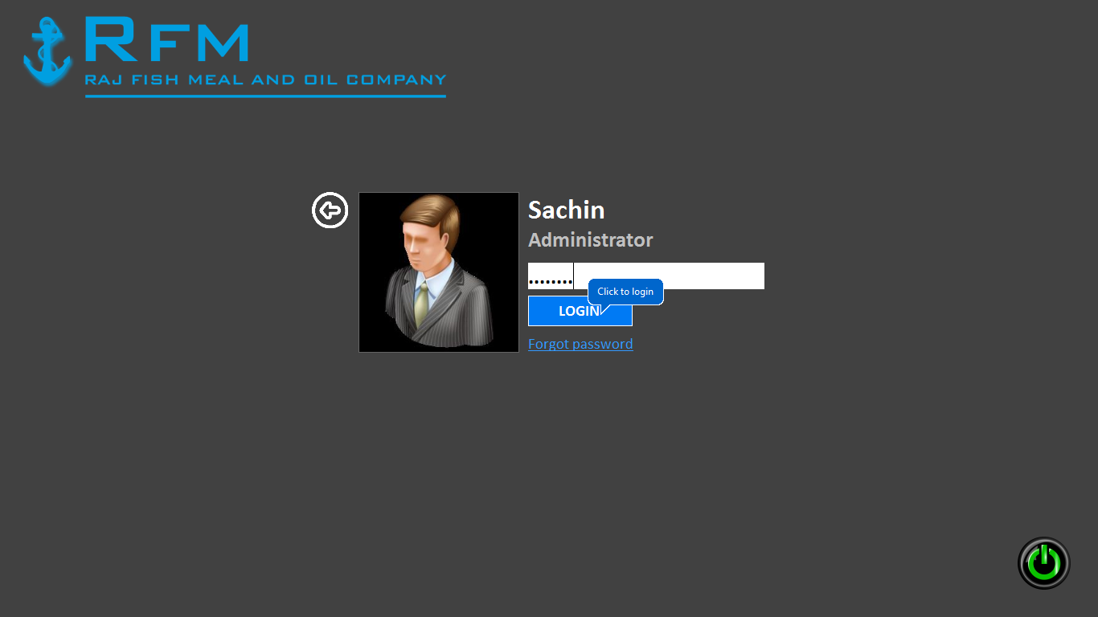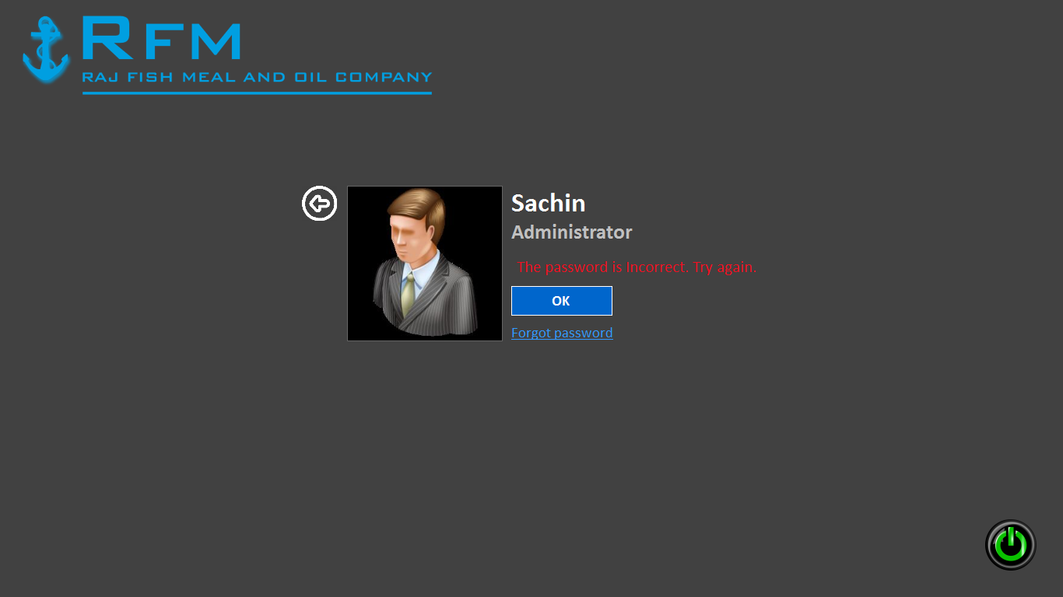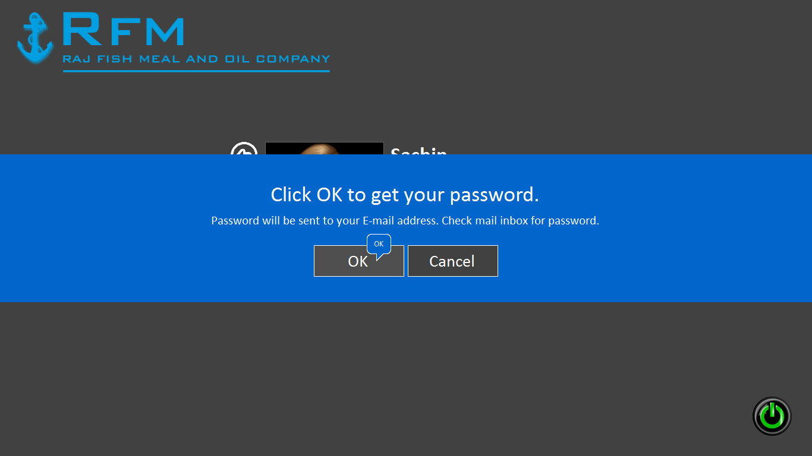

## Test Case 2

|  |
| --- |
| Test objectives: Test for checking correct values entered in  new user account fields or not**.**  Test Data: Valid: Required fields should contain correct values.  Invalid: If the required field does not contain proper values.  Output: Valid: Allows records to be added to the Database.  Invalid: The user is prompt with an error Message.  Result: Valid: The records will be added to the database.  Invalid: The records will not be added to the Database.  Conclusion: Both the valid and invalid results are tested.  Output tallies with the required result, hence test is successful. |

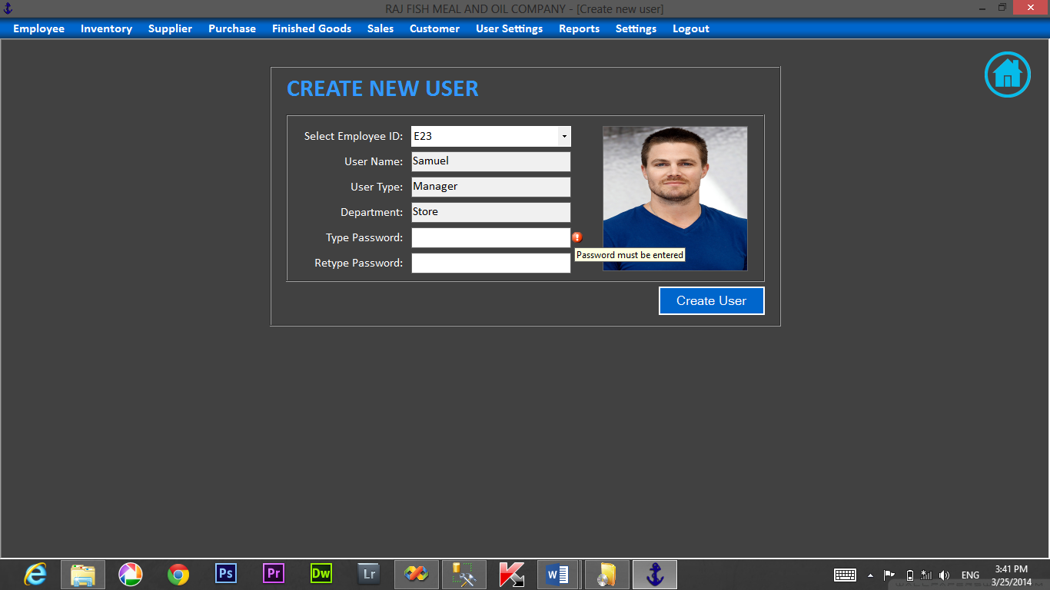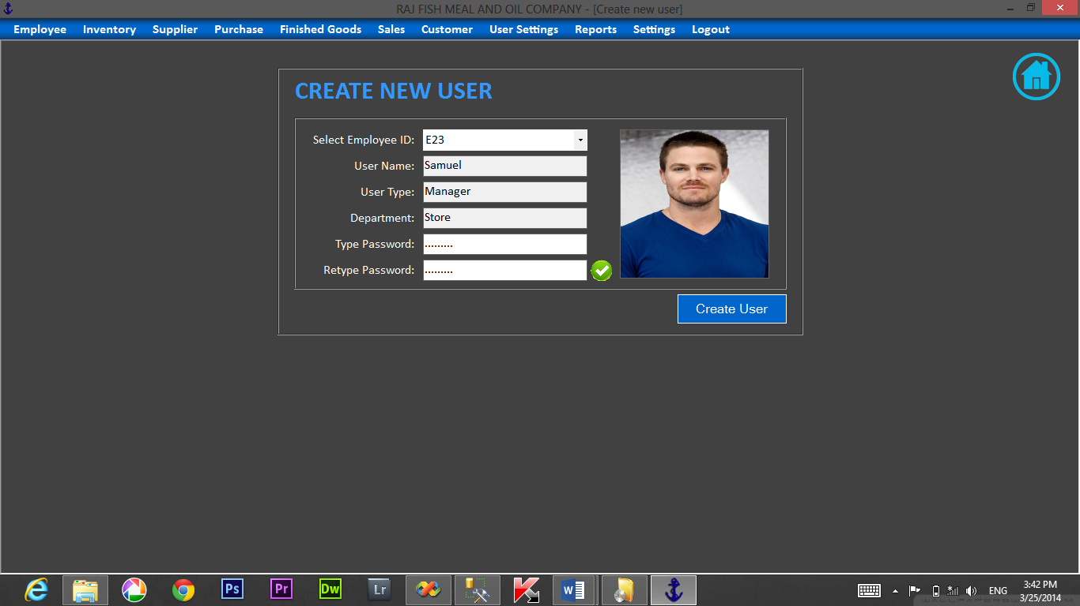

**Test Case 3**

|  |
| --- |
| Test Objectives: Test for adding/editing stock inventory  Test Data: Valid: Required fields should be entered with correct values  Invalid: If the required field is not correct.  Output: Valid: Allows records to be added to the database.  Invalid: The user is prompt with an error message.  Result: Valid: The records will be added to the database.  Invalid: The record will not be added to the database.  Conclusion: Both the valid and invalid results are tested.  Output tallies with the required result, hence test is Successful. |

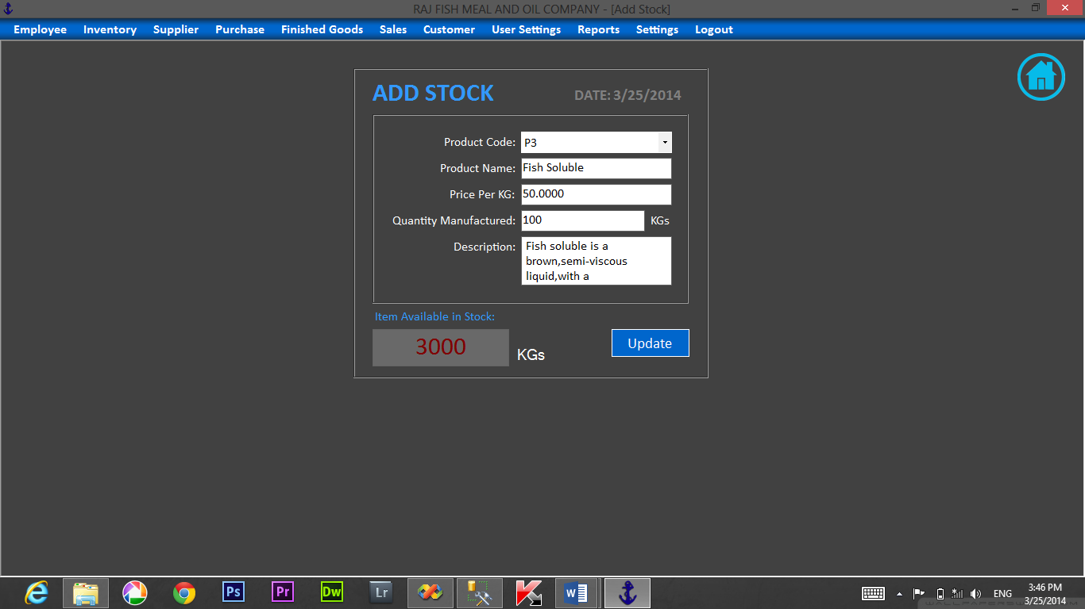

## Test Case 4

|  |
| --- |
| Test Objectives: Test for employee records.  Test Data: Valid: Required fields should be entered with correct values.  Invalid: If the required field is not having proper values.  Output: Valid: Allows records to be added to the database.  Invalid: The user is prompt with an error message.  Result: Valid: The records will be added to the database.  Invalid: The record will not be added to the database.  Conclusion: Both the valid and invalid results are tested. Output  tallies with the required result, hence test is Successful. |

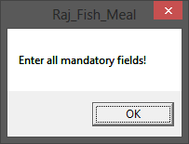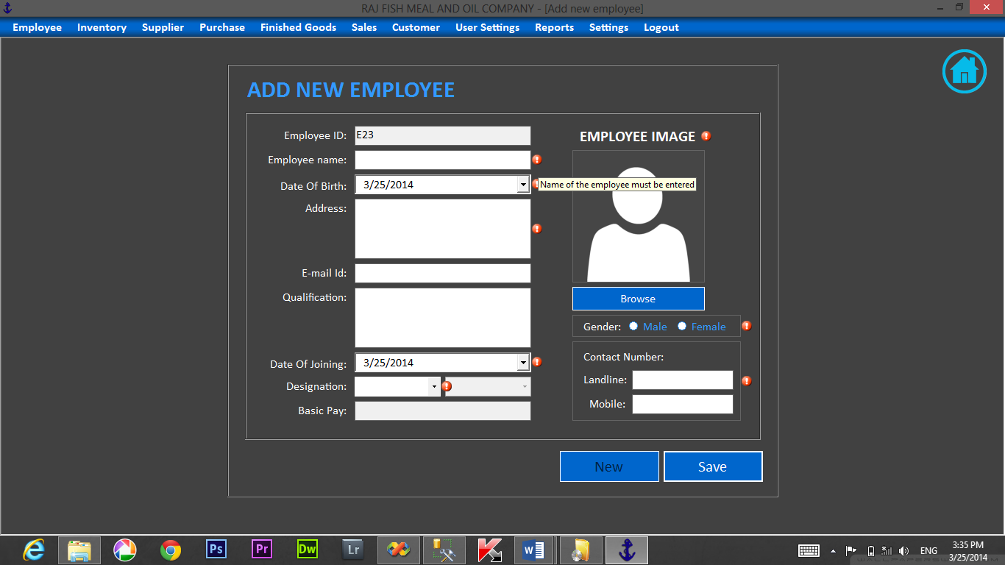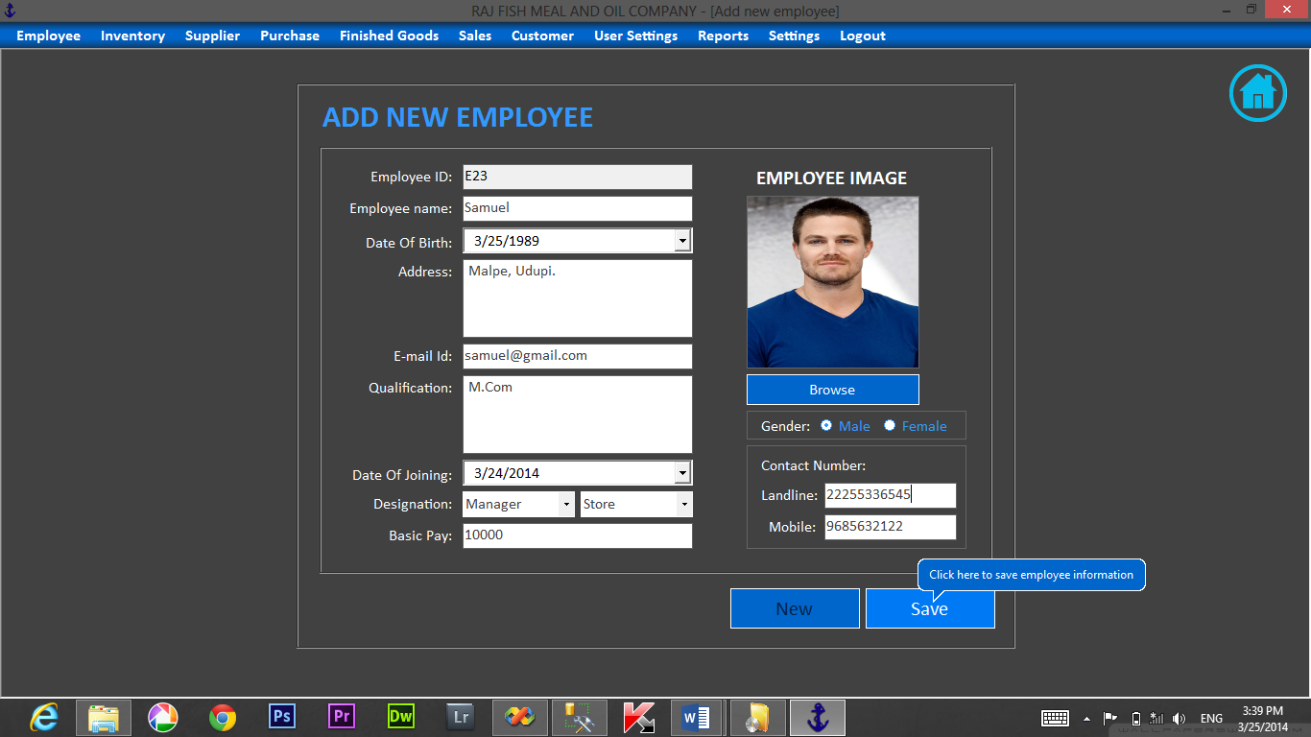

**INTEGRATED TESTING:**

## Test Case 1

Test objectives: Test for the relationship between purchase invoice and raw inventory.

Test data: Valid: When all information for the purchase received is entered as required.

Invalid: When all information is not entered as required.

Output: Valid: Purchase received details are saved in database and hence the updating is done automatically in raw/tin stock.

Invalid: User is prompted with error message.

Result: Valid: Relationship between two forms works successfully.

Invalid: Relationship fails.

Conclusion: Both the valid and invalid results are tested. Output tally with the required result, hence the test is successful.

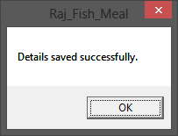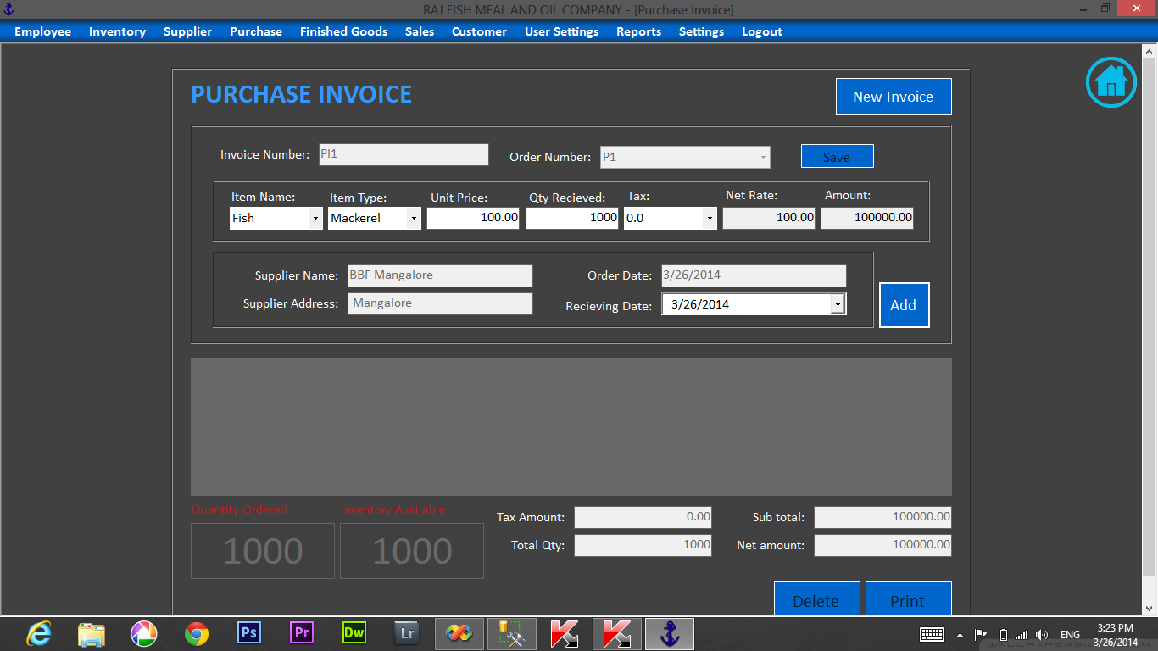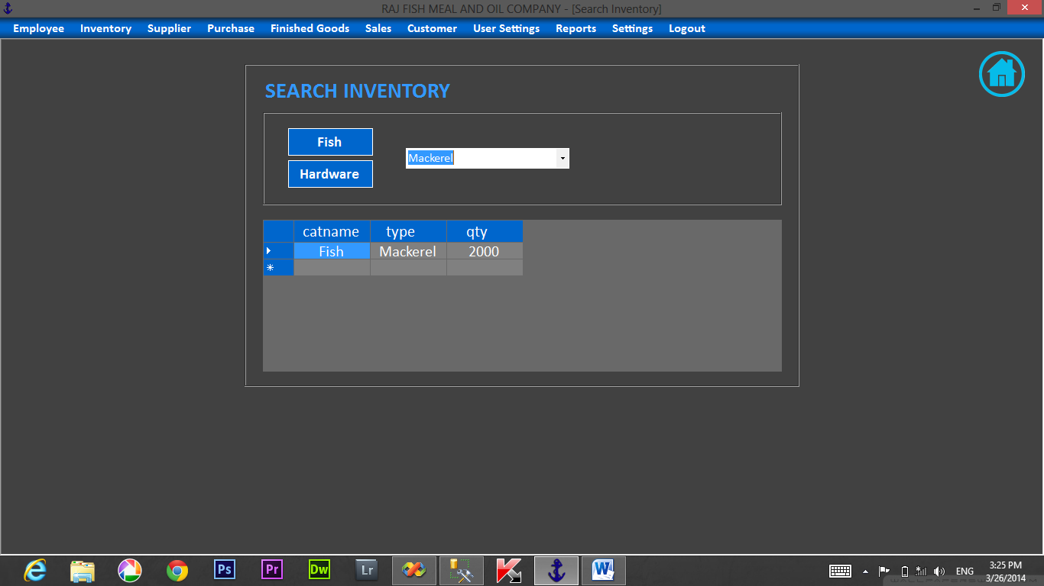

Test case: 2

Test objectives: Test for the relationship between sales bill and stock.

Test data: Valid: When all information for the sales bill is entered as required.

Invalid: When all information is not entered as required.

Output: Valid: Purchase bill details are saved in database and hence the updating is done automatically in raw/tin stock.

Invalid: User is prompted with error message.

Result: Valid: Relationship between two forms works successfully.

Invalid: Relationship fails.

Conclusion: Both the valid and invalid results are tested. Output tally with the required result, hence the test is successful.

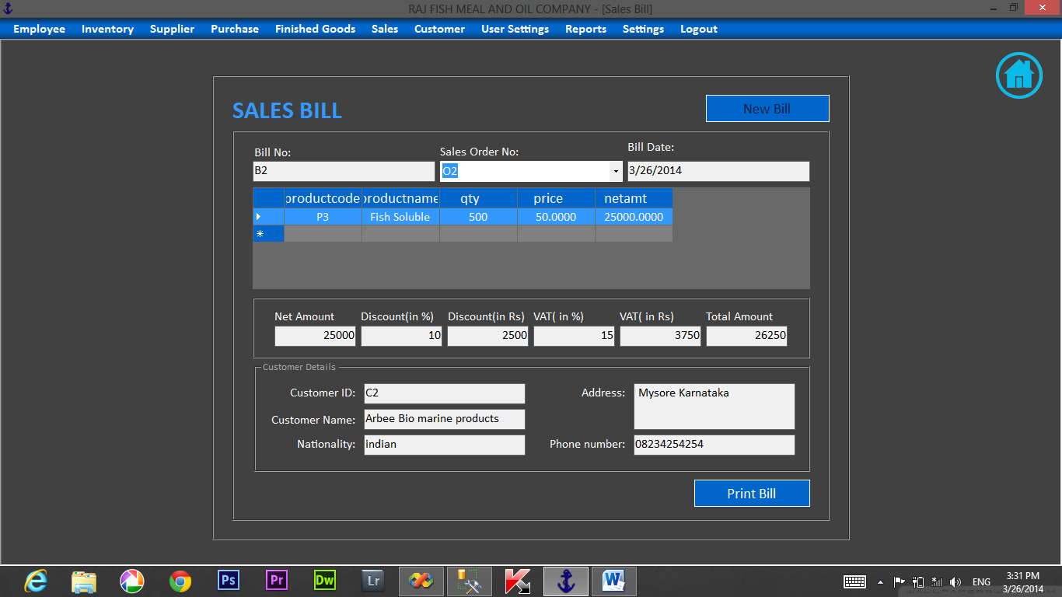

Test case: 3

Test objectives: Test for the relationship between purchase return and stock.

Test data: Valid: When all information for the purchase return is entered as required.

Invalid: When all information is not entered as required.

Output: Valid: Purchase return details are saved in database and hence the updating is done automatically in raw/tin stock.

Invalid: User is prompted with error message.

Result: Valid: Relationship between two forms works successfully.

Invalid: Relationship fails.

Conclusion: Both the valid and invalid results are tested. Output tally with the required result, hence the test is successful.

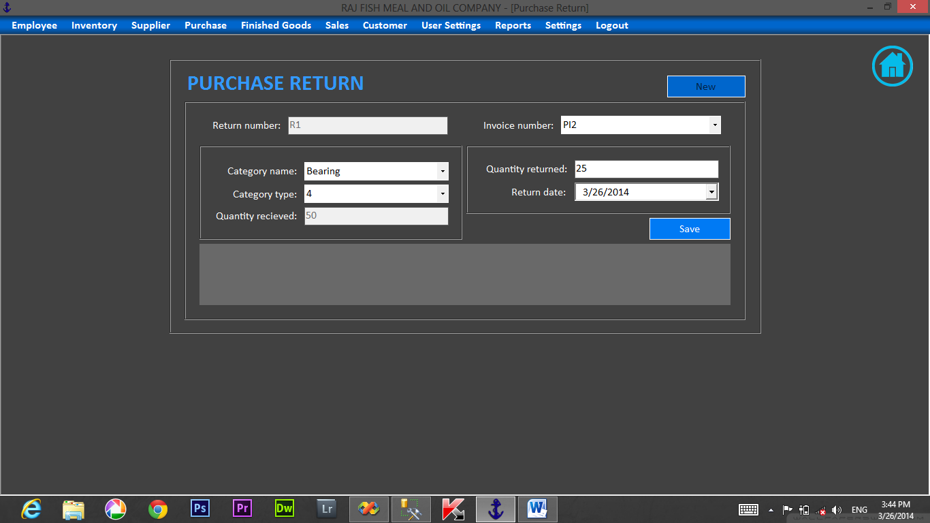

Test case: 4

Test objectives: Test for the relationship between employee attendance and salary.

Test data: Valid: When all information for the employee is entered as required.

Invalid: When all information is not entered as required.

Output: Valid: Employee details are saved in database and hence the updating is done automatically in raw/tin stock.

Invalid: User is prompted with error message.

Result: Valid: Relationship between two forms works successfully.

Invalid: Relationship fails.

Conclusion: Both the valid and invalid results are tested. Output tally with the required result, hence the test is successful.

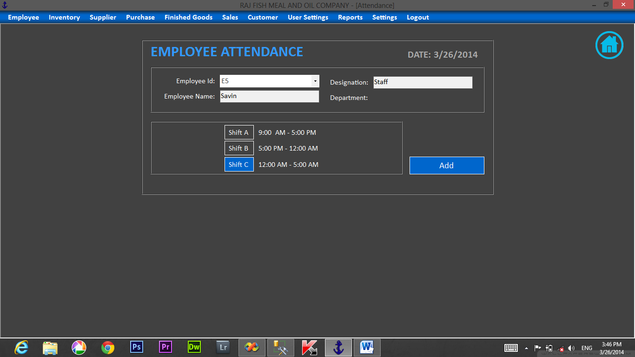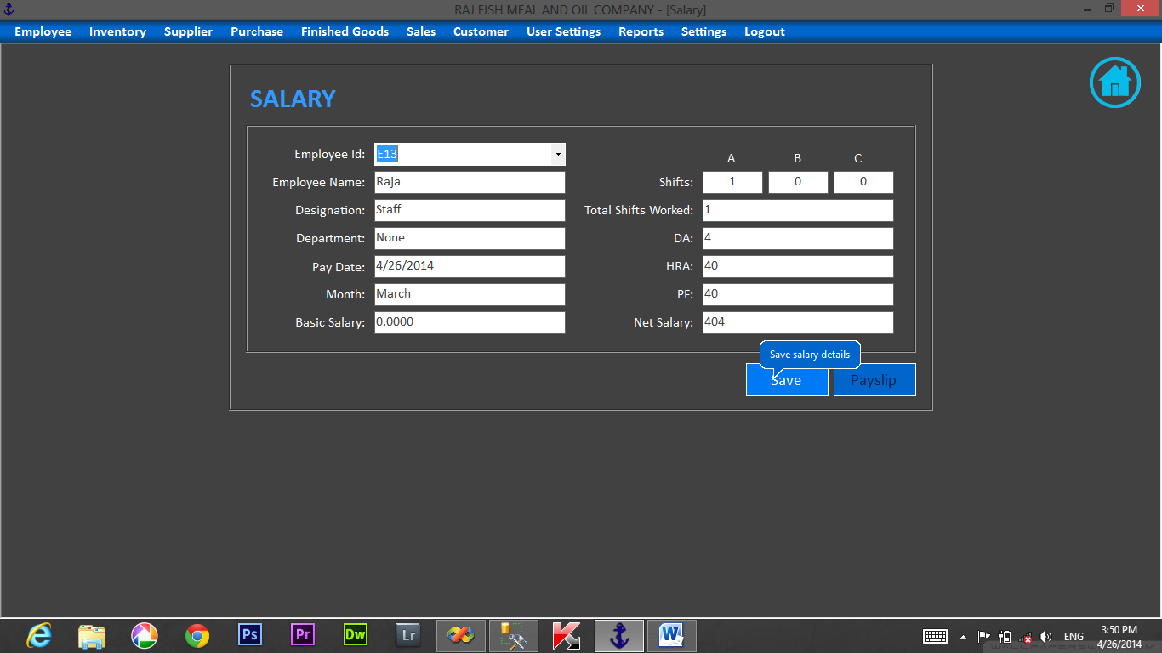

**SYSTEM TESTING:**

## Test Case 1

|  |
| --- |
| Test objectives: Test for changing password.  Test Data: Valid: Valid administrator password.  Invalid: Password is blank or incorrect password.  Output: Valid: Allows changing password.  Invalid: Shows the error message.  Result: Valid: The password will be changed.  Invalid: The record is not updated to the Database.  Conclusion: Both the valid and invalid results are tested.  Output tallies with the required result, hence test I s successful. |

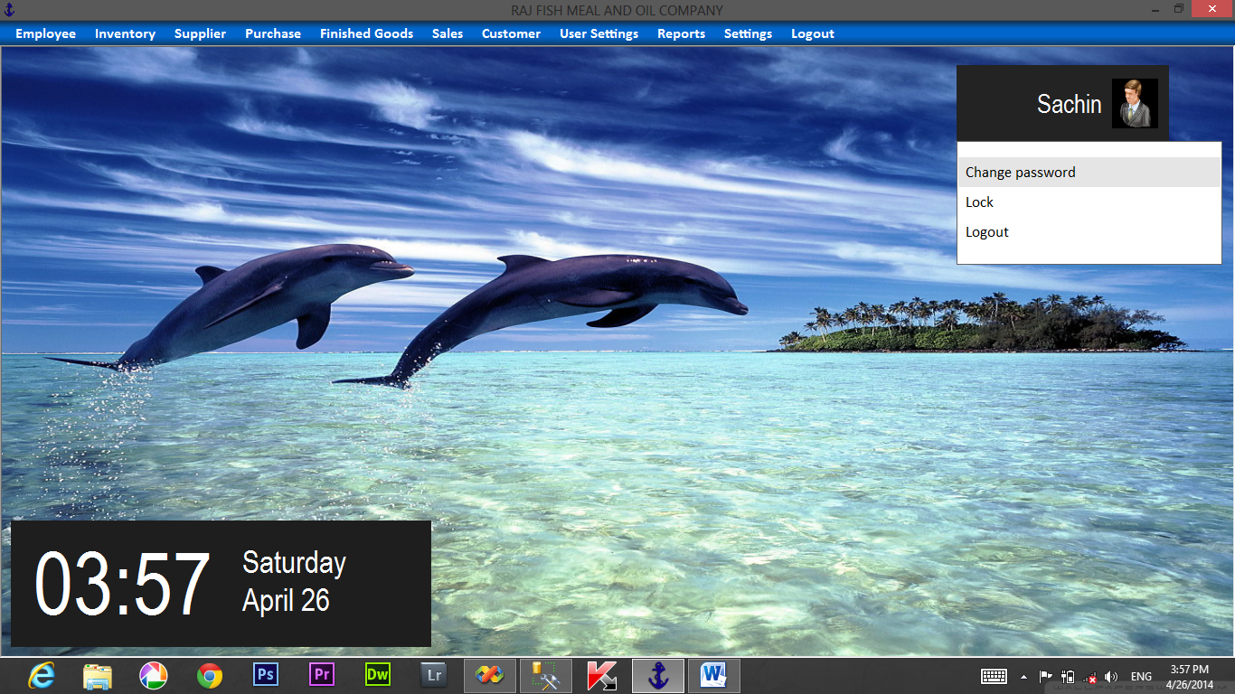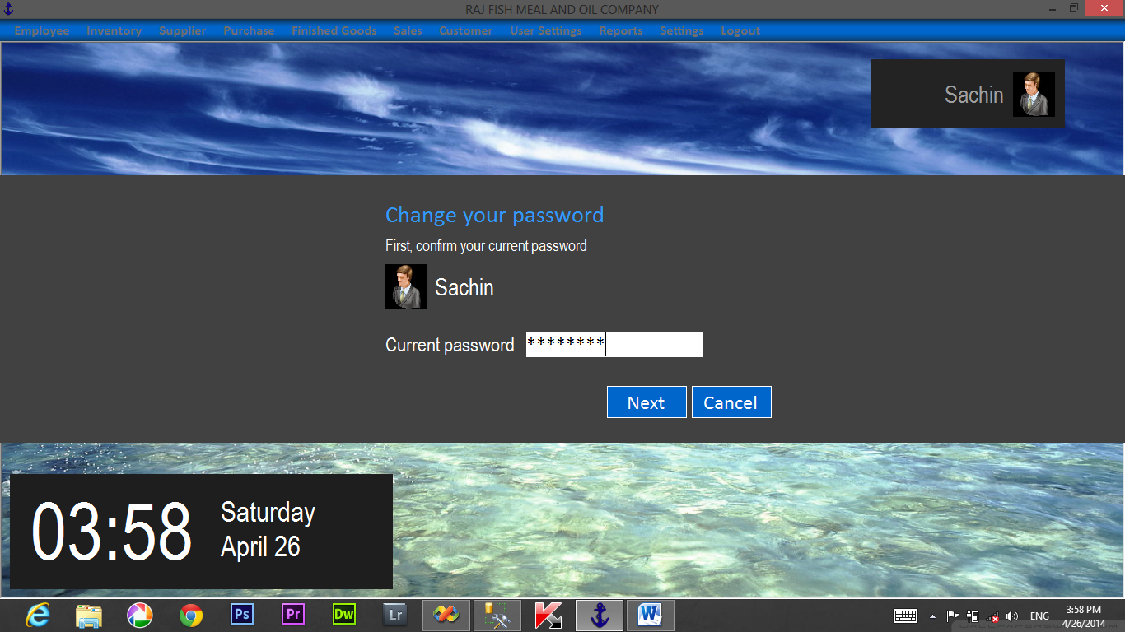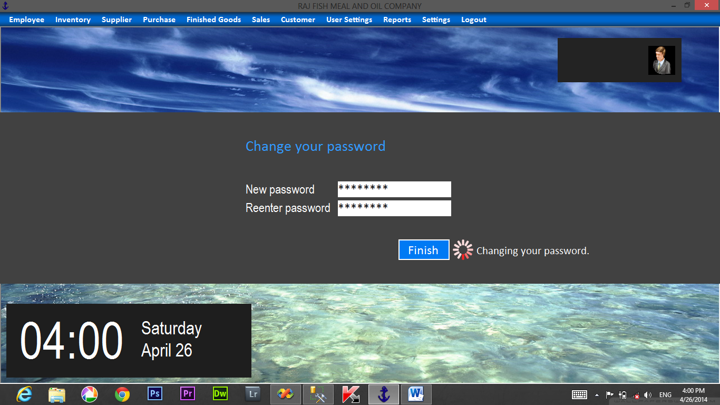

Test case: 2

Test objectives: Test for adding purchase order information.

Test data: valid: All required fields are entered

Invalid: Some required fields are blank or incorrect.

Output: Valid: Allows record to be added to the database.

Invalid: The user is prompt with an error message.

Result: Valid: Record is saved.

Invalid: Record is not saved.

Conclusion: Both the valid and invalid results are tested and the record will be saved into the database.

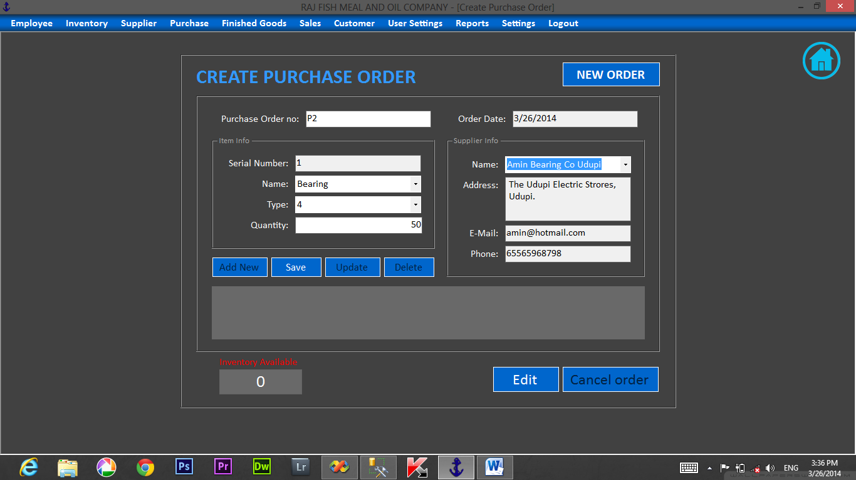

**Test case: 3**

Test objectives: Test for modifying employee information.

Test data: valid: All required fields are entered

Invalid: Some required fields are blank or incorrect.

Output: Valid: Allows record to update to the database.

Invalid: The user is prompt with an error message.

Result: Valid: Record is updated.

Invalid: Record is not updated.

Conclusion: Both the valid and invalid results are tested. Output tally with the required result, hence the test is successful.

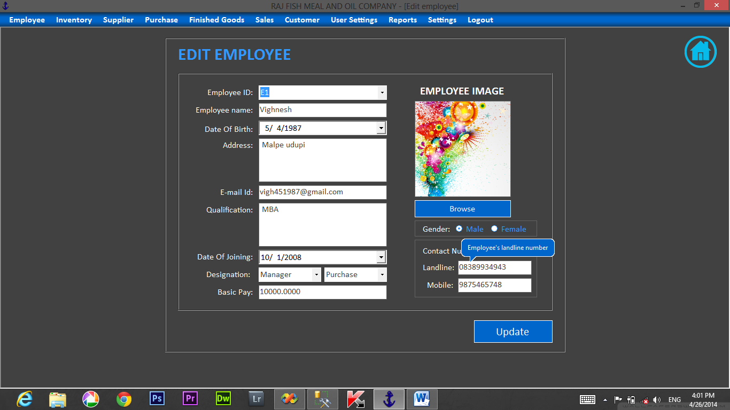

**Test Case 4**

|  |
| --- |
| Test Objectives: Test for unlocking the user Account.  Test Data: Valid: If the user enters the invalid password, username or  User type thrice, then admin has the Rights to unlock.  Invalid: If the user enters invalid username,  Password then user cannot unlock it.  Output: Valid: Shows an error message.  Invalid: Enters into the system normally.  Result: Valid: The users account will be unlocked by admin  And the user can now enter the program.  Invalid: The user will be allowed to enter the Program.  Conclusion: Both the valid and invalid results are tested. Output  Tallies with the required result, hence test is Successful. |

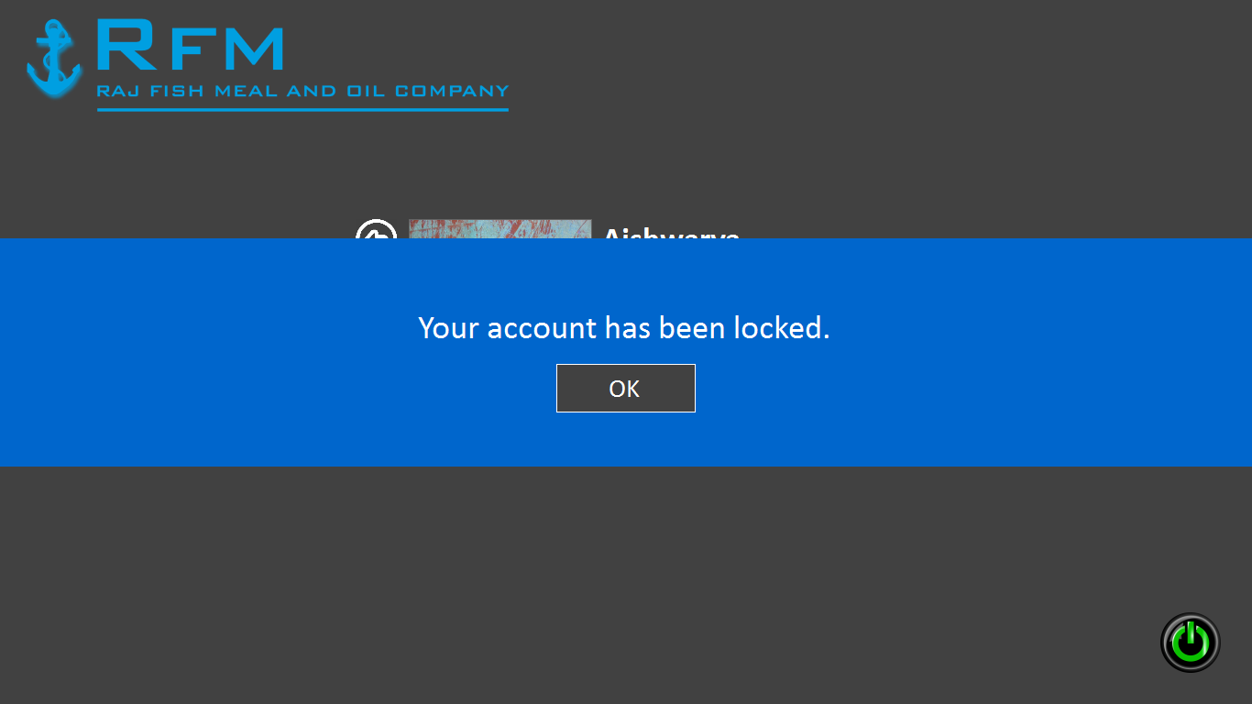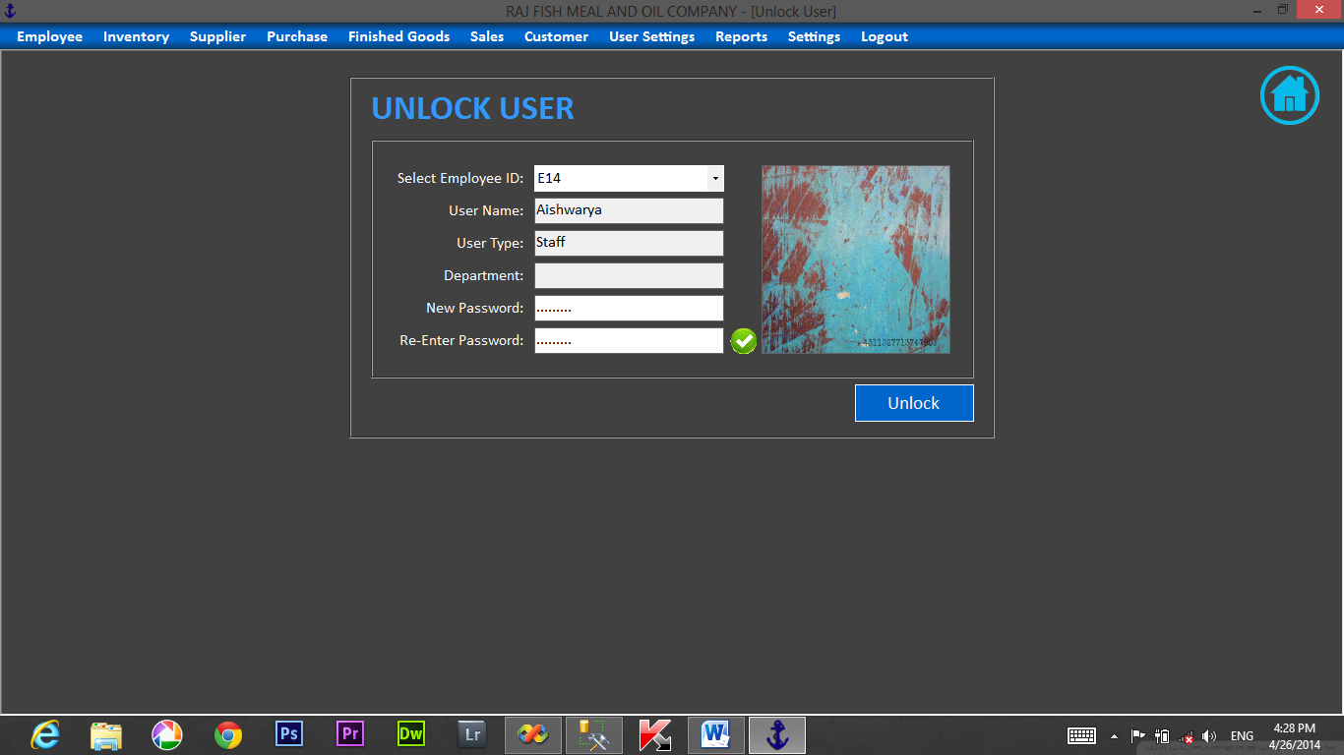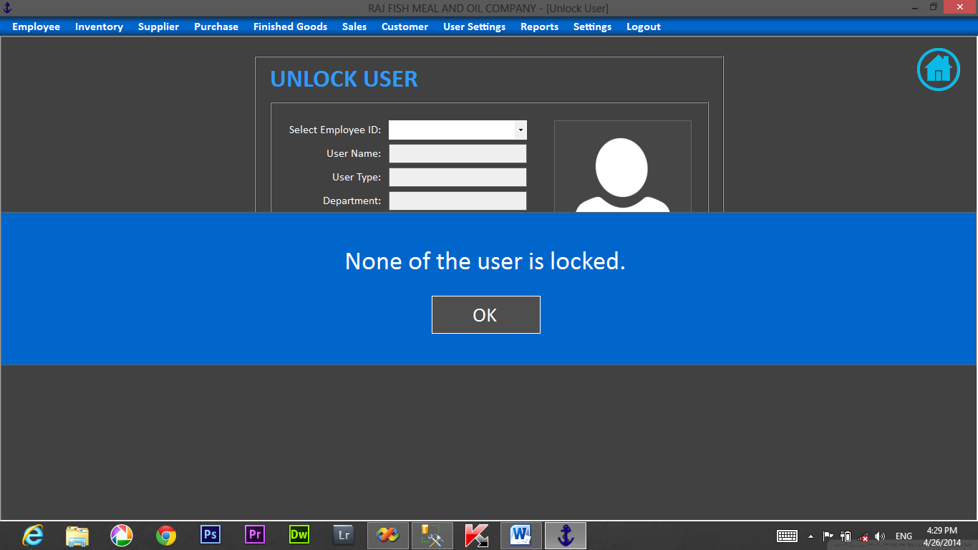

**Input &Output**

**Screens**

**HOME SCREEN**

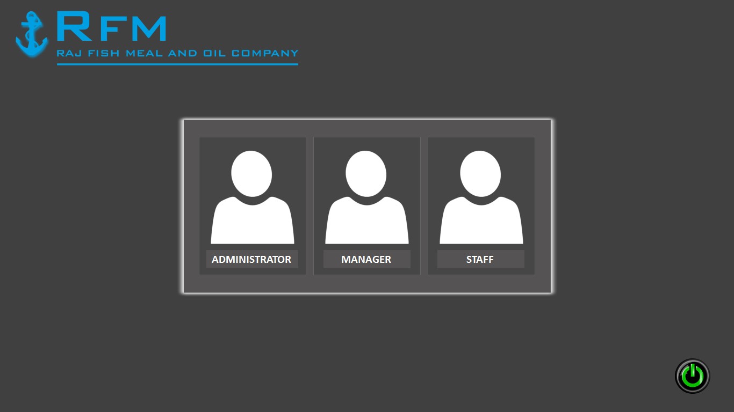

**LOGIN FORM**



**USERS LISTS**



**MENU FORM**



**EMPLOYEE INFORMATION**

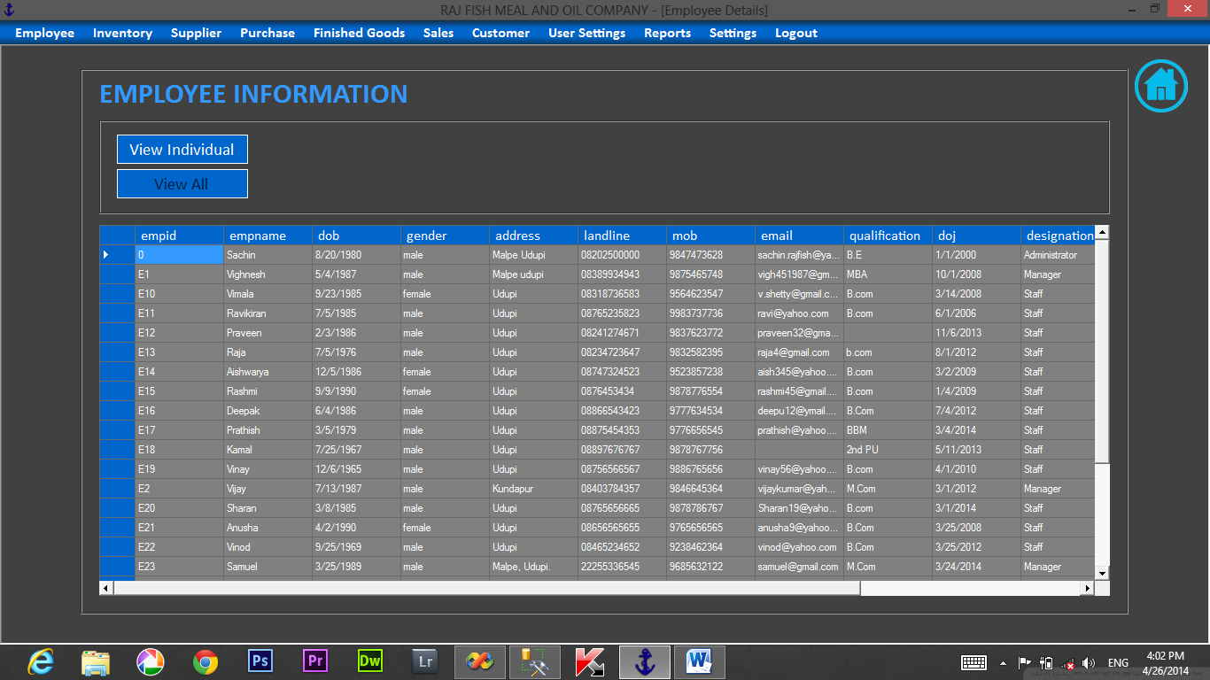

**REMOVE EMPLOYEE**

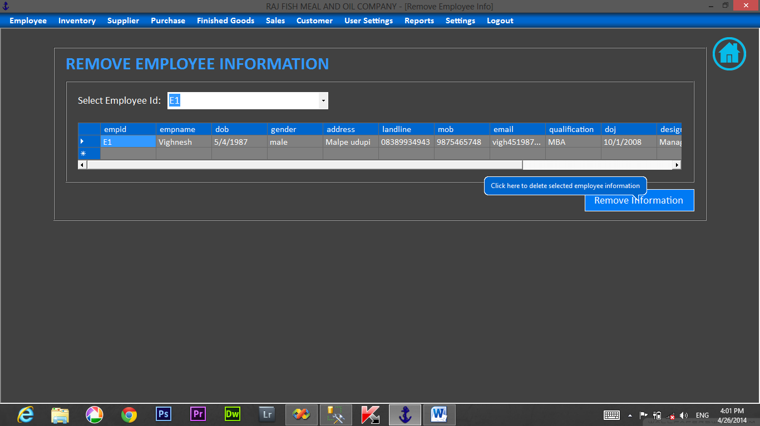

**SEARCH INVENTORY**

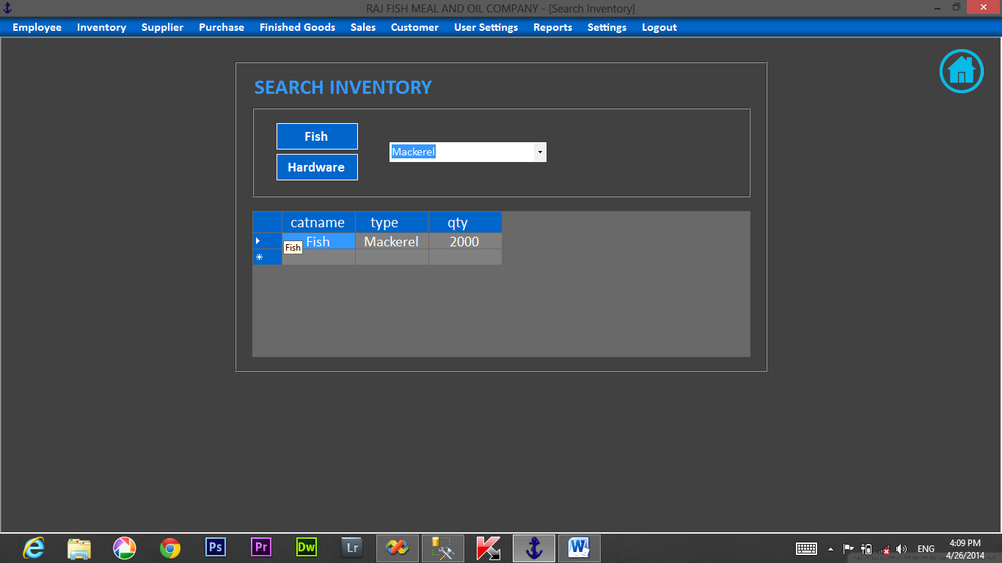

**VIEW STOCK**

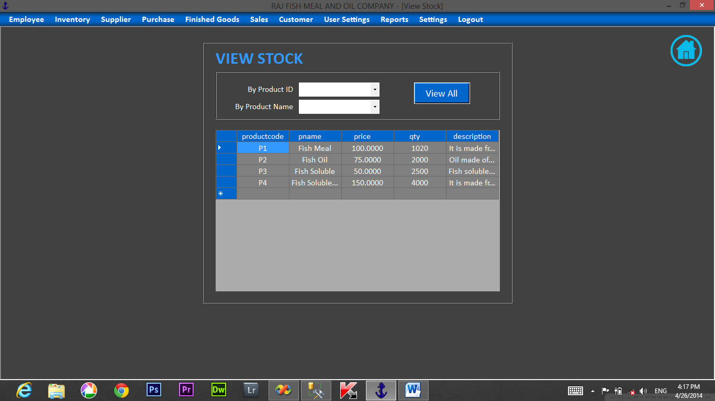

**ADD NEW SUPPLIER**

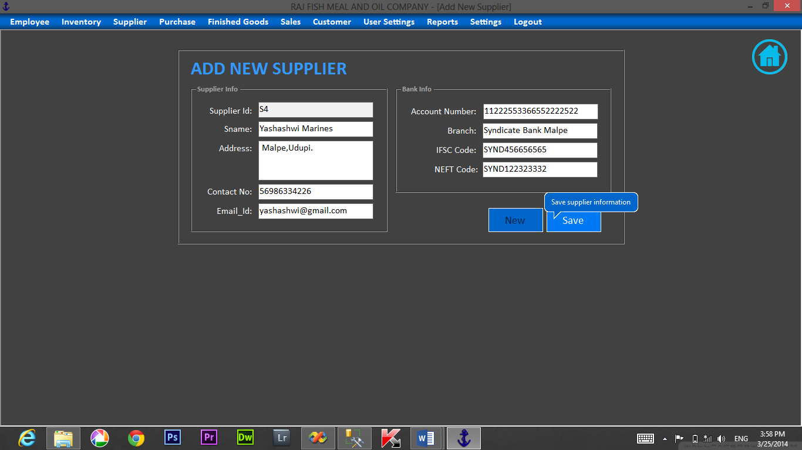

**SEARCH SUPPLIER**

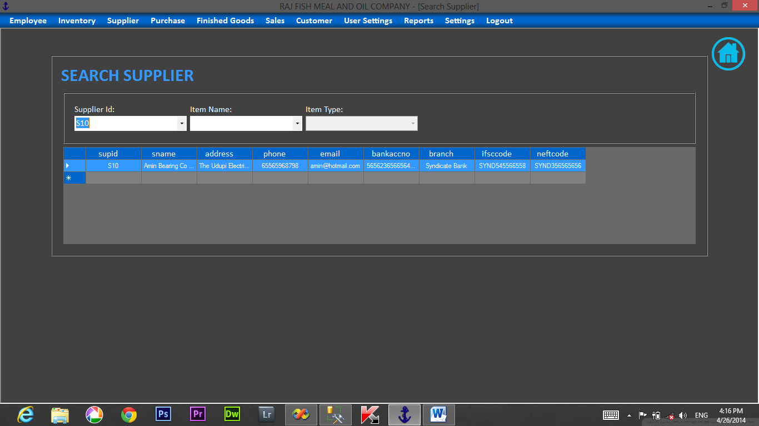

**SALES ORDER**

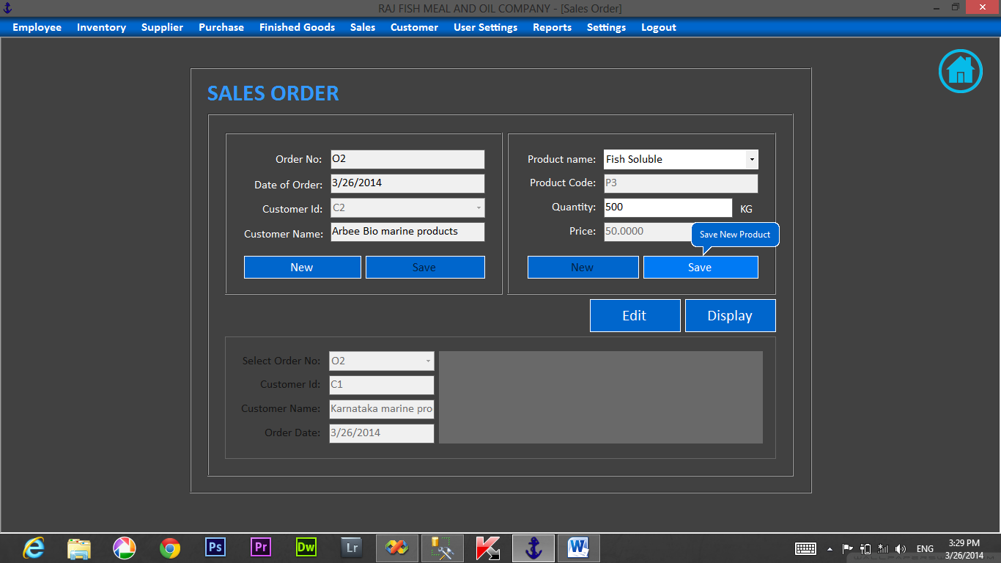

**EDIT SALES ORDER**

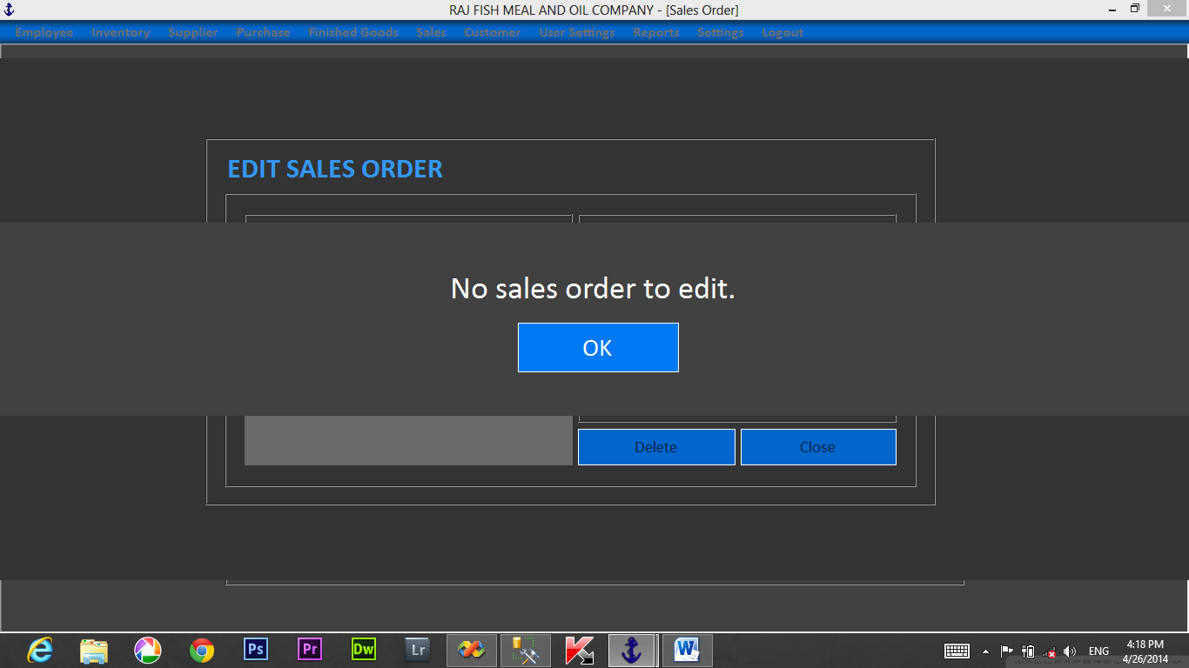

**SALES BILL**

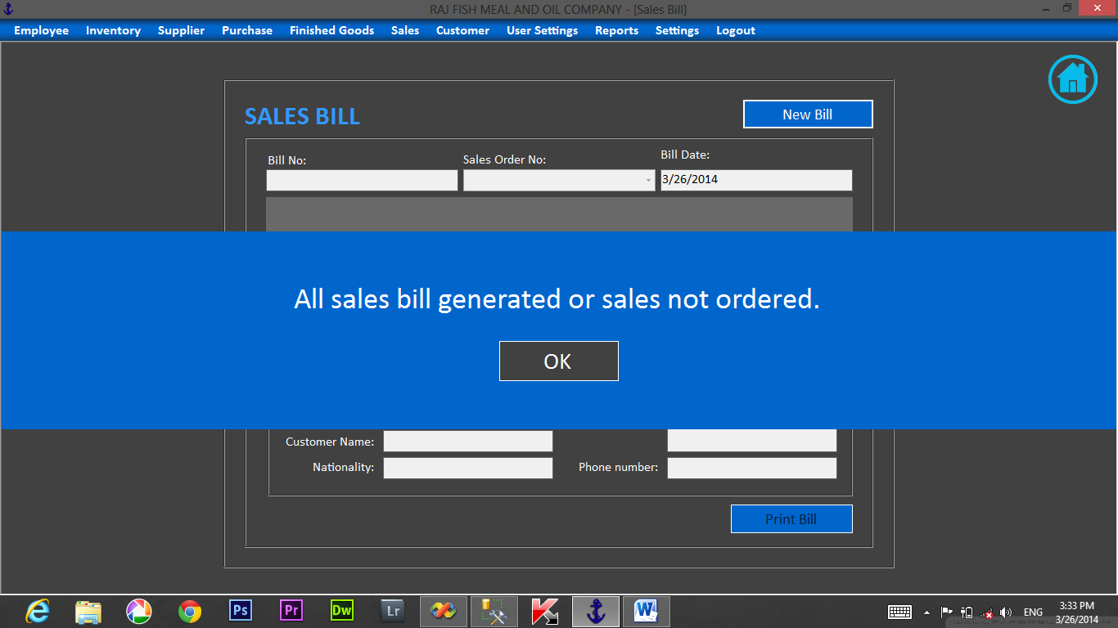

**BILL**

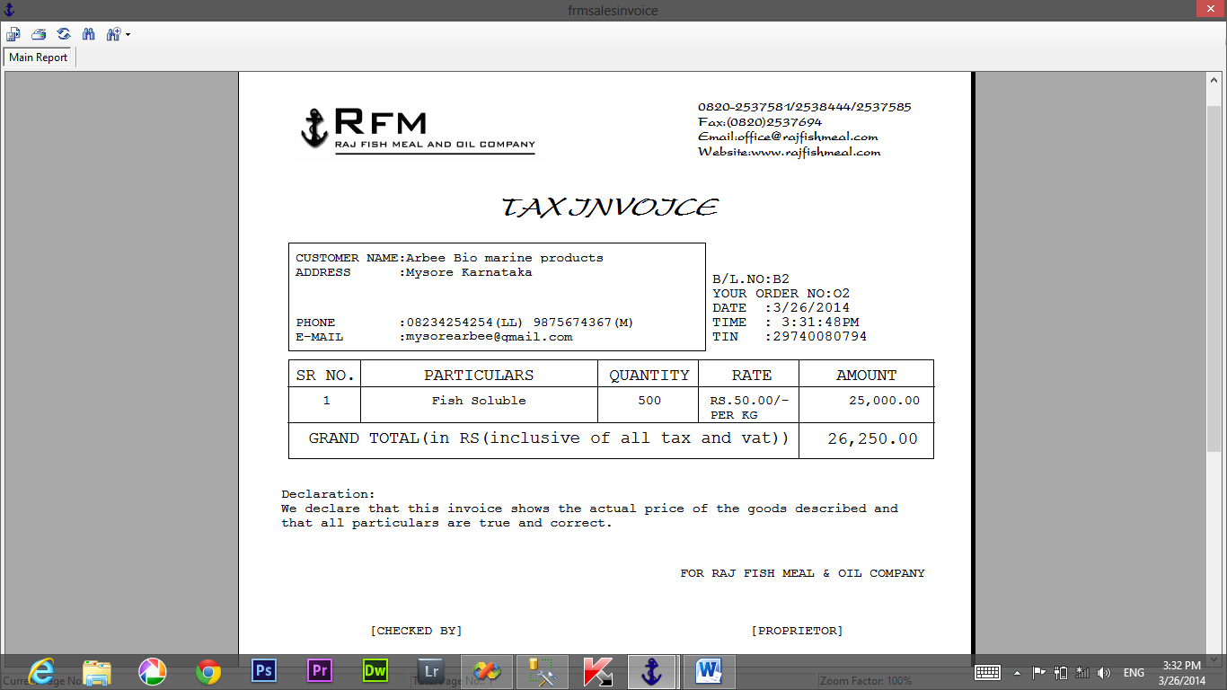

**SALES DETAILS**

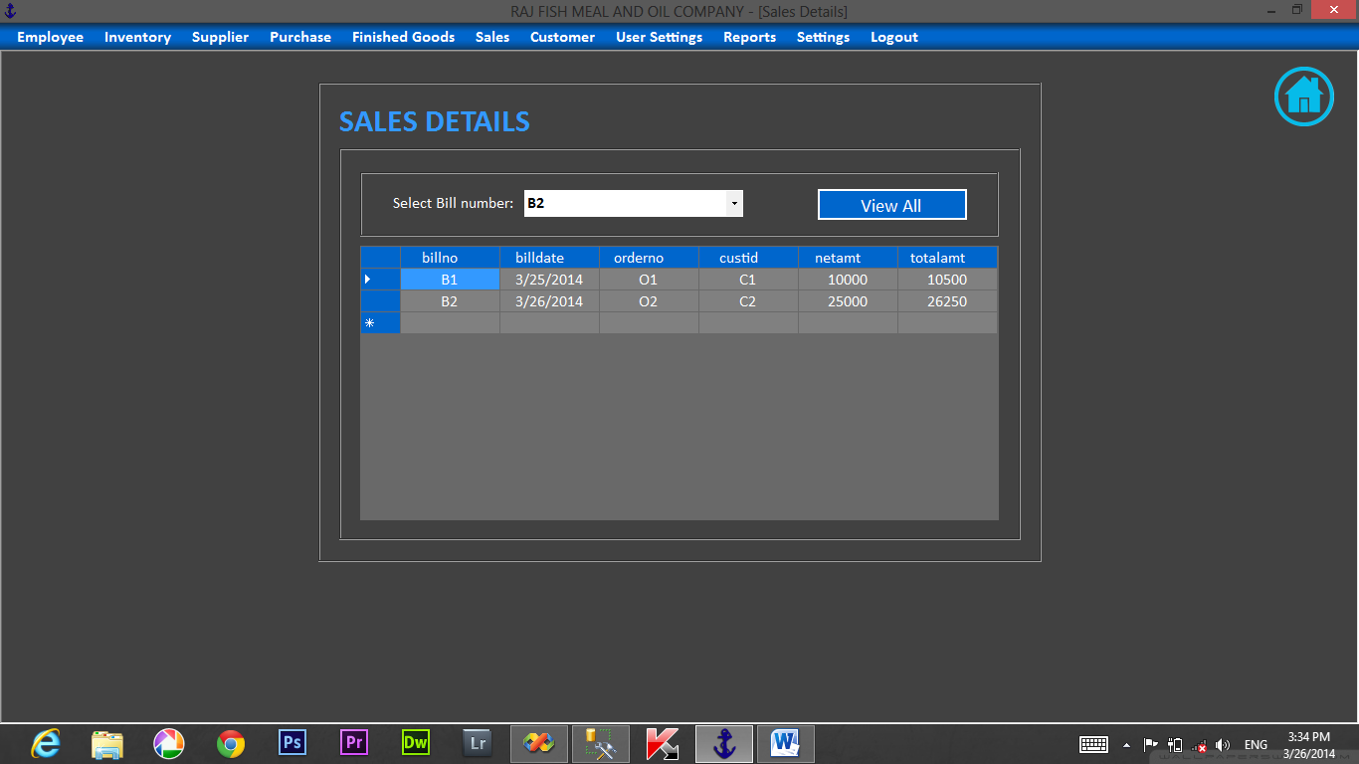

**ADD CUSTOMER**

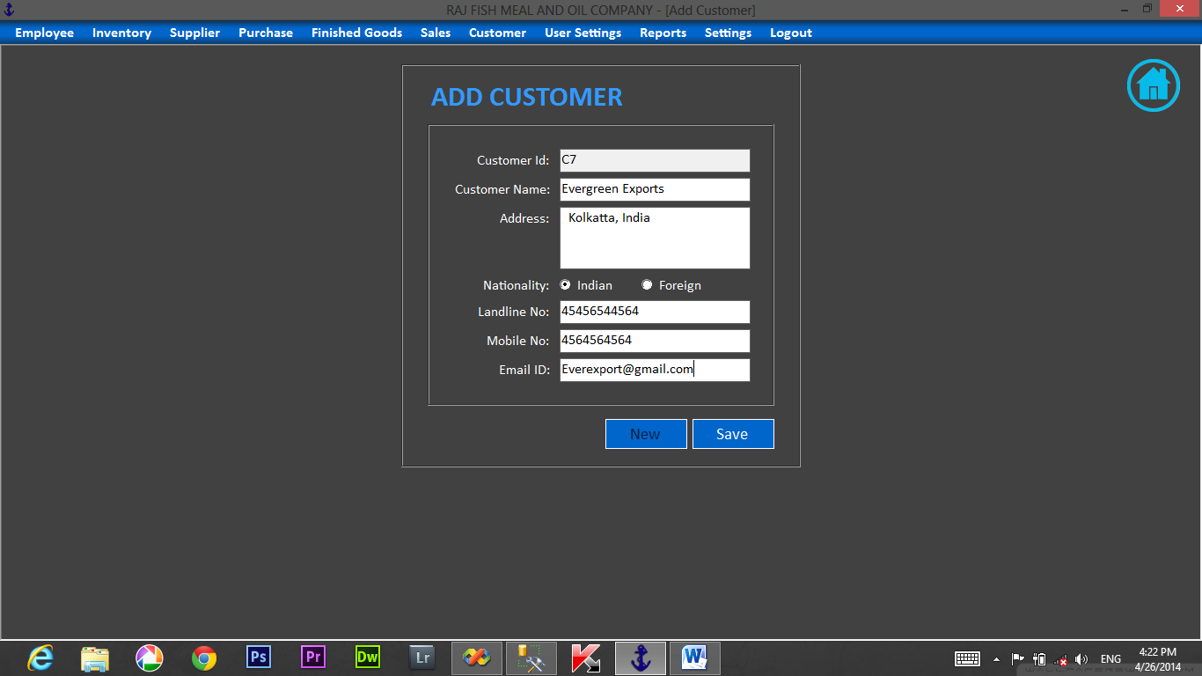

**FACTORY CONSUMPTION**

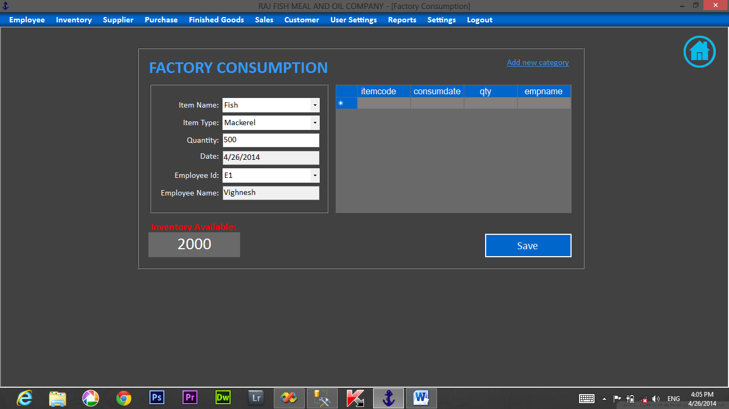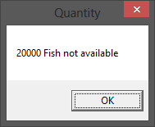

**FACTORY CONSUMPTION REPORT**

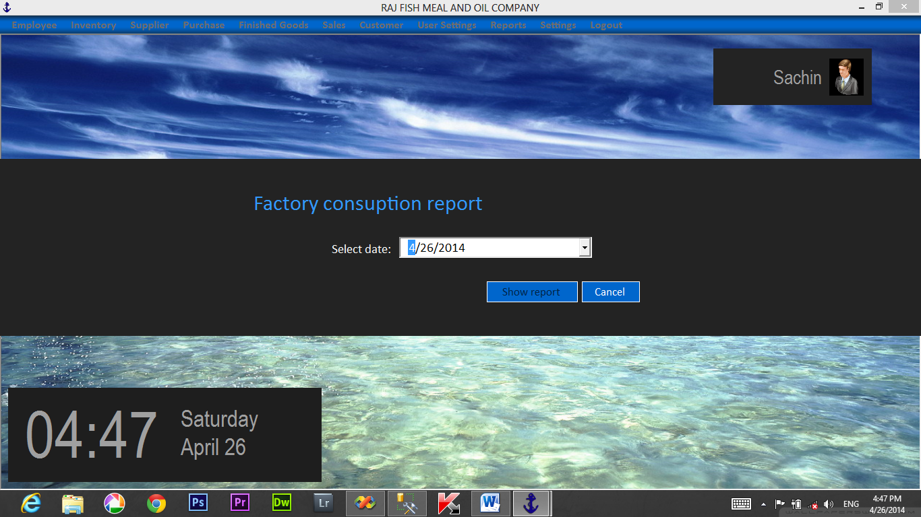

**SALARY**



**PAYSLIP**

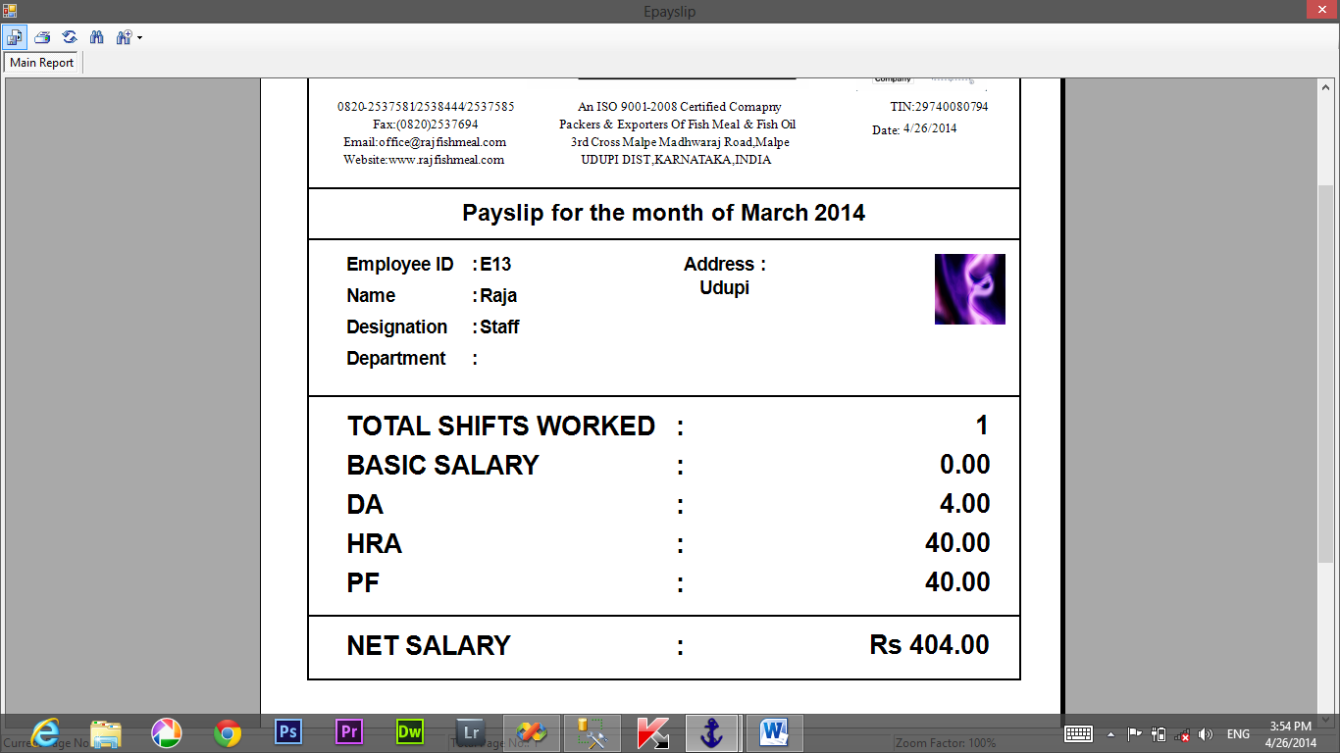

**SETTINGS**

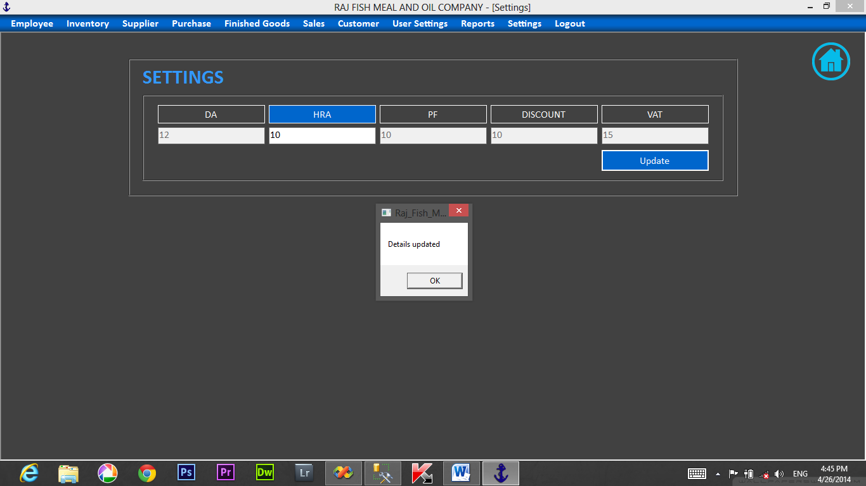

**LOCK SCREEN**



**LIMITATIONS:**

There are certain limitations in the software:

1.SQL Server 2005 has to be installed in the system in which this software needs to be used.

2.The display screen can play only few records at a time, which will be troublesome for the users if there are many records in the database

**CONCLUSION AND FUTURE ENHANCEMENT:**

**CONCLUSION:**

Computerized Management for “RAJ FISH MEAL & OIL COMPANY” is developed for the purpose of computerize the maintenance of customer information,supplier,stock, employee details,and other information, which replaces all the records, that are handled manually. There are many records such as customer information, Employee information sales details, raw and stockinventory details, attendance and salary details, etc. Since it involves a lot of work so it is very difficult task for the user to maintain all these manually. This helps to maintain the records efficiently.

This program is written with the small and easy to access each form by clicking on the command button on main screen. It provides the flexibility to work on the system very easily. The user does not need to remember the entire menu system. It is user’s friendly program.

**FUTURE ENHANCEMENT:**

* Any change made to the requirement in the future will have to go through a formal change approval process
* In future the software can be made more user friendly.

**DEFINTIONS, ACRONYMS AND ABBREVATIONS**

**This software makes use of Connection string for connecting the SQL server. Connection string defines the following constraints namely**

* Data source
* Initial catalogue
* Integrated security

**Data source**: This defines the source from where the data needs to be extracted.

**Initial catalogue:** This defines the name of the database to be used.

**Integrated security:** The database can be accessed using an authorized passwords and user names.

Following acronyms and abbreviations are being used in the proposed software:

* SQL-Structured Query Language
* VB.Net- Visual Basic Studio
* DFD-Data Flow Diagram
* CFD-Context Flow Diagram
* GUI- Graphical User Interface

**BIBLIOGRAPHY**

* An Integrated Approach to Software engineering:

By Pankaj Jalote.

* A book on VB.net Education: By M.Vishwanath Pai**.**

**References:**

# Introduction to Microsoft SQL server 2005.

* Teach yourself SQL in 21 days by Ryan K. Stephens, Ronald Plew, Bryan Morgan and Jeff Perkins.